
Assignment Cover Sheet

Student Name: | Usha Dubey
Student Number: | 11303
Course: | Diploma in Fashion Design
Assignment NO: | 6

1.Discuss, in detail, how the designers work?
A fashion designer is someone who loves to study fashion trends, sketch designs, select materials, and have a part in all the production aspects of their designs. They contribute to the creation of millions, if not billions of pieces of clothing and accessories purchased by consumers on a yearly basis. They assess, carefully select the designs that seem appropriate according to their percipience of the garments, the styles and the state of fashion at the given point of time. They are also accountable for the sources of inspiration in their immediate environment. Overall designers influence fashion. They provide new designs in a various range from which the consumer can choose the ones best suited to express their individual self.
Designers remember other designs that they have seen and these coupled with objects or images will provide the ideas for a new design, they have to be creative which is influenced by their experiences. The design process from design concept to final production takes many months.
Generation of new ideas and concepts is a necessary part of the designing process. Researching current fashion trends and making predictions of future trends is the first step in creating the design. Some fashion designers do their own research while others depend on trend reports published by fashion industry trade groups. These along with original ideas are used come up with even more designs which are continually evaluated and discarded if they feel that it will not produce desired results.
A designer must always be on lookout and aware of what will be in fashion for an upcoming season. Styles continually evolve and the designer has to be aware of this and adapt to the same. The ability adapts to spot trends and mentally transform them into garments is a necessary skill. Fashion research needs to be stuff that inspires you. Most of it is visual but it does not have to be. A song, a smell, a poem, or even a taste could inspire you to design. Normally a research folder (or mood board or sketchbook – however you want to store it) will contain inspiring visuals of things like art, photography, textiles, historical fashion, architecture, nature, or industrial design.
It allows a designer to improve the skills of perception and easily be able to recognize what is or is not is not fashionable at any time, or culture or the undertone that garment may have and also the ways in which a design needs to be modified in order to be par with the fashion of the given time. It also provides them with experience. But this research must be accurate and produce designs in larger variety so that the customers will have a wider range and so that the designers won't have to change the design at a later stage which is time-consuming.
The fashion designer's next step is to take the rough sketch or model and develop a more specific working pattern. Usually, the designer will make a rough model of the design by creating a toile. This is made by sewing inexpensive material (like muslin) to make a rough model of the design. When this is placed on a mannequin-like dress stand, the designer can see how the material will drape or hang on a human form.
Large design houses hire their own pattern-makers, tailors, and sewers who create the master patterns and sew the prototypes. Designers working in small design firms, or those new to the business, usually do most of the technical pattern-making and sewing tasks, in addition to designing the clothing. When the garment is complete, the designer will either modify, scrap or approve the design for showing in a collection.
A fashion designer also usually has full control of a fashion show, often picking the models, determining the price of each garment, and arranging how the garments will be presented. Most designers have assistants to help with all the many small details, but overall, the designer retains full control.

2. "A fashion storyboard is a summary of your collection's inspiration and theme. It is a design tool that will help you remain focused and consistent as your line develops.” Discuss this
"A fashion storyboard is a summary of your collection's inspiration and theme. It is a design tool that will help you remain focused and consistent as your line develops.”
An inspiration is a concept, it can be anything from a flower, leaves, water, solar system, a cause, architecture, or even a person. Anything that generates ideas in the designer’s mind, which they can communicate to people in a specific manner with the audience. The end product can be the original design of the object or a modification of the same object. It enhances one’s creativity and makes them think innovatively.
A storyboard is a visual form of expression which helps designers to create. Pictures for the design can be taken from basically anywhere – magazines, the computer, photos etc. are collected and placed on the board in the form of a story. Upon which name of the collection is decided upon and placed on the board as well including a brief description of the mood of the collection.
As the designer further progress in the process, they may dwindle from the theme or get confused in the process.
Storyboard is used to illustrate the flow of the ideas and behavior of the concept which were decided by you at the starting of the process and contains your original theme and idea, adding to that it is very sequential. So it can be referred to and can be of use in the workflow. A storyboard is a base of every collection, it depicts a designer’s inspiration points, and how it inspired them to create a collection, it includes everything from the initial photographs of the object, architecture etc., textures, fabric swatches, illustrations visual aspects of the designs and the style of the designer. A storyboard is made to tell a story, a story of how one idea, can be used, reimagined and recreated in a different way focusing on one part (texture, color, shape) or the whole of the object. It depicts the originality of the designer. It creates vivid and interesting images to attract the client, and a story that conveys and connects with the audience.
3. What is the difference between a story board and a color board?

Story Board | Color Board
Story board, is a starting point of any collection and is a board which displays and depicts the inspiration of a designer. It tells a story about how a certain object inspired them to create a collection. It gives the client a clarity about the process and ideas , on which the collection is based.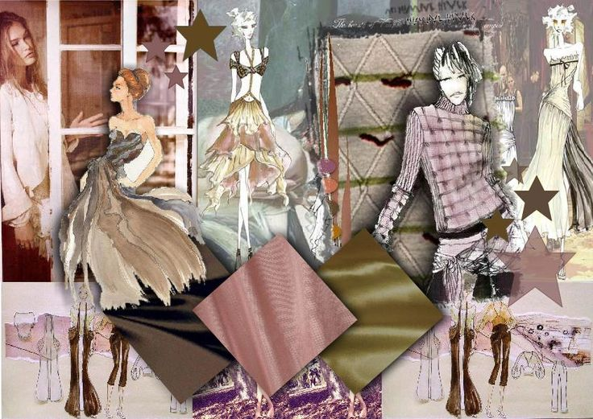 | Color board, is a part of the process of creating a collection, it focuses on the color used in a collection, from where the colors have been taken, why and how are they going to be used (dying, printing, embroidery etc.)  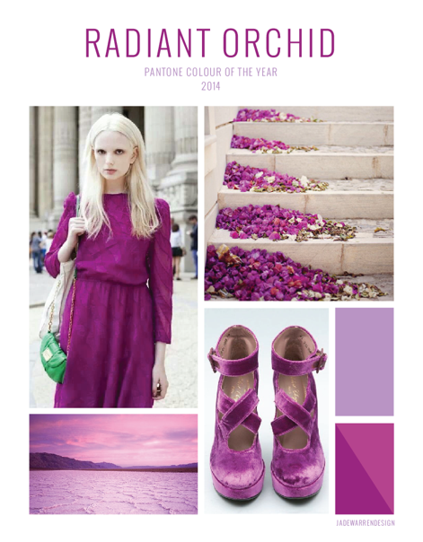
A story board includes of Fabric swatches, Illustrations, photographs and images of the inspiration point, and textures and the name of the collection.  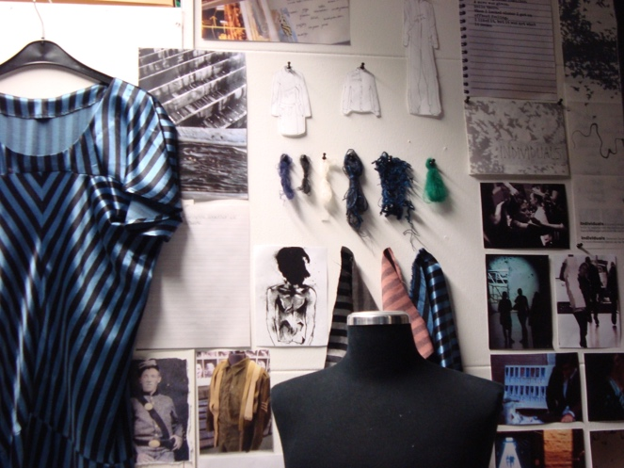 | Color board includes of Pantone shades which are denoted by numbers, color forecast for every year and season, Images that communicate the color to the audience in the form it is going to be used.  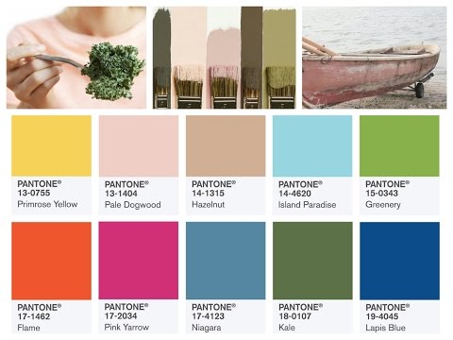
A story board is a visual board, consisting of everything that is important for the client to see and know about the collection, the silhouettes, the fabrics etc. | A color board is only about the colors that are going to be used in the collection.

Student Statement:

By submitting this assignment, I confirm that this is my own work.

Student Signature | Usha Dubey | Date | 23.10.17

For Tutor / Assessor Use Only
Total Marks
Marks Obtained
Percentage / Grade

