
Assignment Cover Sheet

Student Name: | Jonathan Gurak
Student Number: | 10900
Course: | Diploma in Logistics & Supply Chain Management
Assignment NO: | 7

Marking Criteria:
We expect the learners to write minimum one well expressed point in three lines against each allocated mark. This means one needs to write 15 lines with 5 well expressed points to get high grades for a 5 marks question.
For high grades use examples and illustrations where appropriate.
Please insert your completed assignment ( in word format) here:
1. Give short answers for the following questions: (15)
i. What is distribution in a supply chain? What are the channels of distribution? And how do they work?

The Handbook of Logistics and Distribution Management (By Alan Rushton, Phil Croucher, Peter Baker) condenses the relationship between distribution and supply chain as follows:-

SUPPLY CHAIN = SUPPLIER + LOGISTICS + CUSTOMERS

And

LOGISTICS = DISTRIBUTION + MATERIALS MANAGEMENT

So, in summary, distribution is part of logistics, which is in turn can be considered to be part of the supply chain.
Distribution can be defined as the storage and flow of goods from the final production point to the customer or end user.
Different channels of distribution exist and the choice of which channel to use can be said to be a fundamental decision in distribution planning. Physical Distribution Channels are concerned with how the product is physically transferred and Trading or Transaction Channels are concerned with non-physical aspects such as the sequence negotiation and transfer of ownership through the distribution channels.
There are many different types and combinations of physical distribution channels. The book “The Handbook of Logistics and Distribution Management” details some of the many distribution channels available from production to retail store in the following diagram.

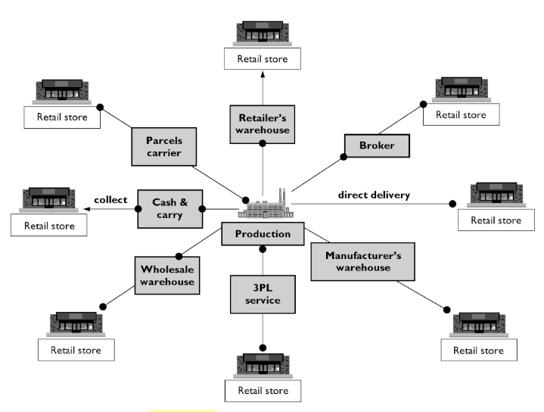
As can be seen they work differently and can change overtime. Distribution via the manufacturers own warehouse and vehicles used to be common but is diminishing in importance as other ways are gaining prominence. For example, third party logistics providers (3PL) such as NFT (http://www.nft.co.uk/), who describe themselves as “the "intelligent link" between food & drink manufacturer and grocery retailer” are growing rapidly due to increasing costs and more restrictive legislation.
Alternative channels exist which by-pass the retail store, for example, consumer products where the distribution channel is by mail order, or from the factory direct to the home. The rise in internet shopping has seen distribution channels open from retail store to home for groceries such as Tesco Home delivery.
Industrial products also have distribution channels which will, by the nature of the product, work differently. This is sometimes call b2b (business to business) distribution channels and might be factory to factory or farm to factory etc. Just as with consumer products, the types of intermediaries can differ (as shown in the above diagram) and also the number. So, for example, a manufacturers warehouse and a 3PL warehouse may be used in the same channel.
Companies will use many different types of distribution channels and intermediaries and so it's difficult to identify a "typical" distribution channel. (The Handbook of Logistics and Distribution Management (By Alan Rushton, Phil Croucher, Peter Baker).)

ii. Who are the channel participants in a distribution process?
There are three main participants in the distribution process; manufacturers, final users and intermediaries.
The two main intermediary participants can be said to be wholesalers and retailers.
Retailing includes all the activities involved in selling goods and services direct to the final consumer. Wholesaling involves all the activities involved in selling goods and services to those buying it to sell to retailers or for business use. Wholesalers and retailers take similar risks in terms of purchasing the product and holding it as inventory.
Brokers or agents are also important participants. The main difference is that agents or brokers do not take ownership of the product they sell. They typically work on commission and can sell to retailers or wholesalers.
Resident sales agents can participate in a distribution channel where products come from a variety of foreign manufacturers. It allows these foreign suppliers and entry into exporting where perhaps they would otherwise not have the knowledge or resources. Resident sales agents afford them this opportunity and are usually paid by commission. The resident agent does not necessarily hold inventory and may just be responsible for importation.
A Buying Office may be another channel that can be used. They are considered a type of commission agent or broker and match retailers with manufacturers.
It should be remembered that manufacturers can also act as intermediaries in the distribution channel. Although this is less common these days some breweries produce, distribute and sell their products to the end user in pubs.
The end user in a distribution channel can either a consumer or industrial user.

iii. What is the importance of market coverage decisions in a distribution process?
Market Coverage Strategy is all about how many and types of intermediaries are used in a distribution strategy. It is vitally important that the correct market coverage strategy is adopted as it can determine a company’s market position for their products. Which market coverage strategy to use can be said to be one of the most important decisions a company can make for a brand. The marketing channel decision will directly affect every other marketing decision.
A company’s Market Coverage Strategy is determined by considering internal and external factors and it is important that it decides whether it should concentrate on one or a few markets or should spread over all the markets. The most obvious and important factor are customers.
There are three main channels which can be summarised in the following diagram.
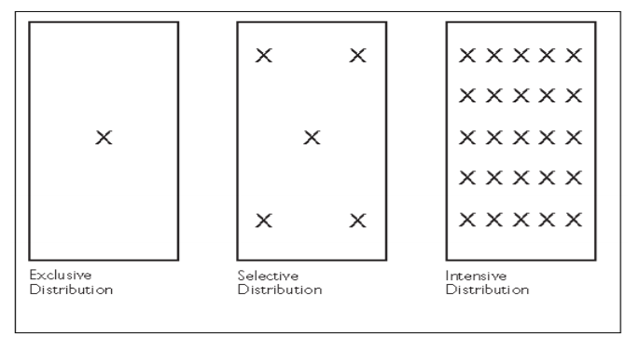
Intensive Coverage Strategy – Where manufacturers sell through all or most possible distribution channels. For example, Coca Cola can be bought virtually anywhere, supermarkets, petrol stations, vending machines etc.
This type of market coverage is not suitable for “exclusive” products so it’s important that intensive market coverage is used for products used on a daily basis. Coca Cola is relatively cheap so intensive market coverage also allows it to be produced and sold in large quantities.
Newspaper distribution is also a good example of intensive market coverage.
Exclusive Coverage Strategy – The total opposite to Intensive Coverage. Here a company will tie up with an intermediary such as a distributor exclusively. The product will not be sold to anyone else. An example of this is BMW, who sell through a limited number of appointed distributors.
It’s important to use this strategy if a company wants to enhance its products image and promote loyalty.
Selective Coverage Strategy – This strategy lie between the two with a limited number of intermediaries in any specific geographical area. An example of this would be home appliances such as Whirlpool who sell through dealer networks and large retailers.
http://www.diva-portal.org/smash/get/diva2:4427/FULLTEXT01.pdf (accessed 1/5/18)
https://www.zabanga.us/sales-promotion/choosing-a-marketcoverage-strategy.html (accessed 1/5/18)
https://marketingwit.com/advantages-disadvantages-of-intensive-distribution (accessed 1/5/18)
https://www.marketing91.com/exclusive-distribution/ (accessed 1/5/18)

iv. How would you differentiate between conventional channels and single transaction channels?
Conventional channels of distribution are the most common type of distribution channel and in its simplest form has producer, wholesaler and retailer all acting independently. It can be represented as follows:-
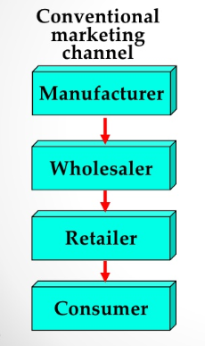
(https://www.slideshare.net/UttamSatapathy/sales-distribution) accessed 3/5/18
Each participant in the channel operates under independent ownership and answers to its own owners/shareholders.
It can be said that they take part in the channel due to the different forms of specialisation they can offer and they can add efficiencies without becoming fully committed. This arrangement can therefore become quite volatile and end suddenly.
A single transaction channel on the other hand, as the name suggests, focuses on a single “point of sale” with an emphasis on maximizing the efficiency and volume of each sale rather than developing an ongoing relationship.
Typically one member might own or have sufficient leverage to wield control over the other members of the channel. For example, Firestone Tyres owns all the elements of its marketing channel. http://smallbusiness.chron.com/difference-between-conventional-vertical-marketing-channels-67357.html accessed 3/5/18
Many single transaction channels are considered onetime and non-repeatable and occur for the sole purpose of facilitating one unique transaction. Once requirements have been met then the basis for the channel ceases to exist. Another example could be a real-estate transaction.

(Distribution Planning and Control: Managing in the Era of Supply Chain Management By David Frederick Ross https://books.google.co.uk/books?id=HONkKWZFYvwC&pg=PA231&lpg=PA231&dq=single+transaction+channels&source=bl&ots=TqjN9snc9d&sig=Q3BntQzAyO9rSEfpL2Jz89XhW6g&hl=en&sa=X&ved=2ahUKEwjU4MDf6enaAhXOb1AKHU7zBD4Q6AEwBnoECAAQag#v=onepage&q=SINGLE&f=false accessed 3/5/18)

v. How can logistics operations affect the pricing?
Typically logistics operations can account for 8-10% of a company’s total costs so this can have a major effect on pricing. Any savings made in logistics can be reflected in lower product pricing and can therefore have a major impact on competiveness. Conversely, if a company does not get its logistics operations running efficiently and is more expensive than its competitors it could lose business as its pricing might have to increase.
In 2005 Walmart in the US committed to a goal of doubling the efficiency of their fleet by 2015 by establishing better logistics techniques through new technologies and simplified logistics networks. They achieved this goal with savings of $1 billion annually, which can have an impact on their pricing policy. https://yourstory.com/2016/10/efficient-logistics-impacts-your-business/ accessed 4/5/18
Another major way logistics can impact pricing is associated with purchasing terms. For example, if purchases are made with a supplier abroad with term FOB (free on board) then the purchaser is responsible for all logistics charges after the supplier has placed the goods on board a ship or plane. This will obviously add to the cost of the product and therefore it’s pricing.
If terms can be negotiated whereby the supplier’s price is a delivered price, then the logistics costs are already included so will not affect the pricing of the product purchased.

2. Discuss the fundamentals of pricing strategy in supply chain management. (7)
A business must take many factors into account before deciding on the price of a product. The supply chain is all about obtaining materials and services at the right quality and delivering them to the right place at the right price. If the supply chain fails to do this it will make a loss on either unsold product or unsatisfied customers.
Although pricing is an important part of supply chain management it should be remembered that it is not the only nor the most important criterion. In supplier selection, for example, an important component in any supply chain, other criteria play an important role, such as quality and delivery reliability.
Having said that, pricing is factor in the supply chain and there can be said to be two main models of pricing strategy; "supplier cost plus" and "market price minus".
"Supplier cost plus" is pricing based on what it costs to produce an item plus the profit margin needed. The disadvantage of this model in the supply chain is that if you are relying on a supplier which follows this pricing model then you could be paying too much as it could hide inefficiencies in the supplier's own supply chain.
"Market price minus" pricing strategy gets rid of this problem as it first determines what price the market will pay for a product (through market research for example) then take away an amount for reasonable profit. What's left is the target price and both supplier and customer will work together to meet this price. This means that all pricing in the supply chain are acceptable to the market.
"Market price minus" are favoured in lean supply chains. An example could be Poundland working with its suppliers to ensure the £1 price point is reached on a range of products by increasing purchasing quantities and decreasing the size of the finished product.
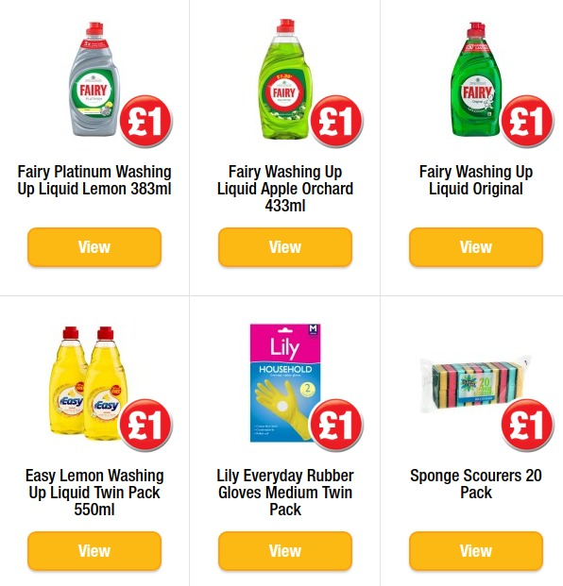
Other important fundamentals relating to pricing strategy are insight and agility. It is easier nowadays with online catalogues to amend pricing to reflect what's going on in the supply chain. If a company's pricing isn't changed to reflect this, or it takes too long to change, then the product could be sold at a loss.
Companies that rely on purchasing commodities, for example, will be susceptible to volatile prices in their supply chain. A manufacturer of chocolate may suddenly have increased prices for cocoa due to a bad harvest. This will have an impact on prices throughout the supply chain and the price of the end product needs to be quickly changed to reflect this.
(Fundamentals of supply Chain Management Dr Dawai Lu)

3. “Channel mapping and matrix approach are of significant importance for a channel design process.” Discuss this here. (8)
Getting the right distribution channel and using the right intermediaries is an important and complex decision and a number of approaches can be used to find the best channel.
Channel mapping can give a detailed overview of the cost build up as a product flows through the distribution channel. The objective is to find ways of increasing efficiency and reducing costs by following each step in the process and identifying any possible redundant steps. By channel mapping the whole distribution flow it may become apparent that information readily available to one company in the channel would be of value to another company on the channel. So, channel mapping could be a very important tool for a company.

In his Michigan State University Lecture "Distribution Fulfilment", Dr Bixby Cooper PhD argues that many companies do not understand how their products get into the marketplace and that there are things going on in the distribution channel that they are unaware of. This, he claims, is due to the fact that the companies involved have not gone through the process of channel mapping. This is obviously less than ideal as it can lead to products ending up in markets for which they were not intended.

He gives an example of golf clubs being sold in the US made by a US company. When there was an issue with one of the products and the customer contacted them, it turned out that they were manufactured in the US solely for sale in Asia. The company had lost control of its own distribution channels and was unaware.

In order to begin the process of channel mapping a company will need identify all the end users for its products and then the paths being used and by whom (e.g. the company itself or another company). When this is done quantities can be given to each stage in the path, e.g. costs, profits and values.

The end result should be a view on how efficient the channels are and to understand them if they are not clear. With this information companies can see where changes are needed in the distribution channel to make them more efficient and profitable.

A simplified example of a channel map is given below.

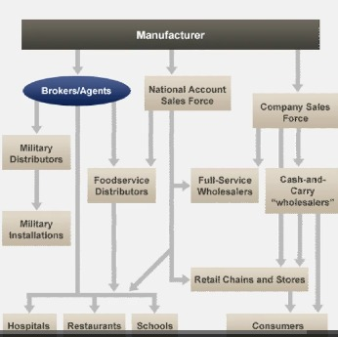

https://www.michiganstateuniversityonline.com/resources/preview-courses/distribution-fulfillment-video-lecture/#.WvBb7ujwa00 accessed 7/5/18
https://www.mdm.com/blogs/1-management-strategy/post/27451-management-strategy-2011-06-08-channel-mapping-the-key-to-improving-profits accessed 6/5/18
The matrix approach in another method companies can adopt to investigate and improve their channel design and find the best participants and structures in the in the channel.
Many different types of channel may need to be used to get product to the end user due to the number of different customers and participants and this is what matrix management is all about; managing individuals with more than one reporting line.
Supply chain distribution channels tend to cut across many functions it lends itself to the matrix approach. So, for example, it can promote the formation of temporary channels for a particular requirement, using the best channels and participants in a task-oriented manner, on a temporary basis.
Adopting a matrix approach gives companies more flexibility when supply chain channels are complex and changing.
https://yourbusiness.azcentral.com/benefits-gained-adopting-matrix-approach-terms-organizational-structure-26476.html accesses 8/5/18
oOo

Student Statement:

By submitting this assignment, I confirm that this is my own work.

Student Signature | Jonathan Gurak | Date | 9/5/18

For Tutor / Assessor Use Only
Total Marks
Marks Obtained
Percentage / Grade

