
Assignment Cover Sheet

Student Name: | Raymond Wilson
Student Number: | 5297
Course: | Diploma in Risk Management
Assignment No: | 7
Marking Criteria:
We expect the learners to write minimum one well expressed point in three lines against each allocated mark. This means one needs to write 15 lines with 5 well expressed points to get high grades for a 5 marks question.
For high grades use examples and illustrations where appropriate.
Assessment 7 Financial Risk Management Total Marks: 30

1. Short Questions: (6)

I. What are the different types of financial risks? Explain each.

Financial risk is the common term for many different types of risks related to the finance industry. These risks include financial transactions such as company loans and its potential exposure to loan default. The term is typically used to reflect an investor's uncertainty of collecting returns and the possibility for monetary loss.

 Of course investors can use a number of financial risk ratios to assess an investment's prospects. For example, the debt-to-capital ratio measures the proportion of debt used, given the total capital structure of the company. A high proportion of debt clearly indicates a risky investment.
Capital expenditure ratio can also be used and this divides cash flow from operations by capital expenditures to see how much money a company will have left to keep the business running after it services its ongoing debt commitment.
As indicated previously there are many types of financial risks. The most common ones include credit risk, liquidity risk, asset backed risk, foreign investment risk, equity risk and currency risk and a brief of each is as below;
- Credit risk (also referred to as default risk). This type of risk is associated with people or companies who borrow money and who are unable to pay it or its associated interest back. As such, the entity goes into default.
- Liquidity risk involves assets and/or securities that cannot be purchased or sold fast enough to cut losses in a volatile market situation.
- Asset-backed risk is the likelihood that asset-backed securities may become volatile if the underlying securities also change in value. The associated risks include prepayment risk and interest rate risk.
- Foreign investment risk is related to changes in prices because of market differences, political changes, natural calamities, diplomatic changes or economic conflicts that may cause volatile foreign investment conditions that may expose businesses and/or individuals to such risks.
- Equity risk is directly related to the risk involved in the volatile price changes of shares of stock.
- Currency risk affects investors holding foreign currencies that, because different factors, such as interest rate changes and monetary policy changes, can change the value of the asset that investors are holding into negativity.
II. Briefly describe the main benefits of financial risk management.

Many larger companies now have teams of specialized employees to guide them through the murky waters of the financial market and create strategies to avoid losses and maximize profits as much as possible. The process is far from an exact science and requires a certain amount of financial market shrewdness to be effective but what is clear is financial risk management is an critical element of any successful business and the main benefits are summarized as follows;
- Avoiding Catastrophe - Planning for potential risks allows for the creation of a financial business strategy that pursues a constant upward trend. This strategy concept is built literally with the objective of keeping the business profitable and managing, through avoidance wherever practicable, financial pitfalls that lead to disaster. These pitfalls can include unreliable business investments, taking on projects that are not cost-effective or paying too much for materials/manpower to complete business projects.
- 
- Maximizing Opportunity - Financial risk management is not only about forecasting potential problem areas, it is also used a catalyst for predicting opportunity. This enables businesses to act quickly on what they see as good investment scenarios and to work to maximize the financial advantage of those opportunities. This can benefit the company's employees as well as existing shareholders. Managing these opportunities correctly allows a company to stay ahead of the financial market trend and can make them appear almost clairvoyant. Whenever a company makes a quick decision on a new product or stock, it is more than likely that financial risk management went into the decision to buy.
- Ensuring Business Growth
Competition is another necessary aspect in financial risk management. By forecasting how the market will respond to competition, a company can produce a strategy that accounts for a “playing field” scenario with multiple players. A business with a well-structured financial risk management plan is able to remain aggressive in the market, within its own pre-determined risk and opportunity scenarios, by predicting what is most likely to occur in the financial market.
III. What is liquidity risk?
All businesses, and particularly financial institutions, require access to borrowed funds to carry out their operations (from paying their near-term obligations or to making long-term strategic investments). An inability to acquire such funding within a reasonable timeframe could place a firm at risk, which has been as graphically illustrated by the recent demise of certain investment banks and other financial institutions.
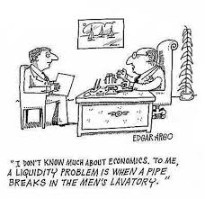Liquidity is defined as the ability of a financial firm to meet its debt obligations without incurring unacceptably large losses, and not as that illustrated above!!. Thus, “funding liquidity risk” is the risk that a firm will not be able to meet its current and future cash flow and collateral needs, both expected and unexpected, without materially affecting its daily operations or overall financial condition.
One clear consequence of extreme liquidity is bankruptcy and certain conditions leading to insolvency are often caused by other associated risks out with a company’s control such as substantial losses made due to a key customer defaulting can raise liquidity issues and concerns about the future of the organisation.

Financial firms are especially sensitive to funding liquidity risk since debt maturity transformation (for example, funding longer-term loans or asset purchases with shorter-term deposits or debt obligations) is one of their key business areas.
Major companies nowadays respond to this well-known risk by establishing and maintaining liquidity management systems to assess their potential funding needs and ensure the funds are available at suitable times. A key element of these systems is monitoring and assessing the firm’s current and future debt obligations and planning for any unexpected funding needs, regardless of whether they arise from influences, such as a drop in the firm’s collateral value, or from economy-wide factors. To balance its funding demand both expected and unexpected, based on known availability, a firm also needs to add in its costs and profitability targets.
2. What is the difference between liquidity and credit risk? (6)

As detailed in answer 1. III. above Liquidity Risk refers to the chance that an entity will have insufficient cash flow to meet its obligations. This can be caused by the undesirability of an asset in the marketplace, such as a company's products or fixed assets set for liquidation.

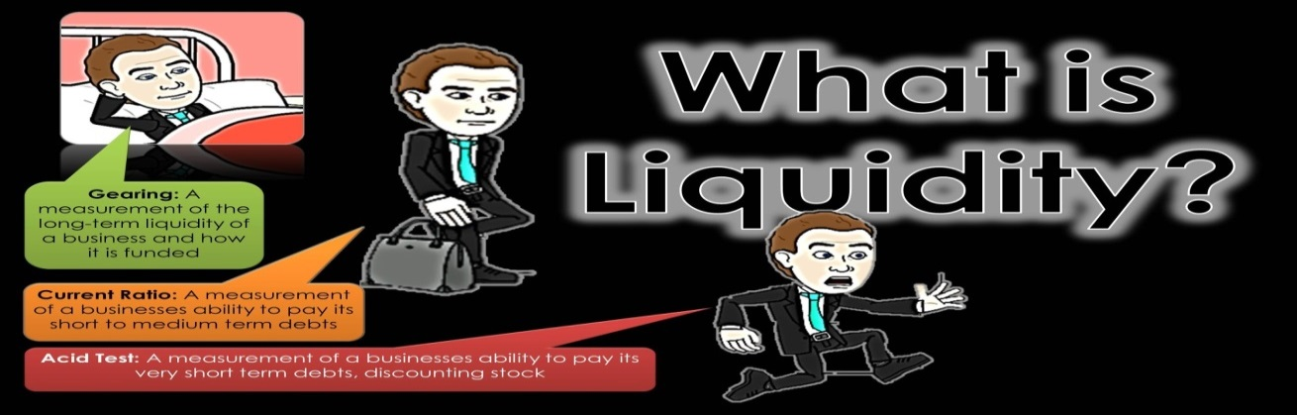
While company’s don't usually have the chance to pick between types of risk with a single entity, it is important that they look at the factors that may increase the level of risk they face. While a firm may presently be liquid, and able to meet its obligations, the wise investor looks forward to predict future market conditions that may adversely impact a firm's ability to meet its obligations.

A simple way to measure liquidity, and ensure solvency at any given time, is by using the current ratio, which measures the association between current assets and current liabilities. Therefore, this is defined quite simply as;

Current ratio = Current assets
Current liabilities

Credit risk differs however, as this is the risk of loss due to non-payment of debts owed by an entity but it is worth noting that credit risk may be compounded by liquidity risk.

Credit risk refers to the probability of loss due to a borrower’s failure to make payments on any type of debt. Managing this risk is the practice of mitigating losses by understanding the adequacy of a companies or bank’s capital and loan loss reserves at any given time – a process that has long been a challenge for financial institutions.
The key to reducing loan losses – and ensuring that capital reserves appropriately reflect the risk profile – is to implement an integrated, quantitative credit risk solution. This solution should get companies and banks up and running quickly with simple portfolio measures. It should also accommodate a path to more sophisticated credit risk management measures as needs evolve. The solution should include;
- Better model management that spans the entire modelling life cycle.
- Real-time scoring and limits monitoring.

- Robust stress-testing capabilities.
- It is important that in this high technology era that data visualization capabilities and business intelligence tools can get important information into the hands of those who need it, when they need it to allow them to avoid significant losses.

3. What is currency risk? And how its effects can be reduced? (8)
Currency risks are those that arise from changes in the relative valuation of currencies and these changes can create unpredictable gains and losses when the profits or dividends from an investment are changed from a foreign currency into U.S. dollars (widely acknowledged as the worlds overriding monetary lynchpin). Investors can reduce their exposure currency risk by using hedges and other techniques designed to offset any currency-related gains or losses.
A simplistic example of currency risk is as follows;
Suppose that a U.S. based investor purchases UK stock for 100 pounds sterling. While in possession of this “bond”, the pound exchange rate decreases from 1.5 to 1.3 pound per U.S. dollar. If the investor then sells the bond for 100 pounds, they will realize a 13% loss upon conversion of the profits from UK sterling to U.S. dollars. However, if that investor hedged their bond by simultaneously short-selling the pound, then the profit from the pounds decline would offset the 13% loss upon conversion.
Investors across the world have several options when it comes to managing currency risk, including the use of tools like currency futures, forwards and options although most of these are often expensive and complicated to use for individual investors. The most simple and flexible ways to hedge against currency risks are currency-focused exchange-traded funds (ETFs) and today there are several large financial institutions that offer various types of currency based ETFs.

Two of the most prevalent ETF sources used are “CurrencyShares” and “WisdomTree”, and both these entities offer a wide variety of ETFs covering a number of different currencies around the world which include popular international investment destinations ranging from Canada to emerging markets countries like Brazil, India and China.
Both of these companies have websites that provide users with numerous options to finding the appropriate ETF to use. Below are a few of the common currency ETFs they provide;
- CurrencyShares Canadian Dollar Trust (NYSE: FXC)
- CurrencyShares Australian Dollar Trust (NYSE: FXA)
- WisdomTree Dreyfus Chinese Yuan Fund (NYSE: CYB)
- WisdomTree Dreyfus Brazilian Real Fund (NYSE: BZF)
Of course there are many other (ETF) provides that can offer more specialized products that may or may not be suitable depending on the investor's situation
To ensure protection against currency risk with an ETF, companies and individuals should consider the follow;
- Identify the ETF. Begin by searching for online ETF providers for a currency ETF that corresponds to the foreign investment. If several are available, investors should seek out ETFs with the lowest expenses and fees.
- Determine the Direction. Hedges always take the opposite direction as the foreign investment. So, if an investor is long on a European stock for instance, they should be short a Euro ETF. On the flip side, if an investor is short a Chinese stock, they should be long a Chinese Yuan ETF.
- Calculate the Amount. Investors can completely or partially hedge their foreign investment against currency risk. To completely hedge, investors should purchase the same dollar amount in the currency ETF. Or, they could purchase options with rights to the same dollar amount.
- Manage the Trade. It is important that once the trade is made, investors should continue to monitor the situation closely. If a currency becomes more stable, it may be prudent to sell part of the hedge, while a destabilizing situation may warrant even more protection.

Case Study (10)

Parker co is a chain of large 250 departmental stores and operates in 35 countries. Their current assets excluding trade debtors are $3.5 million and current liabilities excluding trade creditors are $2.8 million. Trade credits are $1.2 million and trade debtors are $100,000 only. Sale has decreased 3% last year due to recession. Parker co is planning to open new stores in Far East, in a new country with high inflation rate.

All store buildings are owned by Parker co and a recent report in newspaper shows that commercial property value has decreased significantly in last one year due to recession and tight funding conditions from financial institutes.

Keeping in view the above case please answer the following Questions:

1. Calculate current ratio of Parker Co.

The current ratio is calculated by dividing current assets by current liabilities. This ratio is stated in numeric format rather than in decimal format. Here is the calculation;

Regulators require that companies separate current and long-term assets and liabilities on their balance sheets and this split allows investors and creditors to calculate important ratios like the current ratio.

The current ratio helps investors and creditors understand the liquidity of a company and how easily that company will be able to pay off its current liabilities. This ratio expresses a firm's current debt in terms of current assets. So a current ratio of 4 would mean that the company has 4 times more current assets than current liabilities.
A higher current ratio is always more favourable than a lower current ratio because it shows the company can more easily make current debt payments. The current ratio also sheds light on the overall debt burden of the company. If a company is weighted down with a current debt, its cash flow will suffer.
Parker Co clearly are a multi-national operation and their products are very diverse. Their current trading figures report that they have $2.8 million of current liabilities and current assets of $3.5 million. Therefore their current ratio is calculated as follows;
Current assets = 3,5000,000 Current ratio = 1.25
Current liabilities = 2,800,000

As you can be seen, Parker Co are currently in a good financial state as most international Banks/lenders prefer a current ratio of between 1 and 3, so that all the current liabilities would be covered by the current assets. Anything lower than 1 would be worrying for them and risky and it is unlikely that any loan (if required) would be approved.

2. Explain liquidity risk and discuss how it can affect Parker co.

(Liquidity ratio 1 or more is considered healthy)

Liquidity risk can be explained into funding (cash-flow) or market (asset) liquidity risk. Funding liquidity tends to manifest as a credit risk and the case study provided does not indicate this this is currently an issue for Parker Co however should they need to borrow to fund their expansion plans this would clearly come into play.

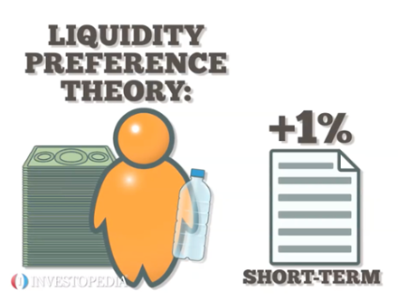

Market (asset) liquidity risk manifests as market risk: here the inability to sell an asset drives its market price down, or worse, renders the market price indecipherable. Market liquidity risk is a problematic situation created by the interaction of the seller and buyers in the marketplace. If the seller's position is large relative to the market, this is called endogenous liquidity risk (a feature of the seller). If the marketplace has withdrawn buyers, this is called exogenous liquidity risk (a characteristic of the market which is a collection of buyers); a typical indicator here is an abnormally wide bid-ask spread.
Liquidity ratios are written as ratios not percentages. This is because they tell us how many times a business can pay off its current liabilities using its liquidity money.
Another way of explaining liquidity ratios is that a liquidity ratio of 2:1 means that current assets are twice the size of current liabilities. If the ratio is 3:1 it means current assets are 3 times the size of current liabilities, 4:1 means current assets are 4 times the size of current liabilities and so on. In Parker Co.’s case 1.25:1, although healthy from a current liability status, there must be concern that the 3% sale deficit over the last year and an unspecified “significant” drop in commercial property value will affect this ration in the coming reporting period.
Their current area of interest, the Far East, were high inflation rates are indicated may counterbalance the risk of liquidation as Inflation, especially high inflation, increases profits as well as the cost of doing business and implies higher demand for products at higher prices and a tight employment market with rising wages. It is worth noting however that an on line investment source reports/quotes - Investopedia reports that inflation, "Is not intrinsically good or bad."

The ideal liquidity ratio will depend on the business and the industry it is based in. Some businesses e.g. fresh food sellers will buy and sell stock daily, so they will need to pay their suppliers quickly and will therefore constantly need enough liquidity to cover current liabilities. Other businesses e.g. those buying services are likely to have arrangements (with suppliers) that gave them longer to pay e.g. 30, 60, 90 days so liquidity is not as important and this is the place that Parker Co are within the industry so may well ride out any impending storm however due diligence is required and constant monitoring of the balance books.

Student Statement:

By submitting this assignment, I confirm that this is my own work.

Student Signature | Raymond Wilson | Date | 1st Apr 2017

For Tutor / Assessor Use Only
Total Marks
Marks Obtained
Percentage / Grade

