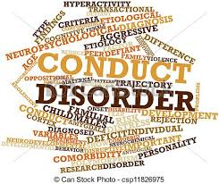
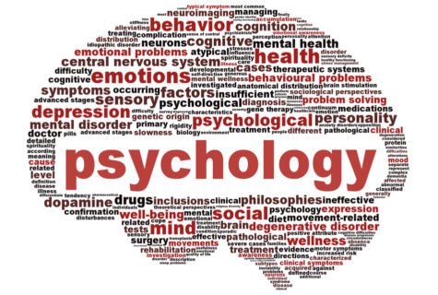

Assignment -11 -Module 11 –The Child Psychology Advance Diploma at Level-5
Problems of Middle Childhood

October 15, 2019
BRENTWOOD OPEN LEARNING COLLEGE [BOLC]
LEICESTER LE3 1HR

Contents
Acknowledgement -Assignment -11
Module -11-Problems of Middle Childhood

1- Define the term ‘conduct disorder.’ 2-3
2- Outline the symptoms of conduct disorder. 3-4
3- How is conduct disorder diagnosed? 4-9
4- What are the two sub-sections of conduct disorder? 9-10
5-What is a social anxiety disorder? 10-13
6- 2. What are the main causes of childhood anxiety and how this anxiety can be treated? 13-14

7- References 14-16

I. Define The Term ‘Conduct Disorder.’

The most significant of this assignment is about how to “Define the Term ‘Conduct Disorder.’ According to my understanding on the subject, the term Conduct Disorder (CD) is characterized by callous disregard for and aggression toward others, from pushing, hitting and biting in early childhood to bullying, cruelty and violence in adolescence but also Conduct Disorder (CD) in childhood is a serious behavioural and emotional disorder that can occur in children and teens. In additional, a child with this disorder may display a pattern of disruptive and violent behaviour and have problems following rules.

This is the term conduct disorder (CD) have an impact on behaviours characteristic of conduct disorder include: Aggressive behaviour that causes or threatens, such as pulling hair to other brothers or classmates or animals like display in the pictures, for instance bullying or intimidating others, often initiating physical fights, or being physically cruel to animals.

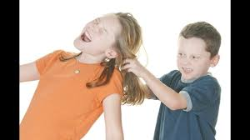
Moreover, the term Conduct disorder (CD) is a repetitive and persistent pattern of behaviour in children and adolescents in which the rights of others or basic social rules are violate.in facts, the child or adolescent usually exhibits these behaviour patterns in a variety of settings at home, at school, and in social situations and also they cause significant impairment in his or her social, academic, and family functioning.


Conduct disorder is a repetitive and persistent pattern of behaviour in children and adolescents in which the rights of others or basic social rules are violated. The child or adolescent usually exhibits these behaviour patterns in a variety of settings at home, at school, and in social situations and they cause significant impairment in his or her social, academic, and family functioning.

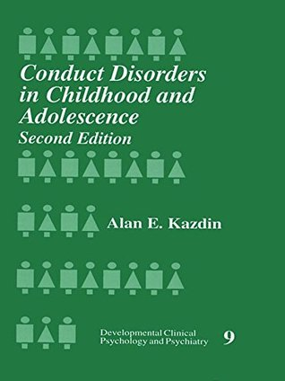
According to the NHS report on November 2018. NHS Digital must be credited as the source of this information. “Mental Health of Children and Young People in England, 2017”, children, consisting mainly of oppositional defiant disorder (1.9%).
Actually, Conduct disorder (CD) is more common among boys than girls, with studies indicating that the rate among boys in the general population ranges from 6% to 16% while the rate among girls ranges from 2% to 9% in the UK report. Conduct disorder can have its onset early, before age 10, or in adolescence. Children who display early-onset conduct disorder (CD) are at greater risk for persistent difficulties, however, and they are also more likely to have troubles peer relationships and academic problems. Among both boys and girls, conduct disorder is one of the disorders most frequently diagnose in mental health settings. (REF: according to the NHS report 2017/18).

Sometimes, parents can say, all young children can be naughty, defiant and impulsive from time to time, which is perfectly normal. However, some children have extremely difficult and challenging behaviours that are outside the norm for their age.

Actually, children with Conduct Disorder (CD) are often judged as ‘bad kids’ because of their delinquent behaviour and refusal to accept rules. Around five per cent of 10 year olds are thought to have (CD), with boys outnumbering girls by four to one. Around one-third of children with (CD) also have attention Deficit Hyperactivity Disorder (ADHD).
Some of the typical behaviours of a child with (CD) may include:
- Frequent refusal to obey parents or other authority figures
- Repeated truancy
- Tendency to use drugs, including cigarettes and alcohol, at a very early age
- Lack of empathy for others
- Being aggressive to animals and other people or showing sadistic behaviours including bullying and physical or sexual abuse
- Keenness to start physical fights
- Using weapons in physical fights
- Frequent lying
- Criminal behaviour such as stealing, deliberately lighting fires, breaking into houses and vandalism
- A tendency to run away from home
- Suicidal tendencies – although these are more rare.
The Causes and Risk Factors for the term Conduct Disorder
The development of Conduct Disorder is said to be the result of a combination of factors, including genetic, physical, and environmental components. Some examples of these factors may include:

Genetic: Personality traits are commonly inherited from family members, so the components that make up conduct disorder may have genetic influences.

Physical: Impairments in the frontal lobe of the brain have been linked to the development of conduct disorder, due to the fact that the frontal lobe is responsible for regulating one’s emotions. The frontal lobe is also said to be “home” to one’s personality. So if there exists any kind of impairment or imbalance in that part of the brain, the more likely a person will be to become susceptible to developing the symptoms of conduct disorder.

Environmental: Parental behaviour is argued to be a large component in determining whether or not a child will develop symptoms of conduct disorder. Children who are raised without any form of appropriate discipline or whose parents tend to be absent more than they are present can experience a resulting impact on the behaviours that they exhibit. Atypical child interaction with a mother who suffers from post-partum depression can potentially have lasting effects on a child’s future behaviours as well.

The Risk Factors Conduct Disorder:
- Being male
- Living in a city as a opposed to a rural area
- Having other psychiatric disorders
- Poor nutrition
- Living in poverty
- Maternal psychopathology
- Poor parenting / lack of parental involvement
- Lack of appropriate methods of discipline
- Exposure to violence
- Having been subjected to physical, sexual, and/or emotional abuse

The most common disruptive behaviour disorders include Oppositional Defiant Disorder (ODD), Conduct Disorder (CD) and Attention Deficit Hyperactivity Disorder (ADHD). These three behavioural disorders share some common symptoms, so diagnosis can be difficult and time consuming. It is seem that, a child or adolescent may have two disorders at the same time. Other exacerbating factors can include emotional problems, mood disorders, family difficulties and substance abuse.
Oppositional defiant disorder: around one in ten children under the age of 12 years are thought to have Oppositional Defiant Disorder (ODD), with boys outnumbering girls by two to one. Some of the typical behaviours of a child with ODD include:
- Easily angered, annoyed or irritated
- Frequent temper tantrums
- Argues frequently with adults, particularly the most familiar adults in their lives, such as parents
- Refuses to obey rules
- Seems to deliberately try to annoy or aggravate others
- Low self-esteem
- Low frustration threshold
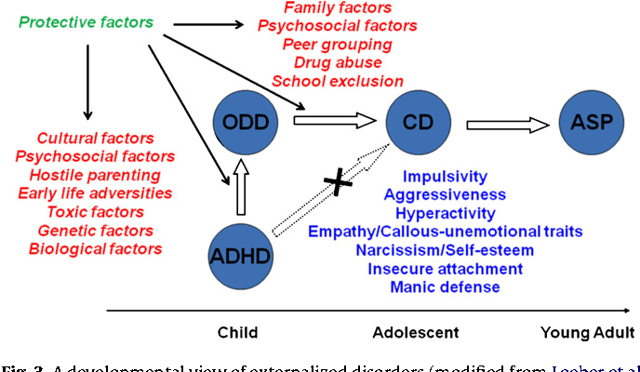
Seeks to blame others for any misfortunes or misdeeds.
Problems could happens in childhood but then again these problems can result from temporary stressors in the child's life, or they might represent more enduring disorders. The most common disruptive behaviour disorders include oppositional defiant disorder (ODD), conduct disorder (CD) and attention deficit hyperactivity disorder (ADHD).

Behavioural disorders in children
- Some children have extremely difficult and challenging behaviours that are outside the norm for their age.
- These problems can result from temporary stressors in the child’s life, or they might represent more enduring disorders. The most common disruptive behaviour disorders include oppositional defiant disorder (ODD), conduct disorder (CD) and attention deficit hyperactivity disorder (ADHD).
- Boys are more likely than girls to suffer from behavioural disorders.
- Treatment options include parent management training, cognitive behaviour therapy, medication and treatment for associated problems.

Therefore, conduct disorder in children and adults
Conduct disorder is a type of behaviour disorder. It is when a child has antisocial behaviour. Both genetic and environmental factors may play a role. Children with other mental health problems are more likely to have this disorder. Symptoms are divided into 4 main groups. They are aggression, destruction, deceitfulness, and violation of rules. Therapy that helps the child interact better with others is the main treatment. Medicines may be needed for other problems, such as ADHD.
Ii. Outline the Symptoms of Conduct Disorder

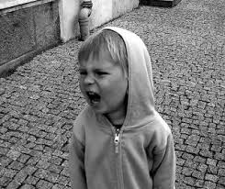
The reason to outline the symptoms of conduct disorder in a way to identify as Specific Symptoms of Conduct Disorder but also, is the main characteristic of conduct disorder is a consistent routine of behaviour by a child or teenager in which the simple rights of individuals are denied and societal norms, or rules, are broken. These behaviours fall into four main categories: aggressive conduct that is the reason for or threatens physical injury to other individuals or animals, non-aggressive action that causes property loss or damage, deceitfulness or theft, and breaking of norms repeatedly.
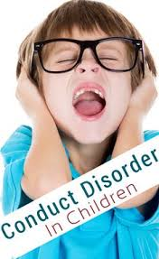

Conduct disorder (CD) is diagnosed by a consistent routine of behaviour in which the simple rights of individuals or other age-suitable societal norms or regulations are broken, as manifested by the presence of three (or more) of the following events in the past year, with at least one event occurring within the past six months:

Conduct Disorder (CD) is Aggression to People and Animals, the problems of middle childhood

Destruction of Property

- Usually annoys, threatens, or scares others
- Often sparks physical bursts
- Has used a dangerous item that can cause injury
- Has been physically cruel to people
- Has been physically cruel to animals
- Has robbed someone
- Has raped someone


Deceitfulness or Theft

- Has gone into someone else's house, building, or car
- Often does not tell the truth to get things or to avoid obligations
- Has taken objects of large value without asking the owner

Serious Violations of Rules
• often stays out at night despite parental prohibitions, starting before thirteen years old

• Has run away from home overnight at least twice while living with parents or a parental surrogate’s home (or once without returning for a long period of time).
- Is often skipping school, beginning before thirteen years old

Behaviours characteristic of conduct disorder include:

- Aggressive behaviour that causes or threatens harm to other people or animals, such as bullying or intimidating others, often initiating physical fights, or being physically cruel to animals.
- Non-aggressive conduct that causes property loss or damage, such as fire-setting or the deliberate destruction of others’ property.
- Deceitfulness or theft, such as breaking into someone’s house or car, or lying or “conning” others.
- Serious rule violations, such as staying out at night when prohibited, running away from home overnight, or often being truant from school.

Many youth with conduct disorder may have trouble feeling and expressing empathy or remorse and reading social cues. These youth often misinterpret the actions of others as being hostile or aggressive and respond by escalating the situation into conflict. Conduct disorder may also be associated with other difficulties such as substance use, risk-taking behaviour, school problems, and physical injury from accidents or fights.

To identify the Summary the Signs and Symptoms of Conduct Disorder

Some examples of signs and symptoms that may be indicative that a child is suffering from conduct disorder can include:

Behavioural symptoms:

- Stealing
- Skipping school
- Harming animals
- Bullying others
- Destroying the property of others
- Running away from home
- Instigating violent, physical fights
- Persistent lying
- Forcing someone into sexual activity against the person’s will
- Physical symptoms:

- Bodily marks resulting from injuries after the instigation of a physical fight (e.g. bruises, scrapes, black eyes, etc.)
- Presence of sexually transmitted diseases as a result of beginning unsafe sexual behaviours at an early age
- Burn marks as a result of fire-setting behaviours
- Cognitive symptoms:

- Difficulty concentrating
- Memory impairment
- Inability to “think things through”
- Psychosocial symptoms:

- Lack of empathy
- Lack of a sense of guilt
- Lack of remorse
- False sense of grandiosity
- Low self-esteem

Therefore, I have learnt Conduct disorder (CD) is a severe condition characterized by hostile and sometimes physically violent behaviour and a disregard for others. Children with CD exhibit cruelty, from early pushing, hitting and biting to, later, more than normal teasing and bullying, hurting animals, picking fights, theft, vandalism, and arson. Since childhood and adolescent Conduct Disorder often develops into the adult antisocial personality disorder, it should be addressed with treatment as early as possible I think the earlier treatment starts, the better the outlook. As a professional experiences working with children and adults in schools environment and also to become a successful child psychologist ahead I should be able to recognise the signs and symptoms of conduct disorder, how it is analyse and options for treatment.

III. How Is Conduct Disorder Diagnosed?
The purpose of this mission is about “How is conduct disorder diagnosed in a child and Adults? I believe as a professional practice, a child psychiatrist or qualified mental health expert can diagnose a conduct disorder. He or she will talk with parents, carers and teachers about the child's behaviour and may observe the child. In some cases, a child may need mental health testing. If parents, carer or teachers notice symptoms of conduct disorder under a responsibility care a child or teen, you can help by seeking a diagnosis right away. I have learnt the early treatment can often prevent future problems.

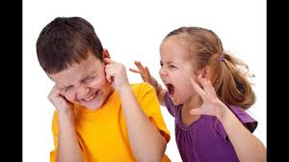
At this ages or stages conduct disorder can be diagnosed. Conduct disorder, to be diagnosed, must be at last 6 months or longer. Most children or adolescents with conduct disorder grow out of this disorder, but if this behaviour persists past age 18 and intensifies, the diagnosis is changed to antisocial personality disorder.

Expert can recognises by a Doctors Group the Symptoms of Conduct Disorder into Four Categories:

- Aggressive behaviour, such as cruelty to animals, fighting and bullying.
- Destructive behaviour, such as arson and vandalism.
- Deceitful behaviour, such as shoplifting and lying.
- Violation of rules, which may include truancy and running away from home.

An NHS Doctor, General Practice (GP) or an expert professional of child psychologist, psychoanalysis, therapy for further treatments would be able observes this diagnosis Conduct Disorder is based on the following findings:
- Criteria are not met for Antisocial Personality Disorder
- In the past 12 months, often bullied, threatened, or intimidated others (still present). People Who Are Violent Towards Animals.
- petaindia.com.
- In the past 12 months, often initiated physical fights (still present)
- In the past 12 months, used a potentially lethal weapon in a fight (still present).
- In the past 12 months, had been physically cruel to people (still present)
- In the past 12 months, had been physically cruel to animals (still present)
- In the past 12 months, had stolen while confronting a victim (still present)
- In the past 12 months, sexually abused someone (still present)
- In the past 12 months, deliberately engaged in potentially serious fire-setting (still present).
- In the past 12 months, deliberately destroyed others' property (other than fire setting) (still present)
- In the past 12 months, broke into someone else's house, building, or car (still present).
- In the past 12 months, often lied (still present).
- In the past 12 months, often stole (without confrontation of a victim) (still present).
- Before age 13, often stayed out at night despite parental prohibitions (still present)
- In the past 12 months, ran away from home (still present)
- Before age 13, often was truant from school (still present)
- In the past 6 months, these symptoms caused clinically significant distress or disability (still present)

In facts that, Conduct Disorder Causes Consistent Misbehaviour
Since any child may show the symptoms and signs of Conduct Disorder (CD) at some point in their young lives, parents or carers need to understand, notices that acting out does not necessarily mean a child has the disorder.
In order to match the diagnosis for Conduct Disorder, children must present at least three symptoms within 12 months. A child who gets into one fight at school probably does not have conduct disorder. If that child starts three or more fights within a year, there is a higher chance that he or she may have the disorder.
This persistence is a foundational characteristic of conduct disorder. Every child misbehaves occasionally. Children with Conduct Disorder misbehave so often that it disturbs their brothers, sisters, classmates in schools and families.

This is will be always parents will asks some questions, does My Child Have Conduct Disorder?
In additional, the symptoms of ADHD, oppositional defiant disorder (ODD), and similar conditions often look like the symptoms of Conduct Disorder. While they look similar, there are some important differences between these conditions.
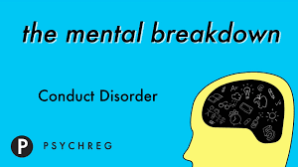

According to my own research working with children in school environment what is being said, children with ADHD and ODD may seem angry or hostile, but they rarely show the cruelty common in children with Conduct Disorder (CD). For instance, a boy with ADHD may get into occasional fights at school because he feels frustrated and insecure. Most counsellors would not diagnosis this as Conduct Disorder (CD). If the boy engage in particularly cruel behaviour towards another student, though, Conduct Disorder (CD) is more likely. Cruel behaviour could include causing intense pain, relentlessly bullying an adversary's friends or harming the adversary's pet. Children with Conduct Disorder (CD) rarely show any guilt after committing cruel actions.
Most children with behavioural problems do not have Conduct Disorder (CD). Those who show several symptoms, however, should meet with a professional who can perform a comprehensive assessment. If a child struggles with difficult behavioural issues or has been diagnosed with a behavioural disorder, contact expert online or find a center near you to learn more about how the Brain Balance Program can help.

Iv. What Are The Two Sub-Sections Of Conduct Disorder?

The two sub-sections of conduct disorder, I think this bad behaviour causes problems in social, academic, or occupational functioning but also influence the two sub-sections of conduct disorder are usually seen and based on the age at onset of the disorder in additional, Conduct disorder is a serious behavioural and emotional disorder that can occur in children and teens. A child with this disorder may display a pattern of disruptive and violent behaviour and have problems following rules, for examples:

(Childhood-Onset Type and Adolescent-Onset Type). The sub-sections change in regard to the features of the presenting conduct issues, developmental course and prognosis, and gender ratio. Both sub-sections can occur in a mild, moderate, or a severe form. In assessing the age at onset, facts should preferably be received from the youth and from adults. Since such behaviour may be concealed, caregivers may underreport symptoms and overestimate the age at onset.

Childhood-Onset Type: This sub-group is defined by the onset of at least one factor of conduct disorder prior to ten years old. People with childhood-onset type are usually male and they often show physical aggression towards other people, have interrupted peer relationships, may have had Oppositional Defiant Disorder(ODD)during early childhood, and usually have symptoms that meet full criteria for Conduct Disorder before puberty starts. These individuals are more likely to have constant Conduct Disorder that grows into adult Antisocial Personality Disorder (APD) than are those with Adolescent-Onset Type.

Adolescent-Onset Type: This sub-group is defined by the absence of any criteria factor of conduct disorder before ten years old. Compared to those with the childhood-onset type, these people are less likely to show aggressive behaviours and tend to have more normal peer relationships. These people are less apt to have consistent conduct disorder or grow into adult Antisocial Personality Disorder. The ratio of males to females with conduct disorder is smaller for the adolescent-onset type than for the childhood-onset type.

Others Conduct Problems -Available studies imply that a mix in conduct problems occurs in the following areas:

- Severity, from mild and infrequent to severe and frequent
- Duration, from recent too long-standing
- Pervasiveness, from home-based to home-, school- and community-based
- Age of onset of issue, from childhood onset to adulthood onset
- Peer influences on conduct problems, from peer-group-based socialised conduct issues to solitary conduct difficulties
- The amount of deceit involved, from overt aggression to stealing and lying
- The presence or absence of concentration issues
- The presence or absence of hyperactivity issues
- The presence or absence of depression and other bad moods
- The presence or absence of specific learning problems

Hormonal Theory: One of the more clear indicators that help in determining the biological factors of conduct problems is a connection between aggressive behaviour and increased testosterone levels in male teenagers.

Arousal Theory: Children with conduct conditions have lower arousal levels than those without conduct conditions and are hence not as responsive to treats and consequences (Raine, 1988). They have a lesser threshold for responding to the positive reinforcement. Therefore, they fail to learn pro-social behaviour or to avoid antisocial behaviour. It is suggested that this unusual low level of arousal is inherited, and the results of twin research supports this in part (A. E. Kazdin, 1995). Treatment based on this statement must have a greatly organised and intensive learning situation if social rules are to be learned.

Attachment Theory :according to the well know the child psychologist (John Bowlby in (1944) suggested that children, who were separated from their primary caregivers for long periods of time, during their first months of life, failed to develop secure attachments and so in later life did not have the mental capacity for strong, trusting relationships. The researcher J .Bowlby categorized these children as showing affectionless psychopathy. Since moral behaviour is based upon functional mentality of how to behave oneself in trusting relationships, such children behave immorally. Treatment of this situation should try to provide the child with a solid attachment relationship or corrective emotional experience. This will lead to the growth of a well-rounded mentality and hence provide a basis for moral behaviour. While the provision of a secure attachment experience within the context of out-patient weekly individual therapy is a non-working treatment for children with conduct disorder, a secure attachment relationship is a vital treatment factor in some effective treatments, such as treatment foster care (Chamberlain, 1994). Here, the foster parents provide the child with a secure attachment experience and pair this with good behavioural management.

Cognitive Theories: Problems with processing social information and social ability deficits are the main factors highlighted in cognitive theories of conduct issues and so on.

V. What Is A Social Anxiety Disorder?

According to my experiences of understanding social anxiety disorder also called social phobia, is intense anxiety or fear of being judge, negatively evaluate, or rejected in a social or performance situation. Social anxiety disorder can wreak havoc on the lives of those who suffer from it. But also, people with social anxiety disorder may worry about acting or appearing visibly anxious (e.g., blushing, stumbling over words), or being viewed as stupid, awkward, or boring. As a result, they often avoid social or performance situations, and when a situation cannot be avoided, they experience significant anxiety and distress. Many people with social anxiety disorder also experience strong physical symptoms, such as a rapid heart rate, nausea, and sweating, and may experience full-blown attacks when confronting a feared situation. Although they recognize that their fear is excessive and unreasonable, people with social anxiety disorder often feel powerless against their anxiety.

Social anxiety disorder affect many young children and including adults is the second most commonly diagnosed anxiety disorder following specific phobia. The average age of onset for social anxiety disorder is during the teenage years. Although individuals diagnosed with Social Anxiety Disorder commonly report extreme shyness in childhood, it is important to note that this disorder is not simply shyness.

Social Anxiety Disorder is (Social Phobia): Children with this condition are very shy and fear exposure to anything unusual. They cling to their parents and might be afraid of other children as well as adult strangers at an age when it is no longer typical. They might be scared of reading aloud, starting a conversation, or going to a birthday party.

Social anxiety disorder (social phobia): Social anxiety disorder, also called social phobia, is a long-lasting and overwhelming fear of social situations. The exact cause of social phobia is unknown. However, current research supports the idea that it is caused by a combination of environmental factors and genetics. Negative experiences also may contribute to this disorder, including: bullying and also these including:
- It is a common problem that usually starts during the teenage years.
- For some people it gets better as they get older, although for many it does not go away on its own.
- It can be very distressing and have a big impact in their life, but there are ways to help them deal with it.
- Symptoms of social anxiety

Social anxiety disorder is more than shyness. It is an intense fear that does not go away and affects everyday activities, self-confidence, relationships and work or school life.

Many people occasionally worry about social situations, but someone with social anxiety disorder feels overly worried before, during and after them. Individuals may have social anxiety disorder if:

- Children and adults dread everyday activities, such as meeting strangers, starting conversations, speaking on the phone, working or shopping
- Avoid or worry a lot about social activities, such as group conversations, eating with company and parties
- Always worry about doing something you think is embarrassing, such as blushing, sweating or appearing incompetent
- Find it difficult to do things when others are watching – you may feel like you're being watched and judged all the time
- Fear criticism, avoid eye contact or have low self-esteem
- Often have symptoms such as feeling sick, sweating, trembling or a pounding heartbeat (palpitations)
- have panic attacks, where you have an overwhelming sense of fear and anxiety, usually only for a few minutes

Another way to define like parents’ separation from divorce, “Separation Anxiety”:

This is the feeling afraid of being away from home or from their parents. This is normal in younger children. It is known as Separation Anxiety Disorder and continues as a child ages. Children with separation worries might to go to a sleepover, sleep at a good friend’s home, or go to a party without their care-givers. They might follow their parents to most places and even try to get into their bed at night. When the child senses a threat with separation from one of the parents, they develop psychological abnormalities. But also they usually are afraid of a separation and fear that either they or their parents will hurt them. In older children, these feelings of might be associated with certain memories of falls, disease, or breaking the law.

An additional other way to explains on this subject, Post-Traumatic Stress Disorder: This condition is the consequence of experiencing or witnessing a traumatic or horrifying event, such as a major accident, natural disaster, or physical or sexual assault. Severe child abuse can also be a cause. There are three kinds of symptoms.
- One is re-experiencing through intrusive memories, nightmares, a tendency to re-enact the traumatic event in compulsive way, and worry when exposed to anything that recalls some factors of the experience.
- The second group of symptoms results from a desperate need to stop thoughts and feelings about the people and places that are associated with the trauma. This avoidance might encompass more and more of life, eventually causing a numb detachment from one’s own feelings and estrangement from others.
- The third set of symptoms is higher than usual arousal, shown through irritability, angry outbursts, jumpiness, insomnia, and poor concentration.

Many children and adults with social anxiety also have other mental health issues, such as depression, generalised anxiety disorder or body dysmorphic disorder.

-When to get help for social anxiety disorder: It is a good idea to see a GP if you think you have social anxiety, especially if it's having a big impact in their life. It is a common problem and there are treatments that can help.
- Asking for help can be difficult, but a GP will be aware that many people struggle with social anxiety and will try to put you at ease.
- They will ask patients about their feelings, behaviours and symptoms to find out about their anxiety in social situations.
- If GP think patients could have social anxiety, patients will be referred to a mental health specialist to have a full assessment and talk about treatments.
- Patients can also refer yourself directly for psychological (talking) therapies on the NHS without seeing a GP.

Social anxiety disorder in adults can wreak havoc on the lives of those who suffer from it. For example, individuals may decline a job opportunity that requires frequent interaction with new people or avoid going out to eat with friends due to a fear that their hands will shake when eating or drinking. Symptoms may be so extreme that they disrupt daily life and can interfere significantly with daily routines, occupational performance, or social life, making it difficult to complete school, interview and get a job, and have friendships and romantic relationships. People with social anxiety disorder are also at an increased risk for developing major depressive disorder and alcohol use disorders.

Despite the availability of effective treatments, fewer than 5% of people of with social anxiety disorder seek treatment in the year following initial onset and more than a third of people report symptoms for 10 or more years before seeking help.
Fear and Anxiety Problems: Fear is the normal response to a stimulus which poses a threat to well-being, safety or security. This response includes cognitive, affective, physiological, behavioural, and relational areas.

Development of Fears and Anxieties: In the first six months of life, extreme stimulation like loud noises or loss of care brings out fear. However, with the making of object constancy and cause-and-effect schemas in the second half of the first year, a typical concern with separation begins and the child fears strangers and separation from caregivers.
In the middle part of childhood, as the child’s awareness of the natural universe and of the world grows, they begin to fear natural disasters, such as floods, thunder, lightning, and media-based fears, for example, those of disease epidemics. In middle childhood, failure in academic and athletic performance at school causes additional concern.

With the onset of adulthood, which is the period of formal operational thinking, room for different thoughts emerges. The child can predict what will happen in the future and, with considerable sophistication, potential hazards, threats and dangers in many areas, especially that of social relationships. Fears of peer rejection appear in this stage.

Children’s Fears and Anxieties: Children’s brains and feelings are often changing and growing. They do not all develop at the same rate so it is difficult to distinguish between typical fears those that need special attention. For examples: new-born babies are typically afraid of falling and very loud sounds. The fear of strangers starts at six months and continues until the age of two or three. Pre-school children often are scared of separation from their parents; they might also be afraid of big animals, dark settings, masks, and large animals. Older children might worry about death in the family, failure in school, and events in the news such as wars, terrorist attacks, and kidnappings. Adults have sexual and social worries, and concerns about their own and the world’s future. These worries become an issue only if they persist and cause serious distress, destroy family harmony, or negatively affect a child’s development or education.

In additional, another way to understanding, Simple Phobias: Fear of specific objects or scenes is typical, normal, and usually temporary in young children. These phobias develop rapidly up to ten years of age and need conditioning for treatment only if they are excessive and unreasonable, continue for a long time, or occur at an inappropriate age. Some phobias include fear of thunderstorms, water, elevators, choking, blood, large animals, and insects.

Generalised Anxiety Disorder: This was formerly known as over-anxious disorder of childhood, normally children are seen as having the same condition of uncontrolled worry that occurs in adults. Children with this condition are self-conscious, self-doubting, and very worried about meeting other individual’s standards. They need constant reassurance and approval from adults. They might worry about school grades, storms, burglary, hurting themselves while playing, or the amount of gas in the tank. They often feel stressed and tense and complain of headaches, stomach aches, and other physical ailments.

Treatments for Social Anxiety Disorder
A number of treatments are available for social anxiety disorder.
The main options are:
- cognitive behavioural therapy (CBT) with a therapist – therapy that helps you identify negative thought patterns and behaviours, and change them
- guided self-help – this involves working through a CBT-based workbook or online course with regular support from a therapist
- antidepressant medicines – usually a type of medicine called a selective serotonin reuptake inhibitor (SSRI), such as escitalopram or sertraline

CBT is generally considered the best treatment, but other treatments may help if it does not work or you do not want to try it. Some people need to try a combination of treatments.

Support groups
There are several charities, support groups and online forums for people with social anxiety and other anxiety disorders, including:
- Anxiety UK
- A Health Unlocked anxiety forum run by Anxiety Support
- Mind and Young Minds
- Social Anxiety UK, who also have an online forum
- Triumph Over Phobia (TOP UK)

Social anxiety disorder in children
Social anxiety can also affect children.
Signs of social anxiety disorder in a child include:
- crying more than usual
- having frequent tantrums
- avoiding interaction with other children and adults
- fear of going to school or taking part in classroom activities, school performances and social events
- not asking for help at school
- being very reliant on their parents or carer

Speak to a GP if you're worried about your child. They will ask you about your child's problems and talk to them about how they feel.
Treatments for social anxiety in children are similar to those for teenagers and adults, although medicines are not normally used.
Therapy will be tailored to your child's age and will often involve help from you.
You may be given training and self-help materials to use between sessions. It may also take place in a small group.

2. What Are The Main Causes Of Childhood Anxiety And How This Anxiety Can Be Treated?
The main Causes of Childhood Anxiety when Children’s anxiety conditions have both genetic and environmental roots. Anxiety disorders run in families. Twin and adoption research shows that heredity is a cause. This temperamental shyness impacts the later development of anxiety disorders. But also the main Causes of childhood anxiety Stress around work, school, do not meet the needs, overcrowded environment, social housing problems or family issues too much alcoholic drugs, gangs matter, parents illness can lead to an anxiety disorder. Anxiety disorders have a complicated network of causes, including: Environmental factors: Elements in the environment around an individual can increase anxiety.

The main Causes of childhood anxiety and the Risk Factors of the Conduct Disorder
The development of Conduct Disorder is said to be the result of a combination of factors, including genetic, physical, and environmental components. Some examples of these factors may include:

Genetic: Personality traits are commonly inherited from family members, so the components that make up conduct disorder may have genetic influences.

Physical: Impairments in the frontal lobe of the brain have been linked to the development of conduct disorder, due to the fact that the frontal lobe is responsible for regulating one’s emotions. The frontal lobe is also said to be “home” to one’s personality. So if there exists any kind of impairment or imbalance in that part of the brain, the more likely a person will be to become susceptible to developing the symptoms of conduct disorder.

Environmental: Parental behaviour is argued to be a large component in determining whether or not a child will develop symptoms of conduct disorder. Children who are raised without any form of appropriate discipline or whose parents tend to be absent more than they are present can experience a resulting impact on the behaviours that they exhibit. Atypical child interaction with a mother who suffers from post-partum depression can potentially have lasting effects on a child’s future behaviours as well.

Generalized anxiety disorder (GAD). GAD causes kids to worry almost every day bullied in school playground, anger problems, and mental health, behavioural and over lots of things. Kids with GAD worry over things that most kids worry about, like homework, tests, or making mistakes and others aspects. In recent researches, adults who had been judged as behaviourally inhibited at age two showed high activity in the amygdala, a focal point of fear scheduling, when they looked at the faces of strangers. Fearful emotions in monkeys and in humans are associated with abnormalities in the activity of the neurotransmitters dopamine and serotonin, and with high levels of corticotrophin releasing a hormone, which triggers the stress response. The early home life can also add to anxiety conditions. Child abuse as a cause of post-traumatic stress conditions are a clear example, but less severe stress is also a factor. Children have a need to be close to their mothers or other guardians for physical and emotional well-being. Their fearful emotion of separation is deep in the emotional bonding needed for survival. Children who are not well attached are more likely to have anxiety conditions. Worried or mentally ill parents might make their children feel unsafe or neglected.

According to behavioural learning theory, fears arise from classical conditioning. An object, person, or situation becomes scary by pairing with something that is naturally frightening. This conditioned learning might then be moved onto other things. Operant conditioning, or learning by reward and punishment, also helps to maintain anxiety conditions. For example, parents may pay attention to their child when the child exhibits worry.

This Anxiety Can Be Treated /treating Children’s Anxiety by acknowledging these conditions in children can be hard because fear and worry are parts of many other diseases, which includes depression, Bipolar Disorder, and Attention Deficit Disorder. Parents are not always knowledgeable about children’s symptoms of worry and teachers frequently give useful views based on their work with many children. Before diagnosing an anxiety problem, it is vital to first determine whether the child phobia is based on sound reasoning, such as abuse by a parent or a person picking on them at school.
The typical treatments reflect those for adult anxiety conditions, although children’s developmental needs must be addressed and the family should be involved.

Some cases of anxiety nothing do with parents’ divorce. Separation anxiety disorder (SAD). It is normal for babies and very young kids to feel anxious the first times they are apart from their parent. But soon they get used to being with a grandparent, babysitter, or teacher. And they start to feel at home at day-care or school.

Some babies born with anxiety conditions because their mothers With Anxiety or Depression Are More Likely to Sleep Poorly. According to the new researchers, study suggests that babies are more likely to have night waking at both six months and 12 months of age if they are born to women who suffered from anxiety or depression prior to the pregnancy.
Illnesses in Middle Childhood has a numbers of illness rise during first two years of school because of exposure to sick children.an immune system that is still developing. About 20–25% of U.K. children living at home have chronic diseases: Asthma, the most common, has increased steadily over past several decades. Severe illnesses (sickle cell anaemia, cystic fibrosis, diabetes, arthritis, cancer, AIDS) affect about 2% of U.K. children.
The Cognitive and Behavioural Treatment: Cognitive Behavioural Therapy is the best treatment for anxiety disorders in children and adults. Its effectiveness has been shown in research that was conducted for as long as four years. A common method is by step-by-step exposure to scary objects or situations, with treats for success in facing fears. Young children with phobias, for example, can be put near the feared object and allowed to do something calm and enjoyable such as eating or playing with a favourite toy. Older children can be taught how to use deep breathing or muscle relaxation, or be taught how to talk themselves out of self-defeating and fear-provoking thoughts. Another method is modelling by asking the anxious child to copy the therapist or another child who expresses no fear.
In additional, cognitive and behavioural methods usually works best in groups, which gives shy and fearful children the opportunity to make friends, increase self-confidence, and the opportunity to try new types of behaviour.

Parent or carer can access available treatments of (The Child Paediatric Anxiety can be Treated) a number of scientifically proven and effective treatment options are available for children with anxiety disorders. As well as school has their own professional refers by the team teachers, working close with parents about their child supports. The two treatments that most help children are cognitive-behavioural therapy and medication. Family doctor or therapist may recommend one or a combination of treatments.

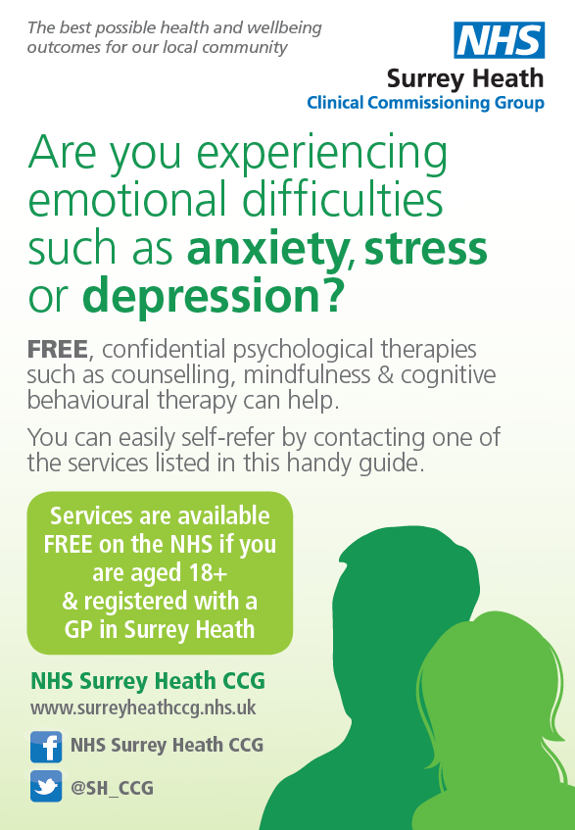

In additional, involving Family helps are very important, for instance, parents, carers and other family members can help in many ways. They can be taught how to manage a child’s anxiety. They can make room for cognitive behavioural therapy by giving models of self-confidence and problem-solving or treats for addressing fears. Sometimes, a family dispute, is the source of the child’s anxiety, or an anxious child thinks they are the cause of any dispute in the family. In that case, joint family therapy in which all members take part might be a good idea. Long-term study on the treatment of these conditions is rare and we know little about what works specifically for children, as opposed to adults. The influence of family and marital issues are substantial but difficult to number. There is little strong evidence that shows the positive and negative impacts of medications. Fortunately, children normally grow out of their fears or can be successfully treated. Shy children do not always become adults with anxiety conditions. Even the effects of traumatic stress might disappear over the years. This is one field in which optimism is a good attitude for mental health professionals.
Children and adults can access The National Health Service (NHS) without seeing a GP.
All Governments Schools and NHS provides support on anxiety disorders for children and adolescences .Find a psychological therapies service in your area .Things parents or carers can try to overcome social anxiety
Self-help probably will not cure your social anxiety, but it may reduce it and you might find it a useful first step before trying other treatments.
The following tips may help:
- Try to understand more about your anxiety – think about what goes through your mind and how you behave in certain social situations to help you and others to get a clearer idea of the problems you want to tackle
- Replace your unrealistic beliefs with more rational ones – for example, if you feel a social situation went badly, think if there are any facts to support this or if you're just assuming the worst
- Do not think too much about how others see you – pay attention to other people instead and remember that your anxiety symptoms are not as obvious as you might think
- Start to do activities that you would normally avoid because this can be tough at first, so start with small targets and work towards more feared activities gradually

Parent carer or patients may find it useful to read an NHS self-help guide for social anxiety for more detail.
Parent carer or patients can listen to a helpful podcast about controlling anxiety from a leading anxiety specialist. Parent carer or patients can also find mental health apps and tools in the NHS Apps Library.

References:

Maurice Chazan, Alice F. Laing, Diane Davies.(1994) Emotional and Behavioural Difficulties in Middle Childhood Identification,

Aletha C. Huston, Marika N. Ripke,(2006), Developmental Contexts in Middle Childhood: Bridges to Adolescence and Adulthood.

W. Andrew Collins. (1984) Development During Middle Childhood: The Years from Six to Twelve, edited .

The Child Psychology Unit -11.(2019) Problems of Middle Childhood . Guideline of College Brentwood Open Learning College (BOLC). London in Leicester.
News & Press (2019) Child Mind Institute:[Online] Available from : https://childmind.org/guide/guide-to-conduct-disorder/: Accessible on the Date [6th October 2019].
Patrick .H. Tolan. (2019) Disruptive Behaviour Disorders, Advances in Development and psychopathology: Brain Research Foundation Symposium Series. Editor Bennett L .Leventhal: [Online] Available from : https://books.google.co.uk/books?id=iKm9BAAAQBAJ&printsec=frontcover&dq=Define+the+term+%E2%80%98conduct+disorder&hl=en&sa=X&ved=0ahUKEwiawOeU_IzlAhXkqHEKHVpVAa8Q6AEILjAB#v=onepage&q=Define%20the%20term%20%E2%80%98conduct%20disorder&f=false: Accessible on the Date [6th October 2019].
The National Collaborating Centre for Mental Health (2019), Antisocial Behaviour and Conduct Disorders in Children and Young People / The nice guideline on recognition, Intervention and Management. The Royal College of Psychiatrist (2013). The British Psychiatrists Society. [Online] Available from : https://books.google.co.uk/books?id=wMl53lZSgEAC&printsec=frontcover&dq=Define+the+term+%E2%80%98conduct+disorder&hl=en&sa=X&ved=0ahUKEwjxlYCphY3lAhWzTBUIHdZvAr8Q6AEIKDAA#v=onepage&q=Define%20the%20term%20%E2%80%98conduct%20disorder&f=false: Accessible on the Date [6th October 2019].
Alan E. Kazdin (2019) Conduct Disorder in Childhood and Adolescence, Second Edition. [Online] Available from : https://books.google.co.uk/books?id=_JY5DQAAQBAJ&printsec=frontcover&dq=Define+the+term+%E2%80%98conduct+disorder&hl=en&sa=X&ved=0ahUKEwjxlYCphY3lAhWzTBUIHdZvAr8Q6AEINDAC#v=onepage&q=Define%20the%20term%20%E2%80%98conduct%20disorder&f=false: Accessible on the Date [6th October 2019].

