
Assignment Cover Sheet

Student Name: | Ime Alfred Akpan
Student Number: | 32605
Course: | Advanced Diploma Project Management Level 5
Assignment NO: | 3

Marking Criteria:
We expect the learners to write minimum one well expressed point in three lines against each allocated mark. This means one needs to write 15 lines with 5 well expressed points to get high grades for a 5 marks question.
For high grades use examples and illustrations where appropriate.
Number 1
- According to PMBOK Guide (6th edition) Project Plan used to guide project execution as well as project control. The major uses of the project plan includes the following:
- Act as a guide and control tool during the execution of the project
- Record planning assumptions and decisions,
- Facilitate communication among project stakeholders,
- Record approved scope, cost, and schedule baselines
- Describe important management reviews with regard to content, extent and timing.
Project Management Plan can be divided into three components and contains but are not limited to the following:
- Supplementary Management Plans
- Scope Management Plan: Determines how the scope will be defined, established monitored, control and validated.
- Requirements Management Plan: Determines how the requirements will be evaluated, recognized, recorded and managed.
- Schedule Management Plan: Determines the standards and the activities for developing, monitoring as well as controlling the schedule.
- Cost Management Plan: States how the budget will be planned, organized and controlled.
- Quality Management Plan: Describes how an company quality policies, standards and procedures will be applied in the project.
- Resource Management Plan: Gives direction on how project resources should be classified, distributed, managed and released.
- Communication Management Plan: Defines how, when and who should manage and circulate information about the project.
- Risk Management Plan: States how the project risks will be identified, analyzed and managed.
- Procurement Management Plan: Defines the procedure for buying goods and services from outside the organization (Vendor).
- Stakeholders Engagement Plan: Outlines how stakeholders will be involved in project decisions making process and implementation, consistent with their needs, interests plus impacts.
- Baselines
- Scope baseline: the approved scope statement, Work Breakdown Structure (WBS), as well as its accompanying WBS dictionary that is to be utilized as the basis for comparison.
- Schedule baseline: The approved schedule that is to be adopted as the basis for comparison to the actual results.
- Cost baseline: The approved budget that is to be utilized as the basis for comparison to the actual results
- Other components
- Change Management Plan: Explains how project change request will be officially authorised and integrated
- Configuration Management Plan: States how the information concerning the item of the product will re documented, and updated.
- Performance Measurement Baseline: This is a deliverable that combines scope-schedule-budget for the project activity against project execution is compared to measure and manage performance
- Project Life Cycle: Describe the project phases
- Development Approach: Defines the product, service or result development methodology
- Management Reviews: Identifies when there will be review of the progress of the project by the project manager and relevant stakeholders.
- Stakeholder Analysis refers to the identification of a project’s major stakeholders, an evaluation of their interests and the modes wherein these interests impact on the project and its feasibility. Stakeholder analysis results should be documented sensibly – due to the sensitive nature of the information (for instance, a stakeholder may dislike to be identified as a blocker). Tools such as PESTLE and Mapping can be used to analysed and present the data.
A typical stakeholder analysis report will contain but not limited to the following:
- Executive Summary
- Acronyms
- Background of the Project: A brief statement on the scope of work
- Objectives of the study
- Methodology: Data collection techniques include reviewing of project’s documents and other relevant documents, stakeholders’ visitation and meetings, interviews, focus group discussions, etc. These data are analysed accordingly. As a minimum 4 step methodology as follows: Identify the stakeholders, Create a Stakeholder Map, Identify Stakeholder Allegiance and Create a Stakeholder Management Strategy
- List of Key Stakeholders
- Primary Stakeholders
- Secondary Stakeholders
- Tertiary Stakeholders
- Results: This may include as a minimum the following:
- Stakeholder Name and Contact Person (Phone, Email, Website, Address)
- Impact (How much does the project impact them? (Low, Medium, High)
- Influence (How much influence do they have over the project? (Low, Medium, High)
- What is important to the stakeholder?
- How could the stakeholder contribute to the project?
- How could the stakeholder block the project?
- Strategy for engaging the stakeholder
- Conclusion and Recommendations
- Annexes: This may be the map for each of the key stakeholder
- References
- The main objectives of he integrated change control process are
- Swaying the factors that produce changes to make sure that changes are useful.
- Determining that changes took place.
- Managing real changes as they happen.
- The major tools and techniques that assist managing integrated change control process are:
- Expert judgment: Stakeholders with expertise may be asked to be in charge of the change control process and be a member of the Change Control Board. Stakeholders may be requested to offer their expertise on change control board. This judgment and expertise is useful to any technical as well as management features during the process and offered by several sources
- Meetings: Meetings of Change are always held to discuss the changes and how to manage them. A change control board is accountable for meeting and evaluating the change requests as well as giving approvals or refusing the change requests. The roles and responsibilities of these boards are well defined and approved by stakeholders. All decisions taken by the change control board are recorded and communed to the stakeholders.
- Change control tools: It can be done manually or automated tools may be used for change management process.
- There are three basic outputs of integrated change control process, which include:
- Change Requests Status Update: The project manager or team member processes all requests for change according to the change control system. Those change requests that are approved will be incorporated into the project and executed. Live and updated change controls register; which shows the status of all change requests; whether approved or rejected.
- Project Management Plan Updates: Sections of the project management plan includes:
- Every supplementary management plan
- Baselines, which are conditional on the formal change control process.
Changes to the baseline should simply indicate the changes to the present time onward. Previous performance may not be affected.
- Project Document Updates:
- Project documents, which may be updated because of the performed integrated change control processes comprise of the change request log as well as any other documents that are affected by the formal change control process.
- A work breakdown structure (WBS) is an important project deliverable, which arranges the team's work into manageable parts. According to PMBOK Guide (6th edition), work breakdown structure is a deliverable concerned with hierarchical breakdown of the activities to be carried out by the project team. The work breakdown structure graphically outlines the scope of work into practicable pieces, which a project team can know, since every level of the work breakdown structure offers more description and facts.
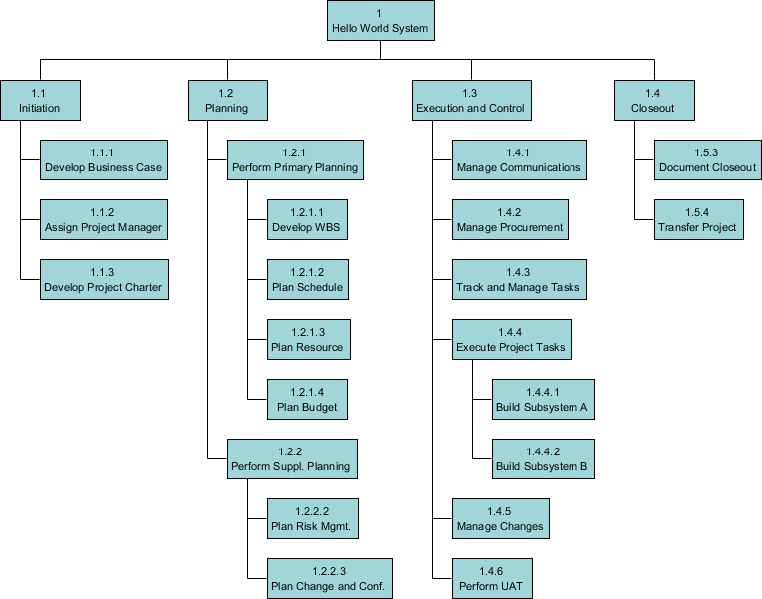
Example of Work Breakdown Structure (Source: https://www.visual-paradigm.com/guide/project-management/what-is-work-breakdown-structure/)
- Developing of Project Management Plan involves the practice of defining, organizing, and synchronizing all secondary plans and tying them together into an all-inclusive project management plan. The major advantage of this process is a principal document that clearly states the foundation of all project work.
The project plan development, a second step in project integration management takes place during the Planning phase, utilizing the output of Initiation Phase to generate a live and valid document used during Execution and Control & Monitoring Phases for guidance. Other outputs of project plan development apart from the PROJECT MANAGEMENT PLAN are the Project Management Plan components and Project Documents such as:
Project Management Plan Components
- Critical Success Factors.
- Scope Statement. .
- Deliverables List
- Financial Plan/Budget.
- Schedule.
- Quality Management Plan.
- Communication Plan.
- Risk Management Plan
- Project Control Plan.
- Work Breakdown Schedule (WBS)
- Procurement management plan.
- Management of Change procedures.
- Human Resources Plan.
Project Documents
- Activity List
- Assumption Log
- Basis for estimate
- Change log
- Cost estimate
- Cost forecast
- Lesson learned register
- Milestone list
- Project schedule network diagram
- Project Team Assignment
- Various reports
- Team Charter

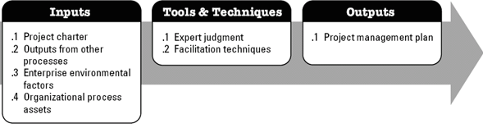

(Developing Project management Plan. Extract from PMBOK Guide – 6th Edition)

Number 2
Project integration management involves the coordination of all components of a project such as resources, tasks, stakeholders, etc., as well as handling the clashes among diverse features of a project, making compromises between competing requests and assessing resources. Consider a project that is not on track as an example. In this situation, the Project Manager need to take a decision on whether to go over budget or it effect on project delivery deadline. Assessing the situation and making the decision is a key part of project. Simply put, project integration management is the knowledge area in project management that guarantees suitable coordination amongst project activities and it is considered a critical success factor for project managers and their projects.
Project manager handles different areas of the project such as schedule, cost, resources, risk, quality, stakeholders, changes, etc. With this projects can be said to complex involving management skills in different areas as stated above.
Managing these areas is very challenging and if not properly managed, it can result in project failure. A good example is lack of proper understanding of the effect of change on cost, schedule and other resources leads to improper management of the change and may cause the failure of the project. More complex issue arise when decision on one project affects other projects within the organization. These and many more issues calls for Project Integration Management. When the principle of Integration Management is not adopted within the organization, it can be difficult to identify and assess conflicts in advance and create a conflict management plan to resolve them.
For successful integration management, seven processes should be followed. These processes are:
- Create the project charter
- Create project management plan
- Direct and manage project work
- Manage project knowledge
- Monitor and control project work
- Carry out integrated change control
- Close the project (or project phase)
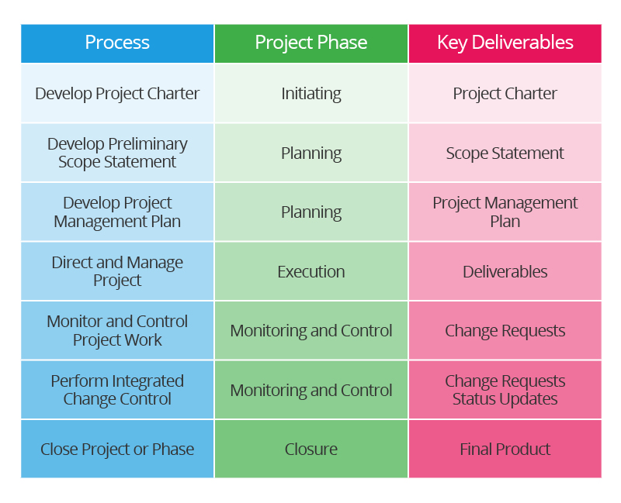
(Source: https://www.smartsheet.com/project-integration-management)

It should be noted that integration management processes occur throughout the whole project lifecycle. In short, as a minimum one of these seven processes falls in each of the five phases of a project. This implies that managing project integration is a continuing task that requires to repeatedly occur during a project.
Integration management demands the ability to assess resources, making substitutions and dealing with competing events, project managers require to posses a blend of soft skills as well as hard skills such as: Planning, Organization, Communication, Leadership, Relationship management, Critical thinking ability, Data analysis, Impact assessments, Scheduling, Budgeting, Change management and Risk management
Worthy of mentioning is the importance of effective communication between project team members and the stakeholders and well as accurate impact assessments to ascertain points of integration or dependencies.
Number 3
There are seven processes involved in integration management. The processes are
- Create the project charter
- Create project management plan
- Direct and manage project work
- Manage project knowledge
- Monitor and control project work
- Carry out integrated change control
- Close the project (or project phase)

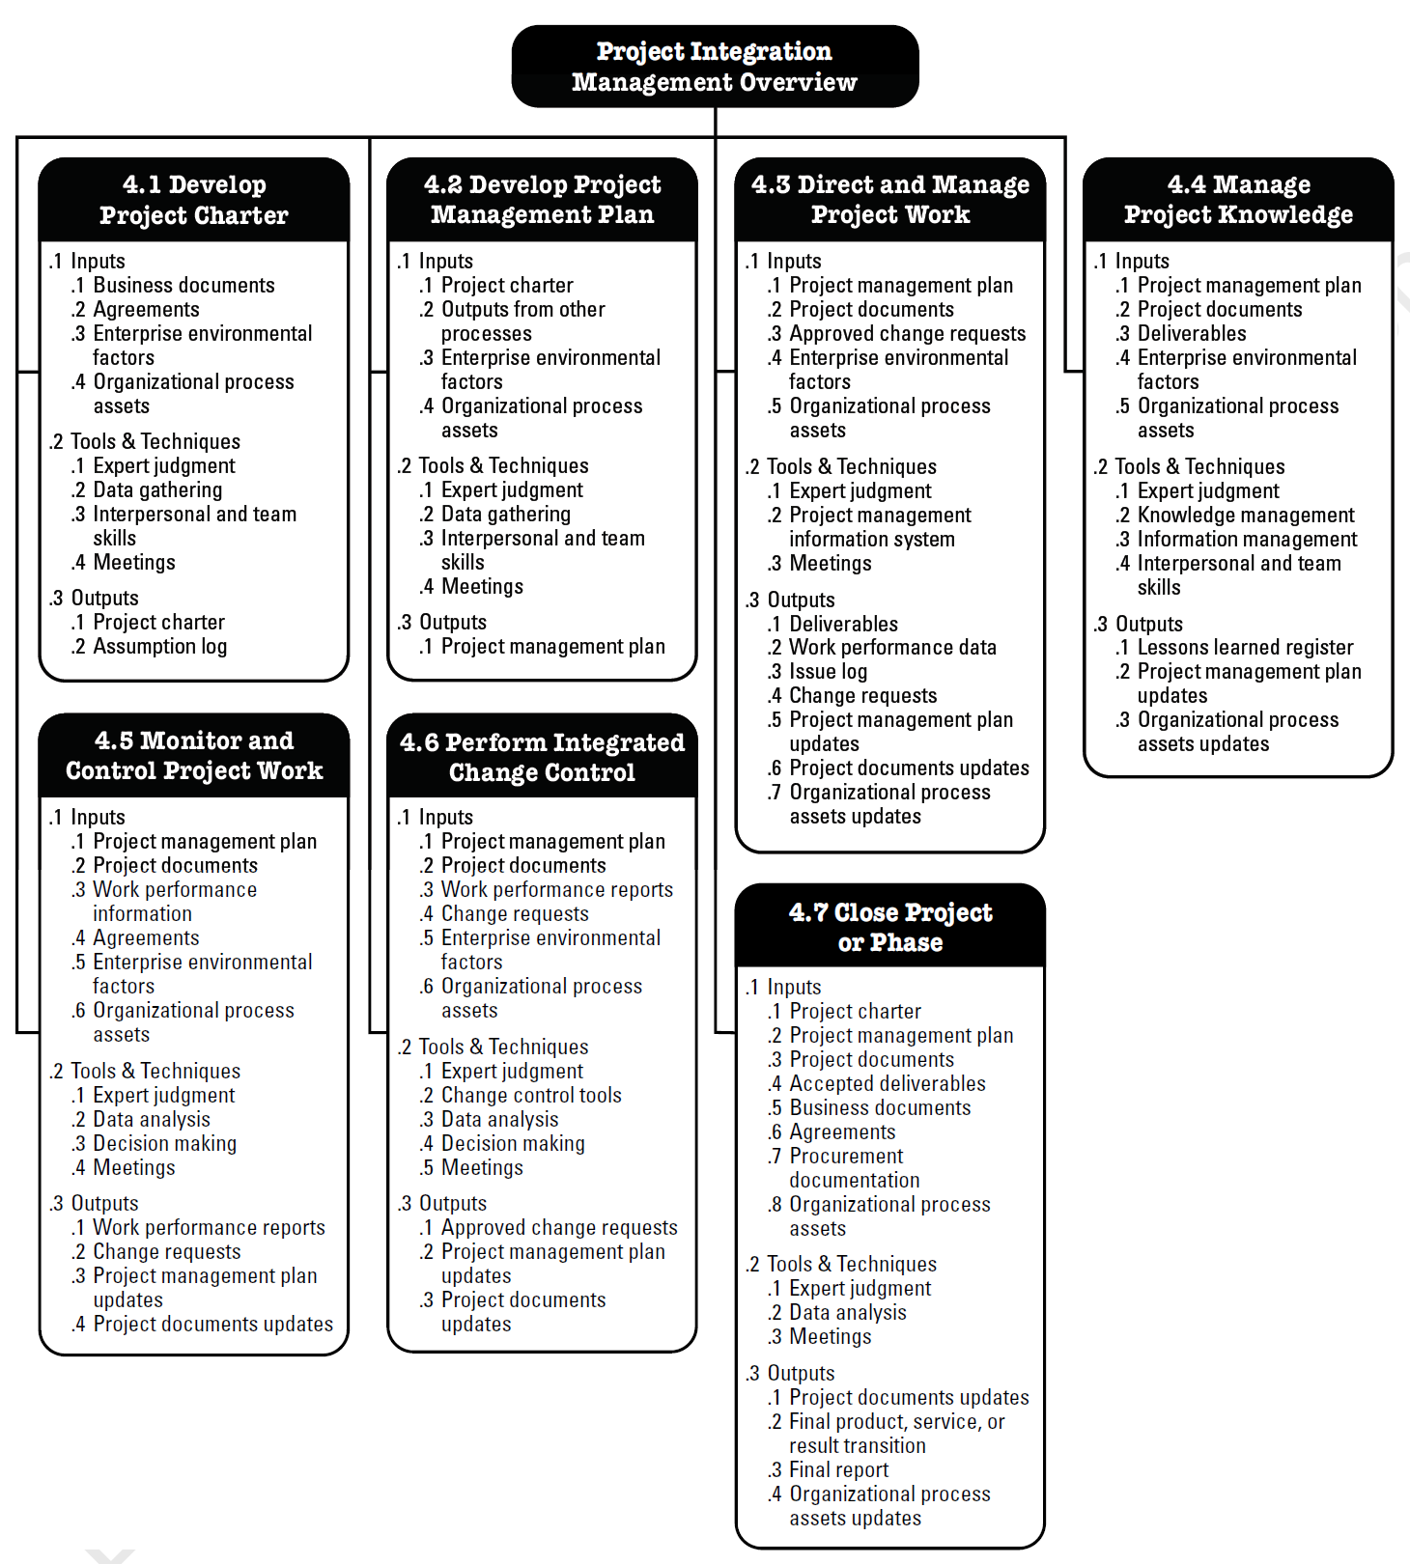(Project Integration Management Overview – Extracted from PMBOK Guide 6th Edition)

Develop Project Charter

A Project Charter is an official document that officially approves the existence of a project as well as providing the Project Manager with authority to use organizational resources to project activities. The project initiator or project sponsor develops the Project Charter during the Initiation Phase of a project. The Project Charter explains the project in well-defined brief language, written for high-level management needs.

According to PMBOK Guide (6th edition), developing a project charter requires inputs (business documents such as business case and benefit management plan, agreements, enterprise environmental factors and organisational process assets) and Tools & Techniques (Expert judgement, data gathering (brainstorming, focus groups & interviews), interpersonal & team skills and meetings).

Develop Project Management Plan
The project management plan outlines what way the project will be managed. It is important to note that all ten knowledge areas are roofed in it, also, over 50% of the PMBOK’s processes are utilised in its production of project management plan. It is regarded as a “live” document since it can update to include any change that may occur in the project.
Inputs to the Project Management Plan include Project charter, Outputs from other processes, Enterprise environmental factors and Organizational process assets. Tools and Techniques employed are Expert judgment, Data gathering (Brainstorming, Checklists, Focus groups and Interviews), Interpersonal and team skills (Conflict management, Facilitation and Meeting management) and Meetings. The output is the project management plan.

Direct & Manage Project Work
This involves managing the daily activities of the project. These activities may include meetings, work allocation to the team members, responding to enquiries, etc. Inputs here include project management plan, Project documents (Milestone list, risk register, lesson learned record, schedule, etc.), approved changed requests, enterprise environmental factors and organisational process assets. Tools and techniques used are Expert judgment, Project management information system and Meetings. The outputs are Deliverables, Work performance data, Change requests, Project management plan updates, Project documents updates(Assumption log, Activity list, requirements documents, lessons learned register, risk register, stakeholder register) and organisational process assets updates.

Manage Project Knowledge
Every project applies a knowledge subsection to create the prerequisite deliverables. The project gets a knowledge depository from its project team members or organizational division. Any additional knowledge required must be learned or hired to the project. And lastly, new knowledge must be transferred by the project back into the organizational knowledge bank for future use.
Inputs required are Project management plan, Project documents (Resource breakdown structure, list of project team members and assignments, lesson learned register and source selection criteria), deliverables, enterprise environmental factors and organizational process assets.

Tools and techniques required include Expert judgment, Knowledge management, Information management, and Interpersonal and team skills (Active listening, Facilitation, Leadership, Networking and Political awareness).

The outputs are project management plan updates, lesson learned register and organizational process assets updates.

Monitor and Control Project Work
The foundation to a good project management is effective project control. Project management plan is worthless without effective monitoring and control. Monitoring and control ensures that the project sticks to the project management plan. The project manager conducts routine earned value analysis to determine the position of the project’s budget as well as schedule.
Inputs required to carry out these tasks are Project management plan, Project documents (Risk register, risk report, quality reports, assumption register, basis of estimate, lesson learned, cost forecasts, issue register, milestone list and schedule forecast), Work performance information, Agreements, Enterprise environmental factors and Organizational process assets
Tools and techniques required are Expert judgment, Data analysis (Earned value analysis, alternatives analysis, root cause analysis, cost benefit analysis, variance analysis and trend analysis), decision-making and meetings.
Outputs include Work performance reports, Change requests, Project management plan updates and Project documents updates (issue register, cost forecast, lesson learned register, schedule forecast and risk register)

Perform Integrated Change Control
Changes create more stress in the project than any other thing, that is the more reason it should be meticulously managed to avoid scope creep. This can be done by properly assessing the change in respect to cost, schedule, quality as well as other factors. Changes must be well documented and communicated to right stakeholders.
The inputs required are Project management plan (Change management plan, scope baseline, cost baseline, schedule baseline and configuration management plan), project documents (risk report, basis of estimates and requirement traceability matrix), Work performance reports, Change requests, Enterprise environmental factors and Organizational process assets.
Tools and techniques required are Expert judgment, Change control tools, Data analysis (Alternatives analysis and Cost-benefit analysis), Decision making (Voting, Autocratic decision making and Multi-criteria decision analysis) and Meetings
The outputs are Approved change requests, Project management plan updates and Project documents updates (Change register)

Close Project or Phase
There are a lot of activities to be performed during this phase. Such activities may include final inspections, closing procurement, releasing resources, etc. Inputs required are Project charter, Project management plan, Project documents (Lesson learned register, basis of estimate issue register, assumption log, change register, milestone list, quality control measurements, project communications, quality report, requirements documentation, risk report and risk register), Accepted deliverables, Business documents (Business case and Benefits management plan), Agreements, Procurement documentation and Organizational process assets
Tools and techniques required are Expert judgment, Data analysis (variance analysis, document analysis, trend analysis and regression analysis) and Meetings
The outputs are Final product, service or result transition, Project documents updates (Lessons learned register), final report and Organizational process assets updates.
ACTIVITY
Community Road Construction (tarring and drainage work)
- The problems presently facing includes the following:
- Scope Change: The initial scope did not specify the depth of the drainage and the specification for the materials to be used.
- Unclear project goal:
- Inadequate risk management
- Communication barrier: Some of the community workers do not speak English language; making it difficult to communicate effectively
- Lack of skilled manpower: This is solely due to the contract terms that the company should employ 90% of its workers from the host community.
- Unrealistic deadline: The government (Project Sponsor) wants to use the project as one of her achievement during campaign and require project to be completed within a very short period of time.
- No stakeholder engagement: The project sponsor and the host communities rarely show up for meetings. They exhibit nonchalant attitude.
- Non release of fund as at when required
The opportunities include:
- Learning of interpersonal and team skills especially when assigning tasks to the community workers. These skills are also required during control and monitoring processes.
- Learning the local community dialect to be able to communicate and function properly in my role.
- The best opportunity this job presented is in the aspect of project initiation and planning. The key word is plan, plan and plan.
- Some processes maybe said to be impediments to quality services delivery in our organisation and they can be categorized into 2: societal and internal structures.
The societal barriers are outside and are not in direct control of the organization. They major one here in my organisation is lack of qualified and experienced project managers and Project Team Members to handle projects.
The internal structural barriers are within the direct control of the organization and specifically include
- Policies: For instance, the employment policy that states 80% of the workers should come from the host community. Some communities may lack certain specialized worker and therefore having effect on the quality of delivery.
- Organizational structure: This prevents direct report and communication to strategic levels.
- Corporate culture which does not give the project manager liberty of making decisions.
- One aspect that interests me most in my job is the opportunity to work in a team setting. I have been looking forward to work with hard-working, professional and experienced people and this job has given me the opportunity. I like contributing to the teamwork, showcasing my best and also acknowledging the great talents in my colleagues for realizing our project goals and achieving the best results.
The other interesting thing about my job is the product (deliverable) we are working on. It is so exciting to work on a project that will touch the lives of the rural people. I want to continually work in community-based projects.
The tight deadline is another interesting point, although it is stressful since we have to work extra hours but it helps maintain a sense of urgency, complacency may set in when you have more time.

Student Statement:

By submitting this assignment, I confirm that this is my own work.

Student Signature | Ime Alfred Akpan | Date | April 27, 2019

For Tutor / Assessor Use Only
Total Marks
Marks Obtained
Percentage / Grade

