
Assignment Cover Sheet

Student Name: | Maung Maung Min Thaik
Student Number: | 3040
Course: | Diploma in Construction Management
Assignment NO: | #2

Marking Criteria:
We expect the learners to write minimum one well expressed point in three lines against each allocated mark. This means one needs to write 15 lines with 5 well expressed points to get high grades for a 5 marks question.
For high grades use examples and illustrations where appropriate.
- Give short answers to the following questions: (18)

- What are the general causes of project cost and time overruns?

During the project initiation, design and planning phases, some processes are not sure feasible study for poor scope definition with cost estimates, lack of planning, resources and procurement management, that can cause prolonged project extended time for cost overruns in project execution and control phase to complete the construction project.

- What are the main resources of project finance?

The main sources of project finance are as follows:
- Commercial banks
- Public Banks
- Debenture or bonds
- Suppliers credit

- Which processes are used in controlling phase?

The project control phase involves:
- The overall scope change control
- Resources control
- Schedule control
- Cost control
- Quality Control
- Risk response
- Performance reporting
- Contract administration

- What are the tasks undertaken in "project close-up phase”?

    - Administrative close
    - Contract Close-out
    - Lessons learnt

- What is Feasibility Study? And which areas does it cover?

A feasibility study is an analysis of how successfully a project can be completed, accounting for factors that affect it such as economic, technological, legal and scheduling factors. The feasibility studies should include market analysis, technical analysis, financial analysis, economic analysis and ecological analysis.

- What items are included in "Project Completion Report”?

This report details the scope of work and the schedules used to complete the works, important events that transpired, the contract executed, the contact details of material and equipment suppliers, the maintenance manual, costs of the projects, problems during construction, any lessons learned and minor defects detected at the time of handing over.

- What is a project? Describe different processes undertaken throughout the development of a construction project.

Project is an unique and temporary nature mean that the project has a definite start date and end date within budget, on time and in scope. In construction industrial project, there is a start with conceptual idea from the client (the project owner). The preliminary design phase to create the idea of the owner with feasible studies and report that cover several areas such as market analysis, technical analysis, financial analysis, economic analysis and ecological analysis. This phase including project design and planning for details for the whole project including schedule planning, resources such as manpower, materials and equipments planning, risk control planning, safety planning and etc. Then Commitment to approve final design to start construction for the execution and control phase. The project executive teams will execute and control over the planning against the actual performance over the site management that can avoid cost and time overruns. Finally, the project will be completed with scope, time and cost according to contract. In this phase, the client’s staffs will ensure the details report to handover the project to the client. In the construction processes, the payment will be across the whole project.

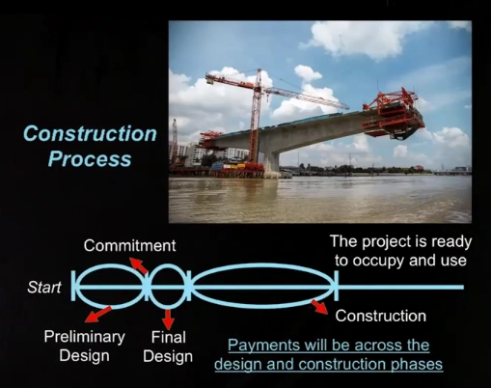
Figure. The Construction Process

Student Statement:

By submitting this assignment, I confirm that this is my own work.

Student Signature | Maung Maung Min Thaik | Date | 11/17/2016

For Tutor / Assessor Use Only
Total Marks
Marks Obtained
Percentage / Grade

