
Assignment Cover Sheet

Student Name: | Frank Street
Student Number: | 23277
Course: | Diploma in Environmental Management
Assignment NO: | 1

Marking Criteria:
We expect the learners to write minimum one well expressed point in three lines against each allocated mark. This means one needs to write 15 lines with 5 well expressed points to get high grades for a 5 marks question.
For high grades use examples and illustrations where appropriate.
Please insert your completed assignment ( in word format) here:
What Is the Environment?
Assignment 1
Q1:
- What is Ecosystem?
An ecosystem is the community of relationships between organisms and their external environment (Sulphey and Safeer 2014). These relationships are based on the constant interactions between the organism and living/non-living components in its surroundings e.g. biotic and Abiotic factors(Sulphey and Safeer 2014, Jongman et al. 2017). The ecosystem is self-regulatory circle based on biomass, seasonal changes, soil development, and energy storage affecting the living and non-living elements (Jongman et al. 2017,Hand out). This constant interactions and regulation process therefore allow an ecosystem can maintain a state of equilibrium (Jongman et al. 2017).

- What is a Lithosphere?
The Lithosphere is the combination of the solid land masses and the ecosystems that are contained on these masses (Sulphey and Safeer 2017, Basu and Xavier 2016). It makes up for around 30% of the Earth’s surface and is composed of the crust and the upper most part of the mantel (Sulphey and Safeer 2017). The Lithosphere is 100km thick and can glide over the mantle, this is what causes earthquakes, volcanic eruptions, formations of mountains and oceanic drift (Basu and Xavier 2016).

- Outline the Functional Components of an Ecosystem.
Basu and Xavier 2016 state the functional aspect of an ecosystem is the relationship between the biotic and abiotic factors. This includes energy flow and the cycling of nutrients, which can be best visualised in a food chain (see Plate 1). The flow of nutrients circles moving from producer through the consumers and then to the decomposers back to producer, however this flow can only travel in that one direction e.g. a herbivore cannot get energy back from the omnivore (Basu and Xavier 2016). This creates balance within the ecosystem (Basu and Xavier 2016, Sulphey and Safeer 2017).

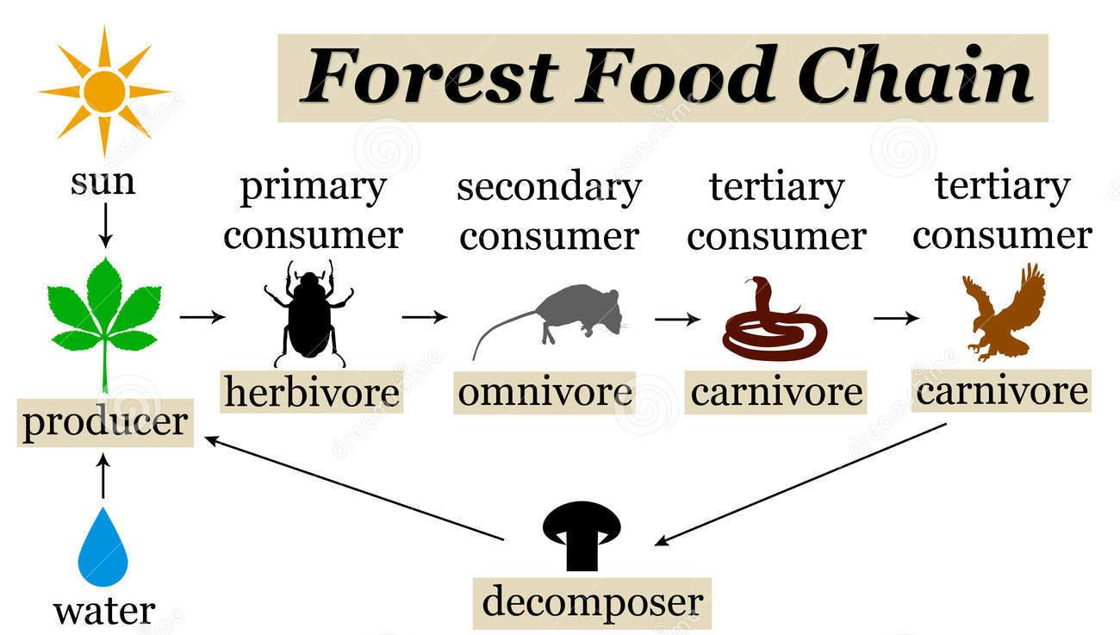
Plate 1: A visual depiction of a forest food chain (dreamstime)

- What did you understand by sustainable environment?
The term sustainable environment has been coined with the goal to conserve natural resources and develop new ways to fuel our growing industrialized society while reducing environmental impact (Rinkesh). A lot of projects exist to aid in achieving this goal such as replanting forests, saving wetlands and minimising resource harvesting, all trying to keep up with the demands and pressures of our industrial development (Rinkesh). We have now become aware that the current methods of development are causing severe long term consequences (SD- Commission). This has led us to more sustainable developments being created but we are far from achieving a perfect balance between sustainability and industrial development (SD Commission).

- What are Biotic and Abiotic components of the natural environment?
An ecosystem is split into two main components, biotic and abiotic. The biotic component includes all living organisms within the ecosystem. Energy flows through the community of organisms in the form of food, depending on how each biotic component receives this energy classifies them in one of the following categories, producers, consumer, parasite or decomposer (See Table 1) (Sulphey and Safeer 2017).
The abiotic components includes the non-living substances within and ecosystem such as land, water, air, elements and compounds (Basu and Xavier 2016). The most important aspect is entry/release of these substances into/from an organism, such as oxygen being extracted from the air so organisms can breathe (Basu and Xavier 2016). These abiotic components can be placed into three groups, inorganic, organic and climatic factors (see table 2) (Basu and Xavier 2016).

Table 1: An explanation the different categories of the biotic component of an ecosystem
Producers | Consist of green plants which harness the sun's energy through photosynthesis to create carbohydrates (Sulphey and Safeer 2017).
Consumers | These are animals which depend directly/indirectly on producers for energy in the form of food. These animals consume other organisms to survive and can be further classified into herbivores, carnivores, scavengers. (Sulphey and Safeer 2017).
Parasites | These organisms get their food directly from either producers or other living organisms, normally at the expense of the host(s) (Sulphey and Safeer 2017).
Decomposers | The decomposers break down dead organic matter into molecules and inorganic compounds, enriching the soil through recycling these nutrients for the producers to use. This is a vital part of the self-regulating aspect of the ecosystem. This category includes fungi and bacteria, which decompose organic matter into simple sugars for their digestion (Sulphey and Safeer 2017).

Table 2: An explanation the different groups of abiotic components of an ecosystem.
Inorganic | Carbon, Hydrogen, Oxygen, Nitrogen, Phosphorus etc. (Basu and Xavier 2016).
Organic | Carbohydrates, proteins, Fats Vitamins etc. (Basu and Xavier 2016).
Climatic Factors | Light, Rainfall, Temperature, Soil type/quality etc. (Basu and Xavier 2016).

Q2: Write notes on the following:
a) Food Chain
Ecosystems can down into food chains, which are a visual representation of a species population (Cozzens 2011). The food chain often depicts a base layer as a plant that feeds a herbivore, which in tern then hunted by a predator, all of which are described as trophic levels, Plate 1 show a basic food chain, with the arrows showing the transfer of energy (Cozzens 2011). Each trophic level is numbered and ascends from 1 referring the plants or producers. The consumers in the food chain are termed primary, secondary and tertiary depending on what it eats (Cozzens 2011). In the example shown in Plate 1 the caterpillar would be termed a primary consumer at trophic level 2 and the blue tit would be called a secondary consumer at trophic level 3. The term trophic interactions is used to describe how each trophic level behaviours with another (Cozzens 2011).

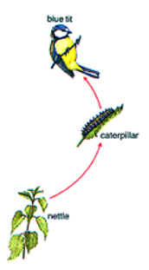
Plate 1: A simple visual representation of a food web, where by a caterpillar consumes nettles and a blue tit consumes the caterpillar. (Rodger et al. 2008)

b) Food Web
The food web is the expansion of a food chain to include other species and more closely represents the inter-species relationships found in nature (see Plate 2). Food webs show various trophic interactions such as consumer-resource, direct competition and indirect competition (Lang and Benbow 2013, Schmitz 2007). The consumer-resource interaction, represents the movement of nutrients from the resource to the consumer, this can be visualized by solid arrows pointing to each trophic level with a with a minus (-) next to resource and a plus (+) next to the consumer (Lang and Benbow 2013). The negative effect on the resource can vary greatly depending on the trophic level, as carnivore need to kill their prey to gain the nutritional benefit whilst herbivore only damage plant tissues such as leaves or the stem and rarely kill the plant (Schmitz 2007).
Direct competition interactions often termed contest or interference competition, is when two species are directly interfering with each others ability to use a particular resources, such as two plant species fighting over soil nutrients (Lang and Benbow 2013). This can be visualised as two solid arrows with a minuses, running between the two species see Plate 2.
Indirect competition is caused by two species sharing one resource, the type of interaction is often termed scramble or exploitative competition (Lang and Benbow 2013). An example of this could be if the aphid number increased the number of caterpillars would decrease due to them sharing the same food source- nettles (Lang and Benbow 2013). As mentioned above carnivores also have an indirect benefit on the plants species by acting a population control, e.g. foxes have a positive impact on grass population due to them controlling the rabbit numbers see Plate 2.

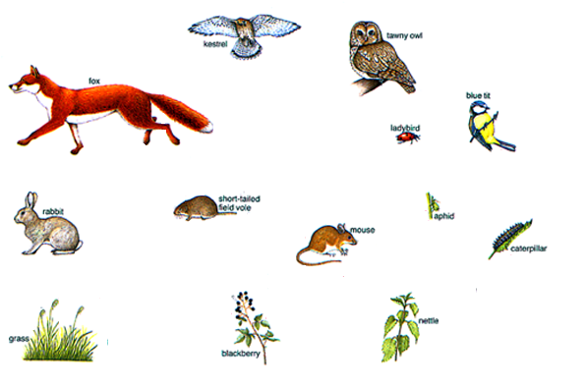

-
+
+
+
+
+
+
-
-
-
+
-
-
-
+
-
+
-
+
-
+
-
+
-
+
-
+
-
+
-
-
-
-
-
-
-
-
-
-
-
-
-
-
-
-
-
-
-
-
-

+

+
+
+
+
+
+
+
+
-
-
Plate 2: A more complex food web showing both resource- consumer interactions (solid red arrows), contest competitive interactions (blue solid arrows) and exploitative competitive interactions ( black dotted arrows) (Rodgers et al. 2008).

Activity
- Visit your nearby rural area for a survey and find out the causes and effects of population growth.
Christ et al. (2017) states that current research shows the trend of increasing human population is creating a substantial loss in biological diversity. Newbold et al. (2015) also agrees with this statement by showing that the “most affected habitats have dropped species richness on average by 76.5%, total abundance by 39.5% and rarefaction-based on richness by 40.3%”. From my survey of a patch of healthland in my home town which I remember being rich in reptile life a new retail park is being built and as a result there was considerably less wildlife in the area. This effect on the natural world comes from the lost of habitat as cities/towns expand and the pressure put on rural areas to feed the population. Elmhagen et al. (2015) shows that the human population in south central sweden tripled in size from 1865-2005 from 807,000- 2.6 million and the percentage of people which now live in towns has increased by 68% in the same period of time. Newbold et al. (2015) suggests a strong mitigation can increase biodiversity on average by 1.9%, but this is less effective in poorer countries. Elmhagen et al. (2015) states that projections of change are difficult to accurately predict due to changes in human values and policies but are useful to show possible outcomes. Christ et al. (2017) believes that as the need increases to feed the increasing population, the protection of the natural world will be undermined. Even though plans that boost food production whilst protecting biodiversity have been suggested, Christ et al. (2017) states that these plans alone are not enough, but only the slowing and the slow reversal of population growth can protect biodiversity, through means such as, improvements to reproductive health services, contraception technologies, women's education and gender equality. My personal opinion is that we cannot sustain the population at its current rising trend and that by slowing this trend is the only way to protect our planet's biodiversity.

- Visit a nearby business school and discuss with the students how important do they feel Environment Education is.
Write a report on your findings
I visited my former workplace, South Essex College, and spoke to a class of business students (15 students with an age range of 16-18). I ran through some questions with them to see how important they felt environmental education was. The questionnaire I devised can be found below, along with a graph to show their responses for each question.

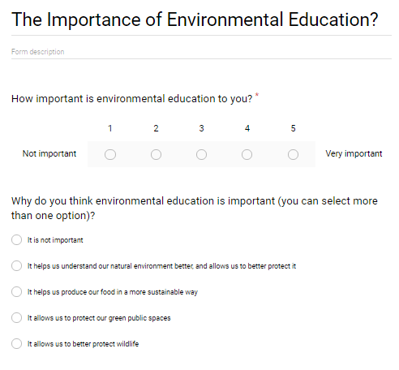
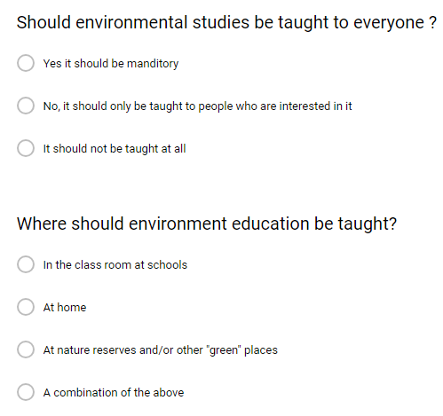
Plate 3: The Questionnaire I handed out to the business students

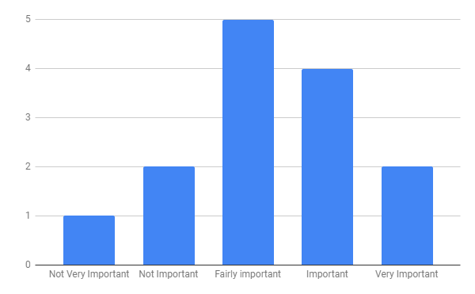
Graph 1: Shows the results from the question “how important is environmental education to you? (ranging from not very important to very important)”

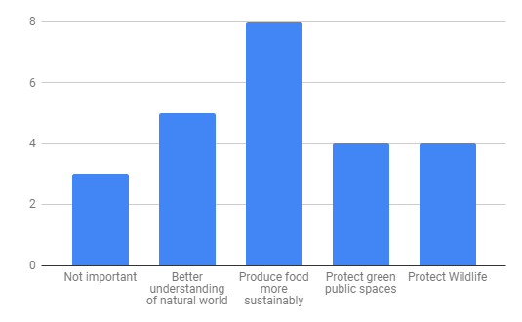
Graph 2: Shows the results from the question “why do you think environmental education is important?” (multiple choice)

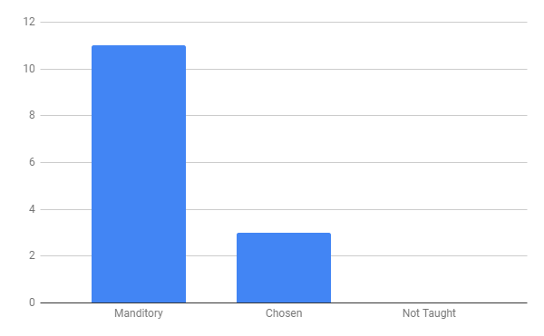
Graph 3: The results for the question “should environmental studies be taught to everyone?”

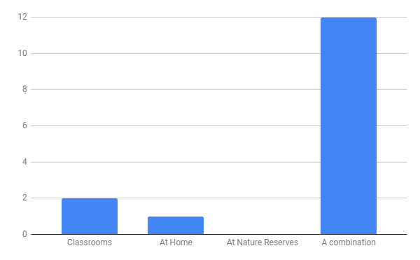
Graph 4: Shows the results to the question “Where should environmental education be taught?”

The results show that the majority of the students (73%) believe that environmental education is fairly important to very important (11 out of 15 students). They also show that the 70.8% of students believed that environmental education is useful to help us better protect wildlife, our green spaces and produce food in a more sustainable way (17 out 24 options) with 47% of those stating it was most important to help us produce more sustainable food . The majority of the students (73%) also believed that environmental education should be mandatory and 80% state that it should be taught in a mixture of classrooms, at home and in outside green spaces. In conclusion the majority of business students asked think that environment education should be mandatory and is useful for the future of our food production and green spaces.

References
- Basu M., Xavier S.S.J., (2016) Fundamentals of Environmental Studies. Cambridge University Press. Available at: “https://books.google.co.uk/books?hl=en&lr=&id=nXmLDgAAQBAJ&oi=fnd&pg=PP1&dq=%22what+is+lithosphere%22&ots=tZCkJ1jaNg&sig=Q5AdTGHp39gMgJuWTNm7FuaxAoU#v=onepage&q=components%20eco-system&f=false”

- Jongman R.H.G., Skidmore A.K., (Sander) Mücher C.A., Bunce R.G., Metzger M.J. (2017) Global Terrestrial Ecosystem Observations: Why, Where, What and How?. In: Walters M., Scholes R. (eds) The GEO Handbook on Biodiversity Observation Networks. Springer, Cham

- Sulphey M.M., Safeer M.M., (2017) Introduction to environment Management, Fourth Edition. PHI Learning Private Limited. Available at: “https://books.google.co.uk/books?hl=en&lr=&id=W_8uDwAAQBAJ&oi=fnd&pg=PP1&dq=introduction+to+environmental+m.+m.+sulphey&ots=EiuLjHVAlJ&sig=gepbeJFxCp3mB8GCTCdLKfSeQpA#v=onepage&q=component%20ecosystem&f=false”
- Dreams time, [ONLINE] Available at: “https://www.dreamstime.com/stock-illustration-forest-food-chain-overview-different-stages-image83373835”

- SD commission, What is sustainable development. [ONLINE] Available at: “http://www.sd-commission.org.uk/pages/what-is-sustainable-development.html”

- Rinkesh, What is Environment Sustainability and Sustainable development. [ONLINE] Available at: “https://www.conserve-energy-future.com/what-is-environmental-sustainability-and-sustainable-development.php#abh_posts”
- Rogers, Y. , Scaife, M., Aldrich F., Price S., (2008). Improving Children's Understanding of Formalisms through Interacting with Multimedia (Figure 1).
- Lang, J. M., Benbow, M. E. (2013) Species Interactions and Competition. Nature Education Knowledge Vol 4, No. 4
- Schmitz O. J. (2007). Ecology and Ecosystem Conservation. Washington: Island Press, pg 7-25
- Cozzens M., (2011) Food Webs, Competition Graphs, and Habitat Formation. Math. Model. Nat. Phenom. Vol. 6, No. 6, pgs. 22-38.
- Newbold T., Hudson L. N.,Hill,Samantha L. L.,Contu S.,Lysenko I.,Senior R. A.,BÃrger L.,Bennett D. J.,Choimes A.,Collen B.,Day J.,De Palma A.,DÃ­az S.,Echeverria-LondoÃo S.,EdgaR M. J.,Feldman A., Garon M.Harrison M. L. K.,Alhusseini T.,Ingram D. J.,Itescu Y.,Kattge J.,Kemp V.,Kirkpatrick L.,Kleyer M.,Correia D. L. P.,Martin C.D.,Meiri S.,Novosolov M.,Pan Y.,Phillips H.R. P.,Purves D.W.,Robinson A., Simpson J.,Tuck S.L.,Weiher E., White H. J.,Ewers R. M.,Mace G. M.,Scharlemann J.P. W.,Purvis A., (2015),Global effects of land use on local terrestrial biodiversity Nature, 2015/04/01/online, 520 45 Nature Publishing Group, a division of Macmillan Publishers Limited. All Rights Reserved. http://dx.doi.org/10.1038/nature14324
- Crist E., Mora C., Engelman R., (2017) The Interaction of Human population, food production and biodiversity protection. Science Vol 356 Issue 6335 pg 260-264
- Elmhagen, B., Destouni, G., Angerbjörn, A., Borgström, S., Boyd, E., Cousins, S., Lindborg, R. (2015). Interacting effects of change in climate, human population, land use, and water use on biodiversity and ecosystem services. Ecology and Society, 20(1). Retrieved from http://www.jstor.org/stable/26269757

Student Statement:

By submitting this assignment, I confirm that this is my own work.

Student Signature | Frank Street | Date | 29/10/18

For Tutor / Assessor Use Only
Total Marks
Marks Obtained
Percentage / Grade

