
Assignment Cover Sheet

Student Name: | Nicola Young
Student Number: | 24904
Course: | Diploma in wedding planning level 4
Assignment NO: | 1

Marking Criteria:
We expect the learners to write minimum one well expressed point in three lines against each allocated mark. This means one needs to write 15 lines with 5 well expressed points to get high grades for a 5 marks question.
For high grades use examples and illustrations where appropriate.
Please insert your completed assignment ( in word format) here:
The Wedding Planning Indusrtry
1 (i) What does wedding etiquette mean?
Wedding etiquette is defined as good behaviour where an individual adheres to rules. There are many traditions that are associated with weddings, yet traditions and customs vary across different countries and religions.
(ii) What is a sake-sharing ceremony and in which culture is it performed?
Sake-sharing ceremony is performed in Japanese ceremonies which are also called Shinto, many Japanese ceremonies in America are performed through a Buddhist ceremony.
Sake-sharing tradition also known as San-San-Kudo (San meaning “three”, Ku meaning “nine” and do means “ to deliver”)
This tradition was believed to create a bond the same as what a handshake would have meant in the Victorian times.
The tradition is where three flat cups are stacked one on top of the other. The bride and groom each take three sips out of each cup and then the bride and grooms families each do the same.
(iii) Why is a civil ceremony important in Russia?
Church weddings in Russia are not official, the Bride and Groom exchange their vows at a civil ceremony. The Bride and Groom are greeted by family members with bread and salt. The rings are exchanged and they are then pronounced husband and wife. The married couple are then offered two crystal glasses which they are to break, the greater the number of broken pieces of glass the longer their happiness will last.
Russian weddings can take many forms, however a marriage is only legally binding when the have signed the papers at the registration office the Zapis Aktov Grazhdanskogo Sostoyaniya (ZAGS).
(iv) Outline the main skills required to be a wedding planner.
- Excellent problem solving skills
- Organisational skills
- Good communication
- Customer care skills
- The ability to deal with the unexpected
- Attention to detail
- Work under pressure
- Meet deadlines
- Keep calm
- Sales and negotiation skills
- Manage a budget
(v) What is the role and scope of wedding consultancy in the modern world?
Duties vary with each client, some will want their whole wedding planning and others may just want you for the run up to the big day.
The wedding consultants job is to bring the vision of the Bride and Grooms ideas to life by planning, organising and looking at all aspects of the wedding ceremony, reception and sometimes the honeymoon. The wedding consultant can also help with events leading up to the big day for example the engagement party and Hen/Stag parties.
They are there to ensure that everything runs smoothly and to take the stress and strain away from the bride and groom.
They are there to create a plan of action and then are responsible of carrying out the necessary work to obtain vendors for example cake makers and florists etc.
2 (a) Traditional English Wedding Reception
Five wrapped almonds would traditionally be given to represent fertility, longevity, wealth, health and happiness.
Something old, something new, something borrowed, something blue is a very old tradition. Something old is that the bride wears something old as a symbol of the brides friends will be faithful when needed. Something new signifies success in her new life, something borrowed is that she may take with her the love of her family and something blue symbolises constancy.
The cutting of the cake at the reception was traditionally rooted in history that when the bride made the first cut was to ensure the marriage was blessed with children.
The throwing of the bouquet was originally formed by the bride throwing her shoe over her shoulder. The tradition is that the person who catches the bouquet will be the one to marry next.
The veil worn by the bride was traditionally worn to fend off evil spirits.
(b) German Wedding Traditions
Polterabend meaning the ‘eve of making a racket’. Traditionally this is where family and friends on the eve of the wedding smash porcelain for good luck.
Baumstamm sagen known as sawing a tree trunk. The brides are expected to put on gloves and start sawing away at a log of wood with the groom after the ceremony.
Schleietanz known as the veil dance is when the bride removes her veil and she and her husband dance underneath it, when the music has stopped, the single women try to rip pieces off it.
Kidnapping of the bride. This is where the bride is taken by the groomsmen and taken from bar to bar until the groom finds her. Once the groom finds the bride he has to pay the bill and the next round of drinks.

Activity.

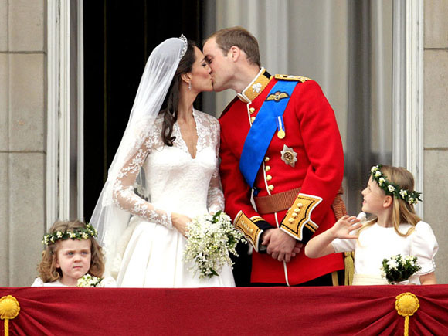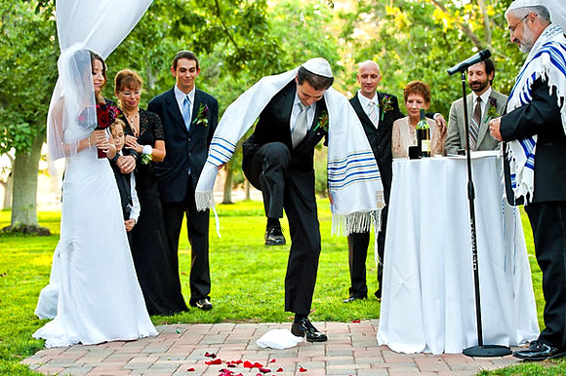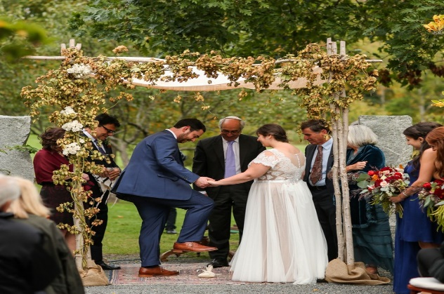
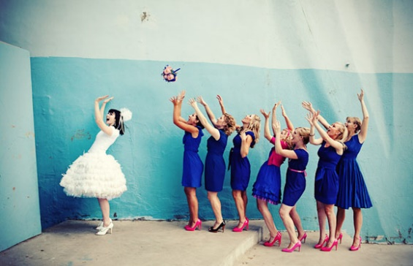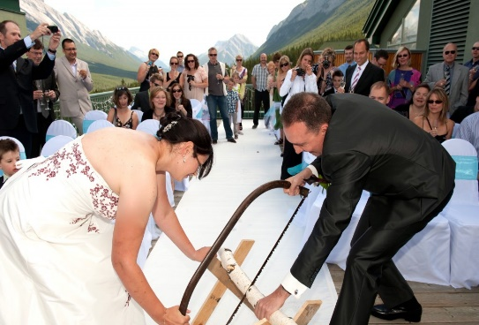

Student Statement:

By submitting this assignment, I confirm that this is my own work.

Student Signature | N.Young | Date | 24/09/2018

For Tutor / Assessor Use Only
Total Marks
Marks Obtained
Percentage / Grade

