
Assignment Cover Sheet

Student Name: | Raymond Wilson
Student Number: | 5297
Course: | Diploma in Risk Management
Assignment No: | 9
Marking Criteria:
We expect the learners to write minimum one well expressed point in three lines against each allocated mark. This means one needs to write 15 lines with 5 well expressed points to get high grades for a 5 marks question.
For high grades use examples and illustrations where appropriate.
Assessment 9 Technology Risk Total Marks: 30

Give short answers for the following questions: (15)

I. What is technology risk?
Technology risks threaten assets and procedures vital to any business in today’s age and these may have a significant impact with regards to compliance with regulations, impact profitability, and damage to a company’s reputation in the marketplace.
Information technology (IT) risk, for example, can be the result of human error, malicious intent, or even compliance regulations. Protecting vital information assets like operational and financial data, customer data, intellectual property, personally identifiable information, or protected health information is almost the norm as businesses are bombarded with attempts to access information kept on line or in other storage “facilities”.

Although many companies have barriers in place to protect them, barriers are often breached, therefore it’s also important to identify and verify events such as data breaches, network failure, electronic fraud, and other suspicious activities before they result in fines and expenses, that damage brands or personal reputation, and prevent companies from reaching their business goals, or even lead to a lawsuit filed in court.
If a business relies on information technology (IT) systems, such as computers and networks, for important business activities they need to be aware of the range and nature of risks to those systems such as;
- hardware and software failure - such as power loss or data corruption
- malware - malicious software designed to disrupt computer operation
- viruses - computer code that can copy itself and spread from one computer to another, often disrupting computer operations
- spam, scams and phishing - unsolicited email that seeks to fool people into revealing personal details or buying fraudulent goods
- human error - incorrect data processing, careless data disposal, or accidental opening of infected email attachments.
On top of the above risks there are of course specific or targeted criminal threats to IT systems and data and these include;
- hackers - people who illegally break into computer systems
- fraud - using a computer to alter data for illegal benefit
- passwords theft - often a target for malicious hackers
- denial-of-service - online attacks that prevent website access for authorised users
- security breaches - includes physical break-ins as well as online intrusion
- staff dishonesty - theft of data or sensitive information, such as customer details.
If the risks already identified are not enough there are natural disasters such as fire, floods and other natural causes to potentially contend with that also present risks to IT systems, data and infrastructure. Damage to buildings and computer hardware can result in loss or corruption of customer records/transactions.
II. Outline the benefits of technology risk management.

For many businesses or organisations today, protecting valuable information from risk is a growing priority. If they want to remain competitive, profitable and trusted by existing (and potential) customers it’s a concern that needs to be taken seriously.
 Information/Technology Risk Management is the solution to managing an organisation’s information risks. It’s a proven process of identifying, understanding and managing the risks that can threaten a business within the context of its business needs. Strong IT Risk Management is an opportunity for the business protect itself and a positive challenge for the management team.
Below is a number of good reasons why a robust Information Risk Management approach makes sound business sense;
- A Vigorous Information Risk Management system brings about competitive advantage through an increase in trust that will improve the company’s reputation in the chosen market place and ultimately provide better sales results.
- Effective Information Risk Management lowers the chances of a damaging information security incident. It will also help a company understand its risks and what is needed to avoid a breach and protect its data accordingly.

- Understanding IT Risk Management gives companies the visibility and confidence to make better business decisions – decisions based on real risk, not rumour or scaremongering.
- Information and Technology Risk Management can save money through more efficient controls, more effective architectures and appropriate levels of protection.
- IT Risk Management includes business continuity even during unforeseen circumstances or emergencies.
- Information Risk Management gives a company full visibility of all its assets. Knowing where the right information is will enable the company to put your hands on the right details fast, faced with any request for information (e.g. HR/legal)
- Understanding and managing your risks brings peace of mind – and entities can be confident that they have taken due care and diligently exercised risk management in accordance with their business needs and requirements.

III. What is ‘intranet’?

This is a network of limited access (that is not available to the world outside of the Intranet). If however the Intranet network is connected to the Internet, the Intranet will reside behind a firewall and, and if it allows access from the Internet, this is called an Extranet. The firewall helps to control access between the Intranet and Internet to permit access to the Intranet only to people who are members of the same company or organization and sometimes with limited access to what is normally available.
In its simplistic form, an Intranet can be set up on a networked PC without any PC on the network having access via the Intranet network to the Internet.
An Intranet system is a restricted version of the internet, that typically does not allow access to anyone outside of its network. An intranet is typically a “local” only network, meaning only people who are directly wired to the intranet can access the information stored on its servers (local in the sense of a company who can be in various countries). Intranets may be used for organizations or networks that do not want their information to be able to be accessed by outside sources, and is especially important for organizations that require a high amount of secrecy - such as a server that holds military secrets or a database for a bank.

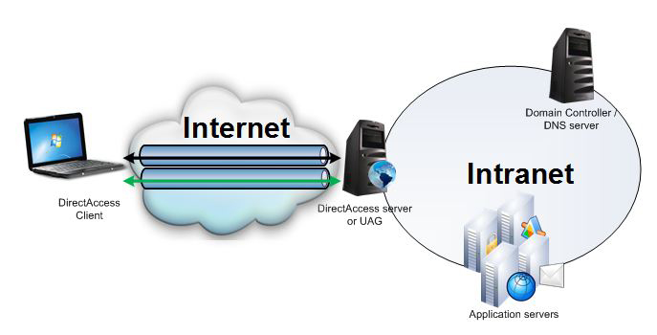

In essence, Intranets are basically mini versions of the internet that connect just a few servers, instead of the countless number of servers that the internet holds and connects with one another.
It’s important to understand that although the terms Internet and Intranet are often used as the most widely used terms (any people think both are similar) there are lots of differences between them as detailed below;
Intranet
1. Intranet is also a network of computers designed for a specific group of users.
2. Intranet can be accessed from Internet but with restrictions.
3. The number of users is limited.
4. The traffic allowed is also limited.
5. Intranet contains only specific group information.
Internet
1. Internet is wide network of computers and is open for all.
2. Internet itself contains a large number of intranets.
3. The number of users who use internet is Unlimited.
4. The Visitors traffic is unlimited.
5. Internet contains different source of information and is available for all.

IV. Define e-commerce.

E-commerce (referred to as electronic commerce or EC) is the buying and selling of goods and services, or the transmitting of funds or data, over an electronic network, primarily the internet. These transactions can happen either as business-to-business, business-to-consumer, consumer-to-consumer or consumer-to-business. It’s worth noting that the terms e-commerce and e-business are often used interchangeably.
The origins of e-commerce go back to the 1960s, when businesses started using Electronic Data Interchange (EDI) to share business documents with other companies and by 1979, the American National Standards Institute developed ASC X12 was adopted as a universal standard for businesses to share documents through electronic networks. Since the 8o’s however the number of individual users sharing electronic documents increased out of all proportion until the 1990’s arrived and the growth of eBay and Amazon revolutionized the e-commerce industry. Consumers today can now purchase endless amounts of items online, both from typical brick and mortar stores with e-commerce capabilities and one another.

 The process of EC is conducted using a variety of applications, such as email, online catalogs and shopping carts, EDI, File Transfer Protocol, and other web services. This practice includes business-to-business activities and outreach such as using email for unsolicited ads (usually viewed or blocked as spam) to consumers and other business prospects, as well as to send out e-newsletters to subscribers. Of course today more and more companies are trying to entice consumers directly online, using tools such as digital coupons, social media marketing and targeted advertisements.
There are some obvious benefits of e-commerce including its around-the-clock availability, the speed of access, the wide availability of goods and services for the consumer, easy accessibility, and international reach. Its apparent downsides though include sometimes-limited customer service, consumers not being able to see or touch a product prior to purchase, and the necessitated wait time for product shipping whereas upon visiting a conventional shop most items can be picked up there and then.

The e-commerce market since the turn of the century continues to grow. In recent years online sales accounted for more than a third of total U.S. retail sales growth and in 2015 alone, according to data from the U.S. Commerce Department, Web related sales totaled $341.7 billion, almost a 15% increase over the previous year.
It remains to be seen ultimately what real affect EC will have on our way of life, especially on the way we shop for goods and food, but what is clear is our lives are changing quickly with the onset of technology. For better or worse? only time will tell.
V. What is ROI? How it is calculated?
Return on investment (ROI) is a means of measuring the gain or loss generated on an investment relative to the amount of money invested. ROI is usually expressed as a percentage, as shown below, and is normally used for personal financial decisions, to compare a company's profitability or to compare the efficiency of different investments.
The return on investment formula is; ROI = (Net Profit / Cost of Investment) x 100
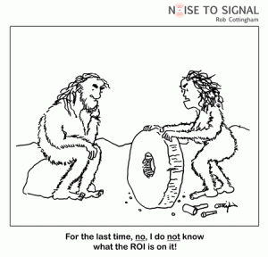The ROI calculation is not hard and fast but flexible and can be manipulated for different uses. A company may use the calculation to compare the ROI on different potential investments, while an investor could use it to calculate a return on a stock. For example, an investor buys $1,000 worth of stocks and sells the shares two years later for $1,200. The net profit from the investment would be $200 and the ROI would be calculated as follows;
ROI = (200 / 1,000) x 100 = 20%
The ROI in the example above would be net 20%. The calculation can be altered to suit individual cases by deducting taxes and fees to get a more accurate picture of the total ROI.
This same calculation can also be used to calculate an investment made by a company or an individual, however, the calculation is more complex because there are more inputs to consider.
Because of its flexibility ROI is one of the most commonly used profitability ratios. There is however one major downside of this formula in as much that the ROI calculation can be manipulated, so results may vary between users. When using ROI to compare investments, it's important to use the same inputs to get an accurate comparison. Also, it's important to note that the basic ROI calculation does not take time into consideration. Obviously, it's more desirable to get a +15% return over one year than it is over two years.
2. Prepare a technology risk management plan for a business. (15)

IT systems are vulnerable to an assortment of disruptions and risks, ranging from slight (power outage, disk drive failure) to severe (equipment destruction, fire). Many of these risks/vulnerabilities may be minimized or altogether eliminated through technical, management, or operational solutions as part of the organization’s risk management effort and as illustrated each “project” can either avoid, mitigate, transfer or accept (or a combination thereof) those risks.
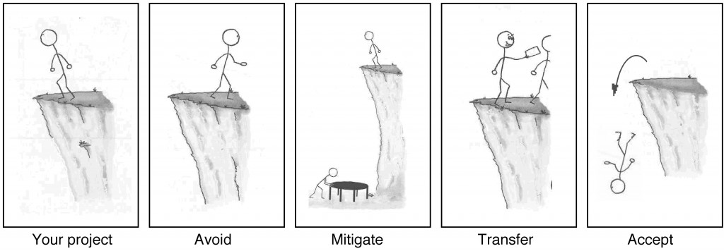
The plan below therefore is designed to avoid, mitigate or transfer the risk of system and service unavailability by focusing on effective and efficient recovery solutions wherever practicable.
To develop and maintain an effective IT Risk Management Plan (ITRMP), the following process approach should be used;
- Develop a planning policy statement
- Conduct a business impact analysis (BIA)
- Identify the preventive controls required
- Develop recovery strategies
- Develop an IT contingency plan
- Plan for testing, training, and exercises
- Plan for maintenance

The risk contingency planning policy statement

To be effective the risk management plan must be based on a clearly defined policy. The first section of any ITRMP is the policy statement. This policy statement should define the organization’s overall risk management contingency objectives, and establish the framework and responsibilities for ITRMP. Key policy elements to include in this section are as follows;
  - Roles and responsibilities
  - Scope (to be applied to the type and organization functions subject to contingency planning)
  - Resource requirements
  - Training requirements
  - Exercise and testing schedules
  - Plan maintenance schedule
  - Regularity of backups and storage of backup media

The Business Impact Analysis (BIA)

The BIA is a key part of an ITRMP as this enables IT departments to identify the system requirements, processes, and interdependencies and use this information to determine requirements and priorities. The main purpose of the BIA is to link specific system parts with the services that they provide. Based on that information, discuss can be had to understand and manage the consequences of a disruption to the system components.

Preventative Controls

There are two types of internal controls: preventative controls and detective controls. Preventative controls are designed to keep errors or irregularities from occurring in the first place. They are built into internal control systems and require a major effort in the initial design and implementation stages. Preventive controls are intended to prevent an incident from occurring e.g. by locking out unauthorized intruders installing anti-virus software.

Recovery Strategy

This section should address the impact that destruction would have, and allowable outage times identified in the BIA section. Several alternatives ought to be considered when developing the strategy, including cost, allowable outage time, security, and integration with larger, organization-level risk management and contingency plans. It is best to list specific recovery methods such as commercial contracts with varying levels of vendors, mobile sites, reciprocal agreements with internal or external organizations, and service level agreements (SLAs) with the equipment vendors.
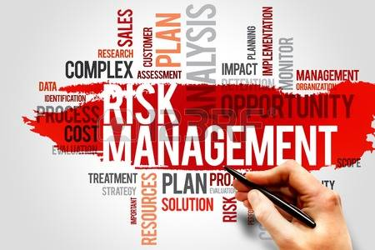

IT Contingency Plan

Detailed roles, responsibilities, teams, and procedures associated with restoring an IT system following a disruption need to be considered and listed here. The contingency section should document the technical capabilities designed to support contingency operations. It clearly differs between companies and can be tailored to any organization and its requirements.
In this segment, the contingency is comprised of five main components;
    - Supporting Information; Guidance in making decisions on how to use the plan, and in providing information on where associated plans and information outside the scope of the plan may be found.
    - Notification/Activation; Use this section to detail the initial actions to take once a system disruption or emergency has been detected or appears to be imminent.
    - Recovery; This component of your plan should focus on measures to execute temporary IT processing capabilities, repair damage to the original system, and restore operational capabilities at the original or new facility.
    - Reconstitution; In the Reconstitution section specify which teams are responsible for restoring or replacing both the site and the IT system.
    - Plan Appendices; Plan appendices should reflect the specific technical, operational, and management contingency requirements of the given system.

Plan Testing, Training, and Exercises

Each ITRMP element should be tested to confirm the accuracy of individual recovery procedures and the overall effectiveness of the plan. This Plan Testing Section will specify how a company would test their ITRMP and should therefore contain the following modules;

    - System recovery on an alternate platform from backup media
    - Coordination among recovery teams
    - Internal and external connectivity
    - System performance using alternate equipment
    - Restoration of normal operation
    - Notification procedures

Training for personnel with contingency plan responsibilities should complement the system testing. By utilizing this training element companies can detail how personnel will be trained and cover areas such as;

    - Purpose of the plan
    - Cross-team coordination and communication
    - Reporting procedures
    - Security requirements
    - Team-specific processes
    - Individual responsibilities

Plan Maintenance

Finally, as with most plans, the ITRMP must be maintained on a regular basis so that it accurately reflects system requirements, procedures, organizational structure, and policies. IT systems undergo frequent changes because of shifting business needs, technology upgrades, or new internal or external policies. Therefore, it is important to review and update your Risk Management Plan regularly.

As a general rule, the plan should be reviewed for accuracy and completeness at least annually, or whenever significant changes occur to any element of the plan which may depend on the dynamics of the business. In this last section of your plan, devise a maintenance schedule to ensure flexibility and scalability.

Student Statement:

By submitting this assignment, I confirm that this is my own work.

Student Signature | Raymond Wilson | Date | 7th May 2017

For Tutor / Assessor Use Only
Total Marks
Marks Obtained
Percentage / Grade

