
Assignment Cover Sheet

Student Name: | Winifred Harewood
Student Number: | 13129
Course: | Diploma in Fashion Design
Assignment NO: | 3

Marking Criteria:
We expect the learners to write minimum one well expressed point in three lines against each allocated mark. This means one needs to write 15 lines with 5 well expressed points to get high grades for a 5 marks question.
For high grades use examples and illustrations where appropriate.
Elements of Design

1. Give short answers for the following questions: (12)
i. How is a formal balance achieved in dress designing?
Formal balance or symmetrical balance is achieved when an object seems equal due to repetition in a design arrangement, e.g., a straight hemline. Both the upper and lower areas of a design must be organized to create a balanced effect, this can be achieved when objects are an exact mirror image of each other or either side of a garment.
ii. How can harmony be created in a design?
Harmony/Unity can be created in a design by using the appropriate degree of contrast between features such as prints, embellishments, and colours that bring disparate parts together to make a cohesive and attractive whole is what harmony is about. It is the relationship between all parts of a whole and is achieved when all design parts are related and arranged in an orderly manner. Unity on a garment will give a sense of appeal and will hold the attention of the observer. Harmony between shape and form – the parts are in scale and the combined proportions look like they belong together and on the figure the garment is covering. The three aspects of design -function, structure and decoration must all correspond with each other in order to achieve harmony on any garment.
iii. What is the relationship between the principles and elements in a design?
The elements of design are what are used to create a composition (lines, shapes, value, etc.), while the principles of design are how the elements are used. A successful design is one that uses the principles of design to arrange the elements of design in a way that creates a desired effect.
iv. Describe at least three ways for creating rhythm in dress designing.
Rhythm is created in designs when all the elements are balanced in frequency, size, direction, or placement. It adds visual appeal to designs by generating a sense of order that draws the eye in. It allows for a touch of sophistication and beauty to be added to designs while also generating visual harmony. Line, pattern, and colour can all be used to achieve rhythm. There are three types of rhythm:
(i) Rhythm by repetition or regular repeats of shapes, buttons, pleats, laces, colour, motifs of design, or pleats. This can be created by having all parts use the same shaped edges such as keeping them all rounded or squared or scalloped.
(ii) Rhythm can be created by progression or by gradation, that is the gradual increase or decrease of similar design elements, e.g., colours may move from light to dark or textures from fine to coarse. Shapes can range from small to large, or vice versa. Lines can range from thin to thick. The gradual changes give continuity while providing a feeling of movement.
(iii) Rhythm by transition is when a curved line guides the eye over an angle. It is the curved lines of transition which result in the eye changing direction gradually, not abruptly. Transitional shapes and lines arc and glide over the figure in a rolling rhythm directing the eye easily and elegantly from one area or direction to another. The absence of abruptness (like that of jagged lines) is created. Transition can be seen and created through dropped shoulder designs, puffed sleeves and cap sleeves. It can also be created using shawls, scarves, ruffles and gathers.

2. What are the principles of design? How do they help a designer analyse the effectiveness of a design? (8)
The five principles of design are: balance, pproportion, emphasis, rhythm, and harmony. The principles of design are concepts used to organize or arrange the structural elements of design. They are guidelines that designers apply to both the garment’s basic structure and its applications. The principles of design are there as a guide for combining the elements (lines, shape, colour, and scale) successfully. If something appears to be wrong with a design, they can then analyse what it could be through awareness of proportion, balance, emphasis, harmony, or repetition.
Activity Find pictures of some dresses from fashion magazines. Describe the beauty of each in terms of line, silhouette, shapes and spaces, colours, and texture (fabric, pattern, and trims) as well as balance, proportion, rhythm, and emphasis. Do all elements and principles work together harmoniously? What elements dominate? Find two garments that you feel are unsuccessful. Analyse them in the same way to discover what element or principle has not been properly used. (10)

Three dresses from Fashion Magazines
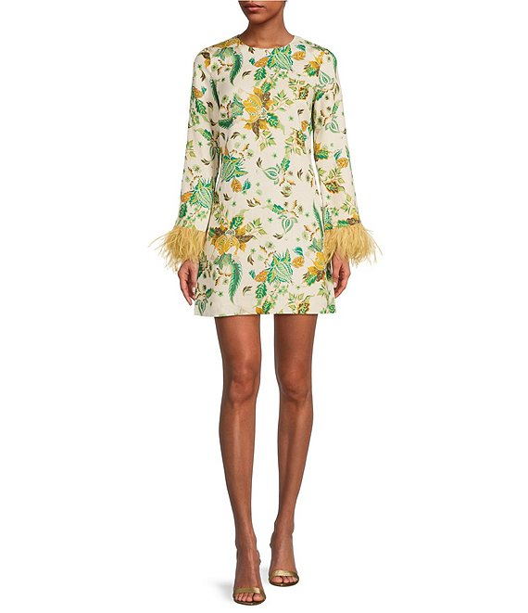
Formal balance the objects on the sleeves are the exact mirror image of each other on either side of the garment.
Emphasis is on the length of the dress which is eye catching.
Harmony, the function, structure, and decoration of the dress correspond with each other.
The height and width of the design seem proportional.
Transitional rhythm the shape of the dress and its lines glide over the figure in a rolling feel directing the eye easily and elegantly from one area the neck to the hemline.
Shape - triangular with a fitted bodice and bell shaped gently widening skirt.

The straight lines of the dress create the illusion of space and emphasize the body angles and offset body roundness.
Space between the neckline and the hemline provides a path of vision along which the eye can travel.
Colour and texture – the colour scheme of white, green, and gold all earthy tones blend and add to the silhouette. The way the dress drapes on the model’s body indicates a soft clingy fabric.
All the elements and principles work together harmoniously.
The elements of lines and shape dominate the design.
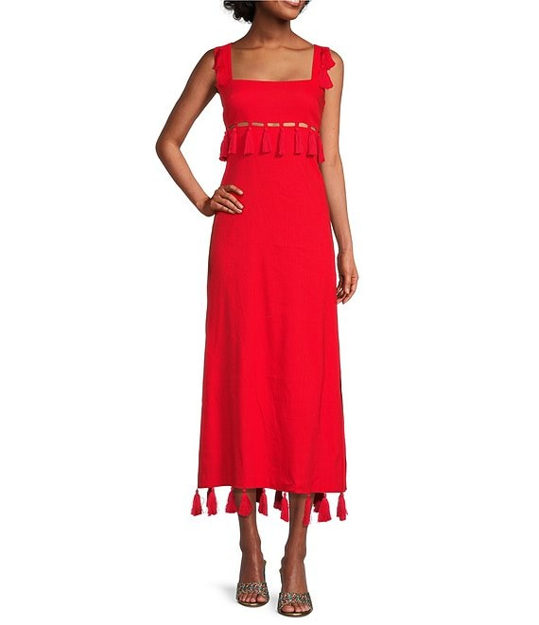 Formal balance the objects on the top and bottom of the suit, the exact mirror image of each other on either side of the garment
Emphasis is on the neckline and fringes on the dress which is eye catching.
Harmony, the function, structure, and decoration of the dress correspond with each other.
The height and width of the design seem proportional.
Rhythm through repetition by both colour and fringes brough continuity in the design
Square shape – straight silhouette with not many curves, shoulders, and hips of similar width, little to no waist definition and very long legs.
The straight lines of the dress create the illusion of space and emphasize the body’s angles and offset body roundness.
Space between the shape of the top and the bottom allows the designer to create emphasis with repetition of colour.
Colour and texture – the colour red is stimulating and lively and adds drama to the design. The way the dress drapes on the model’s body indicates a soft clingy fabric.
All the elements and principles work together harmoniously.
The elements of lines and colour dominate the design.

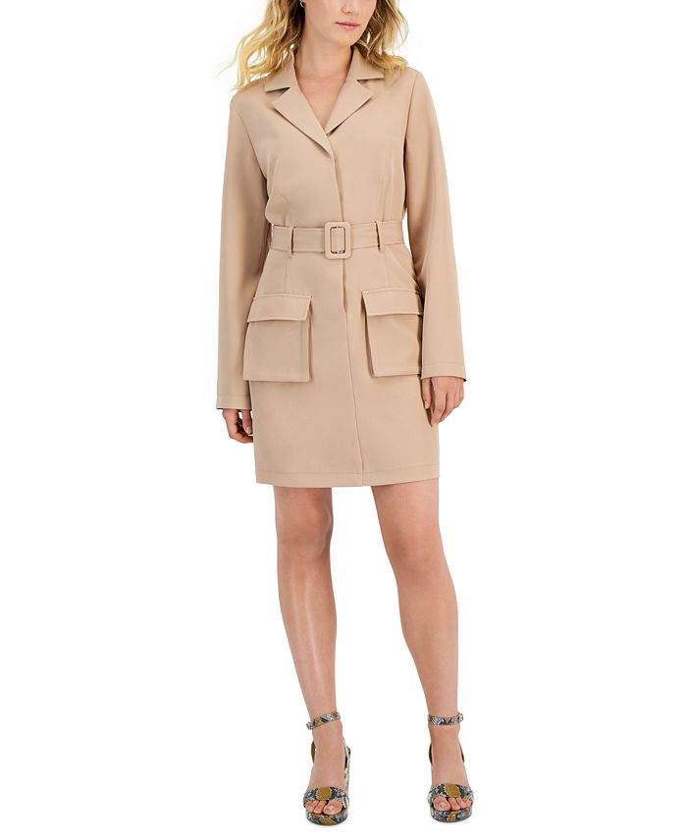
Symmetrical balance the pockets are the exact mirror image of each other on either side of the garment.
Emphasis is on the length of the dress; the center line and the belt are eye catching.
Harmony, the function, structure, and decoration of the dress correspond with each other.
The height and width of the design seem proportional in addition to the size of the pockets which seemed uneven but added interest to the dress.
Progressive rhythm – gradual change in motif from a v neckline with collar to large pockets
Square shape – straight silhouette with not many curves, shoulders, and hips of similar width, little to no waist definition and very long legs
The straight lines of the dress create the illusion of space and emphasize the body angles and offset body roundness.
Space between the neckline and the hemline provides a path of vision along which the eye can travel.
Colour and texture – neutral colour created a smooth background without drawing attention but added to the silhouette. The way the dress drapes on the model’s body indicates a soft but formed fabric, such as linen.
All the elements and principles work together harmoniously.
The elements of colour and shape dominate the design.

Two dresses unsuccessful garments
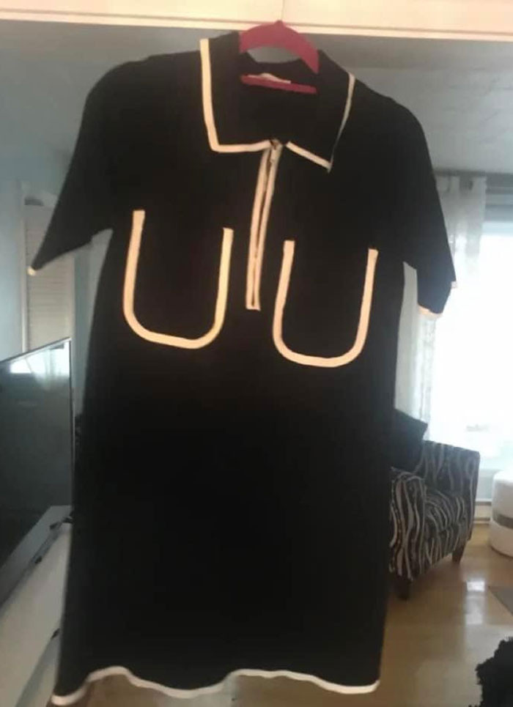
Symmetrical balance the pockets are the exact mirror image of each other on either side of the garment.
Emphasis is on the trimming and pockets are eye catching.
Harmony, the function, structure, and decoration of the dress do not correspond with each other.
The height and width of the design seem proportional however the position of the pockets seemed oddly placed which distracted the design.
Rhythm through repetition by both colour and trimmings attempted to bring brought continuity in the design.
Square shape – straight silhouette with not many curves, shoulders, and hips of similar width, little to no waist definition.
The straight lines of the dress create the illusion of space and emphasize the body angles and offset body roundness.
Space between the neckline and the hemline provides a path of vision along which the eye can travel.
Colour and texture – the neutral colour black created a smooth background without drawing attention but added to the silhouette. The way the dress drapes on the model’s body indicates a soft but formed fabric, such as linen.
The elements and principles do not work together harmoniously.
The elements of lines and colour dominate the design.

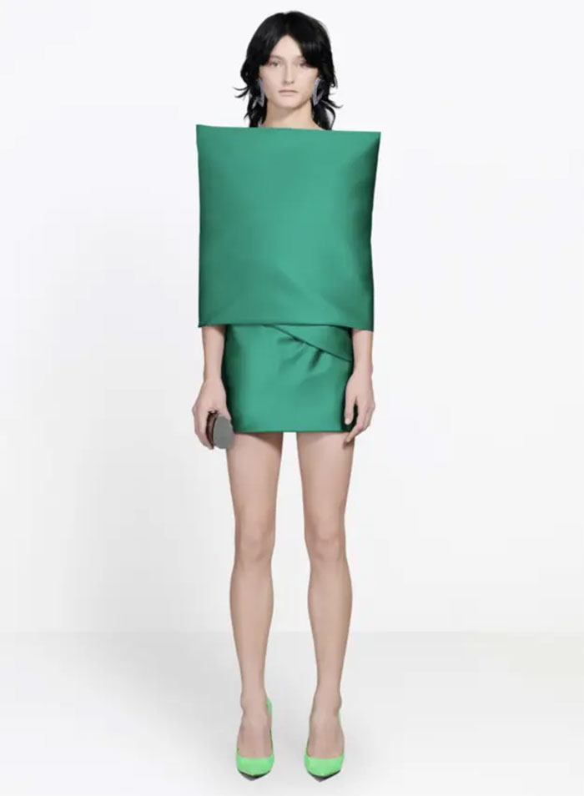
Asymmetrical balance the top of the design is larger than the bottom.
Emphasis is on the length of the dress and the square top with enclosed sleeve which is supposed to be eye catching.
Harmony, the function, structure, and decoration of the dress do not correspond with each other.
The height and width of the design is not too scale and seems restrictive and does not add interest to the dress.
Rhythm through repetition by colour.
Square shape – straight silhouette with not many curves, shoulders, and hips of similar width, little to no waist definition and very long legs
The straight lines of the dress create the illusion of space and emphasize the body angles and offset body roundness.
Space between the top and bottom provides a path of vision along which the eye can travel.
Colour and texture – the colour green is refreshing and attractive. How the dress drapes on the model’s body indicates stuff fabric.
All the elements and principles did not work together harmoniously.
The elements of colour and shape dominate the design.

References:
Dillard's-The Style of Your Life: Official Site of Dillards
Kit & Sky Juniors' Cargo-Pocket Trench Dress - Macy's (macys.com)
https://fashinza.com/fashion-designs/design-trends/what-are-the-most-important-principles-of-design-in-fashion/

The Principles of Design and Their Importance | Toptal®
35 Times Dresses Looked So Bad, They Deserved To Be Shamed On This Facebook Group (New Pics) | Bored Panda
Understanding the Elements & Principles of Design | Liquified Creative
Unit 2 - Elements of Fashion – Diploma in Fashion Design Brentwood College
Unit 3 – Principles of Design – Diploma in Fashion Design Brentwood College

Student Statement:

By submitting this assignment, I confirm that this is my own work.

Student Signature | Winifred Harewood | Date | 05/21/2023

For Tutor / Assessor Use Only
Total Marks
Marks Obtained
Percentage / Grade

