
Assignment Cover Sheet

Student Name: | Vicky Bangay
Student Number: | 11943
Course: | Environmental Management Level 4
Assignment NO: | Unit 4

Marking Criteria:
We expect the learners to write minimum one well expressed point in three lines against each allocated mark. This means one needs to write 15 lines with 5 well expressed points to get high grades for a 5 marks question.
For high grades use examples and illustrations where appropriate.
Answer the following Questions:

- What are the 17 requirements of the ISO 14001:2004 standard? (6)

- Environmental policy: The first step is to create an environment policy. This policy is a statement detailing a company’s commitment to help the environment in its own way depending on the services and activities it carries out.
- Environmental aspects & impacts: Identify the possible aspects and impacts a company will have on the environmental which will be caused by the services and activities it carries out.
- Legal & other requirements: Environmental compliance, highlight the legal requirements a company must follow to prevent them from effecting the environment in any negative way. Some industries have their own environment compliances and policy requirements. Failure to commit to these compliances and break policy can result in large fines or prosecution.
- Objectives & targets: Develop objectives, targets and environmental programs. This allows goals to be set which a company can follow to help them aim to achieve the objectives and targets.
- Structure & responsibilities: Appoint staff members and departments to have individual roles and responsibilities specific to the environmental management system.
- Training, awareness and competence: All staff require training to make them aware of the environmental goals and responsibilities within the company.
- Communications: Processes and rules are to be developed to ensure that all internal and external parties can communicate and are aware on how and why this is important for them to do this.
- EMS documentation: Information about the EMS is to be maintained. This can be done by forms and formats being created specifically for each environment aspect of the EMS. This allows staff to be able to use consistent templates, keeping all information easy to find, use and maintain.
- Document control: Management procedures to control the work flow of documents need to be conducted and developed to ensure a smooth running of the document control process.
- Operational control: Operations and activities carried out by a company must be previously planned and managed in advance to ensure that they are in line with the environmental policy. All objectives and targets need to be preplanned to see that they are met throughout each activity.
- Emergency preparedness & response: In order to prevent environmental emergencies, procedures must be put in place to prepare for such events. This can include appointing people and specialist companies to contact that can respond to any emergencies that may occur and act on the emergency quickly and efficiently.
- Monitoring & measuring: Develop procedures that allows for key activities within a company that have a specific impact on the environment to be monitored and measured.
- Evaluation of compliance: Legal and other requirements such as permits and policies must be evaluated. By developing a procedure to follow it will ensure that these matters will be followed and completed.
- Nonconformance & corrective & preventive action: Past and potential problems must be identified to help correct problems and prevent them from reoccurring again in the future. By evaluating previous mistakes and problems, new systems and procedures can be put in place to prevent them from happening again.
- Records: It is important that records are recorded and kept in an easy and manageable manner as for legal reasons, archives of previous documents and correspondence may need to be referred back to in the future.
- EMS audit: Internal and external audits are needed to ensure that staff members are following and understanding the correct procedure put in place by the EMS, to ensure that goals and objectives are being met.
- Management review: A review of the EMS is needed as goals and objectives throughout the months and years must be amended to suit. Due to the ways that a company operates and products are made and the environment and climate are ever changing, the EMS will never be continuously the same. It will need to be constantly reviewed and edited to meet the needs of the surrounding environment both short and long term.

- Define and explain ISO 14000 in detail. (6)

The ISO 14000 was established in 1947 by a non-government organization located in Geneva Switzerland called “International Organization Standardization.
The organization ISO aims at making the development of goods/products and services around the world safe and clean to prevent as little negative impact on the environment as it possibly can.

The ISO 14000 was created to do just that, designed in a unique way which allows it to be used as a standard document by any organization and business no matter their size, trade, financial income or location.
The ISO 14000 caters for all types of businesses.
It can be described as a standard “template” which must be used and followed by every business.

The primary objective of the ISO 14000 is to promote to all businesses an effective environmental management system.

Standards within the ISO 14000 aim to provide cost effective ways for businesses to make use of the best practices whilst still helping to reduce their carbon footprint. These factors can be:
- Changes and impacts to air, land and water.
- Reducing pollution and waste.
- Comply with environmental laws and regulations.
- Continually improve the above factors.

Like the ISO 9000 series on quality management systems, the ISO 14000 is a guidance widely used and applied for introducing and adopting environmental management systems to companies.

The ISO 14000 is also similar to the ISO 9000 in that both standards focus on how a product is produced (the impacts and effects during production) rather than the product itself.

The ISO 14000 includes the ISO 14001 standard which defines the criteria of the environmental management system. In order for company to receive a ISO 14001 certificate, it must be audited by an external accredited audit body.
As stated in Wikipedia “the ISO 14000 is a practical tool for companies and organizations of all kinds looking to manage their environmental responsibilities.”

- Briefly explain PDCA (PLAN-DO-CHECK-ACT) model. (6)

It is an important task to ensure that the EMS is continuously improved as each aspect of the EMS (from a company’s business structure and methods, to the way it carries out tasks and works) is always changing and improving.
As is the environment it’s self as this too is continuously changing due to global warming and the ways in which it is being used and damaged by humans.

In order to do this, many organizations follow a Plan Do Check Act cycle (PDCA) to help them continuous improve the EMS.
This cycle is a good method to use as it instructs the creation of an environmental policy, plans the EMS and then implements it. It also ensures that a checking system is put in place as well as acting on the findings of the checks carried out.
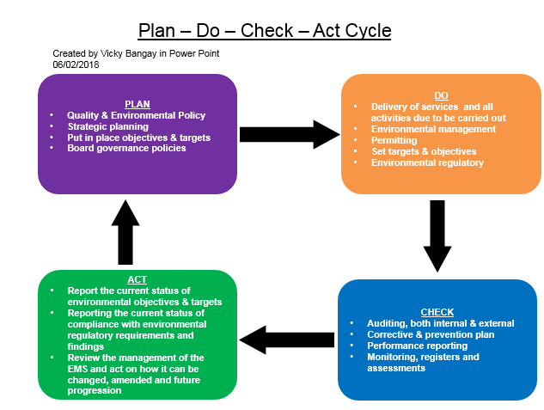

The steps of the cycle above are to:
- Identify the environmental impacts that can be affected and create an environmental policy which is specific to the task or activity towards that impact. Many of these can be created for one organization as each policy is specific to each part of the business. These policies are commitments to the environment by the company which everyone must follow. Failing this could lead to negative actions such as court cases, fines, disciplinary or sentencing.
- Targets and goals must then be created to ensure that the environmental policies are followed and all objectives are possible for the company to achieve.
- A checking system is then put in place to ensure that everyone is following the objectives and that the set goals and targets are being met. This can be done by having an audit system monitor these on a regular basis. It is important that management of this is undertaken to ensure that it is being continuously established and improved.
- Once the results from the checking system have been audited and collated, this information can then be used to help improve the EMS even further and amend it to cater for any future activities. It can also be improved to suit the environment as climate change is continuously changing our environments, eco systems, air, oceans, soils etc so organizations need to recognize this and keep on top of utilizing the environment in a positive and ecofriendly way to ensure that a sustainable environment is possible for everyone.

- Draw and explain Environmental Valuation Methods. (6)

Environmental Valuation is the process of putting a money value (an amount worth) on environmental good and services.

The purpose of environmental goods and services is to prevent, reduce and eliminate pollution and any other form of environmental degradation. It is to conserve and maintain the stock of natural resources (water, wood, coal, oil, gases etc.) preventing them from depletion.

Direct environmental goods and services can include the following factors:
- Scenic views
- Coral reefs
- Mountains
- Animal and plant species (the biodiversity)

Indirect environmental goods and services can include the following factors:
- Water supply
- Carbon sequestration
- Erosion control
- Forests
- Ecosystems and conservation
- The maintenance of these goods and services

Environmental resources such as land, wood, water, air, oil, coal will have a money value of what it is worth. This money value is set on how it benefits an individual or the society.

To use a coastal area as an example of environmental valuation, the direct benefits of a coastal/beach area will be:
- Scenic views, pretty landscapes, sunsets
- Beaches are popular areas for holiday makers
- Tourists providing potential profit for local businesses
- Fish and other edible sea creatures providing food consumers
- Recreation activities and hobbies such as relaxing, surfing, swimming, bird and whale watching.
- Wildlife will attract tourists to the area. Birds, Sea mammals and creatures (whales, seals, crabs, fish, etc)

The indirect benefits of a coastal/beach area will be:
- Climate moderation
- The physical protection of the area and its wildlife
- Does or can it develop a sustainable future or have positivity’s for the next generation
- Maintaining the area and its environmental materials and resources

The environment is valued on the assumption on what people are willing to pay for it. This value is based on both the environmental gains and also any potential losses caused by the environment (weather, climate change, erosion to land, specials decline or incline, natural biodiversity change).
To achieve a value, an individual must assess and demonstrate these preferences and place a money value on all the environmental resources relating to both the direct and indirect benefits.

Different techniques of environmental valuation include:
- Hedonic pricing – Where the price of a good is directly influenced by environmental factors. (Type of land such as waste or residential, water supply, land quality). It can also be applied to the valuation of external benefits.
- Travel costs method – This method is suited for placing a value on natural resources, amenities, parks, hunting, fishing, wildlife watching sites and cultural heritage sites. It is based on the concept that if people travel to site, then their willingness to pay for visiting this site must be at least as large as the travel cost incurred.
- Contingent valuation method – Is the only method that takes into account non-use values. This means values can be over or under estimated. It asks how much an individual is willing to pay for the use of conservation of natural goods.
- Production factor method – This method is based on the natural resources used as production factors. It tries to value natural qualities by valuing their impacts on production costs. (Water effects to agriculture for example, air quality, fishery and the impacts these have on buildings and livestock)
- Averting behavior method – Expenditures made to advert or mitigate negative effects from the reduction of a natural quality. Using climate change as examples, individuals paying not to help the environment, but to prevent the present environment such as buying hats, sun cream to prevent damage to their health.

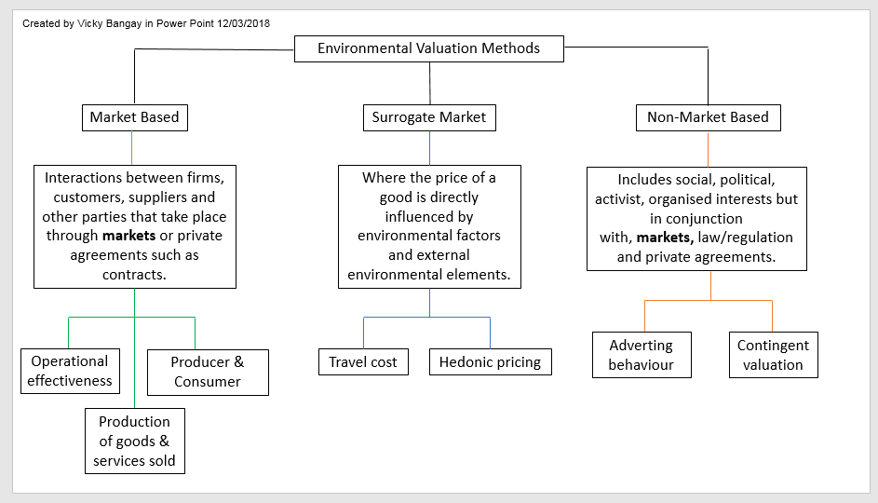

5. What are various forms of environmental accounting? (6)

Businesses have now become aware of their surrounding environments and the impacts in which they can have on it, both positively and negatively.
The growth of this awareness has put a value on the world which has brought attention to both the public and industries the potential problems they are causing to the environment.
Businesses need to consider their lasting impact and footprint that they have on the environment and are now doing this in an economically feasible and financially beneficial way, as well still being ecological and sociable.
Environmental accounting is responsible for a business’s economic sustainability, renewable resources/materials, workforce/staff and global opportunities.
Breaking environmental laws can result in large fines, court cases, prosecution, loss of public relations and reputation. These can all effect profit margins in a single mistake or audit.

Environmental Management Accounting - This method of accounting allows a business to see the impact it is having on its ecological sustainability, everything from their supply chain to facility expansion. (i.e. materials, energy, environmental costs). It can allow a business to accurately trace environmental costs back to a specific event or activity.
This type of accounting can be sectioned down into 3 subsystems:

- Segment Environmental Accounting – Is an accounting tool used internally within a business to evaluate investments of environmental effect to a particular event, activity or period of time.
- Eco Balance Environmental Accounting – Is an accounting tool used internally within a business to support the sustainable environmental management activities which are monitored by the PDCA (Plan Do Check Act Cycle).
- Corporate Environmental Accounting – This is a tool used to inform the public of the businesses conservation information and events relating to their environmental accounting.

Environmental Financial Accounting (EFA) – Reports on the environmental; transactions and events that will or can have an effect on the company’s finances. This method of accounting specifically focuses on environmental liability costs and other environmental costs.

Environmental National Accounting (ENA) – This refers to accounts on a national scale throughout the country and focuses on external environmental costs of a business’s flow of natural resources/materials, the exchanges of these materials within the economy and the returns of wastes and pollutants to the environment.
By monitoring these flows using national accounting it ensures that a business is following its environmental responsibilities asked of them.
These responsibilities are as follows, Corporate Environmental Responsibility (CER):
- Ensure that any waste generated is stored correctly and recycled where possible and all hazardous waste is described and disposed of correctly.
- Take steps to ensure that the business’s activities and functions do not harm or cause damage the environment. If this does occur then remedial action must be taken to repair the environment.
- Ensure that a business does not cause nuisance that can affect someone’s health or annoy local residents. i.e. Noise, smoke, fumes, gases, dust, odor, light or rubbish.
- Comply with legislation regarding emissions in the air. Take action to help clean up current pollution and help to prevent further pollution in the future.
- Business’s operating near protective areas need to be aware of their responsibilities for conservation and protecting biodiversity. Not only to forestry and farming industries but also offices, factories and other businesses based on or near areas. 3
- Promote their company having a positive attitude towards the environment. Certain information such as a business’s waste generation amount and waste disposal methods can be disclosed to provide evidence of this, and costs.

Student Statement:

By submitting this assignment, I confirm that this is my own work.

Student Signature | Vicky Bangay | Date | 19/03/2018

For Tutor / Assessor Use Only
Total Marks
Marks Obtained
Percentage / Grade

