
Assignment Cover Sheet

Student Name: | Dee Eve Ndombele
Student Number: | 27626
Course: | Certificate in Fashion design Level 2
Assignment NO: | No.1

Marking Criteria:
We expect the learners to write minimum one well expressed point in three lines against each allocated mark. This means one needs to write 15 lines with 5 well expressed points to get high grades for a 5 marks question.
For high grades use examples and illustrations where appropriate.
Please insert your completed assignment ( in word format) here:

- During the First World War times fashion was an influential era for new trends, new markets and new products that attracted certain kind of group towards Men and Women all over the world, which included America and Europe. Throughout our lives the clothing we wear changes, from diapers or pyjamas as infants, to a school uniform and then also upon starting a job and getting promoted, even death has a special wardrobe in our society, both for the dead and the mourners. Clothing also helps to establish a person’s identity, which reflects the wearer’s goals and moral principles in life. Plus the changes that were brought by fashion designers from France, Italy and other Europeans countries that was accepted to bring in new unique fashion trends towards the fashion market.

- The characteristics features in the 20th century fashion scheme were due to lacking time, money and other interest to devote in fashion leadership. They all need a period of exposure to new styles before accepting them. Also they wanted to keep up with their neighbours or peers group or want to be accepted by them. Because of the abundance of fashion followers, the fashion industry mainly consists of copyists or adapters. A pattern maker is a person who drafts the shapes and sizes of garments pieces with paper and measuring tools, occasionally an Auto CAD computer software programme, or by draping muslin on a dress form way to create the garment. A tailor is a person who makes custom designed garments crafted perfectly to the clients’ measure for e.g. suits, coats, jackets, trousers and skirts. A textile designer is a person who creates or designs fabric weaves and used for clothes and furnishings.

The 19th century influences the fashion industry by having fashion shows, trends, collection that can capture people’s attention. This was the main activities and attention that the fashion industry had an influence towards people back in the 19th century by spreading the latest gossip, news and current fashion trend going around. It was known in special occasional events such as; Wedding, funerals, social events etc. The major changes that came in the fashion industry during the early 19th century are people in the fashion industry were using the term word of ‘Chic’ that means smart or stylish in French language. It was often used to describe a clothing garment or outfit for French fashion. Plus it has been applied to a wide variety of things such as social events, situations, individuals, and models and models or styles of dress. Also another major change in the fashion industry were some trend watchers use a pyramid shape to represent the dynamics of fashion, each level of the pyramid represents a status level in society. Some theories say that fashion is first worn by the highly visible elite of celebrities, models and then moves down the pyramid for ordinary people. The acceptance or rejection by consumers forms a feedback loop between the fashion industry and the consumer. This loop allows the two parties to communicate and is controlled by trends and the social psychological processes of consumers.

- The works of the two main fashion designers such as;
Sonia Rykiel who was known to design her fluid knitted garments, dark blacks, rhinestones, long boa like scarves and little crocheted fashionable hats during the 1970s era. Also Laura Ashley who was another well known fashion designer during the 1970s has created some nice, unique, lots of floral garments clothing such as; long flounced skirts and high necked blouses in traditional floral prints that was worn with crocheted shawls.

Activity
The modern fashion dresses differ from the 1960s fashion era were very hippy, fun and stylish during the 1960s era it was introduced to many style influence and trend such as; Jackie Kennedy, Twiggy and The Beatles that were bringing the fashion world into everyone’s attention style, sleek, patterns, bright wild colours and modern looks into their clothing outfits garments collection. From the past the 1960s decade of the modern fashion dresses has definitely changed so much and evolved itself comparing to the modern current fashion season trend. Women and Men tend to still embrace the same kind of style that looks more updated, fresh and modernize vibe at this moment. The 20th century times the fashion market are looking at towards a different direction for success and recognition.
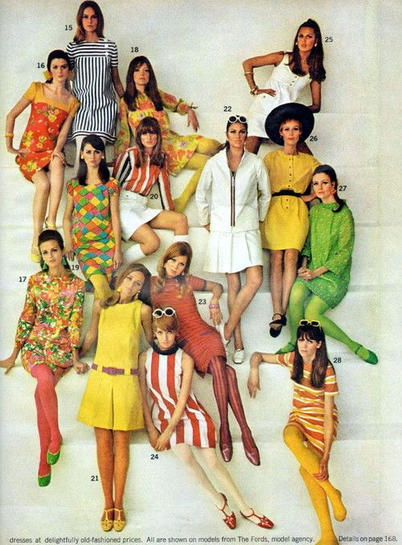
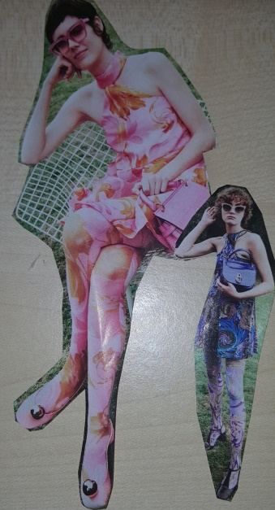
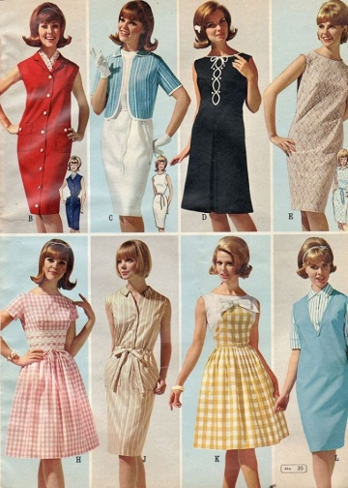

Student Statement:

By submitting this assignment, I confirm that this is my own work.

Student Signature | Dee Eve | Date | 29/01/2019

For Tutor / Assessor Use Only
Total Marks
Marks Obtained
Percentage / Grade

