
Assignment Cover Sheet

Student Name: | Charlene Christiani
Student Number: | 8436
Course: | Diploma in Hotel Management
Assignment NO: | 10

Marking Criteria:
We expect the learners to write minimum one well expressed point in three lines against each allocated mark. This means one needs to write 15 lines with 5 well expressed points to get high grades for a 5 marks question.
For high grades use examples and illustrations where appropriate.
Unit 10
Accounting in Hospitality
Assignment #10
- Give short answers to the following questions:

- Outline the basic principles of accounting.
The basic principles of accounting are;
- The amount paid to the hotel by the guest is added in the debit column. Hence, a debit (dr.) is money owed to the hotel by the guest.
- Any money obtained from the guest is added in the credit column. Hence a credit is money, including deposits made in advance, paid by the guest to settle their bills.
- The balance column shows a continuous difference between credits and debits calculated on of the premise “prior balance + debits – credits = net outstanding balance.” This ideology is applied to every folio/bill in which all cash and credit transactions are noted for every hotel resident guest that add to or reduce the balance of a given guest. It is also known as a “guest account card.” Some hotels refer to it as the Guest Weekly Bill. The debit transactions are noted on the left-hand side of the folio and credits are noted to the right. The remaining balance is determined by subtracting the right from the left.
- What is a guest ledger? Which type of information does it contain?
Guest Ledger (transient Ledger) Front office Ledger/ and the Room Ledger- is the sum set of all folio accounts of registered guests at the hotel. It contains information pertaining to all folio accounts (e.g. house account, guest account and master account) of registered guests at the hotel. It also provides information such as;
- Total number of guests in the hotel
- Total number of guest expected to check out from the hotel
- Total number of guests reserved for the current day
- Total number of guests checked out on the current day
- Which type of information is contained in a city ledger?
The city ledger (Non- Guest Ledger). This records every account that does not belong to a resident guest, however at check-out time, if a resident guest’s account remaining balance is not brought to zero, it will, then, be switched from the Guest Ledger to the City Ledger. Information included in the city ledger are;
- Credit card payment accounts
- Direct billing accounts {guests’ whose bill will be settled by the company}
- Airlines
- Travel agencies
- Skipper’s Account
- Bad cheques account {Bounced cheques of guests}
- Disputed bills account
- Retention charges account from DNA guests
- What are the typical transactions that businesses undertake?
Regardless of the way a business is run, whether it is a sole trader, company, or partnership, it will still go through all of the same kinds of transactions.
Generally, these transactions include the following;
- Making sales - selling goods or services to customers
- Buying raw materials or goods to resell
- Carrying out payments
- Receiving payment - receipts - in return for goods and services
- Paying money into and withdrawing cash from bank
- Paying payroll expenses, such as, wages and salaries to workers
- Paying the owners (either as drawings or dividends).
- Describe profit and loss accounts.
The profit and loss account forms part of a business financial statements. It summarizes the trading results of a business over a period of time (typically a year). The profit and loss account only show ‘revenue’ transactions that are connected with the commercial activity of the business.
The trading account.
The top section of the profit and loss account up to and including the gross profit, is referred to as the trading account. This is because it shows only the direct trading activities of the business.
Sales
At the top of the trading account is the sales figure- this will include all of the work invoiced, whether the invoice has been physically paid by the customer or not. It may even include work the business has undertaken but not yet completed, depending on if you provide services and the particular circumstances they are provided under.
Cost of sales
Represents the costs incurred o generate sales. Any invoices for goods or services that the business received from their suppliers will be included, whether they have been paid or not. Cost of sales also includes any adjustments made for stock. The stock adjustment excludes the stock at the period end and includes the stock brought forward from the last period. This ensures that only the stock purchases used for the current period’s sales are reflected.
Gross profit and the gross profit margin
Gross profit is simply the difference between the businesses’ sales and cost of sales. It shows the sales mark-up and can therefore highlight inefficiencies and pricing issues.

Administrative expenses.
Administrative expenses are the business overheads. Wages can be included under this heading, or maybe reflected under cost of sales.

Example of a profit and loss account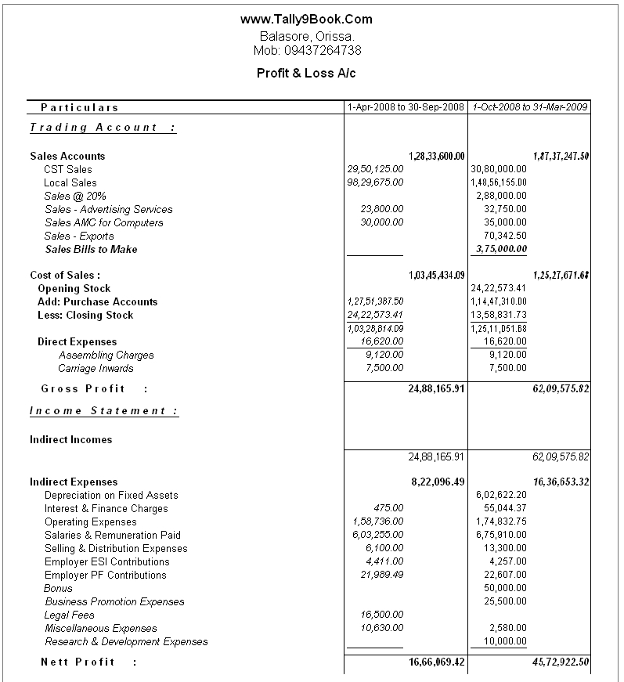

- What is petty cash? How is it recorded?
Petty cash is a supply of cash that is kept on a business premises, that is used to make small payments, for small items of expense in the form of notes and coins.
The petty cash is handed over to each shift, to the oncoming receptionist/cashier.
Example of how petty cash is usually recorded.
Note* A record of petty cash only shows each transaction corroborated with a receipt and a continuously decreasing cash balance, e.g.
Petty cash analysis for the month of November, with an imprest amount of $400.00
Date | Supplier | Amount /(expense) | Balance
20th.Nov. 2017 |  |  | $400
20th. Nov. 2017 | Crystal’s gift shop (pens and stamp books) | $50 | $350
25th.nov. 2017 | Travel expense of employee on official business (travel company) | $35 | $315

- What is a balance sheet?
A balance sheet is a detailed document, that displays the business’ financial standing at a given point in time. It is created at the end of the financial year, by an accountant. It is linked to the financial position on the date upon which the books are closed. The balance sheet shows exactly how the business stands. It demonstrates the balance between total assets and liabilities of the business and its net value.
Example of a balance sheet

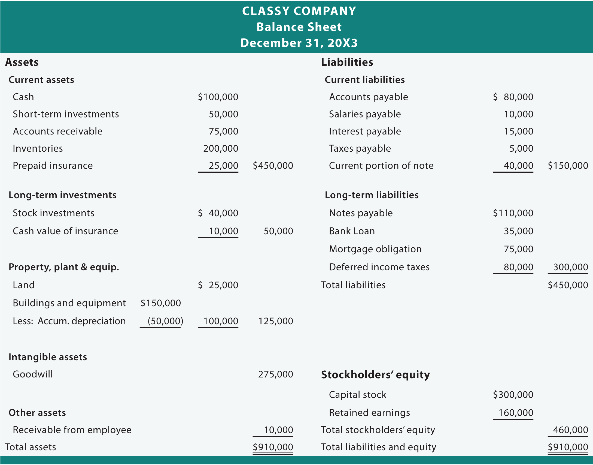

Question 2. Discuss the different types of accounts that are dealt with at a hotel’s front office.
There are two main types of accounts that are dealt with at the front office, the Guest Accounts and the Non- Guest Accounts. At times a third type of account is dealt with at the front desk, known as a Management Account.
- Guest Accounts- a guest account is a detailed financial transaction record taking place between the guest and the hotel. These accounts are established when guests confirm their reservations or when they register at the front desk. This account is maintained by the front desk, as it is their duty to request payment for any outstanding bills. Depending on the circumstances, the front office may require guest to make full or partial payments on to their account, this may be the case in situations where the hotel has established a house limit and it is been enforced because of overbooking, etc.
- Non- Guest Accounts/House Accounts/City Accounts- a hotel can extend in-house limits to local establishments or agencies, or groups sponsoring meetings as a way to promote itself. The front office will make non-guest accounts to keep track of such transactions. Non-guest accounts are established when guests fail to settle accounts at departure time. When the status of a guest changes to a non-guest, the obligation of the account settlement goes from the front office to the back office (accounts department). Unlike guest accounts, which are noted on a daily basis, non-guest accounts are usually billed in monthly cycles by the accounting department of the hotel.
- Management Account- Some hotels allow the managers to entertain the guests’ queries or grievances, or any possibility of acquiring a business deal over a brief interaction with the guests. For example, if a guest has some problem about the hotel policy, the manager calls the guest for interaction over a coffee or a drink and tries to resolve the same. The expenses towards this interaction are then recorded on the management account.

Student Statement:

By submitting this assignment, I confirm that this is my own work.

Student Signature | Charlene Christiani | Date | 5th. December. 2017

For Tutor / Assessor Use Only
Total Marks
Marks Obtained
Percentage / Grade

