
Assignment Cover Sheet

Student Name: | Amritpal Kaur
Student Number: | 24525
Course: | Human resource management level 5
Assignment NO: | 9

Marking Criteria:
We expect the learners to write minimum one well expressed point in three lines against each allocated mark. This means one needs to write 15 lines with 5 well expressed points to get high grades for a 5 marks question.
For high grades use examples and illustrations where appropriate.
Health, Safety and Welfare
Assessment 9

What are the main purposes of Health and Safety at Work Act?

The main purpose of having a Health and Safety at Work Act is to regulate workplace health, safety, and welfare. It aims to protect people from the risk of injury or ill health by the flowing means
- Ensuring employees’ health, safety, and welfare at work.
- Protecting non-employees against the health and safety risks arising from work activities
- Controlling the keeping and use of explosive or highly flammable or dangerous substances.
The Health and Safety at Work Act 1974 applies (with a few exceptions) to everyone “at work”.

As well as placing duties on employers, the Health and Safety at Work Act also:
- Provides for health and safety regulations and codes of practice to be made; and
- Gives the Health and Safety Executive (HSE) or local authority inspectors permission to enforce health and safety laws.
Under the Act, inspectors are given extensive investigative powers and can:
- Serve enforcement notices in the form of prohibition and improvement notices; and
- Bring prosecutions for health and safety offences.

Outline the benefits of health and safety at workplace.
- Effective health and safety practices help you protect your staff from injury.
- Reduces absences and sick leave. Another benefit of good health and safety measures at work is that employees are less likely to take sick leave.
- Retain staff
- Reputation
- Productivity and profits. ...
- Save insurance and legal costs. ...

What is risk assessment about?
Risk assessment is the evaluation of the possible risks in a product, situation, activity or course of action
Risks are inevitable and organizations have a moral and legal obligation to attend to the safety and well-being of those they serve, those who work for them and others who come in to contact with their operations. This is known as "Duty of Care."
Organizations need to look at all the risks throughout their entire operation and incorporate risk management/Assessments into all planning and decision-making.

Diagram of risk management process
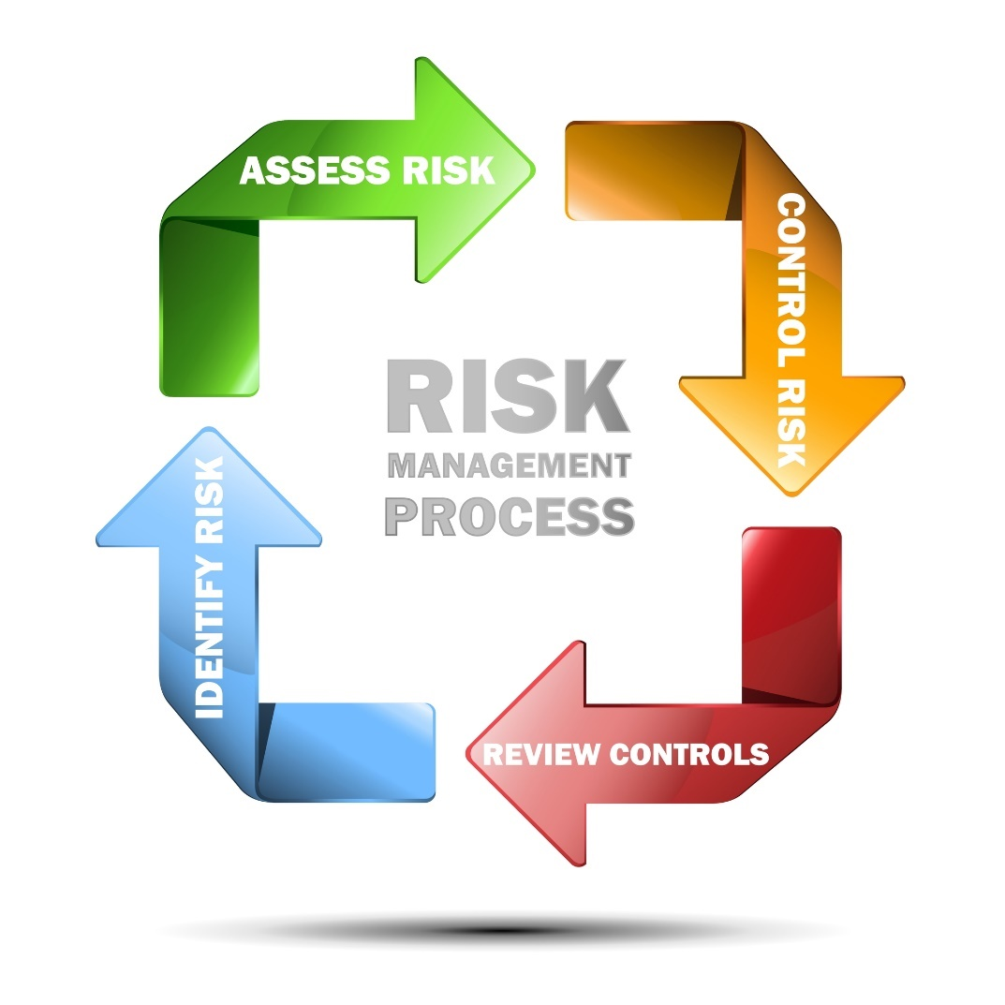

What are the different types of risk assessment?

Qualitative risk assessment
The qualitative risk assessment> is the most common form of risk assessment. You will often see this type of risk assessment in workplaces. It is based on the personal judgement and expertise of the assessor.
Quantitative risk assessment
The quantitative risk assessment is used to measure risk by assigning a numerical value. This type of risk assessment will more likely be used with major hazards, like aircraft design, complex chemical or nuclear plants.
Quantitative measured could be the presence of hazards from chemicals or machinery.
Generic risk assessment
Generic risk assessments cover common hazards for a task or activity. The idea behind generic risk assessment is to cut down on duplication of effort and paperwork. This type of risk assessment will consider the hazards for an activity in a single assessment, where that activity may be carried out across different areas of the workplace or different sites.
The Management of Health and Safety at Work Regulations (1999) require employers to carry out an assessment of the risks arising from their work activities.

A site-specific risk Assessment
A site-specific risk assessment is a risk assessment that has been completed for a specific item of work, that takes account of the site-location, environment, and people doing the work.
Dynamic risk assessment
A dynamic risk assessment is a process of assessing risk in an on the spot situation. This type of risk assessment is often used to cope with unknown risks and handling uncertainty. It might be used by the emergency services, or care workers for example, who need to deal with developing and changing situations.

What is Health and Safety audit?
A health and safety audit are an expert assessment of an organisation’s health and safety policies, systems, and procedures
A safety audit is a structured process whereby information is collected relating to the efficiency, effectiveness, and reliability of a company's total health and safety management system.
Safety audits serve two broad purposes:

- They are routinely conducted to determine whether the company follows safety legislation. These can be performed by representatives of a regulatory body or by the company itself.

- They are used to identify weaknesses in their safety programs and processes. These audits are then used as a guide for designing safety plans or to identify corrective actions that should be undertaken.

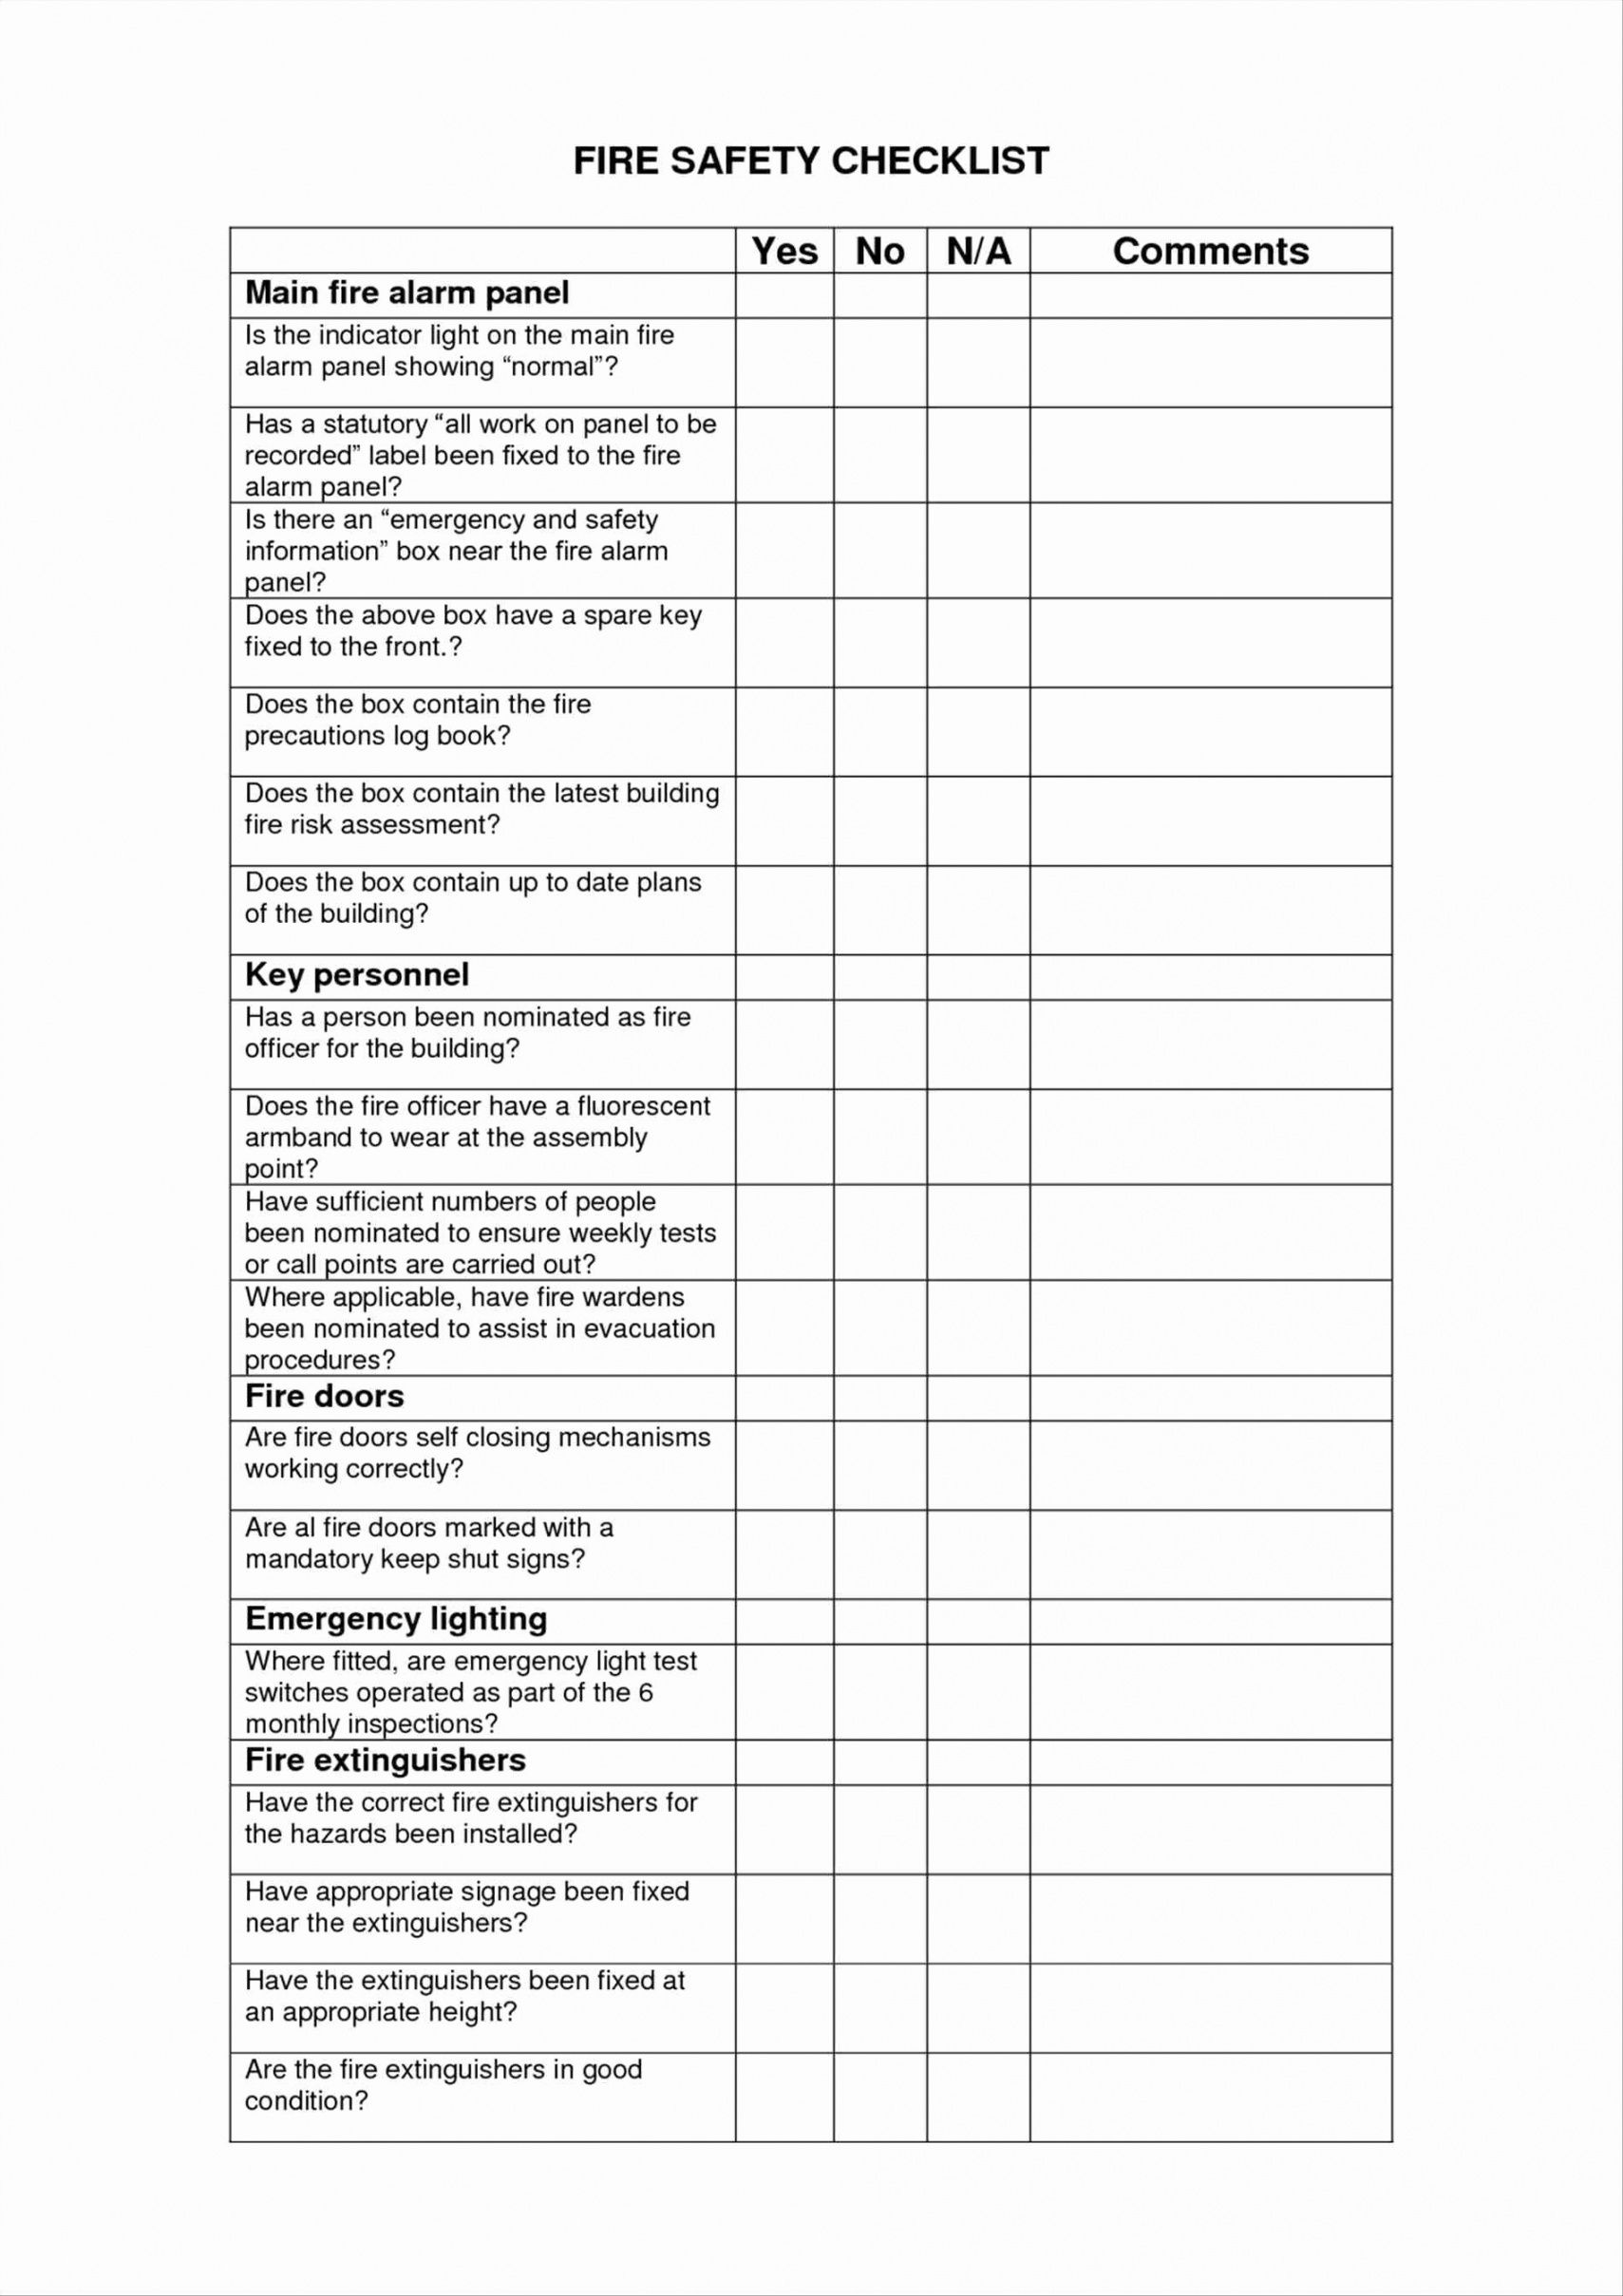
Example of a Fire safety Audit

Discuss different approaches that employers can adopt to help employees manage stress

The following are different strategies which employers can use to manage stress of their employees
- Encouraging more of organizational communication with the employees so that there is no role ambiguity/conflict. Effective communication can also change employee views. Managers can use better signs and symbols which are not misinterpreted by the employees.
- Encourage employees’ participation in decision-making. This will reduce role stress.
- Grant the employee’s greater independence, meaningful and timely feedback, and greater responsibility.
- The organizational goals should be realistic, stimulating, and. The employees must be given feedback on how well they are heading towards these goals.
- Encourage decentralization.
- Have a fair and just distribution of incentives and salary structure.
- Promote job rotation and job enrichment.
- Create a just and safe working environment.
  - Have effective hiring and orientation procedure.
  - Appreciate the employees on accomplishing and over-exceeding their targets.

Individual strategies for managing stress
- The employees should make a “to-do” list daily, prioritize the acts in the list. Take regular breaks during work to relax you. By effective time management, the employees can achieve their targets timely and can meet work pressures and, thus, avoid stress.
- Do hard work. Strive to achieve your goals but do not do it to the harm of family, health, or peer.
- Indulge in physical exercises. It helps in effective blood circulation, keeps you fit, diverts mind from work pressures.
- Encourage a healthy lifestyle. Take a regular sleep, have plenty of water, have healthy eating habits. Promote relaxation techniques such as yoga, listening music and meditation.
- The employees should have optimistic approach about their work. They should avoid connections with negative approach employees.
- The employees should have emotional intelligence at workplace. They should have self-awareness, self-confidence, and self-control at workplace.
- The employees should build social support. They should have close connections with trustworthy peer who can listen to their problems and boost their confidence level. This social network will help the employees to overcome stress.
- Employee counselling is a particularly good strategy to overcome employee stress. Through counselling, employees can become aware of their strengths and how to develop those strengths; their weaknesses and how to eliminate them; and they can develop strategies for changing their behavior. Employees are also given career counselling which helps in reducing their ambiguities regarding career.
- Find a fun way to release stress, such as, cracking jokes, playing tennis, golf, etc.
- Do not remain pre-occupied with yourself. Turn your focus outwards. Help others. This will release some stress.

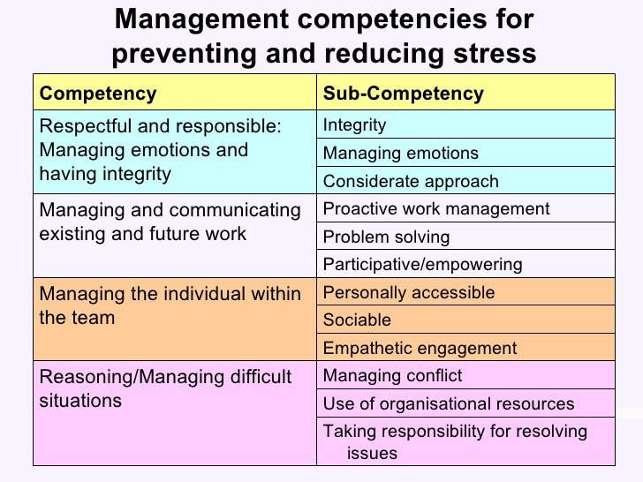

References
Emma Donaldson >Affinity health at work
Ellie Whittam >keeping you compliant

Student Statement:

By submitting this assignment, I confirm that this is my own work.

Student Signature | Amritpal Kaur | Date | 23/09/20

For Tutor / Assessor Use Only
Total Marks
Marks Obtained
Percentage / Grade

