
Assignment Cover Sheet

Student Name: | Andrei-Silviu Piciu
Student Number: | 26610
Course: | Construction Site Organisation and Management
Assignment NO: | 1

Marking Criteria:
We expect the learners to write minimum one well expressed point in three lines against each allocated mark. This means one needs to write 15 lines with 5 well expressed points to get high grades for a 5 marks question.
For high grades use examples and illustrations where appropriate.
1.
i. Site organisation is a detailed and well-thought-out process that ensures the entire safety and the healthy of the entire site. It also ensure efficient construction.

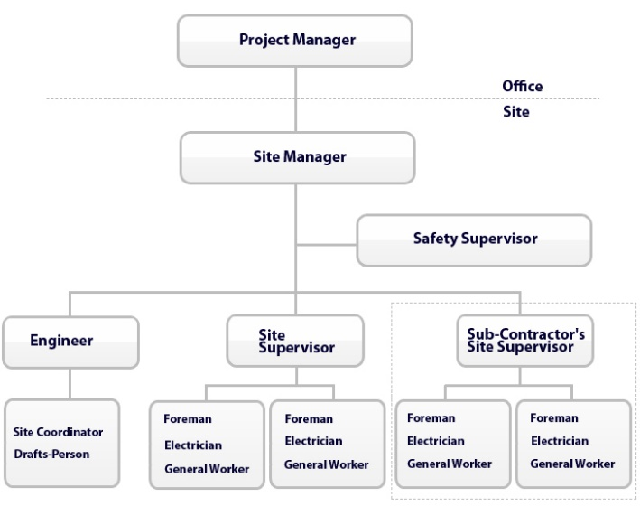

ii. The importance of preparing the site road is to prevent potholes and ditches from developing and damaging vehicles.

iii. Precaution which should be taken for the storage of cement:
1. The building must have adequate ventilation to prevent dampness.
2. Cement should be stack on wooden planks having a gap of 150-200mm from the floor.
3. Minimum space between the walls and the stacks should be 450mm.
4. The cement bags must be packed together to reduce circulation of air within a stack
5. To prevent lumping under pressure a stack of cement should be: width of 4 bags and height of 15bags

iv. Coat steel with cement wash before stacking to prevent scaling and rusting of structural and reinforcing steel.
v. Heavy Traffic Barriers are protecting the site of vandalism or sabotage
Traffic lights giving the warning signal when the barriers are lifting so is a good control to check the vehicle which are leaving the site.
Cards and human advisory are used to control who is access and leaving the site.

2.
The advantages of providing a fence are those that can provide a protection measure for the site. The fence serves towing functions: outline the site boundary and provide protection against loss and theft. Fencing can be constructed to provide physical restraint and also as visual barriers during open work.

3.
The site electricity is different than a building electricity because the electrical installation is unprotected nature which makes a potential hazard.

References
Brook, M. (2008). Estimating and tendering for construction work.
Schaefer, L. (2000). Construction site. Chicago, Ill.: Heinemann Library.

Student Statement:

By submitting this assignment, I confirm that this is my own work.

Student Signature | Andrei Silviu Piciu | Date | 23.11.2018

For Tutor / Assessor Use Only
Total Marks
Marks Obtained
Percentage / Grade

