
Diploma in Logistics & Supply Chain Managment

Student Name: | Georgi Belichanski
Student Number: | 9749
Course: | Diploma in Logistics & Supply Chain Managment
Assignment NO: | Logistics in Supply Chain Management

Marking Criteria:
We expect the learners to write minimum one well expressed point in three lines against each allocated mark. This means one needs to write 15 lines with 5 well expressed points to get high grades for a 5 marks question.
For high grades use examples and illustrations where appropriate.
1. Give short answers to the following questions: (20)
i. What is the importance of location for the supply chain?

The wrong location for a business can be fatal for its existence. For example, if we have a business starting to sell carpets in area close to a well known existing carpet center without a very strong business plan, even if the supply chain is very well structured and working, there will be no demand and the business will fail.

ii. Outline the factors that influence location decisions.

There are several main factors to consider when selecting location for a business:
- Taxes in the area
- Stability of the political system
- Existing infrastructure
- Trade relationships
- Legal system
- Existing potential customer base
iii. What are the alternatives of selecting new facilities?

- Licensing or franchising
- Exporting work (to a distributor for example) to finish the product
- Local distribution and sales: through own circulation and sales force
- Local assembly and finishing at distributor site
- Full local production – opening new production site at new market or region

iv. What are feasible set approaches? How are these used in location decisions?

Feasible set approaches recognize existing sites, compare them, and find the best. One approach is using costing models where costs for transportation and maintenance of location are used to compare feasible locations. A decision may be taken using only cost, however, there are factors which are not measurable only with cost, although cost also depends on them. These are measured by scoring model. This model can be used instead of the costing approach or with it. Examples of scoring model factors are political stability of the region, climate, availability of workforce and its skills, number of competitors, etc.

2. Discuss in detail the process of choosing geographic regions for supply chains. (10)

Whether a company is expanding or starting into a new new market or assessing ways to reduce costs in supply chain, the location of the facility can have a major impact.
The first step is to recognize the features, which are required in a new location, decided by the business and logisticsstrategies, arrangement of the supply chain, customers, aims, and other appropriate factors, such as cost of land. There are several factors such as location that will determine the cost of land. Costs will also be impacted by the company’s financing options and construction needs.
Table 2 ‐ Summary of financing and construction options
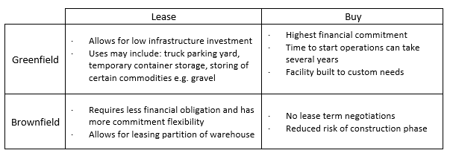
In addition to calculating land costs, the opportunity for future expansion and required utility service level is a critical consideration (e.g. additional access to power and/or water). A business cannot expect future growth if restrained by space / resource limitations.

Access to the transportation network - Operating an effective supply chain is contingent upon having good access to your transportation network. This may include alternate transportation methods. Depending on your commodity, you will rate modes of transport differently. As an example, a courier may require close proximity to an airport, whereas a grain producer would require close proximity to a transloading facility.

Labour availability - Labour availability has become a significant challenge in warehousing and truck transportation. Understanding the labour market situation in the area will assist in determining projected labour costs and the availability of workers with the skills you require.
In addition, transportation access to your facility for your staff is very important. If public transit is limited or inconvenient, you may have challenges in the hiring process.

- Synergies with service providers - The new location may have added opportunities to streamline operations. For example, if the company needs to rely heavily on truck transportation, it may benefit from being close to a refueling site or a truck maintenance shop.

- Assessing risk - Several factors can put the operations of the new geographical place at risk:
- Changes in market demands
- Demographics and workforce availability
- Changes to the transportation network
- Changes to transportation infrastructure
- Natural disasters / hazards
Risks should be assessed and mitigation strategies should be formulated. The cost of mitigating these risks can help qualify the feasibility of the chosen locations.
As a second step, within the selected region, use an endless set approach – like the centre of gravity or a similar model – to find the most excellent area for locations. Transportation costs are usually a large component of total supply chain costs. Generally, the further a company is from their customers and suppliers, the higher the transportation costs will be. To better understand your transportation costs, the company need to understand the frequency of deliveries and pickups from customers and suppliers. Industry practitioners use the center of gravity and load distance technique to determine the ideal location, purely focusing on transportation costs.

As a third step, the company will search around this region to find a possible set of accessible locations.
As a fourth step, use a practicable set approach –like costing model or scoring model – to compare these alternatives. An example is shown on Table 2 below where costing model is used to determine between possible locations in terms of transportation costs
Table 2 ‐ Example of transportation costs comparison by location

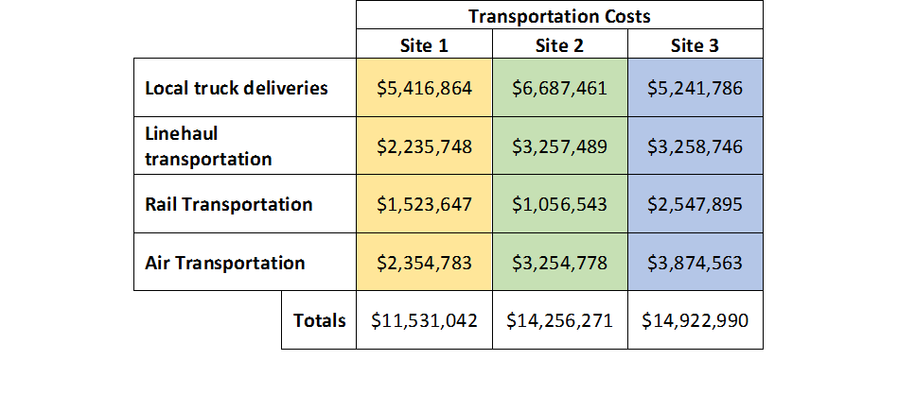

As a last fifth step, discuss all obtainable information and come to a choice.Once all factors have been assessed, the company must prioritize their importance to the organization. To quickly assess multiple factors across various potential locations, a weighted rating table can be used.
Table 3 ‐ Example of ratings table. Rating scale: 1 lowest, 5 highest 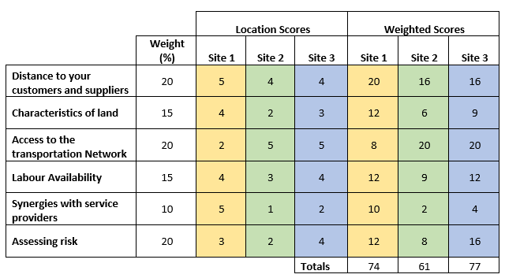

Student Statement:

By submitting this assignment, I confirm that this is my own work.

Student Signature | Georgi Belichanski | Date | 29.10.2017

For Tutor / Assessor Use Only
Total Marks
Marks Obtained
Percentage / Grade

