 Assignment Cover Sheet

Student Name: | Parahsakthi Sivasubramaniam
Student Number: | 7866
Course: | Diploma In Fashion Design Level 4
Assignment NO: | Assessment 1

Marking Criteria:
We expect the learners to write minimum one well expressed point in three lines against each allocated mark. This means one needs to write 15 lines with 5 well expressed points to get high grades for a 5 marks question.
For high grades use examples and illustrations where appropriate.
Please insert your completed assignment ( in word format) here:

Assessment #1
- Short Answers
i. It made the women’s fashion at that point of time to remain considerably for a longer period, i.e wedge shaped big shouldered silhouette. As a result of it, the immediate women’s fashion was radical, i.e small-waisted garment with sloping shoulders and longer skirt lengths. ii. Is depending on the lifestyles changes, immigration, development if new technology and changes in raw material prices.
- In 1970s, the fashion was determined by the younger generation in London and San Fransisco, whereby the fashion industry had to use the combination of old, new and handcrafted. This is known as Reverse Adoption whereby instead of the fashion to flow down from high priced designer clothe to the general public, the consumer decides what the fashion is supposed to be. Bell bottoms, cigarette & baggies were also popular in 70s.
- It became a ‘designer decade’. As well a Fad, whereby there were single fashions during that time, eg ‘punk’ look from UK that was saturating the junior market. And there were this recurring cycle whereby the nostalgic look were back in fashion but the difference was in terms of the colours, fabrics, details which made the looks unique.

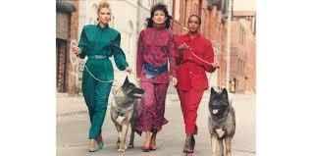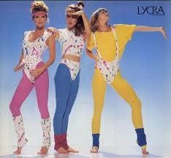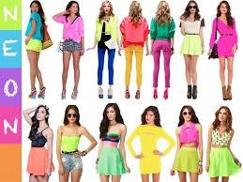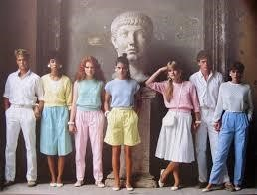
Activity

Following are the description on the styles of different era.

80
s style was bold style, colours &

silhouette, with trends spanning ripped tights & leather
to polished oversized blazers.

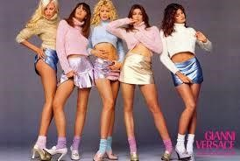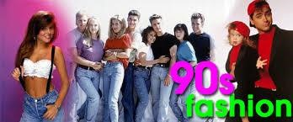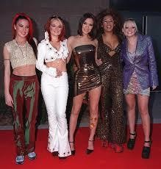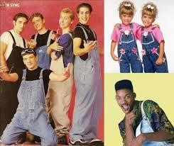
90
s was a time of high top sneakers, velvet chokers, body
-
suits

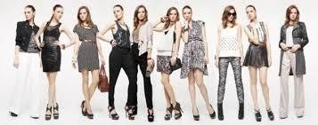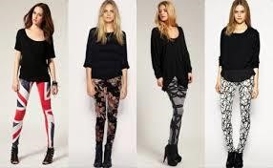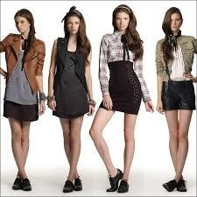
2010
s
–

Revival of austerity
-
era period pieces, hipster & alternative fashi
on

In my observation, the modern fashion dresses are pretty much focusing on
deep/darker/pale colours as opposed to the earlier era whereby, the colours were more
vibrant rather than the current fashion dresses. Crop top with high waist and suiting trends
wit
hout really wearing a suit is trending.

Student Statement:

By submitting this assignment, I confirm that this is my own work.

Student Signature | 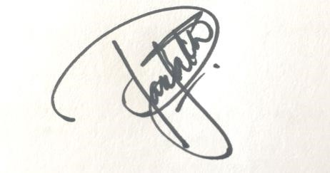 | Date | 17/2/2018

For Tutor / Assessor Use Only
Total Marks
Marks Obtained
Percentage / Grade

