
Assignment Cover Sheet

Student Name: | Elthon Rey R. Lagat
Student Number: | 7550
Course: | Level 4 Diploma in Construction Management
Assignment NO: | Unit 9 Purchase and Storage Management

Marking Criteria:
We expect the learners to write minimum one well expressed point in three lines against each allocated mark. This means one needs to write 15 lines with 5 well expressed points to get high grades for a 5 marks question.
For high grades use examples and illustrations where appropriate.
Please insert your completed assignment ( in word format) here:

- Answer the following questions:

- Outline the various elements of purchasing with the help of suitable case examples.

Elements of Purchasing
The main objective of purchasing is to ensure the availability of all ingredients for a project from start to finish without interruption. Purchasing high quality items at a low price ensures that the final product will be of a high quality and cost less. The purchasing function must be carried out using prescribed procedures such that items are of the highest quality, sourced from the right source at the right price, obtained at the right time in the right quantity using the right mode of transport and delivered to the right place.

Below, figure 9.1 provides details of some of the important elements of purchasing.
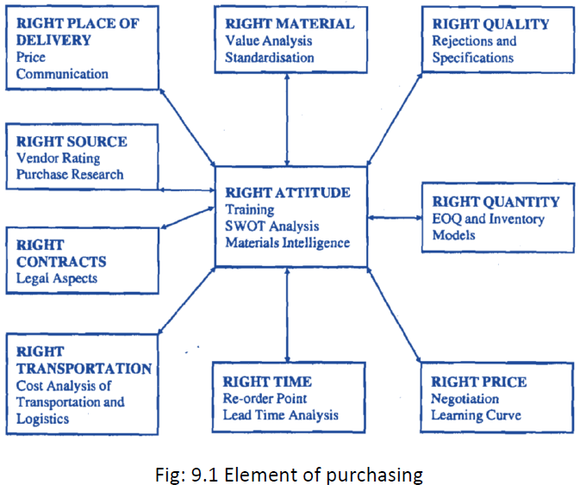
- What are the main objectives of purchasing?
Fundamental Objectives of Purchasing
i. Maintaining.
ii. Minimizing.
iii. Prevent duplication.
iv. Maintaining proper quality standards.
v. Obtain valued for money in terms of obtaining lowest price items at the highest quality and functionality.
vi. Helps to maintain organisation’s competitiveness by purchasing materials at reduced prices.

- What are the various prerequisites for becoming a good purchase manager?
Becoming a good Purchasing managers work as representatives for various companies and organizations. They prepare tendering documents and negotiate with vendors for the best prices on products. Before negotiating, they must review information on suppliers to decide based on several factors and interview them. Purchasing managers work with the suppliers on a contract and other agreements necessary. They must also keep records of all purchases, costs and inventory.

Purchasing managers typically do the following:

- Evaluate suppliers based on price, quality, and delivery speed.
- Interview vendors and visit suppliers' plants and distribution centers to examine and learn about products, services, and prices.
- Attend meetings, trade shows, and conferences to learn about new industry trends and make contacts with suppliers.
- Analyze price proposals, financial reports, and other information to determine reasonable prices.
- Negotiate contracts on behalf of their organization
- Work out policies with suppliers, such as when products will be delivered.
- Meet with staff and vendors to discuss defective or unacceptable goods or services and determine corrective action.
- Evaluate and monitor contracts to be sure that vendors and supplies comply with the terms and conditions of the contract and to determine need for changes.
- Maintain and review records of items bought, costs, deliveries, product performance, and inventories.

- What are the objectives and functions of stores?

Function and Objectives of Stores.
The general definition of as store is simply where materials are kept to be used later during the course of construction. A store can be defined as a place for:

- Receiving raw materials, components, tools, equipment and other items and account for them.
- Providing adequate and proper storage and preservation to the various items.
- Meeting the demands of the user departments by proper issues and account for the consumption.
- Minimizing obsolescence, surplus and scrap through proper codification, preservation and handling.
- Highlighting stock accumulation, discrepancies and abnormal consumption and evolve effective control measures.
- Ensuring good housekeeping so that material handling, material preservation, stocking, receipt and issue can be done adequately.
- Assisting in verification and provide supporting information for effective purchase action.

- Describe the general criteria adopted for the layout of stores.
General Criteria for Layout of Stores
- The design should make for easy identification of items
- Stored items should be easy to retrieve from the facility
- Design of layout should allow free movement of people and equipment.
- Layout should facilitate preservation of materials from dust, moisture, chemicals etc.
- Excellent lighting system.
- Layout must make provision for effective fire-fighting.
- Space should be available for toilet, maintenance and repair areas, safe wiring systems etc.
- The most economic layout should be arrived at after extensive analysis of alternative designs height of store must provide sufficient space to aid vertical movement:
- All major functional areas should be properly marked out and labelled. Areas for bulk storage, inspection section, receiving bay should all be clearly identified.
- Racks, pigeon holes, bins are suitable for individual items
- It is best to fix the racks to the walls. Alternatively you may use revolving racks with castors
- Secure locking systems should be provided for expensive items
- Ideally, trucks and lorries should be packed against the wall of the receiving bay to allow for easy loading and unloading of items using suitable ramps.
- Large doors and sufficiently-spaced columns are best.
- High security measures should be in place.
- Security personnel should be present to prevent theft and store facility should be close to a police station.
- Excellent communication between departments concerned with storage issues should be encouraged for seamless operations.
- Training should be provided to personnel on how to use fire-fighting equipment effectively.
- Differentiate between stock valuation and verification.
There is a distinct difference between the two terms "valuation" and "verification". Valuation is the monetary equivalent of the stock or material in hand whereas verification is the determination or quantification of the material in stock and checking its deviation from the figures shown in the books.

Valuation becomes necessary to assess the assets of the company for sale, determining insurance cover to be taken, during acquisition and mergers, get an idea about the difference between book and actual depreciation etc. Since the procurement price or sale price of a material does not remain constant, it is necessary to valuate the stocks regularly or during specific occasions. For example, if the price of an item in inventory which is required for producing something has gone up during its storage period, selling it by basing its selling price on the past purchase price can mean lesser margins. Similarly, if the price has gone down during the stocking period, selling it at a higher price can mean being outpriced by competition.

Since valuation methods can increase or decrease assets, companies occasionally resort to manipulating the valuation methods to present rosy or drastic pictures as the case may be. For instance, the gross profit is the difference between net sales and costs of production. Since materials cost is a part of production, the valuation basis can determine whether the company is going to have profits or losses. Frequent unauthorised changes are illegal. Under the companies act, a change in the method of valuation has to be approved by the Board of Directors of the company and must be reported alongwith the effect of changes in the profitability due to the changes in method of valuation duly certified by the auditors.

- Discuss the different stages of a "material procurement cycle".

Indenting
Typing mistakes should be avoided when preparing purchase orders. All terms and conditions must be included in the purchase order and copies forwarded to the user, the store and the accounts departments.
The process for preparing purchase order can be lengthy but an indent could be prepared and will usually consist of the following:
- Name of the item
- Description of the item
- Item code (if it is a standard item)
- Quantity of the item
- Specifications
- Date/time by which the item is desired
- End user department's name and location where the item is desired or is to be delivered
- Indent originator's name (for coordinating delivery or for clarifications)
- Other related information, if the item is budgeted
- Signature of the authority for normal procurement, and/or signature of senior management personnel, if it is not budgeted.

Enquiry Stage
During this stage, the buyer’s request or preliminary order is sent to vendor for prices to be quoted for each item and returned to the buyer. The process consists of:
- Name of the item.
- Description of the item.
- Quantity of the items.
- Time till which the offer is to be valid.
- Specifications.
- Date/time by which the item is desired.
- End user department's name and location where the item is desired or is to be delivered.
- Standard terms and conditions which the company follows and desires for its vendors to accept these conditions regarding insurance, warranty and guarantee expected, payment details, mode of transportation, point of transfer of goods from vendor to company etc.

Offer Processing Stage
Incoming offers are compared with the buyer’s own ideal benchmark listings, the expected terms and conditions and the pricing, on and fair and objective basis. The ideal offer may be transmitted to the vendor during the early stage with details of the buyer’s expectations.

Determining the best offer may be difficult because:

- i. Someone may have agreed to all terms and conditions but the price could be too high
- ii. A vendor’s price may appear quite low because he may have excluded some extras such as cost of transportation and/or insurance.
- iii. Other vendors may quote low prices but may have imported the materials from a company or country which does not have a service centre in UK or at the location of final delivery Since this stage is primarily for comparison purposes, the buyer may have to request for requite or he has to recalculate the implications of the results of the cost factors until satisfactory results are obtained. Negotiating with vendors is another option to consider.

Ordering Systems
The Purchase Order (PO) is immediately drafted when the right supplier has been chosen. Given the legal nature of this document which is binding on both parties, it is critical to renegotiate and clarify issues until the terms and conditions are completely accepted by all parties entering into the agreement. Typing mistakes should be avoided and all terms and conditions included. The relevant departments, such as the user, stores, and accounts departments should be sent copies of the final agreement. To optimize purchase orders due to the complexities involved, certain criteria, frequently used and minimum value items may be excluded.

Typical purchase order contains the following:

- The order number, serial number and date of order
- The name and address of the ordering company
- Consignee's name and address
- General terms and conditions of order
- Description of goods, its specifications and quantities
- Supplier's quotation reference and any other correspondence or MOM (Minutes of Meeting)
- Pricing terms and its billing terms
- Payment terms
- Delivery date and schedule
- Packing instructions
- Transport instructions
- Freight payment terms
- Insurance terms
- Warranty and guarantee term,
- Cancellation provisions and damage relating to liquidity clauses
- Incoming inspection details and removal of rejections
- Bonus for early despatch or zero rejections etc.
- Other special terms and conditions

Ordering system may vary depending on the methods used to arrive at the final document. When creating purchase orders, the following methods are usually considered:

Receipt of Materials, Transportation and Inspection
Where planning and commitment of delivering items are not strictly adhered to, it becomes critically important to chase or follow up the orders. Tax and insurance forms have to be obtained and completed while the goods are in transit. This also calls for regular coordination between all concerned parties to ensure orders are delivered in the right conditions and on time.
Inspection of incoming items is done for quality verification. The quality of an item is defined in terms of:
- Dimensions and/or weight,
- Physical and/or chemical properties,
- Design and/or performance characteristics,
- Surface textures,
- Aesthetic values,
- Packaging characteristics,
- Defectives allowable, and
- Service and/or operating characteristics.
Quality can be measurable or immeasurable. Agreed universal standards should be used in determining the quality of an item and there should be no ambiguity in the item specification. Items could be unambiguously described using:
- i. Colour
- ii. Surface finishes
- iii. Lacquer or vanish
- iv. Thickness or size
- To ensure quality procurement, organisations should:
- i. Set quality standard
- ii. Compare performance of products with standards
- iii. Take action to correct defects
- iv. Provide plan for continuous improvement

Communication channels to concerned parties can be improved through regular quality inspection.

When items pass quality checks, they are dispatched to the warehouses or stores for storage. The end-use department may request for the item following store system procedures. All stages in the material purchasing system can be classified as a “ Material Procurement Cycle” as shown in figure 9.2.below;

Figure 9.2 shows this Material Procurement Cycle initiating from indenting materials to issues with the items.

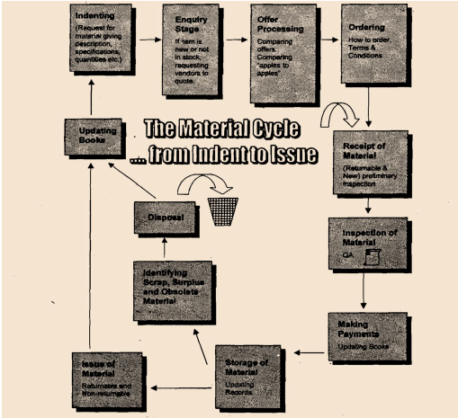

Material procurement cycle

- Explain the various tendering systems used for ordering the materials.

Tender System
This method of procurement is prevalent in the private sector. The objective of this tender system is mainly to encourage fair and competitive pricing and to discourage favouritism or nepotism in procuring items. Nepotism usually occurs when the terms and conditions or the specifications seem to favour one particular vendor. Loading is done to eliminate nepotism by comparing all advantages and disadvantages of purchasing a specific item from vendors in terms of cost and productivity. For instance, a machine which is more expensive may be many times productive that a less costly one. Detailed specifications would ensure objectivity and eliminate suspicion of nepotism.

There are 3 methods of tendering to choose from:
i. Open tender
ii. Limited tender
iii. Single tender

Open Tender
The process begins with the publishing of Notice Inviting Tenders (NITS) in major newspapers and Trade Journals. The tenderers are expected to purchases the tender documents which contain the terms and conditions, as well as the specifications of the project. There is also an option to submit a technical or commercial bid during the process. Tenderers are expected to provide quotes and meet all contractual obligations or a certain minimum technical specification with regards to the terms and conditions. If any deviations occur in the quantity of supply or with the terms and conditions, then this would have to be discussed to arrive at an agreeable solution.
Costly items with high technological content which require global tenders are financed by international financial institutions like the IMF (International Monetary Fund). To ensure a smooth tender process, clear and simple language must be used for this type of tendering. Also, a comprehensive checklist should be prepared before embarking on this global order.
The main problem present by the open tender method is that of the ‘rogue bidder’ who quotes very low prices to win the contract only for him to attempt to renegotiate terms for an increase in payment once the buyers have committed a lot of investment to the project.

Limited Tender
This type of tender is designed to solve the ‘rogue bidder’ problem. It requires having a limited number of bidders who meet certain pre-defined specifications. Precautions must be put in place so that genuine bidders are not disqualified or the criteria for qualification do not favour one particular bidder. Limited tender produces reduce lead times.

Simple Tender
This type of tender is ideal for proprietary items but should be avoided to prevent unfair pricing or blackmail. It may, however, be useful when frequent repeat orders are required in order to reduce lead time during contract negotiations.

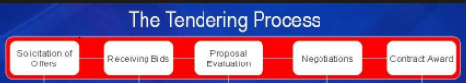

Figure 9.3: The Tendering Process

Student Statement:

By submitting this assignment, I confirm that this is my own work.

Student Signature | Elthon Rey R. Lagat | Date | 17 May 2017

For Tutor / Assessor Use Only
Total Marks
Marks Obtained
Percentage / Grade

