
Assignment Cover Sheet

Student Name: | Sunny Kate Fletcher
Student Number:
Course: | Interior Design Level 1
Assignment NO: | 2

Marking Criteria:
We expect the learners to write minimum one well expressed point in three lines against each allocated mark. This means one needs to write 15 lines with 5 well expressed points to get high grades for a 5 marks question.
For high grades use examples and illustrations where appropriate.
Design Elements

Assessment 2 Total Marks = 30

- When planning a space in interior design scheme why it is important to establish the purpose for which it will be used?

As an interior designer, it is important to establish the size of the space and ascertain from the client what the function of the room is, and how it will be used, and how moderately.

For example;

- Bedrooms; We tend to spend a lot of time here. We sleep, relax, sometimes eat (depending on personal preferences), watch TV, listen to music, or read. A bedroom is a personal space and should be accommodated accordingly. This also reflects someone’s personality from the type of furniture, colour, and belongings on show in their bedroom.

- Work spaces; This is a space where every square meter counts. It is used on a daily basis and will have a variety of uses for different people. Materials and furniture placed in this space should be hard wearing, functional and easy to clean. Comfort is probably the last specification on the list that the client requests.

- Living areas; A space that will be most used by everyone in the household, even if it is at different times of the day, it must reflect comfort to be enjoyed by everyone - a reflection of the household overall and a general flow of continuity within the design.

If a room is being redesigned, following static fittings such as lighting, then it is important to associate as much natural light as possible, assess the directional compass of the facing room, and advise the client what type of colours, furniture and soft furnishings would be recommended for the layout and size of the room.

Failure to do this may result in the room appearing overcrowded, small and poky and not flowing.

2. Why it is important to consider natural light which a room receives when planning
colour scheme for it?

Natural light is always the best light to have. Unfortunately, it is not available 24 hours a day. Letting a room have as much natural light as possible makes it appear bigger, as well as warms it. Depending on the direction of the house, and understanding the size of the room and accommodating windows may dictate the type of artificial light used in a project.

The colour scheme should be reflected on a variety of factors;

- The amount of natural light in the day
- The type of room in the house
- What the particular room is used for
- The location of the room in the house and the direction it faces
- The overall colour scheme of the room
- The type of light that is let into the room, and whether it is soft light, or harsh or dimmed.

Activity
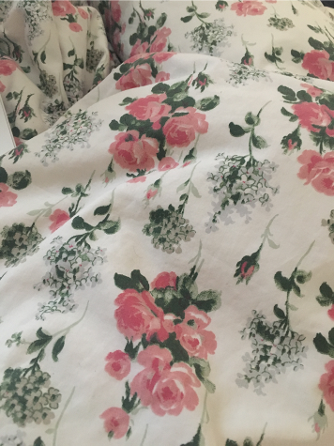
Observe different types of fabrics in artificial and natural lights of varying strengths. Write down the outcomes of your observation. Attach the pieces of fabrics with your written observation.

- Cotton sheets; Natural light, which casts shadows depending on the exposure of the fabric.


- Throw cushions;
Contrasting colours brighten up the room, and remain bright with or without artificial light.

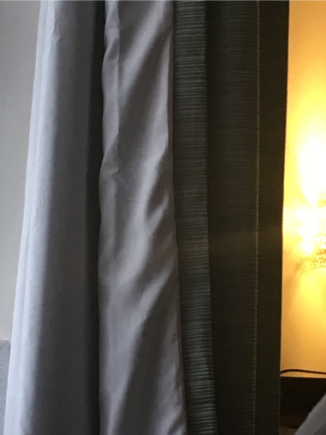

- Curtains;
There is artificial light in the background whilst natural light is coming through the window. As the sun was setting, the light was not as sharp.

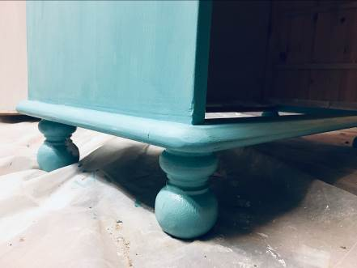

- Chest of drawers;
Taken in the workshop, in artificial light and using a flash on the camera. It does not accurately represent the colour of the paint.

Brentwood Open Learning College Page-1
Student Statement:

By submitting this assignment, I confirm that this is my own work.

Student Signature | S.K.Fletcher | Date | 18/01/2019

For Tutor / Assessor Use Only
Total Marks
Marks Obtained
Percentage / Grade

