
Assignment Cover Sheet

Student Name: | Elena Camperlingo
Student Number: | 5878
Course: | Certificate in Travel and Tourism Level 3
Assignment NO: | 7

Marking Criteria:
We expect the learners to write minimum one well expressed point in three lines against each allocated mark. This means one needs to write 15 lines with 5 well expressed points to get high grades for a 5 marks question.
For high grades use examples and illustrations where appropriate.
QUALITY MANAGEMENT
- A quality management system is a formalized system that involves all those processes, procedures, and responsibilities for achieving objectives and improving business in an organization. It helps to coordinate and direct the organization’s activities to meet customer needs and regulatory requirements and to ensure long term customer loyalty and satisfaction. Quality management is, of course, the result of all the efforts made by employees’ tasks and activities needed to improve and maintain an excellent customer service. Quality management has four components: quality planning, quality assurance, quality control and continual improvement.
Quality planning involves the creation of a good management plan that describes the processes and principles that will be used and it has to be elaborated according to the needs of the relevant stakeholders to ensure that their quality expectations are correctly identified. The processes described in the quality management plan should be the same as the processes, culture and values of the organization.
The next component, quality control, consists of inspection, testing and measurement of the plan itself. It verifies that they meet the stakeholder expectations. Quality assurance is often used interchangeably with quality control and it is a wider concept that covers all policies and systematic activities implemented within a quality system that, to be effective, must be under strict configuration control and modified if necessary.
The last component, continual improvement, is the generic term used by organizations to describe how information provided by quality assurance and quality control is used to make improvements.

- The “ Service gap ” model was proposed by Parasuraman, Valerie Zeithaml and LL Berry and it is a model that describes the major gaps between the actions of organizations seeking to fulfill customer expectations and methods in which those services are provided.
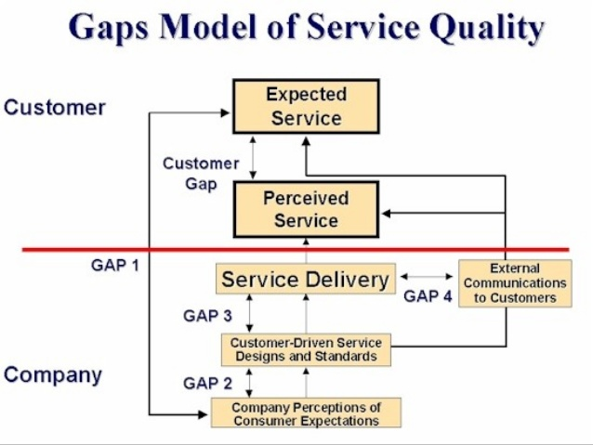
The customer gap ( gap 1 ) is the difference between customer expectations and perceptions. Customer expectation is what customers expect from a service and it is influenced by cultural background, personality, advertising, experience with similar products and information available online. Customer perception is more subjective and it is based on the customer’s interaction with the actual product or service. Perception is determined by customer’s satisfaction and the quality of service delivery. The knowledge gap ( gap 2 ) is the difference between customer’s expectations about the service provided and the company’s provision of the service. In this case, managers are not fully aware or have not correctly understood customer expectations in relation to the company’s services or products.
The gap n. 3 underlines the weakness in employees performance, due to lack of product knowledge and difficulty in managing customer questions and issues, poor human resource policies, lack of cohesive teams and the inability to deliver a good service. Communication gap ( gap 4 ) is the fall between companies advertising and media communication and customer expectations. When promises in advertising do not match the actual service delivery, it creates a communication gap. Consumers are disappointed because the promised service do not satisfy the expected service and consequently they may seek alternative product sources.

- Quality in tourism and hospitality industry means a consistent delivery plan of products and guest services according to expected standards. Delivering quality service is one of the main challenges that hospitality managers have been facing in these years as it is an essential condition for success in the high competition on the market. Many benefits can be achieved by service quality such as establishing customer satisfaction and loyalty, contributing to business image and providing a competitive advantage to the business.
There are various tools that measure and improve quality service, as well as mechanisms for quality recognition in the tourism and hospitality industry. In fact, there are five dimensions ranked by customers to be most important for service quality, they are defined by the SERVQUAL measurement instrument and are: tangibles: use of facilities, equipment, personnel and communication materials; reliability: ability to accurately satisfy the promised service; responsiveness: willingness to help customers and provide a prompt service;
assurance: knowledge and courtesy of employees and their ability to bring trust and confidence and empathy: the personal attention to each single customer. These five SERVQUAL dimensions are used to measure the gap between customers expectation and their perception of the actual service. The SERVQUAL instrument helps service providers to understand both customer expectations, perceptions of specific services and areas that need quality improvements.

- A good quality management plan in the tourism industry should check different steps that assure that products are made to meet customers standards and requirements, work processes are performed efficiently and discrepancies are identified and adjusted.
- Identifying the quality requirements that we are going to use in order to find out how our consumers will assess the quality of the products that we are offering.

- Setting the quality standards that we are going to follow in the execution of the product is the following step to later verify if those standards have been met or not.

- Distributing roles and tasks that need to be clearly explained to the chain of employees meant to deliver the product. In particular the project manager is responsible for the overall results but, depending of the aim of the plan, quality assistance can be distributed among the team.

- Setting the criteria to actually test the quality of the product working with the customer upfront to define what is fine and what needs to be improved. Then we can aim to meet that goal and do service recovery if necessary, so basically “give customers what they want, and then, sell them what they need”.

- In order to assure customers that constant quality is being delivered we should let them know the quality approach processes. Customers love to hear how important they are to a business and love to know the activities and techniques used to provide them the best quality service.

- Setting the tools that we are going to use for quality measurement is important so we should clearly list them.

- Quality control should state the process of setting up a quality control plan and activities that should be performed continually throughout a project shared within the organization and made according to its values and culture .

Student Statement:

By submitting this assignment, I confirm that this is my own work.

Student Signature | Elena Camperlingo | Date | 26-4-2018

For Tutor / Assessor Use Only
Total Marks
Marks Obtained
Percentage / Grade

