
Assignment Cover Sheet

Student Name: | Vicky Groves
Student Number: | 22889
Course: | Diploma in Diet and Nutrition (Level 4)
Assignment NO: | Unit 14 Anti-Ageing Formulas

Marking Criteria:
We expect the learners to write minimum one well expressed point in three lines against each allocated mark. This means one needs to write 15 lines with 5 well expressed points to get high grades for a 5 marks question.
For high grades use examples and illustrations where appropriate.
Please insert your completed assignment (in word format) here:

Anti-Ageing Formulas Unit 14 Brentwood Open Learning College Assessment 14 Total Marks 30

Q.1. Multiple Choice Questions (05)

i. Dairy products provide sufficient amounts of:
a) calcium and vitamin K
b) calcium and vitamin D
c) all essential amino acids

ii. Diabetes is caused when the pancreas cannot make sufficient amounts of:
a) glucose
b) sugar
c) insulin

iii. The liver is the main organ for:
a) digestion
b) blood circulation
c) detoxification

iv. Our skin’s acid mantle performs an important function as part of our: a) blood circulatory system
b) nervous system
c) immune system

v. The health of the skin reflects:
a) age
b) overall health
c) skin colour

vi. The incomplete molecules which lack an electron are called:
a) free radicals
b) chemical compounds
c) the nucleus Anti-Ageing Formulas

vii. Free radicals are usually the byproduct of our:
a) digestive system
b) metabolism
c) blood circulatory system

viii. The damage that free radicals do is called:
a) stress
b) oxidative stress
c) free radical system

ix. Elderly people usually have lower energy expenditure and:
a) higher metabolic rates
b) slower metabolic rates
c) normal metabolic rates

x. Free radicals are usually the byproduct of our:
a) digestive system
b) metabolism
c) blood circulatory system

Q.2. Short Questions: (25) All Questions Carry Equal Marks.

i. How can constipation be prevented?
You can help prevent constipation by doing the following…

Drink 6 to 8 glasses of water (more in hot weather), this includes tea, coffee, fruit juice and squash.
Increase your dietary fibre (NSP Non Starch Polysaccharide) by eating whole grains, beans and lentils, nuts and seeds, fruit and vegetables (5 a day). Whole grains fibre absorbs water and increases bulk, so keeping the faeces soft, making it easier to pass through the digestion system. We should eat 30g of fibre a day. This will also help prevent Haemorrhoids, Diverticulitis and some Cancers

Increase your daily exercise to 30 minutes a day

Have 8 hours sleep will help the body’s digestion system (see body clock image)
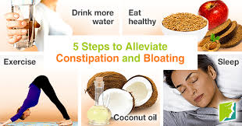

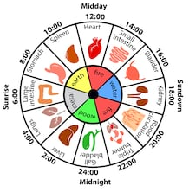
ii. Do elderly people need to do physical activity? If so, for how long?
Yes, elderly people do need to do physical activities. The saying goes “if you don’t use it, you will lose it”, which means if you don’t use the body, day to day activities will become hard to do and you can lose the ability to do them.

It is very important to keep up the stamina which enables a person to walk any distance. Having strength to climb stairs, carry shopping etc, keeps the individual independent. Flexibility is needed for dressing, toileting, bending and washing their own body. Balance comes from keeping up the body strength, stamina and flexibility.

Keeping active helps lower high blood pressure, help to control weigh, help prevent constipation. Strong muscles and bones are important when it comes to helping with reducing the risk of osteoporosis. Physical activities help relieve the discomfort from diseases like arthritis. Walking is a great exercise to do to help a person’s lymph flow, as the lymphatic system doesn’t have a pump to push it around. It uses muscle contraction to squeeze and push it around the body. The lymphatic system collects waste products from the cells around the body and contains immune cells which destroy pathogens.

Doing exercise can be a social activity and releases the hormone endorphin, which are great for a person’s wellbeing.

An elderly person should aim to do at least 30 minutes of exercise a day 5 or more times a week. This can be broken down into small sessions example 3 x 10 minutes a day.
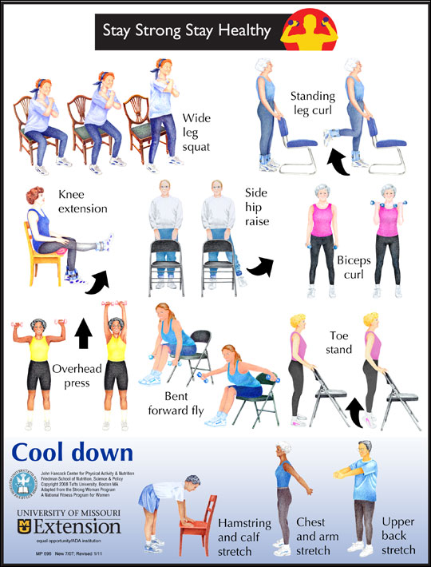

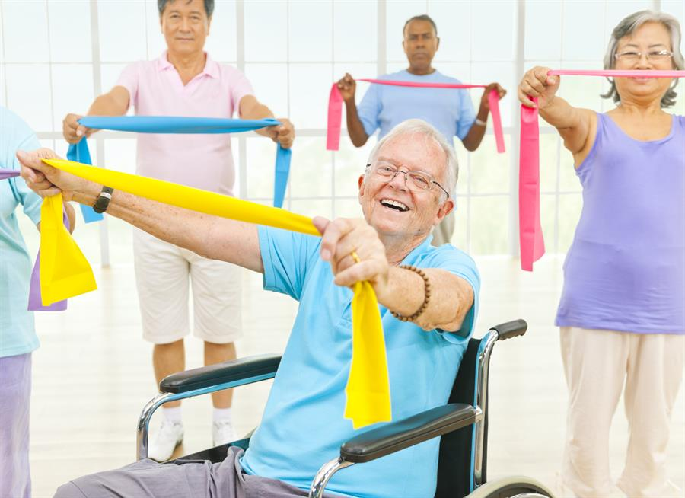
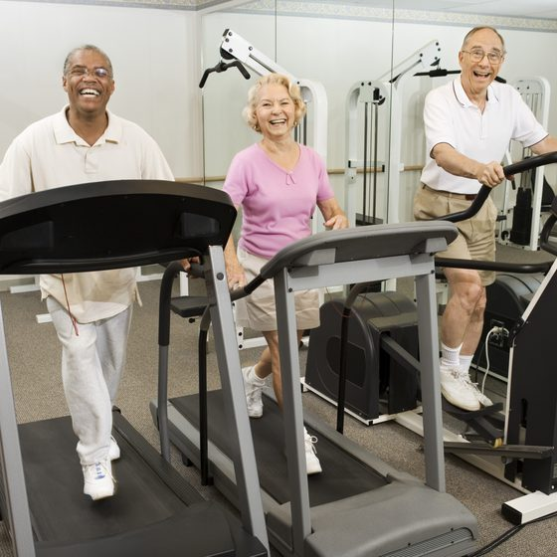

iii. What are phytochemicals and what is their function in the body?
The word Phytochemicals comes from the Greece word phyto meaning plant. Phytochemicals are compounds that come from plants like vegetables, fruits, beans, nuts and seeds etc and contributes to their colour, taste and smell. Foods high in beta carotene, vegetables that are red, yellow and orange, cruciferous vegetables and polyphenols in tea are all good source of phytochemicals.

It is said that by eating these foods which contain phytochemicals protect cells in the body from damage, reducing the risk of cancer by up to 40%. We should eat a wide range of all these plant-based foods.

There are several different types of phytochemicals – Flavonoids act like estrogen which can work against breast cancer – Antioxidants help protect the body from free radicals – Carotenoids helping reduce the risk of cancer – Anthocyanins have anti-inflammatory and anti-tumour properties – Sulfides strengthen the immune system. Phytochemicals help to stop carcinogens attacking cells.

iv. ‘Sugar and refined food can cause problems’. Discuss.
In moderation, small amounts sugar and refined foods can be eaten with little side effect. However, eaten regularly can course health problems from weight gain, high blood pressure, diabetes, heart disease, stroke, cancer etc. This is since sugar makes the body increases insulin into the bloodstream, which affect the arteries, adding stress on the heart. Sugar courses tooth decay and gum disease, which can lead to heart disease. If sugar is not used as energy it is stored as fat around the body.
Refined foods are not only high in sugar, they are high in fats, especially saturated fats and salts which have a negative effect on the body. Both sugar and refined foods are high in calories and low in micronutrients and fibre, which contribute towards pre-mature ageing. Refined foods can have artificial colouring and preservatives in them, these chemicals are hard for the body to deal with. They also create free radicals and inflammatory problems.
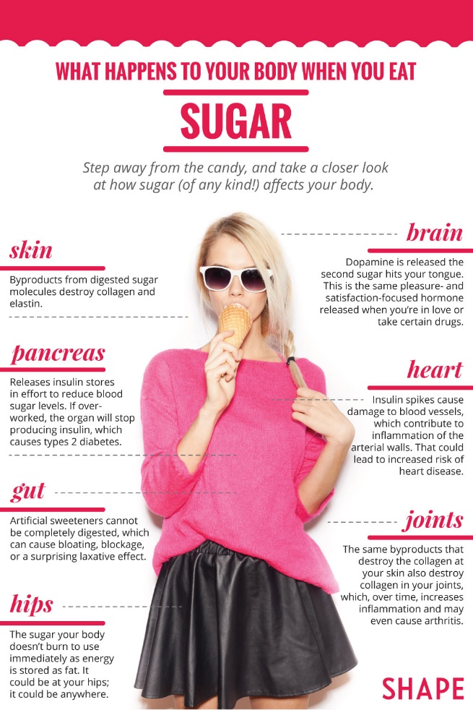
v. What are free radicals? How do they affect our skin?
Free radicals are unstable molecules that cause damage to cells. They are missing an electro from their outer shell and do damage trying to stabilise themselves. This is called Oxidative Stress, which can damage DNA and other parts of the cell, weakening the cells and the tissues. This weakening causes an acceleration of skin aging.

Our skin is the largest organ of the body and our first line of defence, making it vulnerable to free radicals. Free radicals can come from our environment for example pollution, cigarette smoke and from the sun.

They damage the skin in many ways…
- Damaging the elastic fibres, making them sag
- They break down the skin’s collagen creating winkles
- They change the skin colour – brown spots
- Break blood vessels under the skin layer

Therefore, we should reduce our exposure to pollutants like smoking and the sun etc, helping to combat the damage these free radicals can do.
Another way to reduce damage from free radicals, is to interduce antioxidants. Antioxidants release one electron to the free radicals, so they don’t take one from the skin’s atoms, making them stable. Antioxidants which are good for the skin are Vit A, C & E. We get these from the food we eat, and you can also get them from face cream and body lotions.

We should eat foods high in Phytochemicals which come from plants, as they are good source of protection from oxidative stress.

Student Statement:

By submitting this assignment, I confirm that this is my own work.

Student Signature | Vicky groves | Date | 20/08/2019

For Tutor / Assessor Use Only
Total Marks
Marks Obtained
Percentage / Grade

