
Assignment Cover Sheet

Student Name: | Despina Nikolaou
Student Number: | 3106
Course: | Diploma in Business Administration (Level 4)
Assignment NO: | 10

Marking Criteria:
We expect the learners to write minimum one well expressed point in three lines against each allocated mark. This means one needs to write 15 lines with 5 well expressed points to get high grades for a 5 marks question.
For high grades use examples and illustrations where appropriate.
.i. Customer response assessment involves gathering information from customers
and determining which suggestions can be implemented, based on the company’s
best interests. Some of those techniques should be: E-mail surveys, phone surveys,
customer service questionnaire and the company can use them to see how they will
improve their service or to understand better the customer’s expectations.
ii. If the policies and procedures are consistent with the values of the organization
and legislation and the organization demonstrate that is being operated in an
efficient and businesslike manner also ensure uniformity and consistency in
decision making and operational procedures , then it’s easy their customers
*to keep their customer’s promises*.
iii. Quality management and its requirements for continues improvement plays a
vital role in ensuring that customer-focused organizations better indentify and
address core customer needs. Companies are reliant on their customers for their
existence and well-being and should therefore recognize all existing and potential
customer needs, meet customer requirements and strive to surpass customer
expectations by following total quality management processes across the organization.
iv. Well building trust in a customer/business relationship doesn’t have to be difficult
if you are willing to be open, honest and efficient when communication with
customers. If you can be professional , display and report to customer reviews (the
good and the bad), response to inquiries promptly, admit to mistakes and fix them
and value the customer, then, devoted customer’s trust can help to seal the deal.
v. The CRM Manager is responsible for managing the organizations CRM ensuring the
company can make the most out of marketing opportunities it offers. It includes,
planning and delivering CRM strategies across the company, Deciding on the CRM
platform structure and architecture ensuring it works seamlessly across the organization, maximizing commercial opportunities, working closely with all departments,
monitor and maximize customer lifetime value strategies ensuring maximum profitability,
developing testing strategies for all aspects of the CRM to ensure the most effective approach for the company

Q2. CUSTOMER SATISFACTION SURVEY

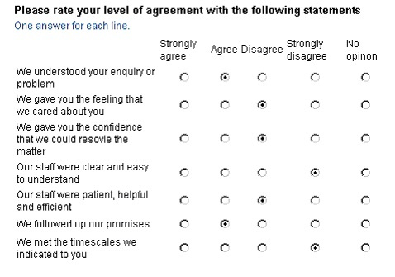

Case Study:
For most people, participation in leisure time exercise “comes and goes” rather than being something they always or never do. Those with time pressures from work or domestic life are less likely to participate in leisure time physical activity. There are important differences women and men as mostly women partake in physical exercise to enjoy the feeling of excess weight falling away on the contrary men feeling of excess the increase of strength building up in our bodies over time. Under all the above it is important for the leisure center to have a sort data of their member's age-range, sex and occupation because , first they could certified the maintanance of their monthly or yearly contracts of the participants and to target for new members from competition offering an upper level services with the new instructor and new updated equipments by giving this information to the market starting their new marketing campaign. Knowing your leisure center’s audience and what makes your center special over the competition will help you use the correct verbiage when marketing your gym.

Student Statement:

By submitting this assignment, I confirm that this is my own work.

Student Signature | Despina Nikolaou | Date | 27/8/2017

For Tutor / Assessor Use Only
Total Marks
Marks Obtained
Percentage / Grade

