
Assignment Cover Sheet

Student Name: | Chinmay Vaze
Student Number:
Course:
Assignment NO:

Marking Criteria:
We expect the learners to write minimum one well expressed point in three lines against each allocated mark. This means one needs to write 15 lines with 5 well expressed points to get high grades for a 5 marks question.
For high grades use examples and illustrations where appropriate.
1: What are the 17 requirements of the ISO 14001:2004 standard?
Ans:
17 Requirements of the ISO 14001:2004 standard are as follows:
- Environmental policy: Develop a statement of the organization’s commitment to the Environment
- Environmental aspects and impacts: Identify environmental attributes of products, activities and services and their effects on the environment
- Legal and other requirements: Identify and ensure access to relevant laws and regulations
- Objectives and targets and environmental management programme: Set environmental goals for the organization and plan actions to achieve objectives and targets
- Structure and responsibility: Establish roles and responsibilities within the organization
- Training, awareness and competence: Ensure that employees are aware and capable of their environmental responsibilities
- Communication: Develop processes for internal and external communication on environmental management issues
- EMS documentation: Maintain information about the EMS and related documents
- Document control: Ensure effective management of procedures and other documents
- Operational control: Identify, plan and manage the organization’s operations and activities in line with the policy, objectives and targets and significant aspects
- Emergency preparedness and response: Develop procedures for preventing and responding to potential emergencies
- Monitoring and measuring: Monitor key activities and track performance including periodic compliance evaluation
- Evaluation of compliance: Develop procedure to periodically evaluate compliance with legal and other requirements
- Non-conformance and corrective and preventive action: Identify and correct problems and prevent recurrences
- Records: Keep adequate records of EMS performance
- EMS audit: Periodically verify that the EMS is effective and achieving objectives and targets
- Management review: Review the EMS

2: Briefly explain PDCA (PLAN-DO-CHECK-ACT) model.
Ans:
It is an iterative four-step problem-solving process typically used in business process improvement. It is also known as the Deming cycle, Shewhart cycle, Deming wheel or plando- study-act.
THE PDCA Cycle
Plan
Establishes the objectives and processes necessary to deliver results in accordance with the expected output. By making the expected output the focus, it differs from other techniques as the completeness and accuracy of the specification is part of the improvement.
Do
Implement the new processes on a small scale, if possible.
Check
Measure the new processes and compare the results against the expected results to ascertain any differences.
Act
Analyze the differences in order to determine their cause. Each will be part of either one or more of the P-D-C-A steps. Determine where changes must be applied so that they also engender improvement. When a check through these four steps does not result in the need to improve, the scope is refined. PDCA is applied to this nascent scope and the cycle is repeated until there is a plan that involves improvement.

In Six Sigma programme, the PDCA cycle is called 'define measure, analyze, improve, control' (DMAIC).
The iterative nature of the cycle must be explicitly added to the DMAIC procedure.
PDCA should be repeatedly implemented in spirals of increasing knowledge of the system that converge on the ultimate goal, each cycle closer than the previous. One can envision an open coil spring, with each loop being one cycle of the scientific method- PDCA and each complete cycle indicating an increase in our knowledge of the system under study. This approach is based on the belief that our knowledge and skills are limited but improving. Especially at the start of a project, key information may not be known; the PDCA- scientific method- provides feedback to justify our guesses (hypotheses) and increase our knowledge. Rather than enter 'analysis paralysis' to get it perfect the first time, it is better to be approximately right than exactly wrong. There is a greater probability of being right this way. With improved knowledge, we may choose to refine or alter the goal (ideal state). Certainly, the PDCA approach can bring us closer to whatever goal we choose. Rate of change i.e. rate of improvement, is a key competitive factor in today's world. PDCA allows for major 'jumps' in performance ('breakthroughs' often desired in a Western approach), as well as Kaizen (frequent small improvements associated with an Eastern approach). The PDCA approach is normally a cumbersome process, which entails detailed efforts from the people involved. In the United States, as a PDCA approach is usually associated with a sizable project involving numerous people's time, thus managers want to see large 'breakthrough' improvements to justify the effort expended. However, scientific method and PDCA apply to all sorts of projects and improvement activities. The power of Deming's concept lies in its apparent simplicity. The concept of feedback in the scientific method, in the abstract sense, is today firmly rooted in education. This concept is easy to adapt when compared to other concepts. While apparently easy to comprehend, it is often difficult to accomplish on an on-going basis due to the intellectual difficulty of judging one's proposals (hypotheses) based on measured results.

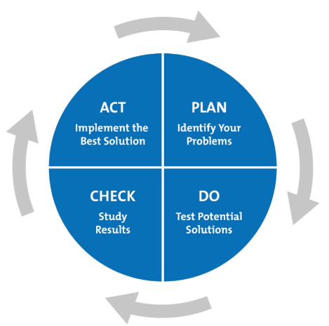

Ref: https://www.mindtools.com/media/Diagrams/PDCA2017.jpg
3: What are various forms of environmental accounting?
Ans:
Every business has an overriding responsibility to make the fullest possible use of its resources, both human and material. An enterprise is a corporate citizen. Like a citizen, it is esteemed and judged by its actions in relation to the community of which it is a member as well as by its economic performance. As far as the corporate sector is concerned, it is sad but true that it has not been performing as a good citizen. Keeping this in view, many laws have been laid down and further amended as per requirement, in order to bind the corporate sector to fulfill their social responsibility for better development of economy. Responsibility towards the environment has become one of the most crucial areas of social responsibility. Recent years have witnessed rising concern for environmental degradation, which is taking place mainly in the form of pollution of various types, viz. air, water, sound, soil erosion, deforestation etc. It is a worldwide phenomenon. It spoils human health, reduces economic productivity and leads to loss of amenities. Developing countries like India are faced with the twin problem of protecting the environment and promoting economic development. A trade-off between environmental protection and development is required. A careful assessment of the benefits and costs of environmental damages is necessary to uncover the safe limits of environmental degradation and the required level of development.

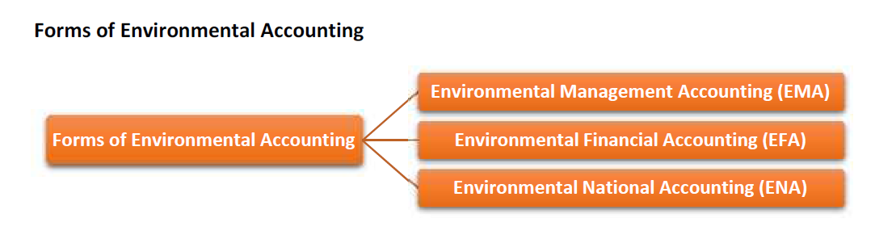
Fig : 2.2
1. Environmental Management Accounting (EMA): This refers to management accounting with a particular focus on material and energy flow information and environmental cost information. This type of accounting can be further classified into the following subsystems:
Segment Environmental Accounting: This is an internal environmental accounting tool to select an investment activity or a project, related to environmental conservation from among all processes of operations and to evaluate environmental effects for a certain period.
- Eco Balance Environmental Accounting: This is an internal environmental accounting tool to support PDCA for sustainable environmental management activities.
- Corporate Environmental Accounting: This is a tool to inform the public about relevant information compiled in accordance with Environmental Accounting. It should be called Corporate Environmental Reporting. For this purpose, the cost and effect (in quantity and monetary value) of its environmental conservation activities are used.
2. Environmental Financial Accounting (EFA): This refers to financial accounting with a particular focus on reporting environmental liability costs and other significant environmental costs.
3. Environmental National Accounting (ENA): This refers to national level accounting with a particular focus on natural resources stocks and flows, environmental costs and externality costs etc.
Need of Environmental Accounting at Corporate Level: It helps to know whether an organization has been discharging its responsibilities towards the environment. A company is expected to fulfill the following environmental responsibilities:
- Meeting regulatory requirements or exceeding that expectation.
- Cleaning up pollution that already exists and properly disposing off the hazardous material. Disclosing, the amount and nature of the preventative measures taken by the management (disclosure required if the estimated liability is greater than a certain per cent of the company’s net worth), to both potential and current investors.
- Operating in a way that those environmental damages do not occur
- Promoting a company having wide environmental attitude
- Control over operational and material efficiency gains driven by the competitive global market
- Control over increases in costs for raw materials, waste management and potential liability of political environment in which they occur.

Student Statement:

By submitting this assignment, I confirm that this is my own work.

Student Signature | Chinmay Vaze | Date | 30/06/2018

For Tutor / Assessor Use Only
Total Marks
Marks Obtained
Percentage / Grade

