
Assignment Cover Sheet

Student Name: | Ahmed Ansari
Student Number: | 23422
Course: | Diploma in Environmental Management (Level 4)
Assignment NO: | 04

Marking Criteria:
We expect the learners to write minimum one well expressed point in three lines against each allocated mark. This means one needs to write 15 lines with 5 well expressed points to get high grades for a 5 marks question.
For high grades use examples and illustrations where appropriate.
Q: 1) What are the 17 requirements of the ISO 14001:2004 standard?
Answer Q: 1) The 17 requirements of the ISO 14001:2004 standard are as
below:
- Environmental policy : Develop a statement of the organization’s commitment to the environment.
- Environmental aspects and impacts : Identify environmental attributes of products, activities and services and their effects on the environment.
- Legal and other requirements : Identify and ensure access to relevant laws and regulations.
- Objectives and targets and environmental management programme: Set environmental goals for the organixation and plan actions to achieve objecties and targets.
- Structure and responsibility : Establish roles and responsibilities within the organisation.
- Training awareness and competence : Ensure that employees are aware and capable of their environmental responsibilities.
- Communication : Develop processes for internal and external communication on environmental management issues.
- EMS documentation : Maintain information about the EMS and related documents.
- Document control : Ensure effective management of procedures and other documents.
- Operational Control: Identify, plan and manage the organisation’s operations and activities in line with the policy, objectives and targets and significant aspects.
- Emergency preparedness and response: Develop procedures for preventing and responding to potential emergencies.
- Monitoring and measuring: Monitor key activities and track performance including periodic compliance evaluation.
- Evaluation of compliance : Develop procedure to periodically evaluate compliance with legal and other requirements.
- Non conformance and corrective and preventive action: Identify and correct problems and prevent occurences.
- Records : Keep adequate records of EMS performance.
- EMS audit : Periodically verify that the EMS is effective and achieving objectives and targets.
- Management review : Review the EMS.

Q: 2) Define and explain ISO 14000 in detail.
Answer Q: 2) ISO 14000 refers to a set of voluntary standards and guidance documents to help organisations address environmental issues. These include standards for environmental management systems, environmental and EMS auditing, environmental labelling, performance evaluation and life-cycle assessment.

ISO 14000 is a series of standards developed by International Organization for Standardization (ISO) to address Environmental Management, or what you do to:
- Minimize your negative impact on the environment
- Continually improve your environmental performance
ISO 14000 environmental standards help organizations manage their environmental requirements and tie them into their overall business objectives.
They fall into six categories (click for details):
- Environmental management systems
  - ISO 14001:2004 -The requirements of an EMS
  - ISO 14004:2004 -EMS Guidelines
  - ISO 14005:2010 -Phased EMS approach Guidance
- Environmental auditing
  - ISO 19011:2018 -auditing requirements of an EMS
- Environmental performance evaluation
  - ISO 14064:2006 – Greenhouse gas measurement
- Environmental labeling
- Life-cycle assessment
- Environmental aspects in product standards
NOTE: Organizations do not register to ISO 14000 as a series, they ONLY register to ISO 14001:2004. The other documents will help an organization implement an EMS, audit properly, etc.

Q: 3) Briefly explain PDCA (PLAN-DO-CHECK-ACT) model.
Answer. Q: 3) The Plan-Do-Check-Act (PDCA) model is explained as below
Plan : Establish all the necessary objectives and processes to deliver the results in accordance to the expected output.
Do : Implement the new processes, if possible on a small scale.
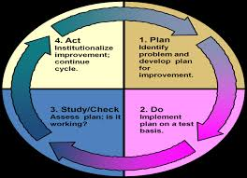

Check : Measure the results of the new processes and hold them against the expected results in order to determine the differences.
Act : Analyse the differences, generated in the checking stage, to determine their cause, and decide where to apply changes for further improvement.

Q: 4) Draw and explain Environmental Valuation Methods.
Answer Q: 4) The figure below presents some of Environmental Valuation techniques and classifies them according to the basis of the monetary valuation, either market-based, surrogate market or non-market based.
Preferences

Stated Preferences
Revealed Preferences

Non-Market Based
Surrogate Methods
Market Based

Defensive Expenditures
Producer/ Consumer Surplus
Factor of Production
Choice Experiments
Contingent
Valuation
Travel Cost
Hedonic Pricing

Market-Based Methods:
Markets enable economists to measure an individual’s willingness to pay in order to acquire or preserve environmental services. In turn, consumers reveal their preferences through the choices they make in allocating scarce resources among competing alternatives.
There are a number of market-based methods of environmental valuation. There are three market-based techniques:
- Factor of production approach,
- Change in producer / consumer surplus and
- Examination of defensive expenditures.
The value of a natural resource can be monetised based on its value as a factor of production. An Economic view of the Environment notes that the output of any firm is a function of several important inputs, e.g. land, capital, natural resources, which are collectively known as ‘factors of production’.

Surrogate Market Methods:
Due to the absence of clearly defined markets, the value of environmental resources can be assessed from information from surrogate markets. The most common markets used as surrogates are those for property and labour. Two common surrogate market methods discussed below are
the Hedonic price method and the travel cost method. The hedonic price method employs surrogate markets for placing value on environmental quality. The real estate market is the most commonly used surrogate in this price method.
Travel cost method is used to measure the value of a recreational site by surveying travellers' economic costs incurred (e.g. time and out-of-pocket travel expenses) when visiting the site from some distance away. These expenditures are indicators of society's willingness to pay for access to the recreational benefits provided by the site.

Stated preference techniques:
A second class of techniques that can be used to estimate non-market values are those based on the stated preferences of individuals. Stated preference techniques involve the use of surveys from which estimates are derived of the non-market benefits of different resource use alternatives. Because they rely on the use of surveys, stated preference techniques can be used in more applications than revealed preference techniques.
The most widely used stated preference technique for estimating non-market values is the contingent valuation method (CVM). CVM questionnaires contain several well defined elements including a description of the study site, details of the proposed changes (including a method of payment), an elicitation question and a series of socioeconomic and attitudinal debrief questions.
A second stated preference technique that has been increasingly used to estimate the value of improved environmental quality and could be applied to valuing improved water quality is choice modelling (CM). CM has been used in a small, but growing, number of studies to estimate non-market values.

Q5) What are various forms of environmental accounting?
Answer Q5) The forms of environmental accounting are listed below
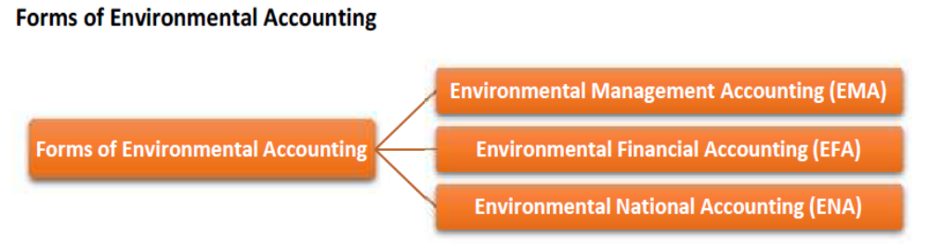
1. Environmental Management Accounting (EMA): This refers to management accounting with a particular focus on material and energy flow information and environmental cost information. This type of accounting can be further classified into the following subsystems:
  - Segment Environmental Accounting: This is an internal environmental accounting tool to select an investment activity or a project, related to environmental conservation from among all processes of operations and to evaluate environmental effects for a certain period.
  - Eco Balance Environmental Accounting: This is an internal environmental accounting tool to support PDCA for sustainable environmental management activities.
  - Corporate Environmental Accounting: This is a tool to inform the public about relevant information compiled in accordance with Environmental Accounting. It should be called Corporate Environmental Reporting. For this purpose, the cost and effect (in quantity and monetary value) of its environmental conservation activities are used.

2. Environmental Financial Accounting (EFA): This refers to financial accounting with a particular focus on reporting environmental liability costs and other significant environmental costs.

3. Environmental National Accounting (ENA): This refers to national level accounting with a particular focus on natural resources stocks and flows, environmental costs and externality costs etc. Need of Environmental Accounting at Corporate Level: It helps to know whether an organisation has been discharging its responsibilities towards the environment. A company is expected to fulfil the following environmental responsibilities.

================== The End ============================

Student Statement:

By submitting this assignment, I confirm that this is my own work.

Student Signature | Ahmed Ansari | Date | 29/08/2018

For Tutor / Assessor Use Only
Total Marks
Marks Obtained
Percentage / Grade

