
Assignment Cover Sheet

Student Name: | LOUISA CONRAD CHORUMA
Student Number: | 6262
Course: | International Diploma in Project Management
Assignment NO: | 4

Marking Criteria:
We expect the learners to write minimum one well expressed point in three lines against each allocated mark. This means one needs to write 15 lines with 5 well expressed points to get high grades for a 5 marks question.
For high grades use examples and illustrations where appropriate.
1

- C

- D

III C

2

- Project scope management looks at the work orientation how the project is going to be done. It is part of planning and involves determining and documenting a list of specific project goals, deliverables, features, functions, tasks, deadlines, and costs. That is – what needs to be achieved and the work that must be done to deliver a project.
- The purpose of Project Scope Management is to ensure the stakeholders have a full understanding of the project and that it is going according to their plans. It clearly defines and communicates the scope to all parties involved in the project. The project scope separates what is from what is not involved in the project. It forms the basis of every decision a Project Manager makes on a job ; time, cost, labor, when it needs to change and why.
- The activities involved in Project Scope Management are ;
A] Planning – which is defining the work to be done
B] Controlling – Control scope process is the process of monitoring the status of the project and product scope and also managing changes made to the scope baseline.
C] Closing – Involves an audit of the project outcomes, their assessment vs the original plan.

IV Project scope is everything that needs to be done to get the product delivered, and product scope is made up of features, functions and characteristics of the actual product. Product scope is the “what” part (functional requirements) and project scope is the “how” part (work related).

V Project scope statement outlines the project's deliverables, identifies the constraints, assumptions, key success factors and defines the boundaries of a project. Both parties who requested the project and the project team should agree to all terms in the Scope Statement before actual project work begins. It becomes the guide for future project decisions.

VI A work package is a group of related tasks within a project. They can also be referred to as mini- projects or sub-projects within a larger project.

They are the smallest unit of work that a project can be broken down to when creating a Work Breakdown Structure (WBS).These are tasks that can be easily assigned to one person, or team of people, with clear accountability and responsibility for completing the assignment At this level cost, time and resource estimates are determined. They feed into the sub task, then tasks and ultimately completion of the project. They are also referred to as terminal element of a Work Breakdown Structure.

VII A project Scope Statement is important as it is the blue print of the entire project. It clearly defines the project, goals, assumptions, constraints, deliverables and expectations. It documents what a successful conclusion to the projects looks like.

It can be referred to as the ‘’VISA’’ of the project as when both parties [initiator and project team] agree- then the project has the green light and proceeds. It details this agreement as well.

3.

‘’A deliverable-oriented hierarchical decomposition of the work to be executed by the project team to accomplish the project objectives and create the required deliverables.’’

— Project Management Institute (PMI)

The above is the Work Break Down Structure .It is important to breakdown the major project outcomes into smaller parts for the following reasons;
* It helps to more accurately and specifically define and organise the scope of the total project.This is done is by using a hierarchical tree structure ,where each level of this structure breaks the project deliverables into measurable chunks
* It helps with assigning responsibilities, resource allocation, monitoring and controlling the project.
*It is a checking mechanism that allows the project team to double check all the deliverables' specifics with the stakeholders and make sure that all is in order.

As per the example below,the main project is broken down into tasks,sub-tasks and finally work packages.This decomposition ensures all details are covered,teams assigned accurately tracked.All taskas are dpenedent on eachother.That is,once the work paskages are compteley they form a sub task which has to be compteled accurately before it becomes a major taask of the finaly project.

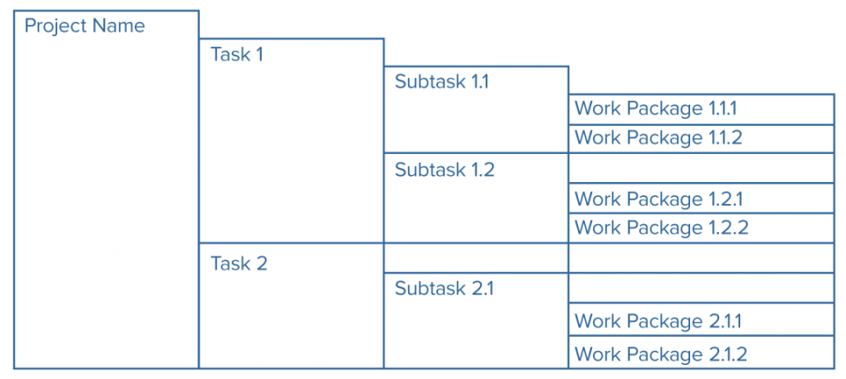

An example ;

Project Upgrade Cafeteria

Tasks Kitchen to be fully equippped

Increase seating area for diners

Sub tasks Extend the kitchen

Purchase and install kitchen equipment

Extend the verandah

Purchase and install tables,chairs

Work Packages Architect to design the new kitchen

Architect to design the extended verandah

Source for quotations equipment

Concepts developed for the kitchen and restaurant

Kitchen and Restaurant construction teams established

The Importance Of The Project Scope Statement

Kim Heldman, PMP Lakewood, Colorado, USA

pm.97things.oreilly.com

www.wrike.com/project

pmstudycircle.com/2012/01

Student Statement:

By submitting this assignment, I confirm that this is my own work.

Student Signature | LOUISA CONRAD CHORUMA | Date | 02/04/18

For Tutor / Assessor Use Only
Total Marks
Marks Obtained
Percentage / Grade

