
Assignment Cover Sheet

Student Name: | Brendan Reilly
Student Number: | 11962
Course: | Diploma in Accounting and Finance
Assignment NO: | 5

UNDERSTANDING PROFIT OR LOSS STATEMENT
ASSESSMENT 5
1.
The contents of a profit and loss statement or income Statement reveals a company's earnings to investors and owners. This is so they can understand how it is performing on a solid, economic basis. In the past Previously people would refer to the income statement as the P&L Statement. Profit and Loss Statement comprises of a Balance sheet, a profit, loss and comprehensive income statement. It is also a statement of changes in equity and finally cash flow.
The basic equation which right now I am simplifying in a big way is Revenues – Expenses + Profit. Some investors will be looking at this to see large profits, Some Shareholders might also want to see stable profits and interest.

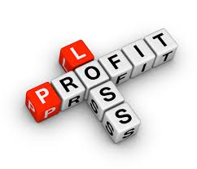
Things you will mostly see on a statement are:

Total Revenue $
Cost of Goods $
Total Operating Expenses $
Operating Profit (EBIT) $
Interest Expense $
Income before taxes (EBT) $
Earnings Per Share (EPS) $

Explained in more depth revenue is the money a business receives from the sale of goods or services. It can also be called the top line and be referred to as net sales or sale revenue. Cost of goods would cover material and labor hire, perishables and amenities. Operating expense is the amount it requires to run and operate the company, this can include research marketing, equipment hire etc.

Operating Profit EBIT is a way of analyzing a company’s profit before tax and interest. It can be useful to compare companies and evaluate them without their financial decisions and environments. Interest expense is essentially calculated as an interest rate which is to be paid off with principal. Income before tax is pretty self-explanatory and is the amount of profit before the latter.

EPS or Earnings per share is another way to compare its value to another similar company. Its value comes from the net income divided by the amount of common shares it has. It’s usually shown in dollars and is a popular choice for a quick and dirty stock value check. People investing, picking stocks etc of a company must know how to read these statements, including the profit & loss statement. It is crucial if they want to have a full understanding of where the company is at with its books.

2.
Assets = Capital + Liabilities. This equation explains about the financial position of a business and what is valuable in its possession. Assets can be Cash, Shares, land, Inventory, vehicles and tools, it can also be buildings, and computers even furniture. They are a resource that is available to the company if it so wishes and therefore if one was to own the company then they could sell off these assets. This is very common when a company becomes bankrupt and its assets are seized and sold to pay offs its debts.( Assets are the Applications of fund in a business) Quote from https://www.accountingcoach.com

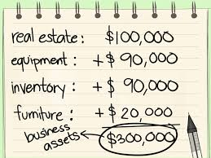
Capital is this scenario stands for what a business owns and it’s the Net worth of such business. Capital is what a business owns also commonly called equity. It is the investment into the business and made accessible by the owners from their own funds.
In a very basic sense liabilities are debts and obligations owed by a business. Liabilities include monthly payments, bills, paying staff and hired goods, corporate credit card debt, bonds issued to investors etc
This equation can be called the balance sheet equation. It will allow you to scale the financial health of a business. While the purpose of the Profit and Loss statement is to show you how a company has performed over a specific time period, the balance sheet is to show the financial position of a company on any day. These number calculated can give a potential investor great insight into some important figures and ratios.

Some important ratios which are commonly seen as a decimal figure are:
- Current ratio (total current assets ÷ total current liabilities): Measures the ability of a company to pay short- and long-term debts, so Is this company capable of paying all its bills in the short term and not accumulating more debt.
- Working capital (total current assets – total current liabilities): shows the amount of capital a business has to operate the business, so what they are working with and to reinvest in the business after meeting all its obligations.
- Inventory turnover (average inventory ÷ cost of goods sold): Measures the number of times inventory is sold and replaced within a certain period, so is inventory being used up and replenished on a regular basis.
- Return on equity: ROE (net income ÷ equity): Shows how much profit a company generates per dollar of equity. This can show whether it is a good investment but should not be the only source of information before a decision is made as lots is missing from this ratio.

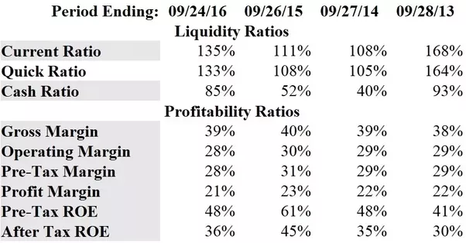
All this info will help people assess you company worth, how it’s managed and where it’s heading. It is strictly what is on the books and for the most part, the balance sheet can be manipulated but you can’t hide the obvious.

3.
I will discuss the following, Realization Concept. The realization concept is a common concept in accounting. It essentially means that accounts recognize transactions before they are complete. They do not just recognize the transactions when the first cash exchanges hands, but also when the transaction occurs at the sale, the service has been given, goods handed over and this is when the transaction is recorded. The payment of the items in question may not occur for days, weeks or months but it is legal once an agreement has been made and a contract has been signed. Also known as revenue recognition principle to some people. Using this concept ensures that the income statement reflects true revenue earned in the period and not the cash which has changed accounts.
Example:
Motors PLC is a car dealer. It receives orders from customers in advance against 20% down payment. Motors PLC delivers the cars to the respective customers within 30 days upon which it receives the remaining 80% of the list price.
In accordance with the revenue realization principle, Motors PLC must not recognize any revenue until the cars are delivered to the respective customers as that is the point when the risks and rewards incidental to the ownership of the cars are transferred to the buyers.
(http://accounting-simplified.com/financial/concepts-and-principles/realization.html)

I will now discuss the Matching Concept. The matching concept in the revenues calculated in a period are to be matched in the same period with the expense made. This is most of the time fairly easy thing to do, so hence it’s again common. It may become tricky with things like salaries and payouts which are not matched but can be taken as a period expense. It is not necessary that every expenses recognize every income. Some expenses are related to the revenue and some are bond by time. So to put it another way, periodicity concept has also been followed while applying matching concept.

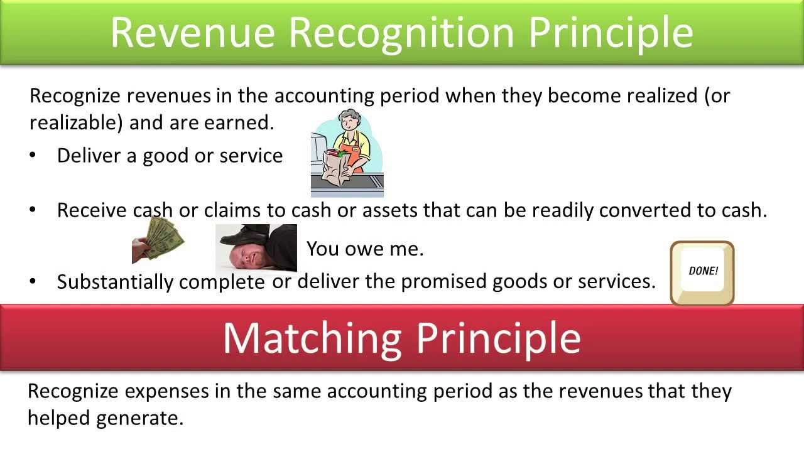
For example
If the fixed assets amount $50,000 and depreciation for five years as the result of economic use. Then, the depreciation expenses amount $10,000 per years should be recorded (https://www.wikiaccounting.com/ultimate-guide-matching-principle/)

To conclude the matching principle states where expenses can be matched with revenues, you should do so because the benefits of an asset or revenue should be directly linked to the costs of that asset or revenue.

Bibliography

A Dictionary of Accounting
by Jonathan Law, Gary Owen

Notes provided by Brentwood

Websites:
https://www.mbacrystalball.com/blog

https://iedunote.com

https://www.finance.gov.au/resource-management/.../australian-accounting

http://www.aasb.gov.au/AASB-Board.aspx

https://www.accountingcoach.com

https://www.wikiaccounting.com/ultimate-guide-matching-principle

Images found with google search

Student Signature | B.Reilly | Date | 2/5/18

For Tutor / Assessor Use Only
Total Marks
Marks Obtained
Percentage / Grade

