
Assignment Cover Sheet

Student Name: | Brian Witbooi
Student Number: | 19786
Course: | Diploma in Finance and Accounting
Assignment NO: | Assignment No 8

Marking Criteria:
We expect the learners to write minimum one well expressed point in three lines against each allocated mark. This means one needs to write 15 lines with 5 well expressed points to get high grades for a 5 marks question.
For high grades use examples and illustrations where appropriate.
1. What is the main difference between fixed and flexible budget?

Fixed budget remains constant or stable, regardless of any changes in activity on the other hand flexible budgets are influence by the level of activity. Fixed budgets only run on the production level or data and flexible budgets includes several budgets as a result also gets influence by different conditions. The flexible budget can be considered more accurate to evaluate the performance, volume and productivity compared to the fixed budget which are based on assumptions.

Why fixed budgets are preferred in government departments?

Most of the government departments workload don’t have a direct relationship to sales, production or other volume related to a department’s operations. It is primarily determined by management decision instead of sales volume.

Discuss the benefits of both types of budgets. (10)

Fixed Budget Benefits:

It eliminates confusion because they provide only one figure as a target. Requires less planning in order to track expenses and adjust for any difference between periods. The implementation of straight forward rules makes more room for honesty and less room for dishonesty by those that struggle to stay within the boundaries. Fixed budgeting also nurtures the same long-term habits because it stays fixed every month.

Flexible Budget Benefits:

It provides a tool that can manage seasonal expenses by adjusting for these large purchases when they occur, without requiring any adjustments in the next month. It is a good performance management tool because it is structed on activity levels and it can be used to evaluate the particular managers performances. Budget efficiency, because it can be used to more easily update a budget for which revenue or other activity figures have not yet been finalized.

2. What is zero based budgeting? Explain the process of zero-based budgeting. (10)

Zero based budgeting begins with zero balance and articulates objectives to be achieved. All activities are analyzed for the specific year. This approach of budgeting sets minimum amounts for each activity and amounts above the minimum levels must be fully justified in order to be approved by the upper management.

Each product, program or service are looked each year and gets reviewed on merit, taking in to consideration the final production output and the input it requires. Anything that doesn’t make financial sense normally gets dropped.

Process are as follow:

1.Indentifying the Decision Units on which a cost-benefit analysis is to be conducted, and then decide whether the programs in question will carry on or not. These units are independent of each other so that they can be stopped without having any effect on other units.

2.Making decision packages from the previous identified units, by braking them down into smaller packages, which should be in line with the company’s objectives. They then act as standalone proposal which are appealing for allocating funds.

3.Ranking all the decision packages with in a unit and among various decision units as per their importance, priority and based on the cost benefit analysis. While doing this all the alternatives options are evaluated in order to select all the better and cost-efficient options. Top management reserves all the right to approved or reject a decision package. The approved packages are normally selected with the company’s predetermined goals in mind, how accurate and realistic they are.

4. Allocating available resources as per ranking in the previous step. At this stage of the process a funding decision are made and because its allocated as per ranking the most promising package get the better funding. This ensures optimum utilization of resources.

5. The final step in the process of zero-based budgeting decision packages are monitored and evaluated for their performance and output. This helps management to understand whether the allocation resources were done accurately or not.

3. How variance in budgets can be used as tools of controls in an organization.

Explain this using illustration. (10)

The variance is the difference between the budgeted cost and the and the actual cost and it is similar for revenue of a business. When business examine this process in detail it becomes an effective controlling tool as illustrated in the below example.

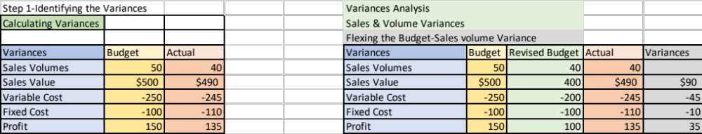
The basic analysis that can be determine from the numbers as the mentioned above is that the difference in the budgeted revenue and actual amount are from the price of the units and not the volumes. It’s important when looking at variances to calculate the percentage of the sales volumes and price.

Reference:

Surbhi. S. 2015. Difference between fixed budget and flexible budget. Available at: https://keydifferences.com/difference-between-fixed-budget-and-flexible-budget.html
[Accessed: 11 September 2018]

Zero based budgeting. Available at: https://efinancemanagement.com/budgeting/zero-based [Accessed: 27 August 2018]

Schmidt, M. 2018. Building the Business Case. Available at: https://www.business-case-analysis.com/budget.html [Accessed: 3 September 2018]

Student Statement:

By submitting this assignment, I confirm that this is my own work.

Student Signature | Brian Witbooi | Date | 17 September 2018

For Tutor / Assessor Use Only
Total Marks
Marks Obtained
Percentage / Grade

