
Assignment Cover Sheet

Student Name: | Marlene Grant
Student Number: | 12435
Course: | Diploma in Forensic Accounting (Level 4)
Assignment NO: | 3

Marking Criteria:
We expect the learners to write minimum one well expressed point in three lines against each allocated mark. This means one needs to write 15 lines with 5 well expressed points to get high grades for a 5 marks question.
For high grades use examples and illustrations where appropriate.
- You are an investigative officer, how would you differentiate between high and low level thieves?
Maguire and Bennett argue that persistent career thieves are divided into three levels:
- High level
- Middle level
- Low level
The level is determined based on the basis of the scale of their crimes.(See figure 1)
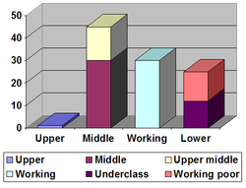
Figure 1

High Level Thieves
High level thieves are committed by top level executives and managers. These thieves cause the greatest damage to the organization. Fraud committed by these executives are three times as costly as fraud committed by lower level employees because it involve large sums of monies. Executive level frauds also take much longer to detect. Executives use their social and cultural background as well as their specialized knowledge and skills to their advantage.
At this level the internal control is easily bypass because they do not work alone, so the collusion will enable employees to better circumvent controls that might otherwise be stopped by a single perpetrator.
There are normally lower incident of fraud at this level. These are normally committed by long term employees who are a trusted part of a team that is able to take advantage of their situation to get their hands on company assets.
These individuals are usually males at the age of over 60 who are at the higher income stream. The gender disparity might be due to males holding more management and executive positions. They are normally persons who have good educational background, the higher the education level, the more costly the fraud.
In most cases these offenders are persons who have never been subject to criminal charges.
High level thieves are involved in fraud, bribery, Ponzi schemes, insider trading, forgery, identity theft, embezzlement and money laundering.
Example- An employee who know that a product is about to be recalled, which would cause stock prices to fall. If the employee sells his or her stock before the information is released to the public or even simply tells a friend to sell or short their stock shares, he or her is committing insider trading.

Low Level Thieves
Low level thieves on the other hand are committed by low level employees. These thieves are the highest percentage of fraudsters who normally work in the accounting department. Because these employees handle financial transactions, they normally have the easiest access to fiscal assets and the most opportunity to conceal fraud.
The incidents of fraud are more numerous because of the large number of employees at this level. The sums stolen are usually much smaller but the frequency is much more than at the higher level.
The internal control is not easily by passed because they normally work alone. These are also normally committed by long term employees who are a trusted part of a team who take advantage of their situation to get their hands on the company assets. These individuals are usually male or females at the age of 41-50 who are at the lower income range. In most cases they only have high school education and have never been subjected to criminal charges.
Low level thieves are involved in Larceny, skimming, check tampering, billing schemes, payroll schemes and expense reimbursement schemes.
Example- Jane Smith is responsible for recording cash receipt. A customer made a payment of $900 but Jane only recorded $850. The customer was contacted about the unpaid amount, the customer provided the company the receipt showing the $900. It was later found out that Jane was skimming money from the business for years.

- Give the profile of a typical criminal who commits more expensive fraud.

Frauds involving large sums of money are particularly committed by:
- High level executives
- Long term employees of the organization
- High income earners
- Males
- People aged over 40
- People with good educational background
- People working in collusion with other perpetrators
- People who have never been subject to criminal charges

Illustration below (figure 2) highlighted some additional characteristics of a fraudster.
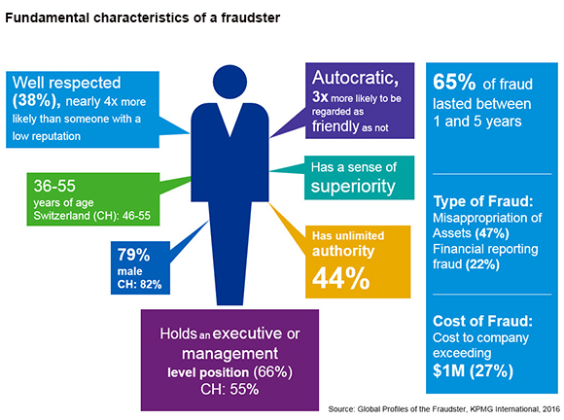
Figure 2

High Level executives
Authority tends to be strongly correlated with loss because high level fraudster generally have greater access to organizational assets and are better able to evade or override controls.

Long Term Employees
The longer the tenure, the greater the loss. Long term employees might have been more familiar with weaknesses in a firm and could find ways to circumvent them. They gain the trust of their co-workers and supervisor which result in less scrutiny over their duties. They also have a better understanding of the organization internal controls which enable them to successfully carry out and cover fraud schemes.

High income earners
These types of fraud are normally committed by Executives and they are the highest paying employees.

Males
Males are more than twice as likely to commit expensive fraud because males normally hold more management and executive level position.

People aged over 40
Younger people have not had the opportunity to start a business or establish themselves in the labor market. Older professionals often occupy positions with authority and more access to company resources.

People with good educational background
Higher educated fraudster possess greater technical knowledge and skills that help them to be more successful in their fraud schemes. The more highly educated individuals have greater authority within the organization.

People working in collusion with other perpetrators
Individuals who have worked for an organization for a long time might engender trust from their colleagues which mean certain decisions are not questioned by other co-workers.

- Define the term calculating criminals.
Calculating criminals are relatively well educated and tend to have higher than average intelligence. They are repeat offenders. (See figure 3)

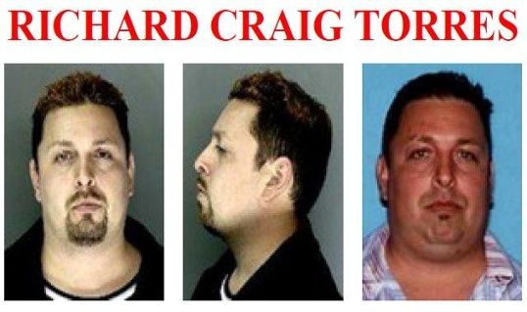
Figure 3

These type of criminals are generally known as predators. These are persons who ruthlessly exploits others for personal gain or profit. Examples of a predator are listed below in figure 4.


Figure 4

They are risk takers and lack feelings of empathy and anxiety. They usually start criminal activities later in life. They lack self-esteem and confidence and are motivated by their desire to fit in and be accepted. Their success is determined by the opinions of the outsiders as they lack inner direction. These criminals are usually very good with people.
Example – An in house surveillance showed a man going through the window of an elderly lady’s home. The man was found and pleaded guilty. It was later found out that the same man had spent 5 years in prison dated back in 1999 for a similar crime.

- What is the main difference between Situation Dependent Criminal and Power Brokers?
The difference between situation dependent criminals and Power Brokers are as follows:
Situation Dependent Criminals
Situation dependent criminals are ordinary people who genuinely intend no harm to anyone but get caught up in something they find themselves unable to stop.
Situation dependent crime arise when the three flags of the fraud triangle are present
- Pressure
- Opportunity
- rationalization
These criminals convince themselves that what they are doing is not wrong because they do not mean any arm to anyone. They even convince themselves that they deserve whatever they get from deception and fraud because their crime are innocent and immaterial.
An example- A bookkeeper at a small but successful company who get into too much personal debt, putting pressure on herself to come up with extra money. The company is small enough that she perform essentially all the accounting function herself with little or no oversight providing opportunity to steal company funds and cover it up.
She start off taking small amounts to pay bills, telling herself she will pay the money back, maybe doing so the first or second time but soon she has taken more than she can ever pay back.

Power Broker
Power Broker is an individual who through his or her connection is able to influence the decisions of other parties. A power broker is typically an industry insider and is familiar with other individuals and groups, and are able to exert influence or make decisions. Power brokers possess characteristic of both calculating criminal and situation dependent criminals. They believe that they have the power to succeed at any cost.
Power broker may be elected officials, business leaders or individuals who are connected. Because of the influence power brokers have on organization decision makers, they are able to command high fees and the attention of individuals, organizations and companies looking to make headway with a particular goal.

- What are the three situations that are usually present in fraud case, according to the fraud triangle:

In order for fraud to occur the following conditions must be met:
Pressure
Opportunity
Rationalization

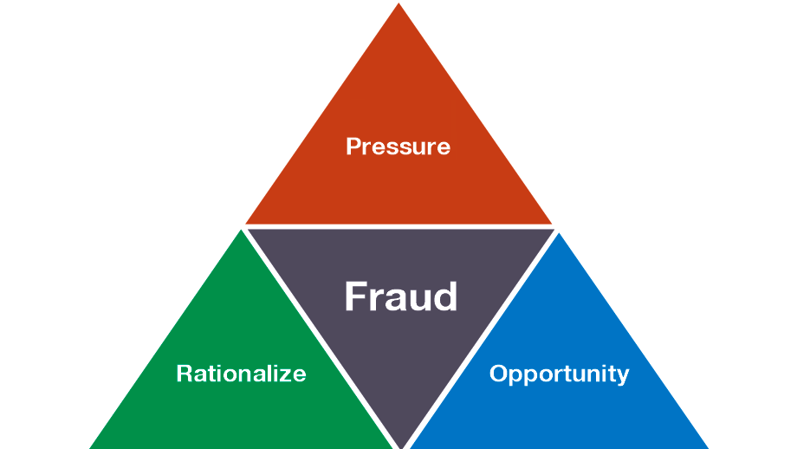
Figure 5

Think of a fire, in order for a fire to burn it must have heat, oxygen and fuel. When all three are present a fire will burn out of control, the same is true for a fraud when pressure, opportunity and rationalization (figure 5) intersects fraud is highly likely to occur.

Pressure
Most individuals require some form of pressure to commit a criminal act. Pressure is what motivate the crime in the first place. The pressure does not need to necessarily make sense to outside observers but it does need to be present. It is based on either greed or need. Most of the time pressure comes from a significant financial need or problem.
Pressure can include money problem, gambling debts, alcohol addiction, overwhelming medical bills. Greed can also become a pressure but it usually need to be associated with injustice. The company has not been paying me what I really worth.
Example of pressure that can lead to fraud are:
- Inability to pay one’s bill
- Drug or gambling problem

Opportunity
Opportunity is the ability to commit fraud. Opportunity is created by weak controls, poor management oversight and or through use of one’s position and authority. Opportunity defines the method by which the crime can be committed. An opportunity to commit the act must be present. The person must see a way he/she can use with low risk of getting caught. In the case of fraud usually a temporary situation arises where there is a chance to commit the act without a high chance of being caught. Companies that are not actively working to prevent fraud can present repeated opportunities to individuals who meet all there criteria of the fraud triangle.
Example - An employee having full control to the company’s asset and there is no segregation of duties, so the employee realizes that the internal control is weak and the risk of being caught is low.

Rationalization
Rationalization involves a person reconciling his/her behavior with the commonly accepted notion of decency and trust. The mindset of a person about to commit an unethical act is one of rationalization. The majority of fraudsters are first time offenders and do not view themselves as criminals, so they try to justify the crime to themselves that make it a justifiable act. The individual manages to justify what he or she is about to do. Some may think they are just going to borrow the stolen goods, or that they need the money more than the big company they are stealing from.
Example of rationalizations are “I was only borrowing the money”; I had to steal to provide for my family.

A financially strapped employee is not going to commit fraud if the opportunity is not available or if the risk of getting caught is too high. The more pressure a person feels to commit fraud the easier he or she can justify it. Being aware of these three conditions can help managers and business owners to minimize the risk of fraud in their organization.

- Briefly describe the Gwynn Nettler’s perception about employees lying, cheating, and stealing.

People who have experience failure are prone to cheat. People who are not liked and hate themselves are more likely to be more deceitful.
People who are thoughtless, capable of being distracted and unable to delay fulfilments are more likely to be involve in deceitful crimes.
People who have a sense of right and wrong are more resistant to commit a crime.
Intelligent people are more likely to be honest than uneducated people. Middle and elite class people tend to be more honest than lower class people.
The easier it is to commit a fraud and cheat, the more people will do so.
Individuals have different need and levels at which they will be adequately driven to lie, cheat and steal.
Lying, cheating and stealing increase when people are under stress to attain important objectives.
The struggle to survive leads to deceit.

- What are the typical motivations for a white- collar criminal, which persuades him to commit fraud?
It is assumed that several factors motivate white collar criminal to commit fraud. Some of the factors that motivate a white collar criminal are:-
- Greed is at the top of the factors that motivate executives to commit a crime. The executives wants for more and so they will use his/her position and related authority to get it.
- Many persons are trying to accumulate material things at any cost. Greedy people believe that everyone commits fraud. Greed affects all professional walls of life; politics, medicine, and business enterprise. A sound reputation is far less important than money, because criminals have started to believe that it is the only way to obtain happiness.
- Crime are committed when people are of the opinion that the advantage of breaking the law outweigh the threat of punishment. White collar perpetrators tend to receive lenient punishment and some even go unpunished.
- Possibility of financial gain seems to be the strongest motivational factor. The pressure on individuals to obtain greater economic wealth is very strong and people will cross the barrier between the legal and the illegal to perform according to social norms.
- Financial failures and frustration with the business or financial problem at home could provide the necessary motivation to commit a crime.
- There are often discrepancies between material possession a person has and what that person wants, such person may underestimate their ability to reach financial success and this might push them to commit crime.
- White collar criminal believe that they deserve better standard of living and that their neighbor has a good lifestyle and they should be entitled to the same standard of living.
- They rationalize their wrongful actions so that they do not have to see themselves as abnormal or as a criminal.
- The internal control that is put in place by the organization to prevent crime are so weak that everyone think that it is easy to steal.
2. The profile of a white collar or blue collar criminal is different from other typical street criminal. Discuss this.

White collar criminals commits non-violent crime that is typically for financial gain. The typical white collar criminal is an office worker, business manager or executive. White collar versatile offenders are highest in criminal thinking. White collar criminals are distinguished from non-white collar criminal by substance use.
Most white collar criminals are very clever in evading detection by enforcement and avoiding skepticism from their victims. They build a wall of false integrity around themselves to increase the comfort level of their victims. These criminals do not have any previous records.
These crimes require a certain amount of status and power with the organization that can only be gained by white collar workers.
Blue collar on the other hand are crime that are committed primarily by people who are from a lower social class. Blue collar worker may not have access to the same resources as white collar workers, so they tend to commit crimes that are immediate and personal in nature, such as robbery, rather than crime that involve elaborate planning.
Street criminal is any criminal offense that typically take place or originate in a public place ex pickpocket, carrying of illegal drugs and trade, prostitution in the form of soliciting outside the law.

3. “Fraud is most common in organizations that have no controls, no trust, no ethical values, no profits, and no prospects.” Discuss this.

An organization that does not have any evidence of control, trust, ethical value, profit and prospects such a situation increase the risk of fraud. Evidence show that the most common factor in all frauds committed is because of the lack of segregation of duties with no effective control.
These situations are common in small businesses and organizations. These organizations are more likely to have only one accountant who is responsible for all financial task, there is no segregation of duties and no control mechanism.
Fraud is also common where there is no ethical values and trust, because managers and employees will do as they please. They do not adhere to the laws and rules of the organization. Code of ethics is a formal statement of the company’s values concerning ethics and social issues, it communicate to employees what the company stands for. These improper behavior can have a bad influence on the organization’s employees, shareholders, creditors, customers and society. It can also cause severe damage to the reputation of the organization and in some cases can cause the organization’s demise.
An ethical infrastructure is needed because it will provide a clear guidance for managers and employees which will help them know what is expected of them in terms of ethical behavior. It will also enhance the organizations reputation and promote an ethical climate and culture in the organization.
The attributes that drive trust are:
- Competence
- integrity
- care
Competence- This as to do with the way we do our job right.
Integrity- Sticking to a code of behavior i.e. behave properly when they are doing their job.
Care- As to do with how we care about our colleagues that we are working with.
Where there is no focus on profit fraud is possible, because there is no internal/external auditor to review the work that is done so employees will do as they please because no one is checking. The company has no budget to spend to have experts come in to do any investigation. In such an organization the layer of managers are not deep, so there is no process or program set up to detect fraud.
A total lack of trust will breed disloyalty and dishonesty.
In order to detect and prevent fraud organizations must have control mechanisms in place. These controls that are put in place must be cost effective and must not be too excessive. Even though it takes time and money for a business to implement proper controls it may pay them in the long run because it will help to reduce loss.

Case study
- If the trader has actually committed the crime, what kind of crime it is?
Based on the information that is provided in the case there are three likely crimes that could have been committed:
- False Representation
- False Advertising
- Copyright Infringement
Any statement representing your product or services should be true, accurate and able to be substantiated. It is therefore illegal for a business to make statements that are incorrect or likely to create a false impression. The trader used photographs from books and magazines to give the impression on his website that he had experience of fitting luxury kitchen. This crime that the trader commit would be consider fraud by false representation because the trader was selling and fitting kitchens using recycled materials and the website he created to support the service displayed some very impressive photographic results of his work.
There could also be a crime of false advertising, because the trader gives consumers an incorrect understanding about the product and services being offered. The consumers have a right to know exactly what they are buying, the services that is provided, as well as what they are paying for. Publishing of advertisement designed to deceived or mislead consumers is against the law and is therefore considered to be a crime.

There could also be copyright infringement. In copyright law, infringement does not refer to theft of physical objects that take away the owner’s possession, but an instance where a person exercise one of the exclusive rights of the copyright holder without authorization.
It does not appear as if the trader as committed any tax evasion because the trader had not sold or fitted any kitchen during the period.

- How can forensic expert investigate the case properly when trader could have sold the goods without generating any invoices or on cash?
- Look at the number of persons who visited the website- this will tell you how many person were misled based on the impressive photographs.
- Check follow up made by these person- check email, telephone records- look for archived emails, extract data from server or hard drives. This will help you to determine the type of conversation that took place and the interest of the consumer.
- Make contact with some of the persons- Able to question whether are not a purchase was made and the payment method.
- Look at material purchased- contact suppliers and get confirmation.
- Look at the stock on hand value- this would determine whether or not material was used.
- Determine the cost of goods sold using the formula- (Opening stock + purchase – Closing stock).
- Check the cost of electricity to determine the usage.
- Look at the payroll register to determine the total salary cost- this could be paid based on production, if so this will determine the amount of kitchen that was actually fitted.
- Bank statement- Able to determine the amount lodged and its source, the withdrawal made and the purpose it is used for.
- Credit card statements -This will reveal what type of services were paid for and the amount. This will also reveal the frequency of the transactions.

References
- Silverstone Howard, Sheetz Michael (2007) Forensic Accounting and Fraud Investigation for Non-Experts. (John Wiley & Sons Inc.).
- Thomas w. Golden, Steven L. Skalak and Mona M. Clayton (2006) A guide to Forensic Accounting Investigation. (John Wiley & Sons Inc.).
- Kass-Shraibman Frimette, Sampath S. Vijay (2011) Forensic Accounting for Dummies. (John Wiley & Sons Inc.).
- Wells,J.T. (2006) Principles of Fraud Examination

Student Statement:

By submitting this assignment, I confirm that this is my own work.

Student Signature | Marlene Grant | Date | April 23, 2018

For Tutor / Assessor Use Only
Total Marks
Marks Obtained
Percentage / Grade

