
Assignment Cover Sheet

Student Name: | Ioana Balint
Student Number: | 29235
Course: | Customer services Level 1
Assignment NO: | 1

Marking Criteria:
We expect the learners to write minimum one well expressed point in three lines against each allocated mark. This means one needs to write 15 lines with 5 well expressed points to get high grades for a 5 marks question.
For high grades use examples and illustrations where appropriate.
- What is customer service?

Customer Service is a mode that a company uses to treat their customers, stakeholders, employees, and all internal and external customers in general that helps the business to grow.

A good customer service can be defined by the following: Patient, attention to details, ability to express, work under pressure….The first one that I have named it can be find in a scenario when a client that ask for help, or maybe he need an advice what product to choose, the service provider needs to be patient and pay attention to what he says in order to respond to the customer expectations.

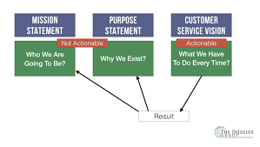

https://www.google.com/search?q=1.+What+is+customer+service

Attention to details: listening with patience can deliver valuable information for and about the business. Solving the problem and have on the back of the mind customer satisfaction so, the representative have to know when to end a conversation and see when the client is happy with the response.
Ability to express: Selecting the correct words to talk can help the customer to make a difference. For example If a product is not available at particular moment in store but “we can put you first on the list for the next week and we can call you to inform that the product is in store”.

Work under pressure: the ability to stay calm in front of an irritated customer, good sales department know they that this is an important point for them in order to keep the customer loyal.

- Explain critical elements of customer service.

I have learned that at least six critical elements that are discussed along this unit.
- Customer service focus
- Defined within your organization
- Given life by the members of the organization
- Be a problem solver
- Measure it
- Reinforce it

The most important point here is to know exactly who the customers are. Because not only the people that buy goods or services from us are the customers. The customers are divided in two main categories “internal and external” Internal customers are those staffs, departments that obtain the goods or services. Talking about LTD’s that nearly all of them have internal customers, but a person that work for himself does not have internal customers.

External customers include the people that end the line of company’s goods/services. There are also VIP customers that are treated different from others and that because they spend more money in the business. An example of this is a football team, in this case and not only VIP, want to be important, to fell welcomed and have an exceptional treatment within the organization.

In the other hand happy customers are the customers that become loyal in the future, and also to spread the word to their families, neighbors that is going to favorer the business. The people that are in contact direct with the happy customer are the most important factor to create point of view of the business.

Capable Employees help to attain more efficient customer service as that lets them to make confident choices generally demanding management intervention. A staff that say to the client “Let me talk with my manager first are getting frustrating and is getting ineffective for the customer. The most critical element for the staff is get them trained to take smart decisions on time.

A Feedback and reword customer it is also a key element in order to get a good customer service. Encourage them to fill a form saying how they see the service that the business provides, what kind of expectations do they have, given them all the information on the back of the receipt, in order to take reasonable action that is necessary to solve problems. Reword customers creating a program like a card points, in order to communicate them how important are them for the business.

3. Outline some ways of meeting customer's expectations.

Every one of the customers like to be attended in the same way that they are the unique like a special care, look for details, even that they know that it happen only at the time they are in the shop or buying companies goods/products. The main expectation that a customer suppose are: be polite, when a promise is done to a customer needs to be carried out even if the business do not gain too much from it, listen them, be there when they need you, and all that because today more than ever the competition is around the corner and when they have a better treatment they will change to another.

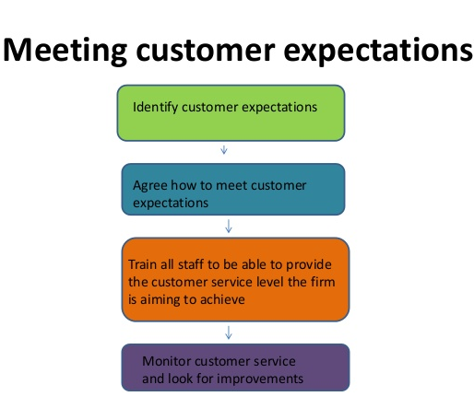
https://www.google.com/search?rlz=1C1CHBF_roGB748GB748&tbm

The way that a business is successful by understands their clients are detecting their needs. For this a business need customer research that helps the business to select products, adapted to marketing, and improve sales strategies for the clients in the market founded on consistent, precise information. Customer research offers more detailed data on the needs, wants, opportunities and behaviors of consumers.

4. What are the important steps of creating a personal vision?

In order to set short and long terms goals a personal vision needs to be created. So tree important steps are needed in order to create a personal vision.

- To identify the values

1. | Decision making
2. | Ethical behavior
3. | Weekly list
4. | Challenged by deadlines
5. | Organized
6. | Building relationship with others
7. | Efficiency
8. | Creativity
9. | Helping those in need
10. | Reliable

- Defining those values

Decision making- is an important step for me they need to be capable to be implemented personal or organizational level. So I need to be confident with the decision not only personally but also persuade others if necessary.
Ethical behavior- is defined as the moral code that guides the behavior of people with detail to what is right and wrong, and to what is good and bad, in regard to conduct and decision making.
Efficiency- After taking decisions and behave ethical I think the efficiency is one of the important thing in order to perform, and it is the main factor to measure productivity.

- Combining this three values
Combining these three values I see myself motivated and I can motivate others too, having a solid will and determination helps me to build a moral motivation and go further in order to achieve my goals and objectives.

5. Why creating a personal vision statement is important?

Because the words have power a personal vision statement is important in order to have a clear long-term goal. Most people think in short term goals in order to make a decision, but it is known that the people that have success are the people that pay attention to the future. A vision statement gives opportunity and hope for better future and certain activities that people do. Even if at first seems to appear meaningless, when a person have a vision statement that can be seen it value in long-term period.
This statement helps to determined people as they have a clear objective in their mind, so that helps to avoid tensions or stress.
Through a worthy vision statement, people discover easier to justice to all facets of life. For example; Relationships, Profession, Money, Health etc.
Additional, having a vision for life aids people push limits and not get into an ease zone, constraining to do things that would not have done otherwise.

6. How can we set goals using SPIRIT?

S – Specific (is about what the person want or not to achieve. The results have to be concrete and measurable).

P – Prizes
I – Individual –(This goals are something that a person want to do/ determinate to do it)

R – Reach High/review the progresses time to time, see if the goal makes any sense, if there is an adjustment need in order to get to accomplish the goal.
I – Inspiring – (Setting the goal clearly. Make it fun to be achieved. Reflect results and framing them for upcoming inspiration.

T – Timeline and Deadline-( having a deadline for the goals and try to split the goals in small parts and so it is easy to have a deadline for each of them )

In order to get this goals set up, leaders pay significant attention to develop an organizational strategy, the goals are as a bridge that link strategies with the good results. In conclusion setting goals is very significant for individuals.

Student Statement:

By submitting this assignment, I confirm that this is my own work.

Student Signature | Ioana Balint | Date | 27/04/19

For Tutor / Assessor Use Only
Total Marks
Marks Obtained
Percentage / Grade

