
Assignment Cover Sheet

Student Name: | Andrew Croney
Student Number: | 228574
Course: | Advanced Skills for Practical Trainer Level 3
Assignment NO: | 5

Marking Criteria:
We expect the learners to write minimum one well expressed point in three lines against each allocated mark. This means one needs to write 15 lines with 5 well expressed points to get high grades for a 5 marks question.
For high grades use examples and illustrations where appropriate.
1. I. Kirkpatrick’s model of valuation is Reaction, Knowledge, Transfer of Learning and Impact/Results.
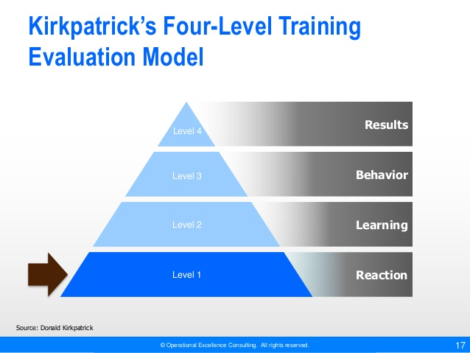
Kirkpatrick’s, evaluation model looks at how effective the training has been for not only the participant, but also the trainer.
Was the trainer effective in training the participants? This is an important question, because the participants could have acted happy and gone away feeling engaged and newly knowledgeable but are they really? This can be down to how the session was run. Therefore a feedback or evaluation form after the session really shows whether the training was effective.
II. If some of the participants in a session don’t have English as their first language then it will be very difficult for them to understand and take part in the session. By using lots of break out team sessions and visual aids they will be able to get a better understanding of the training and the objectives of it. Using the team members who do have English as a first language will aid them in their learning of English and the session.
2. I. Communication within training is extremely important not only for the trainer but also for the participants taking part. Being clear and setting objectives is one part of this and keeping participants notified on the session, training materials to be used, revision before the session and how the session will be run are just some of the key communications that will be needed. They keep the participants informed of what’s to come,
II. Questioning is a valuable tool when training. Without it key information won’t be given and received which benefit the session. It can be used to seek clarification, request information and obtain facts, to name a few. Using the questions can also depend on hearing any hidden meaning from conversations from participants.

III. There are many different types of questions that can be asked by the trainer to gauge participation reaction and to enhance their sessions.
Leading Questions: These contain the correct answer and are used to help get the answers from participants that shy away or are quiet. An example would be, “You can see how well everyone is working in a group in this session, cant you?
Using these types of questions are valuable to ensure all participants are engaged but shouldn’t be used too often as others may feel they are not getting the most out of the session.
Factual Question: These questions focus on open questions so that proper answers are given rather than just a Yes or No. Some examples are: How would you like the session to be run in the future? What would you particularly like to see in the sessions? When would you want to see how the day is planned? Where do you think the best place to hold the meeting is? Why is that particular subject relevant to the session?
Problem Questions: These are to challenge the participants and at the same time stimulate them. They are used to amalgamate numerous factors and set a situation. They may also bring in controversial elements. An example would be: If you have a group of participants that have no interest in the session and won’t participate, what do you do to get them back on track and engaged?
Attitudinal Questions: These types of questions are used to find out the feelings of other people and bring them out. An example would be: If I can get clarification, you feel that the information given isn’t relevant to the task involved. Do the other participants agree with this?
3. Kirpatricks levels of evaluation are split in to four main components.
These are: Reaction, Knowledge, Transfer of Learning and Impact/Results.
Reaction
Reaction looks at measuring the participants reaction to what they are learning. It looks at various parts of this such as were they happy with the delivery, did they like the trainer, was the content relevant enough, did they feel satisfied at the end.
Feedback forms or verbal acknowledgement are often filled in quickly and without full thought, as some participants feel they have to do them to get out of the session. It’s only when you hear the true feedback (often while having a chat over a smoke break!) that you get the true answers.
For some people learning is difficult and sometimes a waste of time, so by using feedback, the organisation and trainer can gauge whether all participants were happy at the end. Alternatively, feedback could be asked for mid way through, or even after each subject delivered.
Questioning that could be asked mid way through or at the end could be:
- Is everyone happy with current content?
- Does anyone need a recap on any part/parts already discussed?
- Are the materials provided adequate enough?
- Am I speaking too fast or slow?
There are so many more questions that could be asked however, this could make the session over run or make other sections shorter, but will give the trainer an indication if they need to change their method of delivery. A commonly used answer to questioning is to have a “Car Park” on the wall. This is a piece of flip chart paper or a section of a blank wall that participant can put stick notes on to with questions they may already have. These can then be analysed in the break times by the trainer for find the answers, or gone through at the end.
Another way to gain this feedback is to use a continuum chart. By placing the 5 points (Strongly Agree, Agree, Neutral, Disagree, Strongly Disagree) on paper around the room, and asking participants to stand by which one they feel this will give the answers required to either revisit a part of the training or offer more help at a later date.
Knowledge
This part of the evaluation process looks at whether the learning has worked. Did the participants learn what was required? Simple tests can determine this i.e.: question and answer tests. However, it is not always about knowledge.
Sometimes a skill is to be learnt. If this is the case then normally a post course test would be needed to assess the learning. For example a part time carpentry course teaching home DIY may have a test where a door needs to be hung, or a stud wall built to show what has been learnt. While a practical test would probably be the best way to assess the learning, a comfort evaluation could be done just as easily.
A change in attitude is the hardest to test for. While there is no specific test that can be done, it is better to evaluate how the participants are working after learning their new skills. This will in turn show how their attitude has changed. This could also be done on a monthly basis also so that if extra training is required this can be sorted sooner rather than later.
Transfer of Learning
Transfer of learning is often the most effective way to evaluate. It looks at whether the participants are going to use their learning when back at work or in the situations that they have needed the training.
When evaluating this step quite often it means having to collect information from not only the participants but also their superiors, colleagues and potentially also customers or key contacts. The aim is to see whether they have learnt and they are using their new knowledge effectively. Questionnaires are a common way of doing this although they are more intricate ways to evaluate to really delve deeper. Using a questionnaire for customers or key contacts would be a better way as they people outside of the organisations. For internal colleagues or immediate managers then a more in-depth evaluation would be more beneficial.
Having a continual development plan for participants will give them something to work towards and also for their line managers or superiors to continually evaluate and work with their staff. This could be set out by the staff member and manager or by the trainer depending on the group size and whether they are an internal or external trainer.
Impact Evaluation
This final part looks at whether the training has been successful and has made a positive change for those taking part. Has the participant shown a big improvement in their work and could they be used in the future to show others what they have learnt and train new members of staff?
Using the evaluation to see if they have made a difference in a sales capacity would be harder to measure as there may be other attributing factors that could aid the increase. However this shouldn’t take away great efforts made by the participant.
Another key aspect of the impact is how has it affected the individual and was the training effective, necessary and did it fulfil what was required?
Taking the sales aspect again, there may have been an increase in sales but did this have a mental effect on the participant. Have they suffered stress in achieving the result? This would indicate the training wasn’t appropriate or effective. If it has given them a new thirst for results then it would and it was necessary.
Other factors to take into consideration are the future outcomes and expectations. This could be that because of an increase in sales, the participant is now given higher harder to reach targets which could then bring on stresses and mental issues. What this also shows is was the original training appropriate and necessary. Ideally, realistic targets and outcomes should be set which helps the participant work in a stress free and manageable way.
Finally an evaluation should be drawn up while the training program is being written.
A checklist should be used to ensure the training going to have the desired effect.
- What is the training for and what is the goal?
- What are the objectives?
- How will the results be measured after the training?
- What is going to be in place to ensure the training is effective and used?

Student Statement:

By submitting this assignment, I confirm that this is my own work.

Student Signature |  | Date

For Tutor / Assessor Use Only
Total Marks
Marks Obtained
Percentage / Grade

