
Assignment Cover Sheet

Student Name: | Simone Talbert
Student Number: | 23271
Course: | Diploma in Environmental Management
Assignment NO: | 7 – Planning for Environmental Improvement

Marking Criteria:
We expect the learners to write minimum one well expressed point in three lines against each allocated mark. This means one needs to write 15 lines with 5 well expressed points to get high grades for a 5 marks question.
For high grades use examples and illustrations where appropriate.
Planning for Environment Improvement

Q1. Evaluate the significance of environmental aspects.

According to www.eco-smartconsultancy.co.uk, an Environmental aspect is
'Any part of an organisations activities, products or services that can interact with the environment, positively or negatively.'
ISO 14001 Requires Organizations to develop procedures to identify environmental aspects in order to determine those which have or can have significant impact on the environment

- Keep aspects information up to date (regularly, and whenever changes occur), not once and done.
- Necessary records will include aspects lists, and significant aspects list
- Aspects are “cause”, impact is the “effect”
- Control and influence of aspects is a factor
- Aspects can be
direct or indirect
normal, abnormal
or emergency past, present, or future
- Aspects address not only waste stream, but resource consumption, energy, and other “non - traditional” factors (noise, odour, visual)

It is good practice for an organisation to look at all areas of the environment when they are trying to determine what an aspect will be. The main ones would be

- emissions to air
- pollution of land
- discharge of water
- use of materials / natural resources
- solid waste management
- hazardous waste
- Other local environmental, community issues

An organisation can then look at their process against these headings to distinguish what the aspects may be. They will then make an ‘inventory’ of these aspects.

According to a report written by Mark Hammer for the website https://advisera.com
There are some aspects that can be controlled
‘Say you have a manufacturing process that uses a raw material but makes 5% scrap. You have the control over the process to make improvements to reduce the amount of scrap, and therefore reduce the amount of raw material that is used in the process. This is an example of an aspect you have control over’
However, some aspects will be harder to control, especially when they involve services from outside organisations. If an organisation is using a haulage/trucking company, it is hard to determine what the amount of C02 emissions will be that are released into the air as this relates to the age of a vehicle and how well it has been maintained.

How does a company identify its significant environmental aspects?

‘In order to prioritize areas for action in your environmental management system (EMS), you need to assess which of the environmental aspects and impacts you have identified are the most significant’
(www.nibusinessinfo.co.uk)
- A significant aspect is one that has or can have a significant impact on the environment
- Site selects the criteria for significance rating and cut off value
- Significance can be determined by numeric cut off value or subjective assessment based on yes/or no answers.
- Significance can be tied to environmental degradation concerns, natural resource concerns, regulatory or legal exposure, concerns of interested parties.

‘If others in your industry are dealing with environmental interaction, you may need to consider them as significant as well. An example would be in the chemical industry, where handling dangerous chemicals requires special training, an indication that the aspect of a chemical spill should be considered significant. Failing any outside indications of what could be significant, it is up to the company to determine a definition and then use it to classify the aspects that the company has identified’
(https://advisera.com)

Environmental Impacts

When evaluating the significance of environmental aspects, I must mention Environmental Impacts. The impacts are the effects from the aspects(cause).
As you can see from the first part of my answer the ISO 14001 does distinguishes between the environmental aspects and the Environmental impacts. As explained the environmental aspects can cause an environmental impact.

It is the consequence of the environmental aspect on people, plants or animals. Examples are

- Air quality degraded
- Water resource depleted
- Storm water contaminated
- Soil contaminated
- Area nuisance
- Increased C02 from coal – fired power plant emissions
- Landfill space conserved, raw materials conserved

 | Environmental Theme | Environmental  Aspect | Environmental Impact
1 | Materials / natural resources | Use of water and non-renewable energy, lighting and paper consumption | Depletion of Natural resources, air pollution, greenhouse effect
2 | Air | Sulphur dioxide emissions from transport, heating etc | Acidification of water and soil
3 | Water | Discharges of polluted water | Adverse impacts on water eco systems

Figure 1. Example of environmental theme used to identify aspect and impact

It can be very difficult for a company to accurately identify its environmental impacts so the ISO14001 makes this distinguish between the two as the aspects can quite easily be identified by an organisation, By doing this the company will, by default reduce the amount of damage or prevent an environmental impact. This is managed by the EMS (environmental management system).
An Environmental management system is used to identify, control and manage
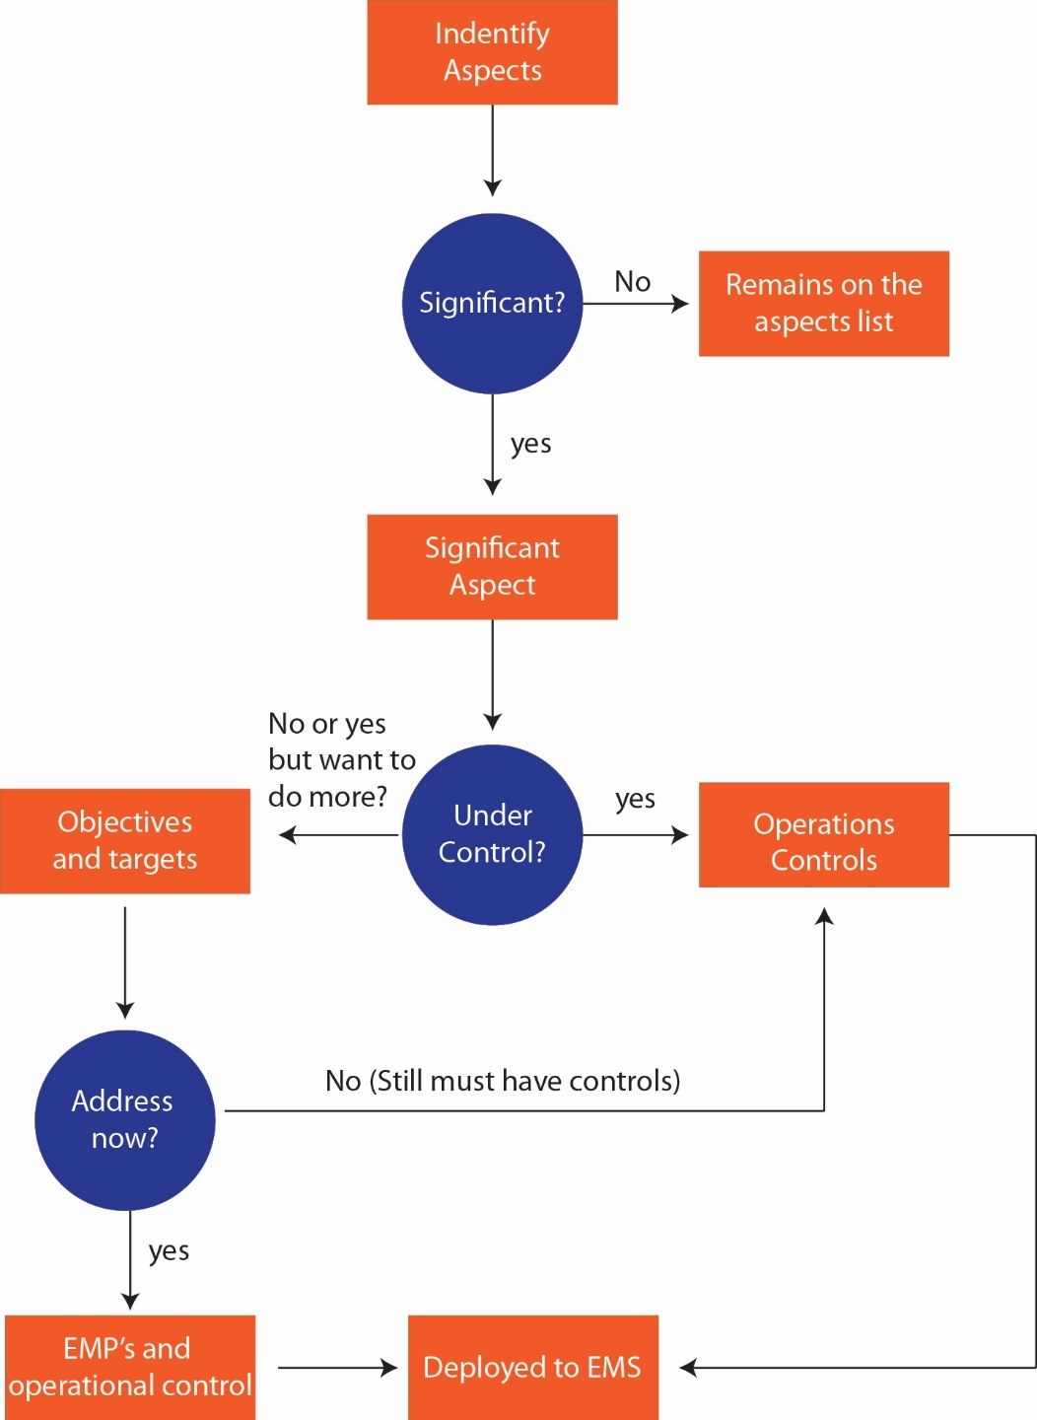

Figure 2. Identifying aspects flow chart

Once the organisation has determined its significant environmental aspects it must then evaluate them.
It must set up objectives and targets. The following steps can be taken
Step 1 – Identifying the environmental aspects which the organization can control or influence
Step 2 – Determining which environmental aspects have significant impacts
Step 3 – Determining and taking measures for the selected significant environmental aspects
Step 4 – Updating the identification and evaluation of environmental aspects.

An organization will have to make choices at each of these steps.
When identifying aspects, it must decide on the level of detail at which to do so, and then which environmental impacts must be considered and designated as significant. For environmental aspects with significant environmental impacts, the question is which objectives must be identified and how they can be embedded in the system?

The below table is a result of the following steps

- Making the inventory of environmental aspects and impacts
- Weighing their significance
- The result: which environmental aspects are significant, and which environmental aspects must be assigned improvement measures

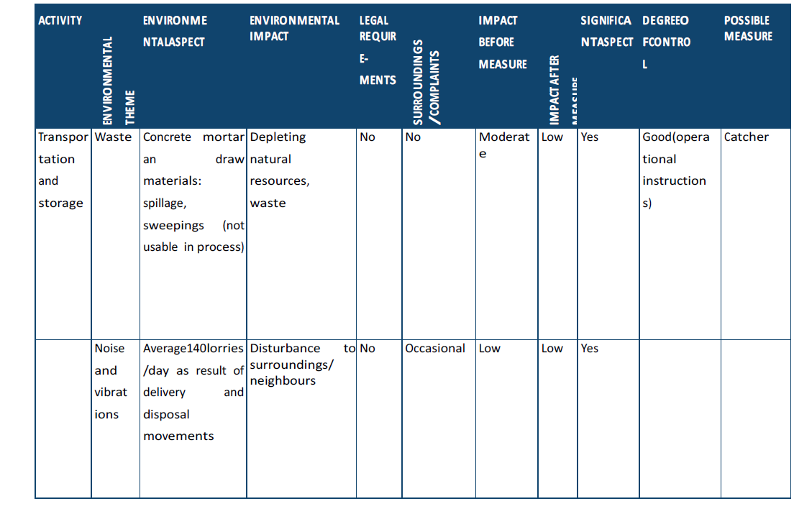

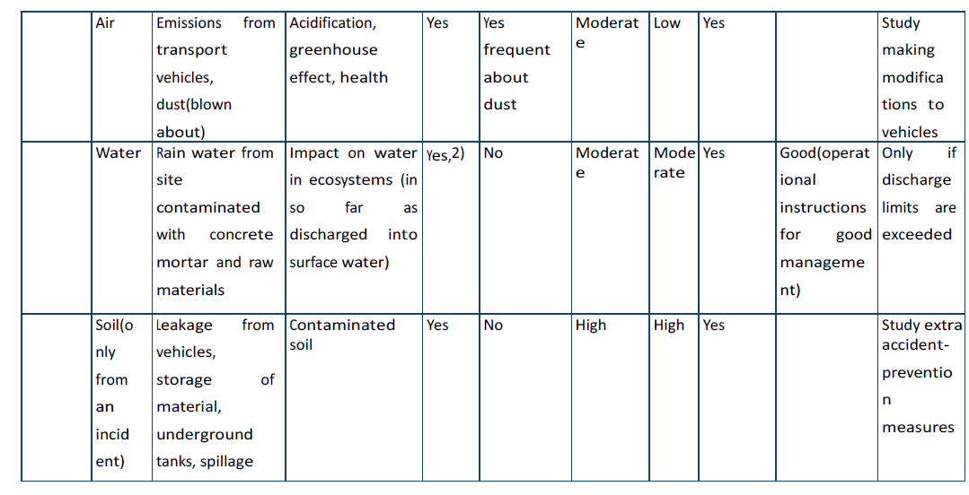

Figure 3 – Evaluation of aspects and impacts

It is important to remember that an organisation must continue to review this periodically so that they continue to ensure they are doing all that they can to reduce significant impacts to the environment.

‘The process of making the inventory of environmental aspects, determining the significant impacts and taking measures is not a one-time action. The organization is expected to evaluate, with a certain regularity, whether the aspects in its inventory are still correct and the significance of impacts has not changed, and what measures can still be implemented. A logical point to do this is during the management review, given that this is often the time when changes in and around the organization, as well as the implemented objectives and targets are evaluated, and new objectives and targets are set. There may be changes in policy (either the organization’s or the government) and legislation and regulations which have changed the listed environmental aspects, significant impacts and the measures formulated.’
(www.sccm.nl)

Q2. Outline the key considerations in setting objectives and targets associated with the significant Environmental aspects of the organisation.

According to www.nibusinessinfo.co.uk, Your environmental objectives and targets should be based on:

- your environmental policy
- information gained from your initial review
- your register of legislation

The aim should be to address any significant environmental aspects and should incorporate specific legal requirements contained in regulations and consents.

- Environmental objectives are the overall aims that your business sets itself to improve environmental performance through its EMS. They indicate your business' aims - e.g. to reduce waste going to landfill by 25 per cent over five years.
- Environmental targets provide short-term goals on the way to achieving these overall objectives. One objective can have several targets - e.g. one target could be to reduce waste going to landfill by 10 per cent in the first year.

Setting targets helps to provide evidence that an objective has just been met. The targets should also be progressive and realistic. So, the overall target would need to be broken down into bite sized chunks with timelines attached to them.
The ISO 14001 states objectives are “documents” whereas targets are “records.” Documents can be modified while records cannot. So, you can change a document but missing a target cannot.
Also setting realistic targets and timelines helps to gain from the organisation’s higher management.
According to ehsdailyadvisor.blr.com It is much better to set an achievable target and meet it the first year and then set progressively more aggressive targets in following years. The senior management team need to be on board with the targets and objectives but most importantly they need to be able to communicate these to the employees effectively. This is because the employees will more than likely be doing the leg work.

The organisations priorities are

- Alignment with EMS Policy – Although this is very important, the objectives also must also be in alignment with the greater environment. These requirements are laid out in ISO 14001:201 which must be adhered to by top management

- Limit the Number of Criteria – Keeping it simple helps to really focus on what the main objectives are and makes it easier to get people on board.

- Regulated - (legal requirements) – self-explanatory really! All plans must fall within all legal requirements set.

- Community/Media Concerns – (community concerns or perception) – Taking steps to keep the local community that plans may influence is extremely important. This way the information is coming from the horse’s mouth and all concerns are questions can be answered.

- Impact to Human Health - (the potential or actual impact to human health) - This must be a huge consideration; proper research must be carried out to ensure there are no risks.
- Impact to Environment - (the potential or actual impact to flora/fauna and/or other natural resources) – These must be looked in to thoroughly and potential measures put in place.

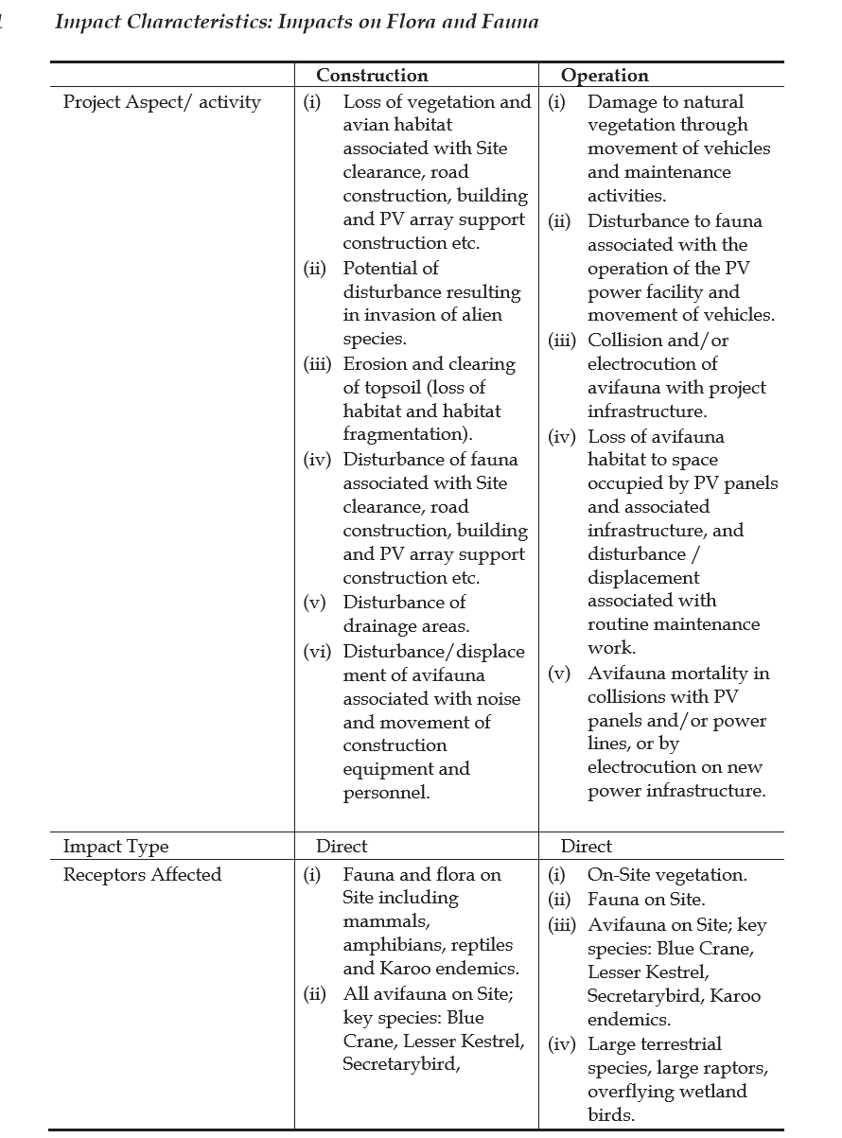

Figure 4 - The above shows an example table put together to identify risks to the
natural environment for a project that was being carried out

- Magnitude - (volume, size, or amount of the Impact) – As above table shows, thought and research must be put into the level of impact an operation will have

- Severity - (measure of the intensity of the Impact; impact, damage, or deterioration) - this must be made available with every possible outcome listed. It is usually best for the very worst scenario to be listed.

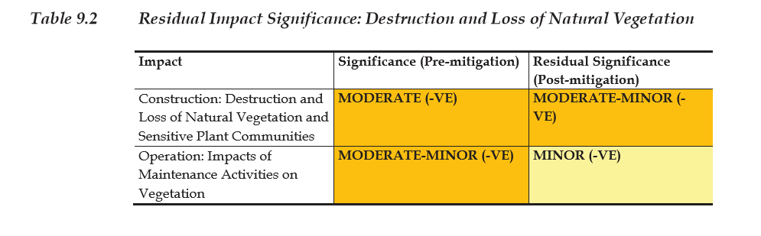
- Figure 5 – The above table showing an example document highlighting severity of damage to a site where a potential project had planned to be carried out

- Probability - (measure of how likely it is that the Impact will occur) – this must be identified and shared. It is also a good idea to remember that the impact may only be temporary so this should be shared.

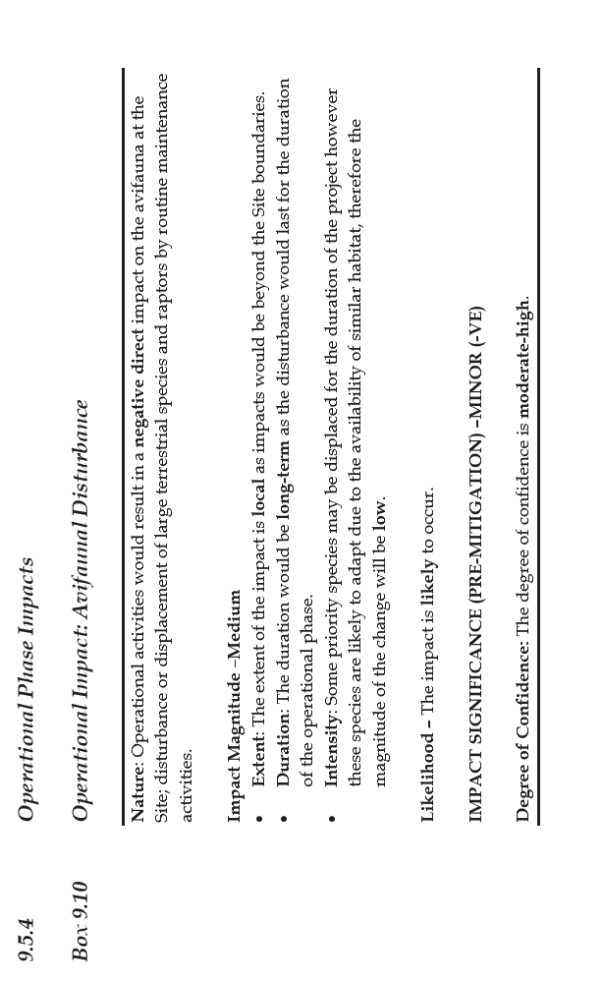

Figure 6 – Document showing likely hood of an impact to birds in the vicinity of
an operation

- Cost - (the total money, time, and resources associated with controlling, mitigating or responding to an impact) – If the research carried out prior to the operation is in depth, (although this may incur costs) it will be better than having to incur costs after an impact has occurred.

- Operational impact - (the level of influence, consequence, or effect an Impact can have on the day-to-day operations of the organization) - This will also have an affect on the reputation of the organisation which will most definitely influence sales or turnover of the company.

Best Practises
- Engage staff across the organisation to develop activities list
- Employ the core team to identify significant impacts
- Make your scoring methods and criteria simple, but meaningful
- Determine significance based on scoring as well as organizational priorities and limitations
- Make sure to address plan components
- Document your methods and final decisions
- Review your list on a periodical basis (annually) – Continual assessment is critical

References
www.nibusinessinfo.co.uk
Available at: https://www.nibusinessinfo.co.uk/content/identify-environmental-aspects-and-legislation
Accessed July 2019

https://advisera.com
Available at: https://advisera.com/14001academy/knowledgebase/environmental-aspect-identification-and-classification
Accessed July 2019

www.sccm.nl
Available at: https://www.sccm.nl/sites/default/files/BM18-SCCM_informatieblad_milieuaspecten_ENG_v14Jul14.pdf

https://www.erm.com/contentassets/ef51f6123d3d436bb2e3c5207b971595/draft-environmental-impact-report/chapter-9.pdf
Accessed July 2019

Student Statement:

By submitting this assignment, I confirm that this is my own work.

Student Signature | S Talbert | Date | 10.7.19

For Tutor / Assessor Use Only
Total Marks
Marks Obtained
Percentage / Grade

