
Assignment Cover Sheet

Student Name: | MICHELLE HAIGH
Student Number: | 25620
Course: | ADVANCED DIPLOMA IN FORENSIC ACCOUNTING (LEVEL 5)
Assignment NO: | 09

Marking Criteria:
We expect the learners to write minimum one well expressed point in three lines against each allocated mark. This means one needs to write 15 lines with 5 well expressed points to get high grades for a 5 marks question.
For high grades use examples and illustrations where appropriate.
Q1. (i)
According to Singleton (2010), “effective fraud risk assessment is dependent on knowledge of fraud concepts (the fraud triangle, red flags, fraud schemes, and accounting information systems), all considered in the applicable fraud environment (entity, time frame, effectiveness of current internal controls, etc.). While the term risk assessment may imply a periodic, point-in-time exercise, true risk management requires a continuous ongoing process”. This is because economic, industry, regulatory, and operating conditions will continue to change and so mechanisms are needed to identify and deal with the special risks associated with change.

In order to carry out a fraud risk assessment, the investigator must first identify the fraud risks. The fraud risk identification process should include an assessment of the incentives, pressures, and opportunities to commit fraud, referred to as the fraud triangle, so the investigator requires knowledge of this. Opportunities to commit fraud exist throughout organizations. These opportunities are greatest in areas with weak internal controls and a lack of segregation of duties. Therefore, the organizations which are most vulnerable are those with the weakest management, accounting, and security controls. Hence, the investigator should have sufficient knowledge of the various fraud schemes that could affect the particular entity they are dealing with and the red flags that could indicate one of those fraud schemes. A thorough knowledge of the entity’s environment and its internal controls is also required.
The investigator should also give consideration to a host of organization-specific factors, such as industry, strategy, and so forth. If an effective risk assessment depends on the knowledge and experience of the investigator, it may be beneficial for the investigator to have brainstorming sessions among cross-functional teams so that their knowledge can be drawn upon also. The investigator can also gain knowledge from the entity’s internal audit reports and procedures.
The results of a risk assessment can be used as a tool for an entity’s antifraud program, where the entity is trying to minimize its fraud risk. According to PwC’s Global Economic Crime Survey 2018: UK Findings (2018), “Given the continuing rise in fraud, it is worrying that 50% of the UK businesses surveyed had not carried out a general fraud risk assessment, which looks at the key risks facing particular parts of
their business or activities in the past two years. This is broadly consistent with the global position.”

Q1. (ii)
According to Singleton (2010), “the fundamental concepts of risk assessment are probability (the chance an event will occur) and impact (the magnitude of the event if it occurs). However simple those concepts are, measuring and applying them is difficult.”
Fraud risk factors can be considered on many levels, including entity, people (behavioural), divisions, geographies, products or services, accounting or business processes, controls, or computerized systems. Typically, factors are considered first on an entity level, as the probability of fraud, theft, or embezzlement in any work environment is a product of the personality of the executive and employees, the working conditions, the effectiveness of internal controls, and the level of honesty therein (the organizational culture or environment). Auditors and fraud investigators should also have an adequate understanding of the business entity’s relationship with its suppliers, customers and business partners.
The investigator should take into account the level of assessed fraud risk in the industry of the entity. This is referred to as Corporate Environment Factors. According to a KPMG (2016) survey, 40% of the victims of the frauds were Multinational/Global organisations. 16% were in the Industrial market, which was the highest market sector. This re-enforces that the nature and size of the company can have an impact on the level of fraud risk by providing greater opportunities, unintentionally, for the fraudsters. In addition, the nature and size of a business provides an inherent opportunity to fraudsters. For example, the number and types of transactions and the kinds of balances and accounts may be vulnerable to manipulation or falsification. Similarly, certain organizational structures and assets are more prone to fraud than others. Another factor to consider while conducting risk assessment is whether the entities working in industries that have a higher susceptibility to fraud, are at a greater risk of fraud as well.
KPMG (2016) survey results:
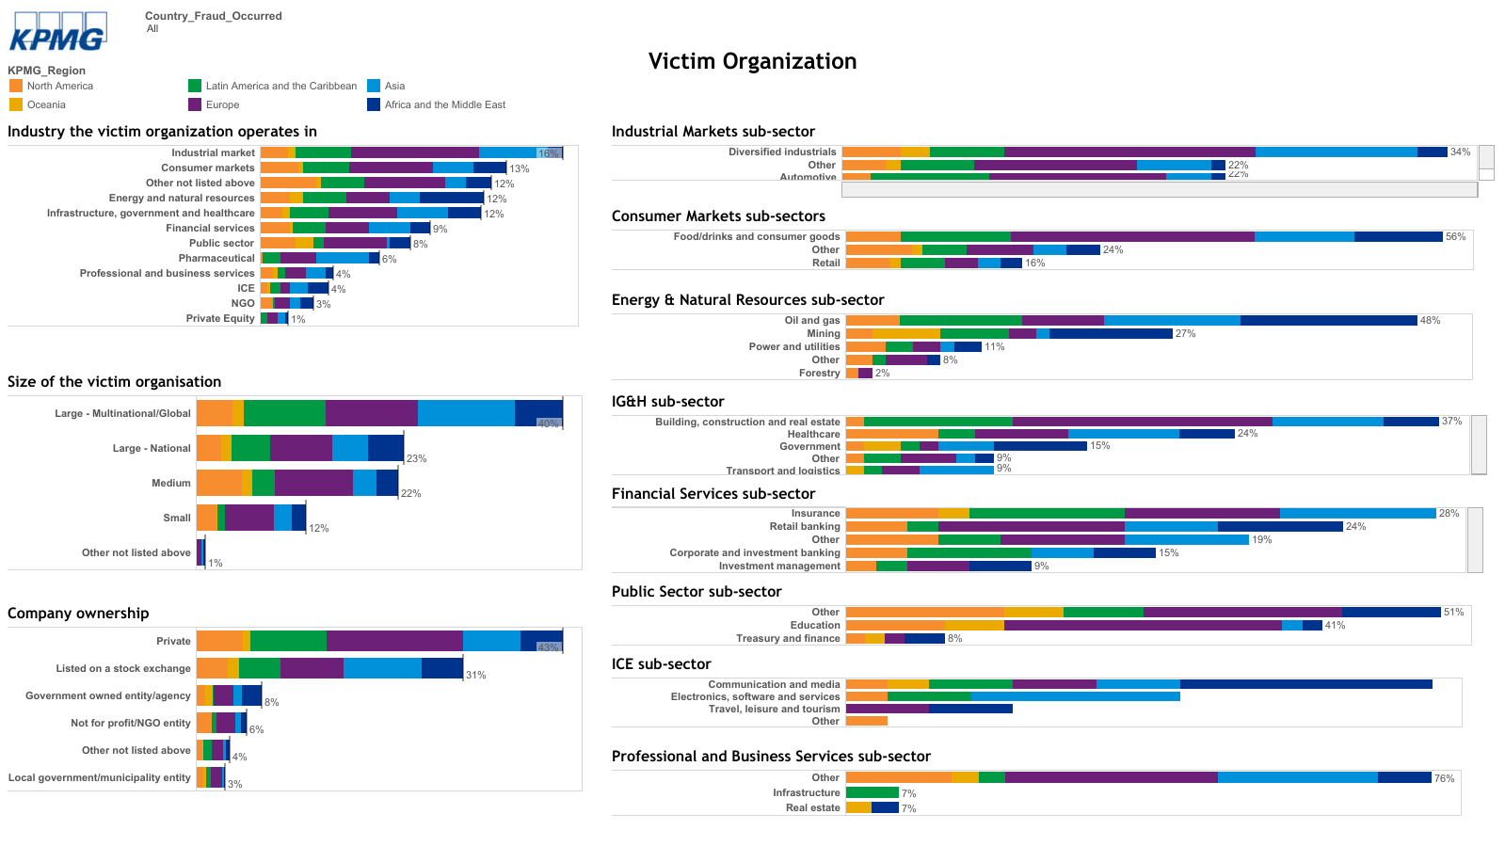

They should also consider the current economy. In good times, people steal; in bad times, people steal more. People generally are under more pressure during an economic recession and in that sense there would be an expected increase in frauds.
Internal factors that contribute to the increased probability of fraud and embezzlement, are lack of monitoring activities and inadequate controls. According to a KPMG (2016) survey, 60% of the frauds where attributed to weak internal controls.
Any risk assessment should also consider the fraud schemes that are more likely to occur in order to guide the antifraud program. (Referred to as Fraud factors). Prevention and detection countermeasures are certainly more effective if they address the most likely fraud schemes to be committed. For financial statement frauds, clearly the executives of the entity are the most likely would-be fraudster and thus a risk assessment would necessarily include those individuals. For asset misappropriation, an employee in a trusted position is likely to be the culprit. For corruption, it might be the same but it includes somebody outside the entity working with someone inside, a unique characteristic of corruption schemes.
Q1. (iii)
Internal factors that enhance the probability of fraud, and should be considered for fraud risk assessment, include inadequate management controls or monitoring activities such as the following:
- Failure to create an honest culture
- Failure to articulate and communicate minimum standards of performance and personal conduct.
- Inadequate orientation and training on legal, ethical, fraud, and security issues
- Inadequate company policies with respect to sanctions for legal, ethical, and security breaches; especially for frauds and white-collar crimes.
- Failure to counsel and take administrative action when performance level or personal behaviour falls below acceptable standards, or violates entity principles and guidelines.
- Ambiguity in job roles, duties, responsibilities, and areas of accountability.
- Lack of timely or periodic audits, inspections, and follow-through to ensure compliance with entity goals, priorities, policies, procedures, and governmental regulations; generally speaking, a lack of accountability over key positions of trust.
These internal factors can also contribute to the circumstances that provide opportunity. i.e. If there is ambiguity in job roles or areas of accountability, it creates an opportunity for the fraudster not only to commit the fraud, but to also go undetected for a long period of time, as management/staff would be unsure as to whose job it is to verify something, or who’s signature should have been on the order/invoice/payment receipt, etc. It is important to note, however, that opportunity alone does not necessarily mean that a fraud will occur, it merely increases the risk that it may occur.
Other Internal Risk factors that provide opportunities could include:
- The organization’s control environment, i.e. its effective internal controls, effective accounting systems, information technology and efficient accounting personnel.
In large organizations, the extent of the management’s role in internal control systems and their ability to bypass controls may determine fraud opportunities. Factors that contribute to creating a high risk of misappropriation of assets include:
- The value, demand, convertibility and movability of assets.
- Weak internal controls intended to protect assets, such as lack of supervision, poor employee screening, weak accounting and physical controls, infrequent reconciliations and lack of segregation of duties.

Q1. (iv)
According to BusinessDictionary.com (2019), “Inherent Risk” is defined as “The probability of loss arising out of circumstances or existing in an environment, in the absence of any action to control or modify the circumstances”.
The team should determine what the inherent risk is for this fraud scheme, for this entity or business process. The assessment could be a probability (1 to 100 percent) or simply low, medium, or high risk. A number of factors can be considered here, some of which are industry, strategy, market volatility, and organizational structure.
In simple terms, the inherent risk is the likelihood of occurrence of a fraud before any action is taken, as the diagram below shows.

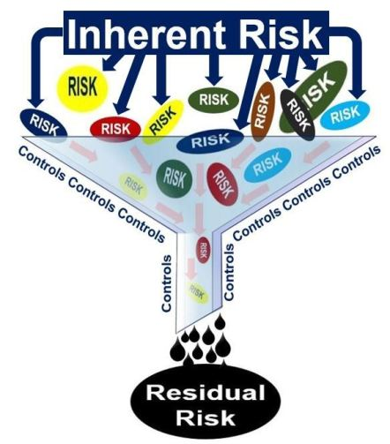

Q1. (v)
Residual Risk is defined as “Exposure to loss remaining after other known risks have been countered, factored in, or eliminated” in businessdictionary.com (2019).
Residual risk can be simply calculated by subtracting the level of internal controls being used to mitigate risk from the inherent risk. The assessment would take the form of whatever was chosen for Inherent risk. There are two possible responses to residual risk: no action, as the remaining risk is accepted; or action to mitigate or remediate through further preventive or detection measures (such as purchasing insurance) in order to mitigate residual risk. In either case, the response should be documented and tracked in order to determine the organization’s ability to measure and manage risk.
Q2.
With risk assessments being an increasing feature of enforcement actions (as well as part of an “adequate procedures” or “reasonable procedures” defence under the UK Bribery Act and the Criminal Finances Act), it’s more important than ever that a business’s fraud risk assessment is fit for purpose.
As previously mentioned, the fraud risk identification process should include an assessment of the incentives, pressures, and opportunities to commit fraud. When identifying risk factors, the company’s culture, procedures, policies, processes, controls, products or services, etc. should be assessed. Below is a risk assessment checklist (Singleton 2010), which is designed to assist accountants in assessing and managing the risk of fraud in their organizations and those of their clients. Generally, all “No” answers require investigation and follow-up, the results of which should be documented. Where there is such additional documentation, the purpose of the “Ref” column is to cross-reference the checklist to the appropriate working paper (or to the notes on the reverse).

Risk Assessment Checklist | Yes | No | N/A | Ref
1. Does the organization have an adequate level of fraud awareness and are appropriate policies in place to minimize fraud risk? Specifically:
a. Generic risk factors
Has each employee been assigned a maximum “opportunity level” to commit fraud; for each employee, has management asked itself: “What is the maximum amount of which this employee could defraud the organization, and does this represent an acceptable risk?”
Has a “catastrophic” opportunity level been set; that is, has management asked, “Have we ensured that no single employee—or group of employees in collusion—can commit a fraud that would place the organization in imminent risk of survival?”
Is it the organization’s policy to immediately dismiss any employee who is found to have committed a fraud?
Is it the organization’s policy to report all frauds to the authorities and press charges?
For any and all frauds that the company has experienced in the past, have the reasons that led to the fraud been evaluated and corrective action taken?
b. Managing individual risk Factors (i.e., to promote moral behaviour and minimize the motivation to commit fraud)
Does the organization have a corporate mission statement that includes as an objective good corporate citizenship (i.e.,
maintaining good standing in the community)?
Does the organization have a written code of ethics and business conduct?
Does the organization conduct ethical and security training for new employees with periodic updates for existing employees?
Does management set the right example? Does it follow the corporate mission statement, code of ethics and business conduct, and other organization policies, and do the employees clearly see it doing so?
Does the corporate culture avoid characteristics that promote unethical behaviour (e.g., high or even hostile competitiveness within the organization, pushing employees to burnout, rigid and/or petty policies, or over-centralization of authority)?
When hiring, does the organization, to the extent possible, seek out individuals of high moral character and weed out those of low moral character?
For especially sensitive positions, are screening and/or testing procedures used (e.g., psychological testing, drug testing, lie detector tests where legal)?
Does the organization provide and/or encourage counselling for employees with personal problems (e.g., alcohol and drug abuse)?
Does the organization have fair employee relations and compensation policies (e.g. salaries, fringe benefits, performance appraisal, promotions, severance pay)?Do these policies compare favourably with competitors’ and promote an environment that minimizes disenchantment and similar motivations to commit fraud?
Are fair mechanisms in place for dealing with employee grievances?
As a feedback mechanism on its policies with respect to employee relations, does the organization conduct exit interviews of departing employees?
c. Management awareness
Overall, does management exhibit an awareness of fraud and its possible manifestations: signs of employee problems such as drug addiction and low-paid employees who suddenly appear with trappings of wealth?
2. Does the organization have an adequate system of internal controls? Specifically:
a. Fraud integral to internal controls
Has the need for fraud prevention been explicitly considered in the design and maintenance of the system of internal controls?
b. Control over physical and logical access
Does the organization have a policy and practice of locking doors, desks, and cabinets after hours and when unattended, especially for areas with valuable assets, including files and personnel and payroll records, checks and other accounting documents, customer and vendor lists, corporate strategies, marketing plans, and research?
Does the organization have a policy and practice of using IDs and passwords for general computer access?
For sensitive files and applications, does the computer system require additional access controls? Does the access control of each user ID limit him/her access? Are there additional layer(s) of access control for remote access (i.e., smart cards, temporary PINs, biometrics, etc.)?
Does the organization have a stated and enforced policy that access is restricted to those requiring it to perform their job functions, including a strict policy against employees allowing access to unauthorized personnel by lending keys, sharing passwords, and so on?
For especially sensitive areas, are there additional computerized security and/or electronic surveillance systems?
To an impartial observer, does the workplace appear to have adequate access controls?
c. Job descriptions
Does the organization have written and specific job descriptions?
Do employees and managers adhere to them?
Does the company have an organization chart that reflects and is consistent with the employee job descriptions?
Are incompatible duties segregated (i.e., handling of valuable assets, especially cash and related records)?
Is the purchasing function properly segregated (e.g., to ensure that one individual cannot requisition goods or services, approve and make the related payment, and access accounts payable records)?
Are especially sensitive duties duplicated (i.e. the double-signing of checks over a specified amount)?
Do job descriptions specify that annual vacations must be taken?
Overall, has the process of formulating job descriptions been an integrated one, giving adequate consideration to the importance of fraud prevention?
d. Regular accounting reconciliations and analyses
Bank reconciliations, for all accounts?
Accounts receivable reconciliations (month to month, general ledger to sub-ledger)?
Accounts payable reconciliations (month to month, general ledger to sub-ledger)?
Variance analysis of general ledger accounts (budget to actual, current year versus prior year)?
Vertical analysis of profit and loss accounts (i.e., as a percentage of sales, against historical and/or budget standards)?
Detailed sales and major expense analysis (i.e., by product line or geographic territory)?
e. Supervision
Do supervisors and managers have adequate fraud awareness? Are they alert to the possibility of fraud whenever an unusual or exceptional situation occurs, such as when supplier or customer complains about its account?
Do supervisors and managers diligently review the work of their subordinates (e.g., accounting reconciliations), and, where appropriate, even have the employee re-perform the work?
For smaller businesses or where division of duties is not possible, is close supervision in place so as to compensate for the lack of separation?
Is supervisory or management override (a manager or supervisor taking charge of, altering or otherwise interfering in the work of a subordinate) prohibited, and are others in the hierarchy alert to this situation as a fraud “red flag”?
f. Audit
Is there an internal audit function?
Does the internal audit function perform regular checks to ensure that fraud prevention mechanisms are in place and operating as intended?
Are external audits performed on a regular basis (quarterly for larger businesses)?
Does management fully cooperate with external auditors with respect to its work in general and fraud matters in particular (i.e. through the audit committee)?
3. Has the organization addressed the following fraud prevention issues?
Promoting an ethical environment?
Risk financing?

BIBLIOGRAPHY

Dictionary, o. 2019. Inherent Risk Meaning in the businessdictionary.com dictionary. [Online] Businessdictionary.com. Available at: http://www.businessdictionary.com/definition/inherent-risk.html [Accessed 30 Mar. 2019]
Dictionary, o. 2019. Residual Risk Meaning in the businessdictionary.com dictionary. [Online] Businessdictionary.com. Available at: http://www.businessdictionary.com/definition/residual-risk.html [Accessed 30 Mar. 2019]

KPMG 2016. Global Profiles of the Fraudster. 13 May 2016 [Online] Available at: https://public.tableau.com/profile/kpmg.poaf#!/vizhome/TableauPOAF_Final/1Generaldetailsofthefraudster [Accessed 30 Mar. 2019]

PwC, 2018. PwC’s Global Economic Crime Survey 2018: UK Findings [Online] Available at:
https://www.pwc.co.uk/forensic-services/assets/gecs/global-economic-crime-survey-2018-uk-findings.pdf [Accessed 30 Mar. 2019]

Singleton, T.W. & Singleton, A.J. 2010. Fraud Auditing and Forensic Accounting (4th Ed). John Wiley & Sons, Inc. 2010. pp 114-129.

Student Statement:

By submitting this assignment, I confirm that this is my own work.

Student Signature | Michelle Haigh | Date | 31/03/19

For Tutor / Assessor Use Only
Total Marks
Marks Obtained
Percentage / Grade

