
Assignment Cover Sheet

Student Name: | Dora Szabolcs
Student Number: | 27413
Course: | Diploma in Construction Management 4
Assignment NO: | #1

Marking Criteria:
We expect the learners to write minimum one well expressed point in three lines against each allocated mark. This means one needs to write 15 lines with 5 well expressed points to get high grades for a 5 marks question.
For high grades use examples and illustrations where appropriate.
Please insert your completed assignment ( in word format) here:

1i,
What makes the construction industry different from others is that every project is unique. This uniqueness of each project is the result of the nature of the site of construction, ground conditions due various site locations, influenced by weather conditions.

1ii,
The main reasons why are more accidents in the construction industry than any other industries are the following, the extensive varying working conditions involving supported structures , moving equipment(such as earth movers, cranes ,logistics etc) and labour make the site very unpredictable environment.

1iii, Construction Supervisor’s main responsibility to make sure all work meet the right quality, the work is completed on time and within budget.
The Construction Supervisor gives clear instructions to workers what to do, also keep them motivated to ensure all objectives are accomplished. She/he deals all kind of conflicts at the work site. Responsible for staff trainings and developments (for example health and safety training to prevent accidents which could cause time loss.)

2,
“Construction is a general term meaning the art and science to form objects, systems, or organizations. In general, there are three sectors of construction: buildings, infrastructure and industrial. Building construction is usually further divided into residential and non-residential.”
Construction industry is one of the most important industries; it got a reach history as it exist since the beginning of civilizations all around the globe in Asia, America ,Europe, Africa, South America. Some of the greatest examples are Megalithic buildings Malta ( see pic a), Great Wall of China (pic b), Pyramids of Egypt, Taj Mahal, Roman Amphitheaters of Italy, Chichen Itza of Mexico(pic.c).
Construction as an industry comprises six to nine percent of the gross domestic product of developed countries.It’s got the second biggest source of employment in the world. Time and cost effective construction highly depends on using new materials and technologies and require well trained workforce.

Pic a,
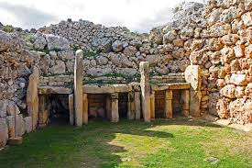

Pic b,
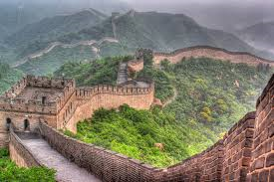

Pic c,
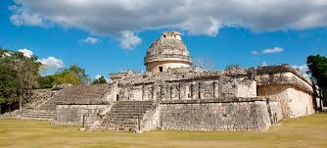

References:
Construction" def. 1.a. 1.b. and 1.c. Oxford English Dictionary Second Edition on CD-ROM (v. 4.0) Oxford University Press 2009

3,
The growth of technology helps the construction industry to be more effective (means saving time and money). New technologies mean better materials, quicker and more effective machineries, new techniques, safer work environment. To keep up to date with all changes everyone who works in the industry must have update and upgrade their knowledge and skills constantly.

Student Statement:

By submitting this assignment, I confirm that this is my own work.

Student Signature |  | Date

For Tutor / Assessor Use Only
Total Marks
Marks Obtained
Percentage / Grade

