
Assignment Cover Sheet

Student Name: | Rosalind Parker
Student Number: | 22398
Course: | Diploma in Environmental Management
Assignment NO: | 1

Marking Criteria:
We expect the learners to write minimum one well expressed point in three lines against each allocated mark. This means one needs to write 15 lines with 5 well expressed points to get high grades for a 5 marks question.
For high grades use examples and illustrations where appropriate.
Please insert your completed assignment ( in word format) here:

Q:1: Give short answers to the following questions: (10)
- What is Eco-system? II. What is Lithosphere? III. Outline the functional components of eco-system. IV. What did you understand by Sustainable Environment? V. What are biotic and Abiotic components of natural environment?

Q1
- What is Eco system?
A species or organism cannot survive alone and is dependent on other living (Biotic) and/or non-living (Abiotic) organisms. In its surroundings it is part of a Eco-system (Environment system). Which is where they produce and exchange materials in a cycle. A pond is an example of an eco-system.
- What is Lithosphere?
Lithosphere is solid matter in The Earth’s biosphere (Where there are many smaller Eco-systems) The biosphere is made up of Lithosphere, hydrosphere, and atmosphere. Lithosphere is solid matter and is the source of soil and minerals. This helps the metabolic functions, such as growth.
- Outline the functional components of eco-system
The functional components of an Eco-system consist of Biotic (Living) and abiotic (Non-living) organisms. Biotic components can include green plants and algae (Producers/Autotrophic), animals (Consumers, some are heterotrophic), and decomposers such as worms and fungi. Abiotic components can consist of energy, temperature, water, and fire.

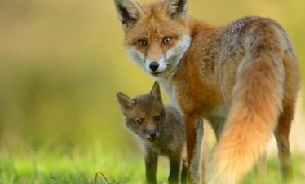
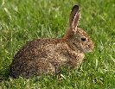
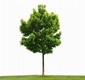
radiation ------Energy flow to plants & animals
Plants eaten by herbivores, herbivores eaten by carnivores (Food chain)
Waste (urine, faeces, decay, and respiration) and nutrients re absorbed back into cycle.
To summarise the functional components of an ecosystem has Energy flow, a food chain, a reason something is there, and at that time, cycles of nutrients and biochemicals, development and evolution, and control of cybernetics

- What did you understand by Sustainable Environment
I understand that Sustainable Environment is where a balance or growth is to be maintained between nature and man, without compromising the resources.
The World Commission on Environment and Development (WCED) in its milestone report Our Common Future (otherwise known as the Brundtland Report) in 1987 (WCED 1987) p. 43. termed Sustainable Environment.
'Sustainable development is development that meets the needs of the present without compromising the ability of future generations to meet their own needs. It contains within it two key concepts: - The concept of "needs", in particular the essential needs of the world's poor, to which overriding priority should be given; and - The idea of limitations imposed by the state of technology and social organisation on the environment's ability to meet present and future needs.'

- What are biotic and Abiotic components of natural environment?
A natural environment has Biotic (Living) and abiotic (Non-living) organisms. Biotic components can include green plants and algae (Producers/Autotrophic), animals (Consumers, some are heterotrophic), and decomposers such as worms and fungi. Abiotic components can include energy, temperature, water, and fire.

Q:2: Write notes on the followings: (10)
- FoodChain
A food chain is a feeding hierarchy in which organisms in an ecosystem are grouped into trophic (nutritional) levels and are shown in a succession to represent the flow of food energy (which is one way) and the feeding relationships between them.
An example of a food chain is one that consists of plants that get eaten by herbivores or omnivores. Omnivores and herbivores get eaten by Carnivores or omnivores.
Plants are the first trophic level and are autotrophic organisms. They do not need a living source of energy for growth (Autotroph means self–feeding in Greek) They are also known as producers as they can produce their own food.
The next trophic or nutritional level are primary consumers, known as herbivores or omnivores, they are heterotrophic (As are carnivores; Cannot produce their own food). They live on the plants (omnivores also live on animals).
The next trophic level are secondary consumers, generally known as carnivores which live on primary consumers. They can hunt and kill their prey or can be scavengers. In the case of humans, they breed and kill primary consumers.
The next and generally final trophic level is tertiary consumers, they are carnivores and do not tend to have a predator or are eaten by another animal. They live on either primary or secondary consumers.

- FoodWeb
Food Webs are the interconnections of foodchains (What eats what) by autotrophs and heterotrophs. There are factors of the placement and involve adaptations. The energy flow is one way For example plant to hedgehog to badger. It can involve interlinks, (See diagram below). for example, plants to badger to fleas. Some have more than one consumer (predator). This can have an effect if a food source becomes scarce. The trophic levels can be affected. For example, if the plants and berries died, the rabbits and birds would decrease and so too would hawks and weasels unless they found another food source and that could decrease in numbers. If fleas where taken out of the food web, there may be no change, or numbers could go up as the fleas are parasitic and unwelcomed. They say a predator’s numbers are dependent on the prey’s numbers. Hawks were killed by humans, ingesting toxins and being hunted. If habitat is changed some animals decrease (Dormouse) or change habitat (Fox). Some animals known as carnivores have been known to eat plants/berries/vegetables (Dogs) or Herbivores have been known to eat birds (Deer). This could be to get ‘missing’ nutrients.

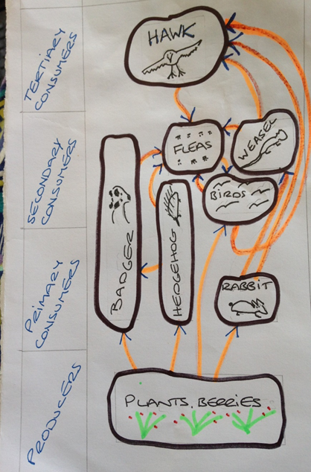

1. Visit your nearby rural area for a survey and find out the causes and effects of population growth.

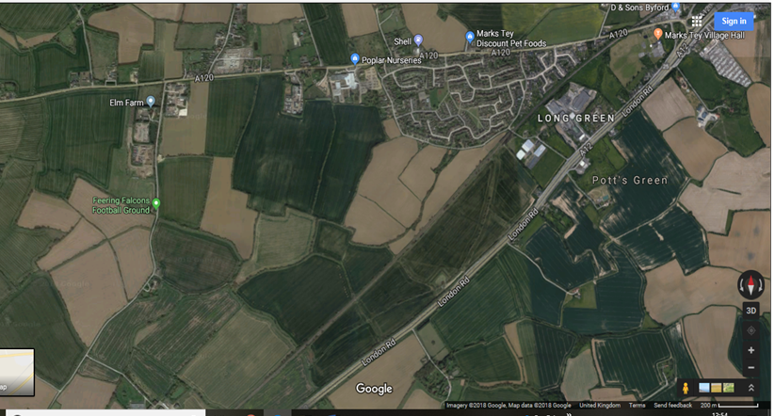
I live in what can be considered a rural area on a suburban estate built in the 1970’s There are arable fields surrounding the estate. Crops grown are traditional cereal crops and newer crops such as borage. There are no field margins which would help wildlife. There are footpaths and they are used mainly by dog walkers. It is beneficial for health reasons and a feel good factor to be outdoors in the countryside as per Rosalind Ryan Femail, The Daily Mail, ‘Helath Benefits of the Great Outdoors’
http://www.dailymail.co.uk/health/article-113948/The-health-benefits-great-outdoors.html
The area as the map (Above) shows access to railway line, main roads (A120 and A12) which provide transport for commuting. This has caused population growth of humans in the area. People live here as the area has commuter/travel connections (work opportunities), schools for families with children. Medical needs and Shops for day to day living are also local. This has resulted in an increase in waste, noise, air and light pollution and reduction of the rural area. As there are already some houses here, the local councils and house builders also want to build 20,000 houses in the area around the estate (which is the whole current rural area shown on map above) because there is a housing shortage,
Government UK. 2015 Housing supply 2015 – 2020 [Online] Available at https://www.parliament.uk/business/publications/research/key-issues-parliament-2015/social-protection/housing-supply/ [accessed 10th July 2018] This will add to future population growth of humans in the area, and negative impact on the rural area.
The above factors have affected the rural area, (Which I often visit), and the wildlife population in it, because of various eco systems and food chains being affected. It has caused some species to decline as there has been loss of habitat for example Dormice require bramble and hazel hedges which have been removed. Some have their food source removed or reduced. A local farmer growing borage stated ‘ “Rabbits and pigeons don’t like it at all…The crop is also great for bees, and bee keepers” from Anglia Farmer, Borage and bees make profitable combination. http://www.angliafarmer.co.uk/borage-and-bees-make-profitable-combination/ (Judith Tooth 22nd September 2013) [Accessed 16th July 2018] Borage is still being grown as of July 2018.
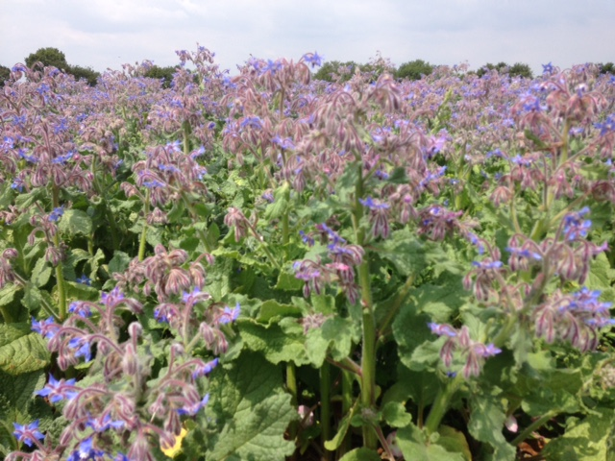

Borage Field in Marks Tey July 2018
There are no signs of any rabbits; No droppings or burrows. However, pigeons although not in large flocks are observed in gardens, particularly where there is bird food. As for bees I cannot find any information if their numbers have grown in this area, my own observation is that their numbers seem to be consistent.
I have noticed over the years how there is such a decline in ‘weed’ in crops. For example, you rarely see wild oats growing in barley or wheat fields because of the use of chemicals has affected the soil. Which in turn will affect growth of plants and living bodies in the soil
There has been an increase in some raptors in the area. Buzzards are often seen (A Sparrow Hawk with its kill of Wood pigeon has been seen in our garden Sept 2017).
The Royal Society for the Protection of Birds. Birds of Prey in the UK. “On a Wing and a Prayer” [Online] p2 and 3. Available at
http://ww2.rspb.org.uk/Images/wingprayer_tcm9-188788.pdf [Accessed: 11July 2018] states that the increase can be due to DDT (Type of Organochlorine pesticide) being banned. The decrease in gamekeepers and the Wildlife and Countryside Act 1961.
Many raptors are protected species. This also means their food source is in good supply.
Many people feed the birds in their gardens, so that in this area, there has been a change of bird life. One area Skylarks have stayed for a number of years and I have heard them in the winter months.

2. Visit a nearby business school and discuss with the students how important do they eel Environment Education is.
On speaking with business students those that engaged were positive that Environmental Education is important. Such as to raise awareness and to keep searching to improve how businesses impact on the environment. One student studying both business and environment ‘”There are so many different areas, that people have no understanding of environmental issues and have never been made aware of them.”
Environmental Education can be rewarding and help in Business, eco systems with no/little waste. A student replied that studying Circular economy is being studied and some businesses are slowly going from linear model (Take, Make, Dispose) to a more circular model.
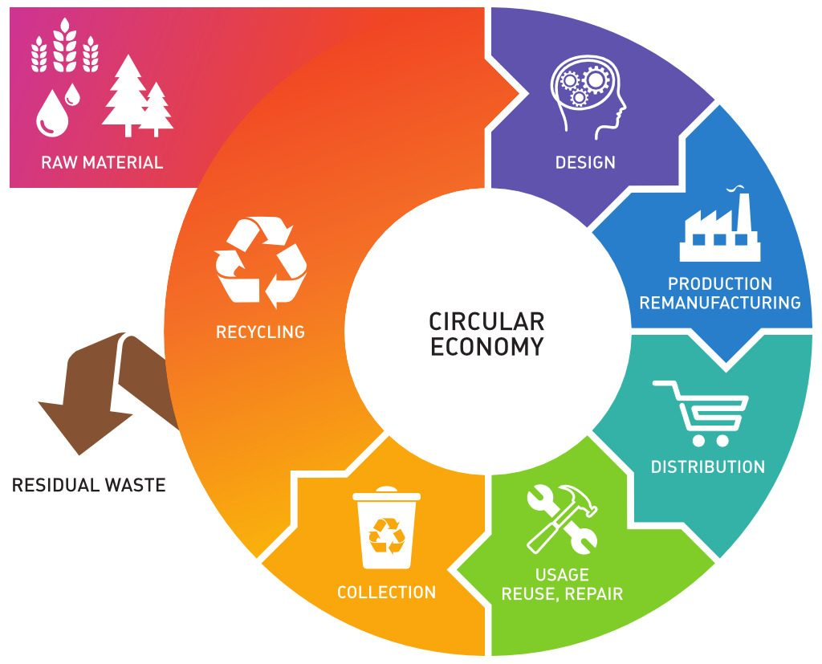
Some business studies are aware how business can be lucrative to have environmental issues as in using less plastic (Southwold Brewery Adnams have ‘this is not plastic’ written on their glasses at festivals). Vegan and vegetarian food is becoming more popular, which means less energy used in food chains. The way things are packaged (Less cardboard or plastic), has become a ‘hot’ topic.
The students realise that it is a case of drawing attention to issues, so people are. People often need to be taught to respect the natural environment.
Some businesses are being more responsible for the natural environment.
I understand from the students there may be incentives to promote environmental education: Eco housing, plant roofs. Carbon footprint. Money in developing energy saving devises.

References
Government UK. 2015 Housing supply 2015 – 2020 ‘Social Protection/Housing supply’
https://www.parliament.uk/business/publications/research/key-issues-parliament-2015/social-protection/housing-supply/

Ryan, Rosalind. ‘Health Benefits of the Great Outdoors’ Femail, The Daily Mail,
http://www.dailymail.co.uk/health/article-113948/The-health-benefits-great-outdoors.html
The Royal Society for the Protection of Birds. ‘On a Wing and a Prayer’ Birds of Prey in the UK. [Online] p2 and 3. Available at
http://ww2.rspb.org.uk/Images/wingprayer_tcm9-188788.pdf

The World Commission on Environment and Development (WCED) ‘Our Common Future’ (otherwise known as the Brundtland report) in 1987

Tooth, Judith. ‘Borage and bees make Profitable Combination’ http://www.angliafarmer.co.uk/borage-and-bees-make-profitable-combination/

Student Statement:

By submitting this assignment, I confirm that this is my own work.

Student Signature | Rosalind Parker | Date

For Tutor / Assessor Use Only
Total Marks
Marks Obtained
Percentage / Grade

