
Assignment Cover Sheet

Student Name: | Olivia Chamberlaine
Student Number: | 20051
Course: | Certificate in Coaching and Mentoring Level 2
Assignment NO: | #2

Marking Criteria:
We expect the learners to write minimum one well expressed point in three lines against each allocated mark. This means one needs to write 15 lines with 5 well expressed points to get high grades for a 5 marks question.
For high grades use examples and illustrations where appropriate.
Please insert your completed assignment ( in word format) here:

Student Statement:

By submitting this assignment, I confirm that this is my own work.

Student Signature | OLIVIA CHAMBERLAINE | Date | 11/05/2018

For Tutor / Assessor Use Only
Total Marks
Marks Obtained
Percentage / Grade

Q:1:

What is the difference between passive and active listening? Give at least one example for each.

Listening is not as simple a process as it might seem, in the sense that it has several nuances linked with it. Most people don’t realise there are two different types of listening, these are categorized as ‘active listening’ and ‘passive listening’. Both types are starkly different and have certain characteristics that distinguish one from the other.
Passive listening
This form of listening is when we hear something without the intention of responding. Passive listening isn’t much different to ‘hearing’, which is why in passive listening it’s possible that our mind can drift away from the topic of discussion and let things pass by our brain.
When someone is practicing passive listening, we’re usually sitting back and listening to what’s being said without much reaction. The key to being a better communicator lies with our ability to listen. Passive listening requires little to zero verbal replies from the listener. As a listener, we should try to focus on the speaker’s body language and not just the words that are being said. In passive listening, it’s possible you may reply silently with a nod to show the speaker that you are paying attention, or reply with a short response like, “tell me more . . .” however, passive listening primarily asks the listener to remain completely quiet. Less talk usually means we can really hear what someone is telling us without the apprehension of wanting to have our say.
Some examples of passive listening can be scenarios such as, sitting in a lecture, watching tv or listening to the radio. In these instances, we are usually listening to what’s being said, and taking in information without responding. In cases like these, we are accepting information as it is given to us with no intention to challenge or question the idea for improvement.

Active listening
Active listening means what its name suggests, actively listening to someone or something. This is fully concentrating on what is being said rather than just ‘hearing’ the message.
Active listening requires us to listen with all our senses, not just our hearing. As well as giving our full attention, a good active listener will show that they are listening. This means letting the speaker see from our non-verbal communication what we are really listening and that we are interested in what’s being said. Our non-verbal messages will usually involve maintaining eye-contact, nodding our head, smiling, and agreeing.
Active listening is where we are listening not only to hear what is being said and gain understanding (like in passive listening) but also to provide feedback at the same time. In active listening the person is interested in knowing what message the speaker is trying to portray, not only by the words they are saying, but by paying attention to their body language and the non-verbal communication techniques that are taking place.
Other than listening, this method also involves providing feedback wherever it will facilitate better understanding. For example, a person may ask questions and perhaps provide the speaker a summary of what they have said. This allows the speaker to iron out any misunderstanding or add any factors that have been missed.
Common examples of active listening are when we are having any sort of open dialog; this can often be in a coaching scenario. A coach will actively listen to the ‘student’ and provide feedback either in a verbal or non-verbal way.


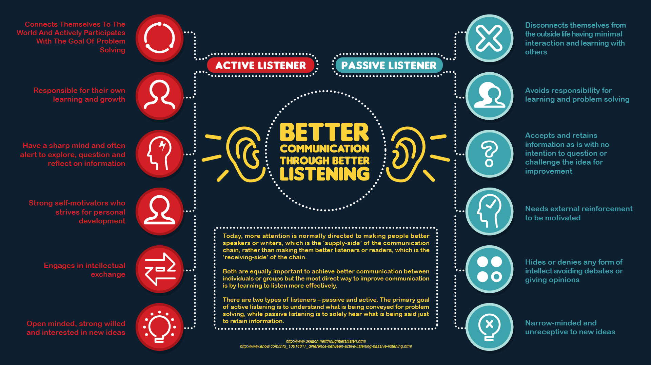

Q:1:

II. Outline the techniques that help you to listen actively.

Active listening is a skill that involves putting into practice several techniques.
With these techniques I’ll learn to develop my interpersonal communication skills and become a more effective coach. These skills and techniques involve;
- Paying attention –
Focusing your attention entirely on the speaker. This will help not only to remember the conversation, but also allow the speaker to feel more comfortable in sharing more information. To help with this technique we need to rid ourselves of all possible distractions such as mobile phones etc. It will also help to have the discussion in a quiet place where distraction from other people’s chatter will be limited.
We can also show our attentiveness with non-verbal communication like body language. Maintaining a physical stance/position that will make you appear more open to the speaker will let the speaker know that our attention is not being drawn elsewhere. This type of ‘open’ body language can include; facing the person, opening our posture (not crossing our arms and turning our body away), maintaining eye contact, and relaxing (avoiding fidgeting and moving around).
Verbal communication can be just as helpful to show that we are paying attention. Using minimal vocalizations and agreeing words like “yes” “uh-huh” “I see” etc.
Because not all important conversations happen face to face, these verbal prompts can help people who may not be able to see us (like over the phone) to know that our attention is with them.
- Show empathy and withhold judgment –
Empathy is the act of understanding and feeling what the speaker is saying, it’s “putting yourself in someone else’s shoes”, and this is important in active listening because it helps you identify and name the other persons feelings which will show the speaker that you care about what they are saying.
Empathy isn’t necessarily about agreement; it’s more of an understanding. You might not agree with how the speaker is feeling but at least you are able to understand it and know why they feel the way that they do. This leads into withholding judgment; you should be open to new ideas, new perspectives and possibilities. Even if we have strong views, as a good active listener we should suspend judgment and hold criticism unless it’s constructive of someone’s work (like in a coaching scenario) and avoid arguing or trying to get a point across before the other person has finished.
Taking note of the speakers body language will also help you develop empathy, ask yourself; “are they genuinely smiling when they are conveying happy news?” – is the person looking away from you because they may be embarrassed about sharing something? Signs like these can help us gain understanding of how the other person is feeling and allow us as listeners to show empathy which may help the other person to speak up. It also lets them know we’ve paid attention to the signs that others may have missed.
- Provide feedback and respond appropriately
As an active listener our role is to understand what’s being said. This may require us to provide feedback and reflect verbally.
A good way to reflect on what’s been said is to paraphrase with words like “What I’m hearing is...” “What it sounds like you are saying is…”. This gives the speaker an opportunity to correct any misunderstanding and the listener a chance to better understand the message being put across. Asking questions is also another great way to do this, like “What do you mean when you say…?”.
Active listening is designed to encourage respect as well as understanding, so responding appropriately is a key skill/factor when doing this. As an active listener we are trying to gain perspective and take in information. Attacking the speaker or putting them down adds nothing to the relationship or conversation. So, when responding we need to remember to be open and honest, assert our opinions respectfully and treat the other person how we would want to be treated.

It takes a lot of concentration and determination to be an active listener, but by using the techniques above and developing these into skills over time we can show that as an individual we are a good active listener.
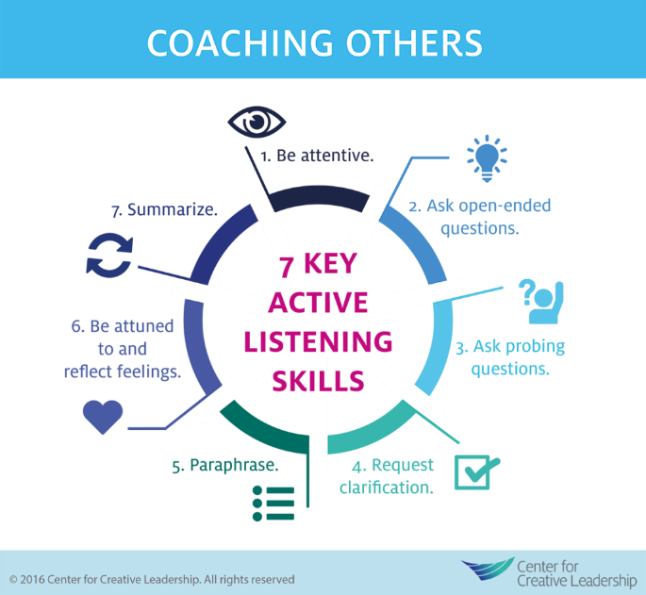

Q:1:

III: What is the difference between open and closed questions?

As coaches and leaders, we should always try to practice asking questions and providing information. When it comes to asking questions, we’re not always aware of our technique when doing so, and the question we ask may not prompt a very detailed response, which as a coach is not going to help us.
When engaging in normal conversation we tend to ask a mixture of open and closed questions, and though both can be useful in different scenarios they are used for different reasons and prompt vastly different responses.

Closed questions
Closed questions are usually those that can be answered with just a few words, or even a simple yes or no. They can provide a good opening to a conversation and be used to begin closing down an exchange because they don’t usually lead to any richer engagement.
The advantage of closed questions is that they allow the individual asking them to control the conversation easily. They allow for more questions to be answered in a shorter space of time, which can be useful when filling out surveys, diagnosing a problem at the doctors or achieving closure.
However, the disadvantage of closed questions is that they don’t allow for detailed explanations or allow the person responding to express how they feel. They also don’t really give the responder a chance to ask another question in response to this and therefore keep the conversation flowing.
Some examples of closed questions are as follows;
“Did you have fun?”
“Does this make you angry?”
However, you can easily turn closed questions into open questions by changing the wording e.g.
“Tell me how you feel about this meeting”
“Please explain how you feel about this situation”
Open questions
Open questions are usually broader, more general, and require a more detailed response. Open questions are usually phrased as more of a statement than an actual question and allow the person responding to demonstrate their understanding.
Open questions are usually unstructured and the answer is not directly suggested like when asking a closed question and immediately knowing the response will either be “yes” or “no”.
These types of questions usually start with “how, what, when, where and why”
Examples are questions such as;
“What factors do you consider when interacting with a customer?”
Or
“Tell me about how coaching helps you develop”
These types of questions allow the responder to give qualitative information rather than quantitate information and are used mostly when statistical validity isn’t a prime objective.

Q:1:

IV: How do open questions help in the conversation?

Open ended questions allow respondents to include more information, include feeling, attitudes and understanding of the subject. It allows the coach/leader to better understand the respondents’ true feelings on an issue.
With open ended questions the questioners bias is minimized because they’re not proposing the options, and the respondents get to decide themselves how they express their answers.
When expressing yourself freely, it allows the person asking the questions to see how the individual really feels about the subject. Getting someone to elaborate encourages us to actively listen and pick up on more detailed things such as body language and the tone of voice being used.
Allowing for a more detailed response, which in turn allows for better active listening lets us display our genuine interest and respect in what others have to say. When we feel like the person asking the question has a genuine interest in the response, we are generally more willing to open up and express how we feel which creates a feeling of trust between the two individuals – this is something that’s always useful in a coaching scenario.
Using open questions can be scary, as they seem to hand the baton of control over to the other person. However, well-placed questions do leave you in control as you steer their interest and engage them where you want them.
A good technique, especially when coaching, is to get the individual to ask you open questions. This then gives you the floor to talk about what you want and provide the feedback that you feel is appropriate.

Q:1: V. What is the difference between verbal and non-verbal probes? Give example for each.

When questioning someone, it’s common that we may at times want to get into deeper detail about a particular subject or issue.
When we’re not getting enough information from just asking questions, we can use probes to allow the respondent to elaborate.
There are two types of probes usually used in these instances and these are; verbal, and non-verbal.
Verbal probes, are a direct way of getting our conversation partner to tell us more and expand on what’s already been said. There’s nothing subliminal about using verbal probing as when doing this we are literally asking for more.
Verbal probes can often be a single word or a short phrase related to the response someone has just given.
For example, we may have already asked an open question to our respondent such as; “In what way is coaching benefiting you?”. Usually this type of open question prompts a detailed response, however, it’s common to come across resistance with individuals who are naturally shy, quiet, or dismissive. You may receive a response to this question along the lines of “It doesn’t” or “I don’t like coaching”. A verbal probe is a good way to control this kind of situation and prompt a more detailed response.
Using simple responding phrases to this like; “Why?” or “That’s interesting, tell me more about why you feel that way”, allows us to take back control of the conversation and get the information we need.
Non-Verbal Probes, are a much more subliminal form of ‘getting more’ out of the respondent.
This is where we rely on body language and gestures to allow the respondent to carry on giving us information.
Sometimes saying nothing at all can be the best probe as many of us feel uncomfortable with silence and therefore try to fill this by expanding on what was previously said.
Non-verbal probes can be simple things such as; raising our eyebrows if we are surprised, nodding to encourage someone to carry on speaking and frowning if we don’t understand something. All of these signals can prompt the speaker to explain further.
When using non-verbal probes, we are relying on the fact that the speaker is paying attention to our reactions. This form of probing can be useful in interview situations when you want to find out more about the individual.

Q: 2: Discuss some probing techniques.

Before we begin to use probing techniques, we must first identify the signals are being sent to tell us there is more than meets the eye and that there is more to be gained out of someone’s initial response.

Things to look for include:
Vagueness: When we come across an individual who is being vague and is often giving abbreviated responses it can be because they are shy, or unsure how to express the way they feel or because they assume the answers to the questions we ask are already known. For example, if someone says, “I don’t know” this can indicate doubt or uncertainty. What we need to do is use probing techniques to find out what they don’t know and how they got to this point.

Judgment: The other person may well have made decisions which imply an evaluation or judgment of some kind. Either they or someone else has decided, which can be surfaced and explored for weaknesses.
For example, if a person says, "that wouldn't work", then you could explore who decided this and why.
There are many ways we can use affective probing in our conversations.
Here are some of the techniques to help us to so:
Repetition & Mirroring questions:
A simple way of getting someone to tell you more is to repeat key parts of the response they’ve previously given and turn it into a question.
For example, if an employee responds with something like “I don’t feel like coaching benefits me”, we can respond by repeating the key word used and turning it into a question such as “Benefits? Please elaborate on this” or “How do you want coaching to benefit you?”. Usually the other person will explain what they mean further. When we take just one or two key words from what’s been said and ask someone to explain this it allows the speaker to tell us more without feeling interrogated. It allows them to feel like we want to gain a further understanding and care about what they have to say without us asking 5 more questions.
Paraphrasing & Summary questions:
Paraphrasing is similar to repetition except when paraphrasing we’re repeating the speaker’s response in our own words. Using starting points like “So what you’re saying is…” and “If I understand you correctly, I believe what you’re feeling is…”, shows that we are looking for a further understanding of what has been said.
It also allows the conversation partner to hear what they have said from another’s point of view. In a coaching scenario this can be beneficial when encouraging someone to self-evaluate.
Summary questions serve a similar purpose to paraphrasing but also help to bring the conversation to a close. An example of a summary question is as follows;
“You’ve sent out a polite notice to the team about leaving rubbish on desks, you’ve also confronted the culprits directly and they have ignored the request. You remain concerned that the build-up of rubbish on desks is giving a bad impression to our customers and have found that none of your attempts to stop this are being listened to, so you now feel like its time disciplinary action be taken on those who persist on doing this? Is this correct?”
Summary statements like this and paraphrasing should be used to sum up what’s been said, show that we have listened, and allow the speaker to correct any misunderstanding.
Silence:
As well as using verbal proves like the above, saying nothing at all and using facial expressions/gestures can sometimes be just as effective in drawing more out of the conversation.
Maintaining silence as the questioner and waiting for the respondent to break this can be useful when the person is taking a long time to respond or is hesitant. As individuals, we often feel uncomfortable with long silences and will look to fill these as a way of making things less awkward.
Using gestures such as tilting our head, or raising our eyebrows can show our conversation partner that we are interested in a particular point and may prompt them to say more without you having to say anything or interrupt them.
Giving suggestions:

Although silence can often be an effective probe, sometimes we come across individuals who simply don’t get the message or who are struggling to think for themselves.
As a resort we can give suggestions or ideas for the individual to think about. This also helps the respondent understand the kind of answers we’re looking for and the things they should be thinking about to help improve their performance.
For example, using phrases like “Have you thought about…?” and “Have you considered…?”, make it easier for the person to respond by giving then a nudge in the right direction.

