
Assignment Cover Sheet

Student Name: | Victor Omotoso
Student Number: | 34830
Course: | Advanced Diploma in Logistics Management (Level 5)
Assignment NO: | Assessment # 2

Marking Criteria:
We expect the learners to write minimum one well expressed point in three lines against each allocated mark. This means one needs to write 15 lines with 5 well expressed points to get high grades for a 5 marks question.
For high grades use examples and illustrations where appropriate.
Please insert your completed assignment ( in word format) here:

- What are the different types of decisions made in an organisation?
- Tactical and Strategic Decisions
- Programmed and Non-programmed Decisions
- Basic and Routine Decisions
- Organisational and Personal Decisions
- Off-the-Cuff and Planned Decisions
- Policy and Operating Decisions
- Policy, Administrative and Executive Decisions
- Routine and strategic decisions

- What are the tactical decisions about?
Tactical decisions are decisions and plans that concern the more detailed implementation of the directors' general strategy, usually with a medium-term impact on a company. Tactical points requiring decisions include, but are not limited to: Size and structure of a work force.

iii. What is the logistics strategy about?

A logistics strategy can be defined as a set of guiding principles, attitudes and driving forces that help you coordinate plans, goals and policies between different partners across any supply chain. It helps you increase the supply chain performance while improving supply chain management on a whole. A logistics strategy emphasis on the following:
- Cost
- Customer Service
- Timing
- Quality
- Product flexibility
- Volume flexibility
- Technology
- Location

- What is the value added strategy about?
Value added is that extra feature a company adds to its products and services before offering them to customers. Adding value to a product or service helps companies attract more customers, which can boost revenue. Value added is the difference between a product's price and the cost of producing it.

There are five ways to create added value that can be easily implemented into business plan:
    - Always consider your customers’ perspective
    - Consistently work to improve customer satisfaction
    - Implement marketing models into your strategy
    - Develop a memorable customer experience
    - Never underestimate the value of free resources
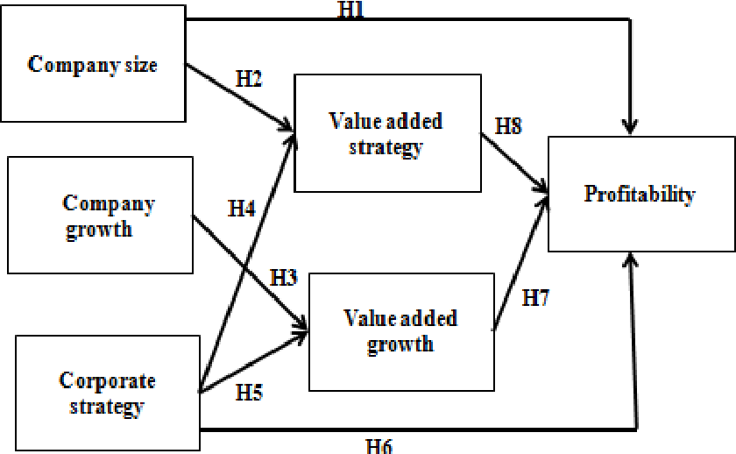

- What are the three factors to be considered when designing a logistics strategy?
There are three factors to consider when designing a logistics strategy:
- The Higher strategies
- The business environment
- The organisations distinctive competence

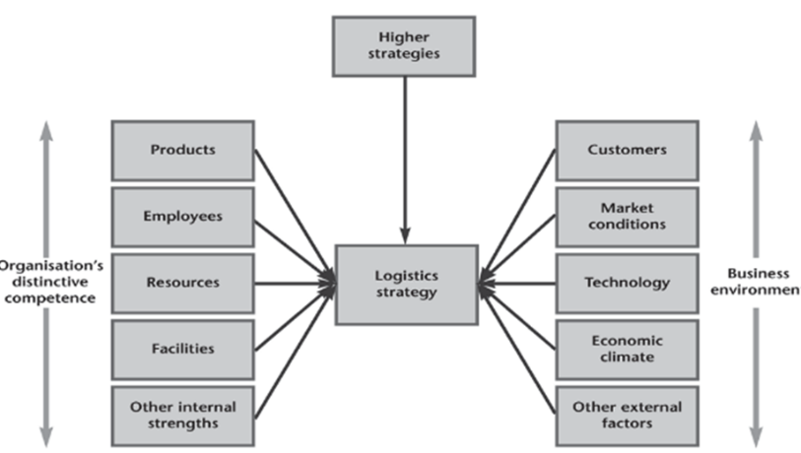
- How do logistics play a strategic role in organisations?
The recognition of the strategic impact of logistics is one of the most important events in recent years for many organisations. It changes the way the supply chain is managed and closely links it to other strategic decisions. Logistics plays a new and prominent role and takes the same focus as other core functions.

vii. Outline the main areas that a logistics strategy emphasises.

A logistics strategy is most likely to emphasize the following:
- Cost: Lower costs lead to higher profits for organisation and lower prices for customers.
- Customer service: Logistics controls stock levels, delivery times, speed of response, and so on. This strategy allows organisations to get a long-term competitive advantage.
- Timing: It mean rapid supply of new products, or delivering at the time specified by a customer. A common logistics strategy guarantees fast deliveries.
- Quality: a common logistics strategy guarantees high quality service to satisfy customers.
- Product flexibility: One logistics strategy is based on a specialized or customized service to individual specifications.
- Volume flexibility: It allows an organisation to respond quickly to changing levels of demand.
- Technology: A logistics strategy can be focused on the development and use of the latest technologies for communications, tracking loads, identifying product, recording stock movements and so on.
- Location: One logistics strategy is to provide a service in the best possible location since customers generally want products to be delivered as close to them as possible.
viii. What is a Lean strategy?
Lean strategy: means that the company charts its course to improve its profit by reducing costs, or by becoming the highest quality or most responsive supplier in its market.
Lean Thinking lays out the five Lean manufacturing principles; value, value streams, flow, pull, and perfection. Here's some insight into what Womack and Jones meant by each.

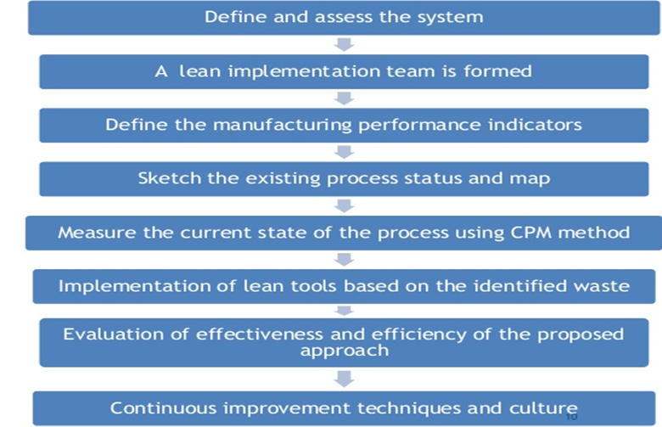

ix. What is the main purpose of logistics audit in organisations?
The purpose of a logistics audit is to collect relevant information about existing practices and performances of logistics. Logistics is the process/chain management of transport/flow and the storage of goods and services from its origin to its consumption. Logistics, by description is coordinating complex operations involved in the moving of people, equipment, and supplies. The primary objective of Logistics Audit is to match the logistic requirements and customer service expectations, taking the market dynamics into consideration, and to identify areas for improvement to achieve customer service excellence.
    - Getting information about business environment (external audit): the nature of customers, types of demand, accepted service levels, competitors and their operations, benchmarks and comparisons, economic conditions, geographical and political constraints, and other relevant external information.
    - Getting information about distinctive competence of organization (internal audit): the structure of the supply chain, warehouse locations and size, stock holdings, lead times, order processing, damage, productivity, and other relevant internal information.

2. Outline the steps involved in developing a logistic strategy.
- Use volume to leverage price
- Define what you are trying to accomplish
- Focus on your competencies
- Utilize the technology available
- Fine tune your warehouse and processes
- Stay away from decision making
- Focus on your customers
There are eight steps for designing a strategy:
1. The external audit gives an analysis of the business environment and then shows the factors that lead to success in this environment.
2. The internal audit analyses higher strategies from a logistics viewpoint, giving the context and overall aims for logistics, its strategic focus and perhaps includes a logistics mission.
3. Design the general features of supply chains that can best deliver the desired services. This includes the design of the network, location of facilities, capacity, technology used, and so on.
4. Set specific goals to show what each logistics activity must achieve. The internal audit shows how well the current logistics achieve these goals, and identifies areas that need improving.
5. Design the best organizational structure, controls and systems to support the logistics network.
6. Benchmark logistics, looking at the performance of leading organizations, defining measures to compare actual performance with planned, optimal and competitors’ performances.
7. Implement the strategy, setting the conditions for lower levels of logistics decisions.
8. Monitor actual performance, continually look for improvements, keep the strategies up to date, and give feedback

CASE STUDY:
How does Charlotte currently organise her logistics? What do you think are her aims and priorities?

Eight years ago, Charlotte took over a small field and started growing herbs. She sold a small range of herbs to local people who wanted fresh, organic produce for cooking.

Five years ago Charlotte started growing more unusual herbs, expanded her growing area into a second field and opened a visitors’ center.

Three years ago, Charlotte introduced a new range of herb products. This was a major expansion, converting some of the farm buildings into a ‘herb kitchen’ and making products for cooking (sauces, dressings, and marinades), perfumes (posies, potpourri, and sachets of dried herbs) and what she called ‘healthy stuff’ (herb mixtures traditionally said to have beneficial effects).
Logistics plays an essential part in supply chain management. She plan and coordinate the movement of products timely, safely and effectively.
It is used to plan and coordinate the movement of products timely, safely and effectively.
- Logistics helps in reducing costs and improves efficiency
- Logistics helps businesses create value
- Effectively coordinated logistics leads to positive business results
- Logistics helps in reducing costs and improves efficiency
- Effectively coordinated logistics leads to positive business results
- Keep your customers satisfied, rely on experienced logistic professionals
What do you think are her aims and priorities?
Satisfied customers are the most precious asset for any business. Her main aim is to drive the supply chains in each of the three phases: manufacturing, marketing and logistics. For this reason, it is a priority for her business to clearly understand customer needs, preferences and demands, and then work relentlessly to meet them.
When successful business leaders acknowledge the needs and requirements of their existing and potential customers, she develop a strategies and rely on effective logistics to improves, manage growth and expand.
What would be the effect of the expansion on logistics?
- Flexible Logistics
- Competence Capability
- Physical Supply Flexibility
- Physical Distribution
- Purchasing Flexibility
- Demand Management
- Customer Satisfaction

What problems would Charlotte face and what options does she have to overcome them?
- Diversified products
- Short order cycle times
- Shipping in small quantities
- High frequency and reliability of deliveries
- Customer service orientation
- Low stock level and rapid inventory turnover
- Timely and accurate information requirements
Customers now not only include your neighbours and local friends; they include people from across the globe, as well. Regardless of the distance, each customer expects their products to be delivered quickly and flawlessly. In order to do this, smart businesses hire experienced professionals to align the pattern of movement of products in the most convenient and practical way.

Student Statement:
By submitting this assignment, I confirm that this is my own work.
Student Signature | OmotosoVOT | Date | 06/11/2019
For Tutor / Assessor Use Only
Total Marks
Marks Obtained
Percentage / Grade

