

Student Name: | Servane Wentzel
Student Number: | 6431
Course: | Certificate in Interior Design
Assignment NO: | 3

Marking Criteria:
We expect the learners to write minimum one well expressed point in three lines against each allocated mark. This means one needs to write 15 lines with 5 well expressed points to get high grades for a 5 marks question.
For high grades use examples and illustrations where appropriate.
What do you understand by the term “human dimensions”? How important it is to consider for an interior designer when planning interior schemes?
“Human dimensions” mean that clients have physical differences that must be taken into account by the Interior Designer. Humans come in all shapes and sizes. With that in mind, products must to be made to fit the size and the height of the people who will use them, in order to make the users as comfortable and efficient as possible in their environment.
For the Interior Designer, when planning interior schemes, he/she must remember to work on a design concept that will meet the client’s needs.
There are 4 postures that must be considered:
- Standing: whether it’s cooking in the kitchen or working behind a counter, the height of the work surface must be adequate to allow a good standing posture. The height of a work surface will increase as the work goes from “heavy work to light work to precision work”.
- Sitting: because we have become more desk-bound, choosing a chair that allows a good posture and prevents back problems is key for workers. Nowadays, chairs come with numerous features: padded with adjustable seat and armrests height for example.
- Reaching: when planning shelves and cupboards, the Interior Designer must design a comfortable environment for the users, with easy to reach shelves to increase productivity as well as decrease any risk of injury (shelves too high or difficulty to reach windows because of a desk).
- Moving: people should be able to move around a house/room or an office without any risk of hurting themselves or someone else. Depending on the level of traffic and for health and safety reasons, the Interior Design must adapt the design of a space to maximize the flow of movement.

How different contrasts can be introduced into an interior scheme? What is their importance in a design scheme?

A contrast is a display of opposite elements in a space that will highlight a visual interest. A balance of contrasts is important otherwise they end up fighting with each other. They can be introduced into an interior scheme in many ways.
- The size contrast: in a space, large elements have more visual weight than small elements. I like the idea of placing a beautiful statue of a small/medium size in front of a big wall mirror to attract a focus on the statue.
- The orientation contrast: to create an interest on repetitive positioning of objects, it might be an idea to change the orientation of the objects. When displaying books or dvds, it might be an idea to position some vertically and some horizontally. It will make the wall more interesting – see photo 1 below.
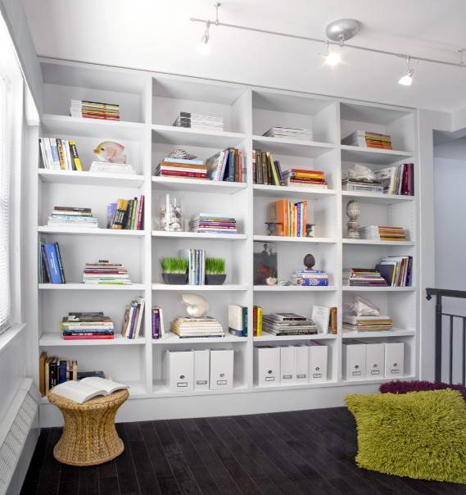Photo 1

- The shape contrast: round shapes often have a softer touch than square or rectangular shapes. For example, in kitchens where most elements have a 90 degree angle, adding circular lampshades or round chairs will help softening the overall appearance – see photo 2.
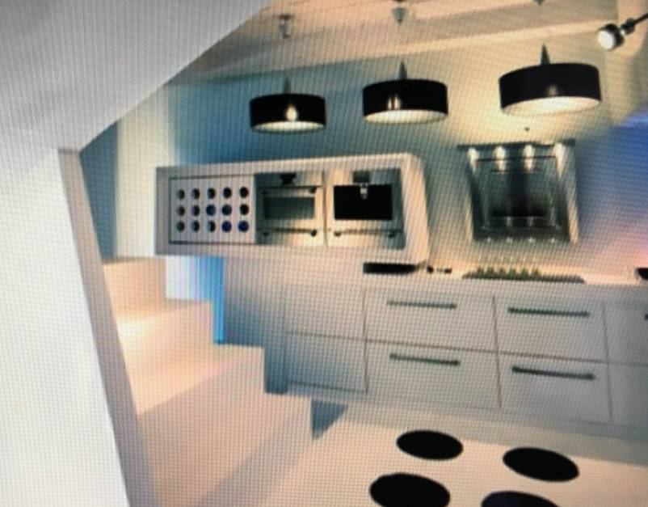Photo 2
- The texture contrast: a good way to create some contrast in a space is to use different textures: “satin and leather, silk and suede, velvet and chenille”. For example, a leather sofa with some satin cushions will draw attention.
- The colour contrast or a number of different colour combinations. For the colour combination to work, one colour must be the dominant one and its “opposite” colour an accent, such as:
- Contrast of complementary hues: they are colours that sit opposite to each other on the colour wheel. The combinations of those colours create an energetic look.
- Contrast cold/warm: some colours are considered “warm” and stimulating (red, orange, yellow), but other colours like blue, green or light purple are calm. A blalance of warm and cold colours will create a mood and have an influence on the size of the space.
- Contrast light/dark:: this contrast creates depth and drama in an interior. Colours can be changed by adding white to lighten them or black to darken them. In addition, black and white can create a visual illusion: black areas appear recessed and while white areas seem to come towards you.
In conclusion, a space without contrast can be boring but a space with too many contrasts can be sore for the eyes..The role of the Interior Designer is to use his/her knowledge to find a balance and make different elements work in a room. Contrast is what makes a room interesting.

“Too many disjoined elements can be dis-quietening to the mind’s eye”. How can an Interior Designer avoid this in an interior design scheme?

The interior of a house must reflect the personalities, tastes and experiences of their owners. By getting familiar with the different elements of a space, the Interior. Designer will strategically blend them to create a unique look that meet the client’s requirements.
With a few rules, different elements in a room can work together:
- Different styles: they can either be organised throughout the room, so it’s easier for the eyes to accept, or they can be linked by an element that works as a bridge: a see-through chair (see photo 3) or an antique piece of furniture reupholstered with some modern fabric.
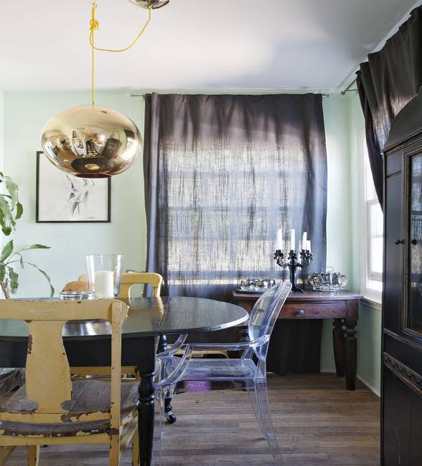Photo 3
- Balance: it’s about distributing the weight of elements in a room. When entering a room, the eye should travel. It exists 3 styles of balance: symmetrical (elements are identical on both side of a central axis), asymmetrical (elements are not identical on both side of the centre but there is a sense of visual balance), radial (elements well-organised around a centre point).
- Grouping items: to make them work, one must find something they have in common, ie. colour, size or texture, etc.
- Colour: dealing with different colours in a space can be tricky so referring to the colour wheel is always a good start. It’s about understanding how to make the colours work. It is important to consider the colour harmonies. By adding colours, it is possible to tone down or brighten the room feeling.
- Form/Size: items of a similar form or size (like vases, bottles or bowls) will make a bigger visual impact as a group than individually spaced across a room.
It might make sense to group collection items together, rather than spreading them throughout the room, they would have a bigger impact – see photo 4. 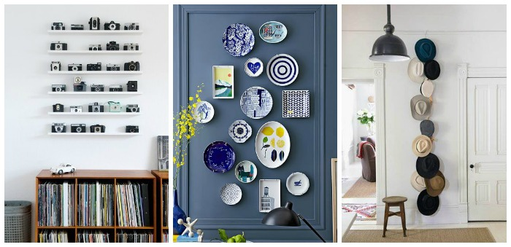Photo 4
- No solitary items: every element in a room must have a “buddy”, the photo 5 below illustrates very well this: wooden side table and the coffee table tray, the colour of the armchair and the lampshade and a pillow, the frames are all different but they all have a buddy.
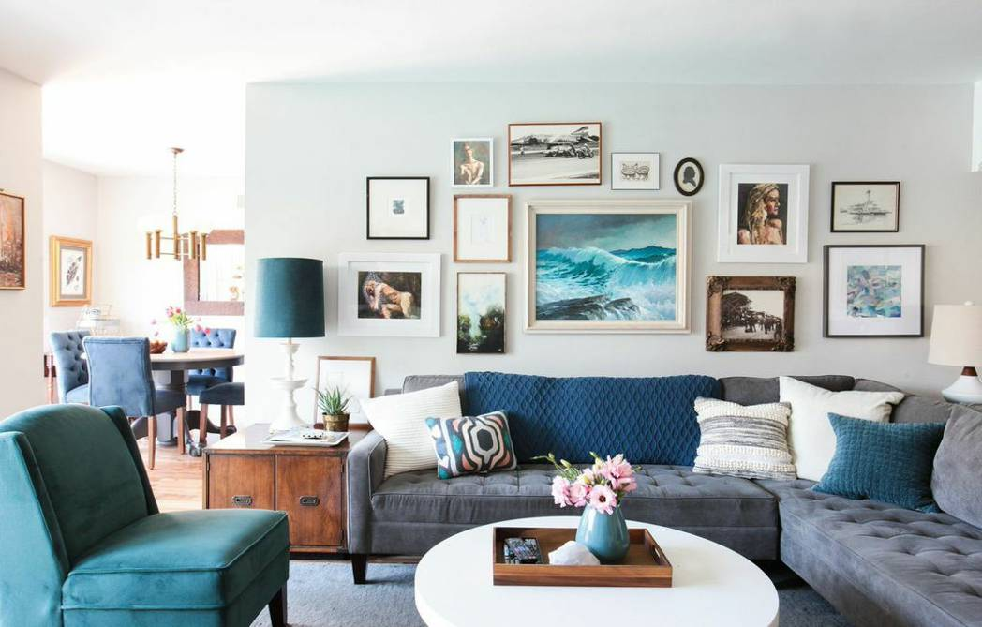Photo 5
- Focal point: in a room busy with contrasts, a focal point will help the eyes and mind to rest. It can also take the focus off less attractive elements in the room. And finally, it will be a good starting point to position the other elements in the room.

Student Statement:

By submitting this assignment, I confirm that this is my own work.

Student Signature | Servane Wentzel | Date | 20/07/17

For Tutor / Assessor Use Only
Total Marks
Marks Obtained
Percentage / Grade

