
Assignment Cover Sheet

Student Name: | Sinéad Louise Brain
Student Number: | 8953
Course: | Diploma in Business Administration – Level 4
Assignment NO: | Unit 7 – Time, Stress and Crisis Management

Marking Criteria:
We expect the learners to write minimum one well expressed point in three lines against each allocated mark. This means one needs to write 15 lines with 5 well expressed points to get high grades for a 5 marks question.
For high grades use examples and illustrations where appropriate.
Unit 7 – Time, Stress and Crisis Management.

Q1. Short Questions

- Discuss the relationship between time management and the effective performance of individuals in an Organisation.

Time management is a process of planning and organizing how much time is spent on specific activities. By producing a time management matrix a business / organization can organize its priorities.

ACTION | ACTION
Do 1st | Do Next
ACTION | NO ACTION
Do Later | Don’t do anything at this stage

By creating this matrix effectiveness and efficiency in the workplace can be increased due to:

- Creating and keeping deadlines
- Delegation of tasks to ensure everything is covered
- Delegation leads to increased individual responsibility and pride in work through goal setting and goal achieving
- Effective and timely decision making
- Effective team management which contributes to individual performance.
- Multi-tasking
- Strategic Thinking
- Implementing Strategies
- Managing appointments
- Making and managing schedules
- Collaborative problem solving and events

All of these enable the individual to achieve their best performance level by understanding:

- What is expected of them
- What tasks they are individually responsibly for
- Who they are responsible to / who they can look to for help
- Understand what their own and collective deadlines are
- Project task management. – on time, behind schedule
- Identify through appraisals, 1-2-1’s were they have worked well / exceeded expectations – leading to praise / rewards
- Identify where problems have arisen and adjustments can be implemented.
- Accountability

Poor Time Management leads to poor performance on an individual and collective basis.

In an office I have seen a sign

“Poor time management on your part will not constitute a crisis on mine”

Individually if deadlines are missed there is a knock on effect with the next process. However when individuals are constantly lacking time management skills and are not reprimanded for their tardiness, workforce ethos changes:

- I wasn’t told … so I didn’t do ….
- Not in my job description
- Deadline? What deadline? Which deadline?
- A Mañana attitude – yet weeks later nothing has been done.
- Easy tasks with lower priorities completed first

Effective time management should be a business priority as it is this that provides the structure for individuals to be effective and efficient and thus achieve high performance levels.

- How do managers use appropriate skills to resolve conflicts?

Conflict resolution refers to workforce / client / supplier interactions and the difficulties that arise from those interactions. Whilst there is normally a company process or separate department for handling customer complaints; one of the hardest jobs a manager has is dealing with ‘difficult’ individuals within the team.

These difficult people ensure that:

- Team morale is lowered
- Teamwork – what is that????
- Constant excuses and interference in activities
- Lack of collaboration and co-operation
- Friction and raised tempers
- Reduced efficiency
- Deadlines missed or just narrowly avoided

If a team is to be effective, a manager cannot permit an individual team member to sabotage the work undertaken. Using a ‘carrot’ or ‘stick’ may help but within reason and only with a ‘cool head’. It is important for team members to see that their manager is fair and acts with the team’s best interests.

Unfortunately most skills are learned from experience – both good and bad. The following skills provide the theory basis which managers can adapt in dealing with conflict.

Communication:
Clear written and verbal communication can prevent the 2 main causes of conflict miscommunication / misinformation. The grapevine is usually where most employees get their information from as management try to keep decisions ‘hush hush’. Speculation and mis-information can change colleagues into competitors very quickly. The sad fact is that teams that once worked well together can be torn apart by rumours which are completely baseless.

Emotional Intelligence:
The ability to understand your own and others emotional state. This also includes the ability to react to these emotions in a safe and mature way. Being able to diffuse emotionally charged situations helps both the individual and team. Emotional people do not always act rationally. The skill of emotional intelligence provides that rational perspective. Emotional Intelligent managers acknowledge when things are not going well but instead of focusing on the ‘what if’s they look into what preventative measures can be undertaken.

An example of this was from a recent restructure within the department I work in. Our manager told us that redundancies were coming as the departmental budget was being cut by a specific figure. Rather than letting the department fall apart and turn on each other through having to prepare for competitive interviews he used our anger, frustration etc. to turn the situation around.

Sitting down as a team we worked out where we could make savings, job share, reduce days, reduce to term time contracts et al. Instead of losing 50% of our team (4 people) we only lost 1 through re-deployment which was the individual’s choice. The team has remained close and conflict avoided.

Empathy:
Being able to look at the argument from others perspectives whilst maintaining the balance and wider picture. It is possible for 2 opposite sides of an argument to be right. E.g. Is a beaker half full or half empty.

Empathy will give affirmation of the 2 perspectives whilst looking for a way forward. i.e. it doesn’t matter if it is half full or empty – there is still sufficient room to add xxx amount of liquid to the beaker.

This resolves conflict without taking sides or being seen as biased.

Problem Solving – Discussed in the next question.

- What is the importance of problem-solving skills for managers?

Business contingency planning gives managers the opportunity to think ahead and assess what problems may arise. What these plans don’t account for are the unexpected problems that will inevitably arise. Problem solving then becomes an essential skill.

Albert Einstein is often quoted in relation to problem solving:

“You can never solve a problem on the level it was created”, neither can you “solve ..problems with the same thinking … used to create them”.

The reading material compares how 2 different companies solved their product and image problem after a fatal incident. How they solved the issue left 1 company recovering and the other not. This shows how important the ability to solve a problem is, (as both companies did); but also using the right solution to the problem in the given circumstances.

Managers should be able to see problems arising through:

- Observation – has workload / morale decreased? Then look into why
- Lateral Thinking –thinking outside of the box for problem solutions
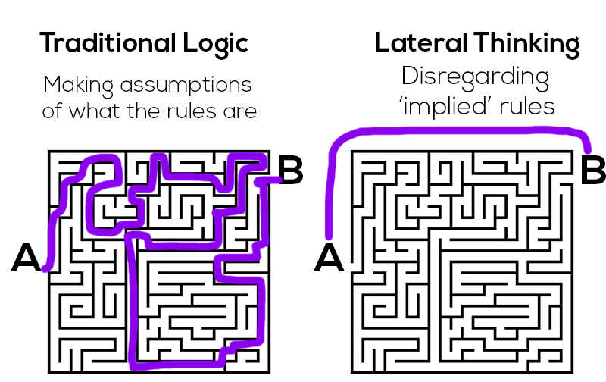

- Analytical Skills – Sometimes creative ideas are not suitable or cost effective. Practical skills in breaking down the issue, why it isn’t working and what can be done to resolve the situation is often needed E.g The Americans and Russians response to the difficulty of writing with a pen in space due to lack of gravity disrupting ink flow. The Americans spent millions of dollars creating a pen that would function correctly in space – The Russians used a pencil. This may seem laughable and both solutions worked; but sometimes breaking down an issue and looking at the most practical solution is the best and most cost effective method.

Good problem solving skills require:

- The ability to define the problem. This requires looking beyond the symptoms to the actual cause. E.g. low morale is a symptom, the cause is that the new policies and procedures are unrealistic and unachievable.
Solution – look at what the new regulations were meant to achieve – what makes them unrealistic/ unachievable - what adjustments need to be made to make them achievable
- The ability to recognize Alternatives – This can be done as an individual or as a team ‘brain storming’ session. Using a method of putting every idea of the table – no matter how bizarre – can start the process on ‘what would work’ thinking. The alternatives that are then seen as possibilities can then be analyzed to determine the best course of action based on the evidence available.
- Implementing Strategy. Being able to decide a course of action is only the start. Being a good manager means making the final decision and taking it forward with all the responsibility that it entails. This will then include being prepared to accept possible risks and deal with what arises based on decisions made.

Businesses / organizations rely on managers – whatever tier they may be on in the organization to be able to
- Identify problems
- Analyze problems
- Assess severity of problems
- Assess the impacts
- Assess solutions impacts
- Decide on final course of action
- Implement.

In order to achieve the above – good problem solving skills are essential.

- How does good diary management support effective time management?

Most businesses today use a computerized diary system. Personal Assistants may keep more details of appointments in a written diary in conjunction with the electronic diary.

For the purposes of this question I will be referring to the electronic diary ‘Outlook’ from the Microsoft Office package. – the example below is my current diary (all info is non-confidential).

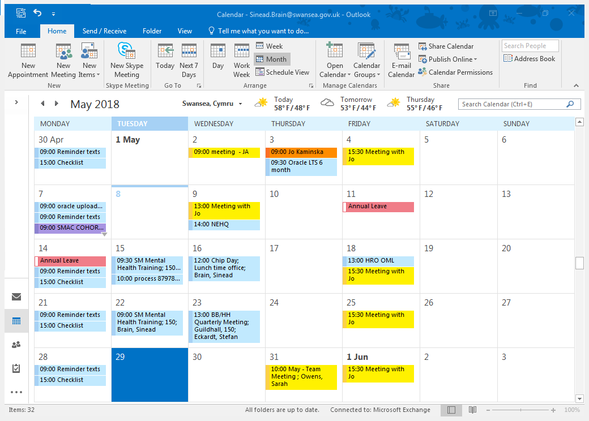

This diary provides

- Daily record of activities
- Books and records business meetings
- Allows others to view your diary to see if you are free to contact / send a meeting request
- Set reminders for upcoming events
- Set recurring meetings / tasks at daily, weekly and monthly time frames
- Reminds of training courses booked months in advance
- Allows travel time to be marked so that no requests will be received for that time.

Good diary Management means keeping all of the above updated, adding and cancelling appointments / meetings / training etc. as required

Personally I colour code activities to provide a quick visual of the day’s activities:
- Meetings
- Travel time
- Training
- Protected time
- Meetings which can / can’t be rearranged

These examples of time management through good diary maintenance reduces stress by:
- Knowing what is happening in advance in order to prepare
- Ensure that meetings offsite can be reached within a comfortable time frame – allowing for parking / traffic etc.
- Ensures you are in control of what is happening and when.

Poor diary management leads to:

- Missing important meetings – whether in work or early finish to attend a parent / teacher meeting
- Being unprepared for meetings
- Being late due to double bookings – especially when travel time was neglected
- Missing deadlines
- Missing invoicing / payment dates – many company’s require travel / expenses to be in for a certain date each month or else they won’t be paid
- Perceptions of individual / corporate incompetency, disorganization and unreliability

All of the above cause un-necessary stress and are completely avoidable by good diary management.

- How do you know when you are stressed?

Everyone has their own stress tolerances. What might cause stress for one person would not affect another. The following chart is used by our ‘in-house’ stress management and counselling service.

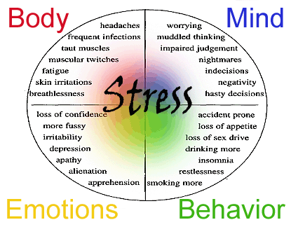

Personally, I function best when under pressure and have too much to do. The thought of being in work with nothing to do would cause me severe anxiety and stress. My mind needs to be constantly challenged if I wish to avoid some stress. The danger with this is that it is only a small slope between functioning and stress burn out. My stress levels also rise when unforeseen events arise which prevent me from doing what I know needs to be done. This can be from the computer in work working at a snails pace to the disruption through hospital admissions and surgery which have delayed my completion of this course at the pace I wanted to.

When I see the following symptoms of stress in my own life I know it’s time to take a break to relax before carrying on:

- Headaches
- Lack of sleep
- Dry mouth – constantly drinking (non-alcoholic!!)
- Craving sugar to boost energy levels
- Getting annoyed with myself and others around me for not achieving targets
- Overworking – especially in down time hours at home – to catch up on work

Being able to recognize these symptoms ensures that stress can be reduced to a manageable level and not have an impact on work / personal life.

- Outline the effective measures to control stress

The following are a list of measures that can control stress. The same caveat as above applies – some of these will work better than others depending on the stress and the personality of the individual.

- Practical Measures:
- Plan your workload (time management matrix Q1)
- Plan your social and leisure activities – permitting rest time
- Tidy and organize your workspace
- Tidy and organize your home

These measures reduce stress by relieving some time pressures through prioritising, cutting down on activities if not sufficient time and ensuring preparation.

Princeton University of Neuroscience published an article in the Journal of Neuroscience Jan 2011 which evidenced how a cluttered environment can reduce wellbeing by preventing the ability to process and focus on the task at hand.

- Physical Measures:
- Get enough sleep (don’t burn the candle at both ends)
- Exercise to release endorphins
- Eat a balanced diet to ensure your body has all the nutrients it needs to function – e.g. low magnesium levels prevent ability to go to sleep.
- Likewise ensure your fluid intake (esp water) is high. Dehydration causing dizziness / headaches and can reduce brain function.

- Relax!! - this is easier said than done but is essential to good wellbeing:
- Mindfulness Sessions
- Yoga / Tai-chi
- Pamper Days
- Going to the gym
- Playing / Listening to music
- Craft Activities
- Painting
- Walking etc.

- Get Help: If managing stress becomes more than can be personally handled then it’s time to get help. There used to be a stigma around stress but the Time to Change movement has worked to change that perception.
http://www.time-to-change.org.uk/

Ways to get help include but are not limited to:
- In house Occupational Health / Stress Counselling
- GP – temporary medication and referral to specialised community support
- Walk in at hospital if suicidal / wanting to self harm
- Private Therapy – talking therapies such as CBT and creative therapies can be a release valve – a safe place to vent and learn coping mechanisms to reduce stress levels.
- Samaritans or other online / telephone / text services

Q2. “Time management is, in part, a tool for stress reduction”. Discuss.

To some extent the answer to this question has been provided in the above answers.
Stress occurs when we are fearful and / or when we feel that we do not have the ability to cope with a given situation. In many cases it is when time seems to be slipping away and there is still so much to do that people become ‘stressed out’.

At the outset it is important to realise that there are only so many hours in a day and in a work day. Having to do extra work at home on a regular basis despite optimised usage of time in the office means that an unrealistic timescale has been set initially and this needs to be addressed.

In order to regain control and thus the perceived ability to cope and reduce stress levels the following skills regarding time management are useful:
- Use time in work to complete tasks – don’t procrastinate
- Set end time for the work day and finish (certain projects or emergency services may require additional time but in general normal business hours should apply)
- Be realistic about what time you have
- Set aside time at the start of the week / day to plan activities
- When busy set aside time to reply to emails. Read them on arrival in the mailbox but flag to reply later if not essential to present tasks
- Set priorities – back to the time management matrix
- Set Skype to busy or do not disturb
- If needed – set your out of office on so that you won’t be disturbed

It is also important to realise that time pressures and deadlines can be positive. Having these can remove procrastination and apathy towards a project. E.g. knowing an essay must be submitted in 4 weeks time permits reading, planning, draft and final assignment preparation. You can only put it off for so long if you wish to do well (the case study is a good example of poor time management in this form).
Poor time management causes stress not only to the individual but to those around as well – including work colleagues, clients, managers and 3rd party stakeholders by:
- Missing deadlines
- Project failure due to missing deadlines
- Financial repercussions – loss of income due to failure to complete, loss of future custom as clients won’t return – bad company reputation
- Failure to secure investment – stakeholders will not want to reinvest money into a project that was badly time managed from the outset.
- Could lead to compensation claims against the business
- Productivity decreases – less product to sell
- Individual having to work longer hours to recoup financial losses e.g. working overtime due to loss of monthly bonus for meeting targets
- Individual being passed over for promotion due to poor time management skills
- Individual being disciplined or fired – e.g. always turning up late to work

Whilst the above are work examples, time management stress also has an impact in the non-working environment.

I have a number of friends who if you want them to be in a certain place by 6pm then you tell them to be there at 5pm. The stress and time pressure that this puts on the wider circle of friends can be significant e.g. losing a dinner reservation by being more than 10 minutes late.

Other personal impacts that this can have are:
- Missing out on family birthdays and events
- Missing family lunch / dinner dates
- Missing dental / medical appointments which can mean that referral is cancelled
- Late payment of bills can incur charges and bad credit ratings
- Embarrassment to the individual and those accompanying them by arriving late
- Missing out on quality time with spouse / partner / children

Work related stress can be managed with personal support and supportive management; but, when work and personal lives are stressful then the impact on an individuals wellbeing and ability to function can be seriously decreased. When stress levels rise to this extent there is the potential for developing a mental illness which will require treatment e.g. mental breakdown, self harm, depression and unfortunately in some cases suicide.

Good time management cannot remove all stresses. However, it gives an individual more control over a situation. With this control, anxiety can be managed or removed thus reducing stress levels to a more manageable level.

Q3. Case Study

- Time Management Problems

As a teacher I have seen this situation arise with so many GCSE / A Level students. My initial reaction was ‘why was distance learning a good idea to begin with’ as it requires self-motivation, time management and taking responsibility for your own learning. When reading further and realising that this is an adult in the workplace it becomes a disaster looking for a place to happen!!

Alison’s time management problems include:
- Leaving an assignment until the last minute means that the assignment would never be done to the best of her ability as it precludes sufficient time for reading, research, drafts and reflection.
- After an evening meal when you are at home, brain functions start to wind down and relax. This is a good thing except when you have to be alert to write an assignment. A heavy meal also makes you sleepy / lethargic which is not the right mind-set for studying.
- Wrong priorities. Alison seems to be doing everything but what she is supposed to. Exercise and fun activities are great to do; however, sometimes sacrifices have to be made in the short term in order to achieve goals. If achieving a qualification to enhance future job prospects was a priority and an assignment was due then going out for sporting activities would not be high on the list of priorities. Going to church would be a priority but this should have been factored in to a time management plan.
- Not setting an alarm. Ensuring you get enough sleep is essential, but again when there is a task that needs done you cannot spend as much time in bed as you would like. Even with the lie in Alison could have still had some time to read and write a draft assignment.
- Trying to squeeze to much in to the time available. Alison not only left no time for her assignment but also didn’t leave enough time to rest her body mentally and physically as she was running from one activity to another.
- Late for work. In many places of work this can lead to a reprimand and cumulatively lead to demotion or dismissal. It also creates a rushed and anxious environment for the rest of the day. There is no time to settle in to the working day and set out priorities for the day as she was already running late and playing catch-up.
- Left insufficient time to complete assignment. Trying to squeeze writing an assignment into 2 evenings after a busy and stressful day at work will never lead to the best work possible.

Alison’s bad time management also caused indirect problems which escalated:
- Leaving Notes in work. Whilst this may have been accidental, it does indicate that she rushed out of the office without ensuring she had what she needed with her.
- Reading time. After 30 minutes of reading time Alison should have been able to understand the material. If not (possibly due to tiredness) then she should have marked what she found difficult to look at with fresh eyes in the morning.
- Tutor unavailability. As a general rule tutors are not available at weekends – unless prior arrangements have been made. Alison did not leave herself any time to get clarification if she still didn’t understand the reading material / questions asked.
- Missing breakfast. Scientific study shows that eating breakfast sets your body and mind up for the day. By being late and missing breakfast, Alison has deprived herself of the energy she needs to support her through the day. Thus making herself more susceptible to tiredness, lethargy, lack of concentration headaches etc.

- List 5 Strategies and explain how Alison might use these to overcome her time management problems.

The strategies given below refer to Alison’s work / student and personal life. If she wasn’t a student then other strategies would have been added whist others were omitted.

- Create a life schedule.

This schedule plans a month ahead. Monthly paper planners or whiteboard planners like the one shown below are easy to use to plan what needs to be done and by when. In Alison’s case this may be backed up with phone / tablet apps that give reminders whilst on the move.

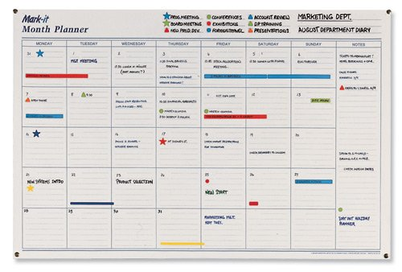

This planner gives an at a glance view of any given day in the month. Shifts in work can be blanked out, church on a Sunday morning, medical / other appointments events etc can be added in. Then in terms of coursework / assignments reading / research time can be booked in over a few days, then first draft, reflection and final copy times can be added. Thus giving time to prioritise important events and only accept other events if time permits. This method can also plan annual leave / flexi days in the run up to an exam or assignment submission to facilitate designated study time.

2) Avoid Procrastination

The case study shows how Alison does everything except her assignment. We all have jobs or assignments that we don’t like doing e.g. taking out the bins – but they have to be done. Usually the longer you put them off the worse the build-up to doing them becomes. In order to avoid procrastination setting deadlines on the planner and then going to a different location – preferably outside of the house, will help Alison focus and avoid distractions. By doing the reading and research element of her assignment in a library, not only will she have access to the information to help her study, but, will also provide a calm, quiet environment to work in. Her mobile phone will need to be on silent if not turned off – thus avoiding social distractions.

3) Job compatibility

Working full time and studying is a difficult balancing act. Distance learning rather than evening classes also comes with its own pressures and challenges. Before any learning is undertaken this should be carefully thought through. It may mean having to look at the job you do and ask for a reduction in shifts or to drop a day in order to facilitate learning. In some cases it may mean having to look for a different job that will allow you the flexibility that is required with long term study. It also should try to reflect when you study best. E.g. If you are a night owl and work best at night then looking for a job that has afternoon shifts would be best (to facilitate studying to the early hours of the morning and having enough sleep before work starts). Likewise if you study best early in the morning then look at later morning shifts.

For Alison it also means knowing what hours she works and looking at ways to make best use of her time around her working hours. E.g. can she read on a train / bus in her commute to work? Can 15-20 minutes of her lunch break facilitate a reading of a draft assignment for proof reading…

4) Get enough sleep

This is linked with all of the above strategies. You can’t burn the candle at both ends long term without getting burnt out. The case study shows that Alison is so tired at the end of the day that she forgets to set her alarm. Also oversleeping to 10am indicates that she is not sleeping early enough at night. It is not just that Alison is constantly busy, it is also the level of physical energy required in playing sports and the mental energy to try and keep up with what is happening and when.

Getting enough sleep will ensure the mind and the body have a chance to rest and thus be refreshed for the next day and the challenges / decisions that it brings.

5) Learn to say ‘NO’

As mentioned previously there are only 24 hours in a day. Alison cannot seem to say no to anything or anyone. Whilst it is important to socialise – it is impossible to keep up the schedule Alison was setting. Once a life schedule (strategy 1) is in place, priorities will already have been identified and time booked in for essential events – including social events. Essential protected rest time also needs to included here.

After this Alison would need to use this schedule and be able to say ‘no, I can’t come ….. as I am working / studying. However, I can meet you …… as I am free then.’

Any friend will understand that if an assignment is due then socialising may not be an option that week. Or if it has been a long week working and studying, then a night in with a movie and wine is more beneficial than going clubbing to 3am.

All of the above strategies will ensure a balance between work / student and personal life and help Alison with her time management issues. Submitting an assignment that has been done to the best of her ability will then allow Alison to celebrate her achievement accordingly.

Student Statement:

By submitting this assignment, I confirm that this is my own work.

Student Signature |  | Date

For Tutor / Assessor Use Only
Total Marks
Marks Obtained
Percentage / Grade

