
Assignment Cover Sheet

Student Name: | SuheilAbdelshafie
Student Number: | 28418
Course: | Advanced Diploma Project Management Level 5
Assignment NO: | 07

Marking Criteria:
We expect the learners to write minimum one well expressed point in three lines against each allocated mark. This means one needs to write 15 lines with 5 well expressed points to get high grades for a 5 marks question.
For high grades use examples and illustrations where appropriate.
Please insert your completed assignment ( in word format) here:

- Give brief answers for the following questions:
- Outline the processes involved in project quality management.
The processes involved in project quality management are as follows:
- Plan quality management: which is about identifying the quality requirements and standards for the project and product.
- Perform quality assurance: auditing the quality requirements and quality control results to ensure appropriate quality standards are used.
- Control quality: monitoring and recording the results of quality activities to assess performance and recommend necessary changes.

- What are the main characteristics of project quality management?
- Client satisfaction: The project must fulfill the client necessities by delivering what it guaranteed so as to satisfy the requirements of the client.
- Management responsibility: The project team or group must work towards the quality objective. The management should likewise give the fundamental assets to convey on the quality guarantees.
- Prevention: Quality is arranged into a project, not examined into it. It is in every case more cost effective to avert errors than to correct them.
- Kaizen technology:Kaizen is a quality management theory of applying constant little upgrades to lessen costs and guarantee consistency or project performance.
- Marginal analysis: Marginal investigation considers the expense of the steady enhancements to a procedure or item and looks at it against the increase in income produced using these enhancements.
- Plan-do-check-act: This methodology is like the project management processes through which every task passes.

- What does the term ‘benefits and cost analysis’ mean? And how it is performed?
A benefit/cost analysis is a procedure of deciding the upsides and downsides of any process, product, or activity. Benefits ought to exceed costs. It is performed by considering the costs of the quality management activities versus the benefits of quality management activities.

- What is benchmarking?
Benchmarking project management is the process of continuously comparing the project management practices of your organization with the project management practices of leaders anywhere in the world; its goal is to gain information to help you improve your own performance. The information obtained through benchmarking might be used to help you improve your processes and the way in which those processes are executed, or the information might be used to help your company become more competitive in the marketplace.
Benchmarking is a continuous effort of analysis and evaluation. Care must be taken in deciding what to benchmark. It is impossible and impractical to evaluate every aspect of project management. It is best to decide on those few critical success factors that must go right for your business to flourish. For project management benchmarking, the critical success factors are usually the key business processes and how they are integrated. If these key success factors do not exist, then the organization's efforts may be hindered.
- What is a flow chart? Discuss the ‘Cause and Effect Diagram.
A flowchart is a visual representation of the sequence of steps and decisions needed to perform a process. Each step in the sequence is noted within a diagram shape. Steps are linked by connecting lines and directional arrows. This allows anyone to view the flowchart and logically follow the process from beginning to end.
Cause and effect diagram, also called a fishbone or Ishikawa diagram, is a visualization tool for categorizing the potential causes of a problem in order to identify its root causes. Typically used for root cause analysis, a fishbone diagram combines the practice of brainstorming with a type of mind map template.
When you have a serious problem, it's important to explore all of the things that could cause it, before you start to think about a solution.
That way you can solve the problem completely, first time round,

rather than just addressing part of it and having the problem run on and on. Cause and Effect Analysis was devised by professor Kaoru Ishikawa, a pioneer of quality management, in the 1960s.Although it was originally developed as a quality control tool, you can use the technique just as well in other ways, such as discovering the root cause of a problem, or why a process not working.
Solving a problem with Cause and Effect Analysis as follows:
Step 1: Identify the Problem
First, write down the exact problem you face. Where appropriate, identify who is involved, what the problem is, and when and where it occurs. Then, write the problem in a box on the left-hand side of a large sheet of paper, and draw a line across the paper horizontally from the box. This arrangement, looking like the head and spine of a fish, gives you space to develop ideas. As illustrated below:



Step 2: Work Out the Major Factors Involved
Next, identify the factors that may be part of the problem. These may be systems, equipment, materials, external forces, people involved with the problem, and so on. As illustrated below:

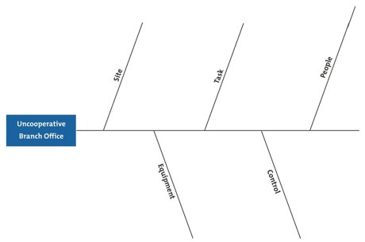

Step 3: Identify Possible Causes
Now, for each of the factors you considered in step 2, brainstorm possible causes of the problem that may be related to the factor.
Show these possible causes as shorter lines coming off the "bones" of the diagram. Where a cause is large or complex, then it may be best to break it down into sub-causes. Show these as lines coming off each cause line. As illustrated below:

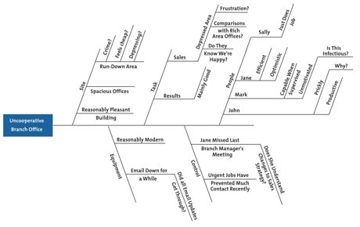

Step 4: Analyze Your Diagram
By this stage you should have a diagram showing all of the possible causes of the problem that you can think of.
Depending on the complexity and importance of the problem, you can now investigate the most likely causes further. This may involve setting up investigations, carrying out surveys, and so on. These will be designed to test which of these possible causes is actually contributing to the problem.

- Discuss quality management plans. How will you complete quality assurance activities? How will you implement that plan as a manager?
Plan Quality Management is the process of identifying quality requirements and/or standards for the project and its deliverables, and documenting how the project will demonstrate compliance with relevant quality requirements. The key benefit of this process is that it provides guidance and direction on how quality will be managed and validated throughout the project. To create the Plan Quality Management, inputs such as the project management plan, risk register, requirements documentation, stakeholder register, organizational process assets, and the enterprise environmental factors are necessary. This project management process is necessary

to create the quality management plan, quality metrics, and checklist. It can also lead to project document updates.
The quality management plan tends to discuss three things about the project and the project work:
- Quality assurance: The general performance is assessed to guarantee that the project satisfies the applicable quality guidelines. Quality assurance is commonly viewed as the work of applying quality plan.
- Quality control: Work results are checked to decide if they fulfill quality guidelines. On the off chance that the outcomes don't fulfill the quality guidelines, the project manager applies root-cause analysis to determine the cause of the poor performance and then eliminates the cause. Quality control is inspection-orientated.
- Quality improvement: The project performance is assessed, and remedial activities are applied to improve the product and the project.
The quality assurance activities is done through the following steps:
- Plan - Organization should plan and establish the process related objectives and determine the processes that are required to deliver a high-Quality end product.
- Do - Development and testing of Processes and also "do" changes in the processes
- Check - Monitoring of processes, modify the processes, and check whether it meets the predetermined objectives
- Act - Implement actions that are necessary to achieve improvements in the processes

References:

- An article available at: https://www.globalknowledge.com/us-en/resources/resource-library/articles/what-is-project-quality-management/
- An article available at: https://pmtips.net/article/benchmarking-in-project-management
- An article available at: https://www.smartdraw.com/flowchart/
- An article found at: https://www.mindtools.com/pages/article/newTMC_03.htm
- An article available at: https://www.guru99.com/all-about-quality-assurance.html
- Darnell, R. and Preston, J. 2018. Project management from simple to complex, version 2
- Rouse, M. 2017. Quality Management Planning. Available at: https://whatis.techtarget.com/definition/fishbone-diagram
- Russ, M. and Dragan, M. 2016. Project management Toolbox, second edition
.

Student Statement:

By submitting this assignment, I confirm that this is my own work.

Student Signature | Suheil Abdelshafie | Date | 28/10/2019

For Tutor / Assessor Use Only
Total Marks
Marks Obtained
Percentage / Grade

