
Assignment Cover Sheet

Student Name: | Hajar Haseeb
Student Number: | 14253
Course: | Diploma in fashion design level 4
Assignment NO: | 7

Marking Criteria:
We expect the learners to write minimum one well expressed point in three lines against each allocated mark. This means one needs to write 15 lines with 5 well expressed points to get high grades for a 5 marks question.
For high grades use examples and illustrations where appropriate.
Q: 1: Multiple Choice Questions:

- A fashion figure is about;
• Eight to ten heads tall.

- The best rule to follow in sketching the face is to;
• Omit as much detail as possible

- The fashion artist exaggerates the;
• Length of the figures and maximizes the width of the hand

Q: 2. What is most important thing to consider when sketching for dressing the figure?
The most important thing to consider when sketching for dressing is making the garment appear to be on an actual body rather than a flat hanger. Being able to see the garment on an actual figure will help the fashion artist enormously when sketching it.

Q:3. How does fashion design sketch help a fashion designer? Fashion design sketches are tools that are used to help designers paint the picture they have in their minds. Visualizing the garment must happen before a good design can be done. Once this is done, the image can then be recreated by pen and paper.

Q: 4. How should bottom of the skirt be sketched? Why is it important to harmonise the mood and action of the figure with the clothes in which artist draws her. Explain giving at least one example.

Folds and lines of skirts will be determined by the position of the legs. Circular skirts or those cut in a specific way may be quite snug on the waist and hips and then flare outward around the thighs and hemline. The amount of flare will depend on the fullness. artist must be able to get the right effect in order to capture the ‘spirit’ of the fabric and the design. For example, using a soft and clinging fabric in the illustration of what should be a crisp taffeta evening gown would completely take away the feel of the outfit.

Activity

Sketch a fashion dress for a female showing all the details required in that garment. Then sketch a fashion figure dressed in same outfi

This is the flat sketch

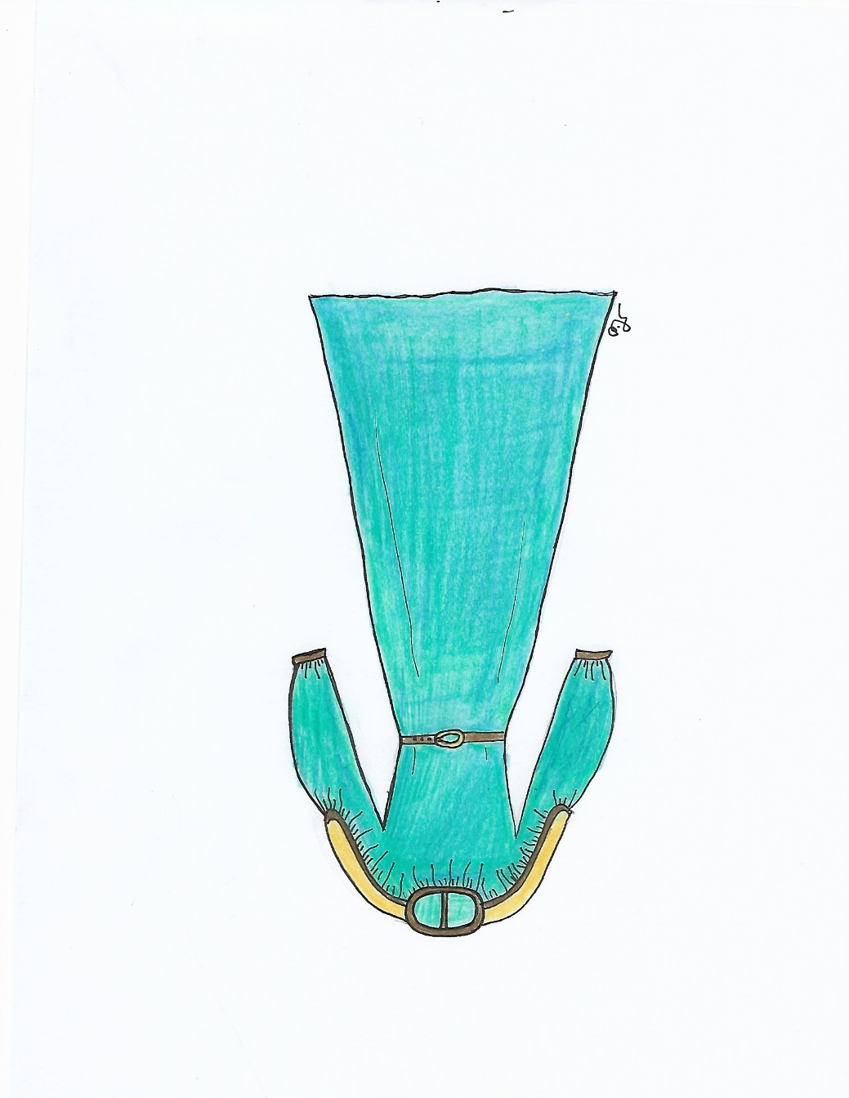

And this on the model

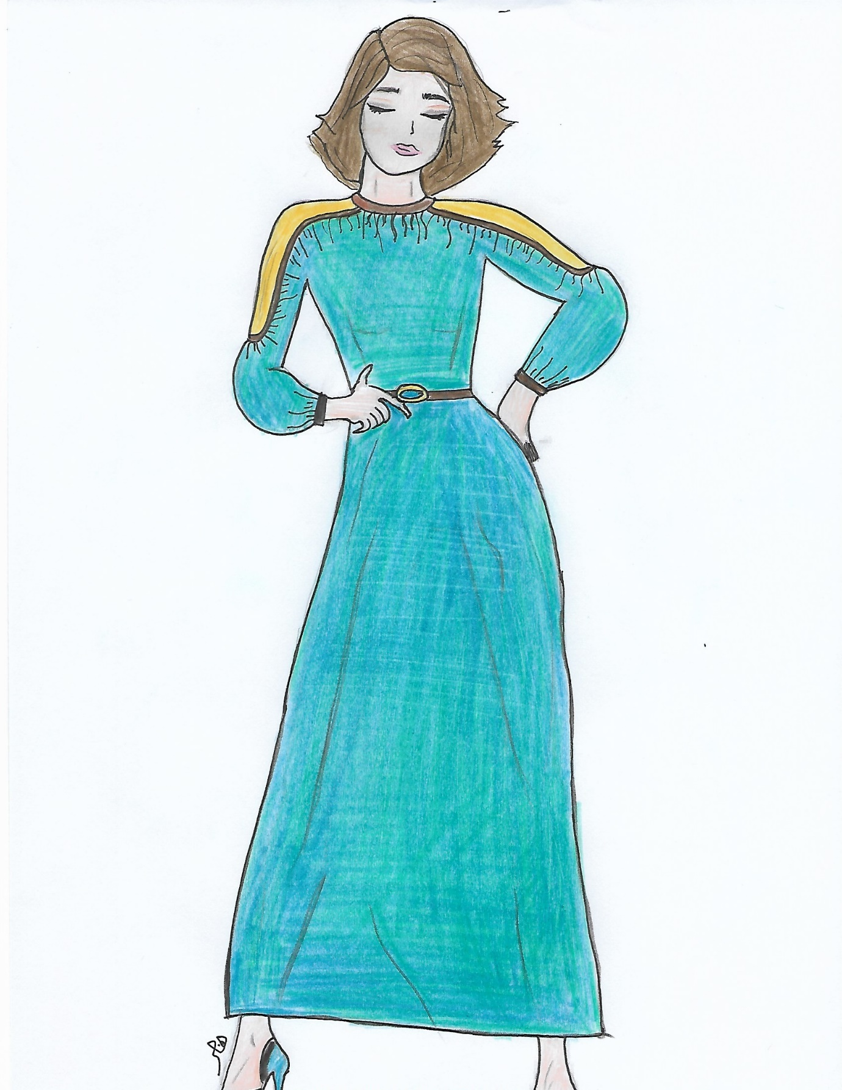

Student Statement:

By submitting this assignment, I confirm that this is my own work.

Student Signature | Hajar Haseeb | Date | 22/7/2018

For Tutor / Assessor Use Only
Total Marks
Marks Obtained
Percentage / Grade

