
Assignment Cover Sheet

Student Name: | Doreen Ntalo
Student Number: | 32621
Course: | Advanced Diploma in Hotel Management-Level 5
Assignment NO: | ASSESSMENT # 10

Marking Criteria:
We expect the learners to write minimum one well expressed point in three lines against each allocated mark. This means one needs to write 15 lines with 5 well expressed points to get high grades for a 5 marks question.
For high grades use examples and illustrations where appropriate.
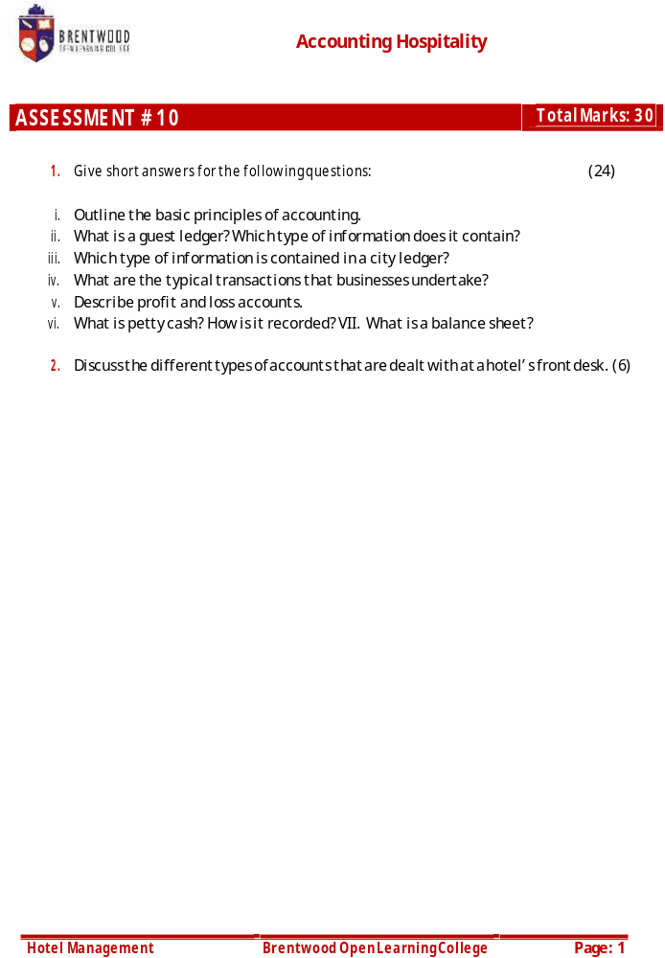

Student Statement:

By submitting this assignment, I confirm that this is my own work.

Student Signature | Doreen Ntalo | Date | 25 Aug 2019

For Tutor / Assessor Use Only
Total Marks
Marks Obtained
Percentage / Grade

Doreen Ntalo
32621
Assessment # 10
Page: 1
1.
- The basic principles of accounting are:
- The amount paid to the hotel by the guest is added in the debit column. Hence, a debit (dr.) is money owed to the hotel by the guest.
- Any money obtained from the guest is added in the credit column. Hence, a credit (Cr.) is money including deposits made in advance, paid by the guest to settle their bills.
- The balance column shows a continuous difference between credits and debits calculated on of the premise “prior balance + debits – credits = net outstanding balance.” This ideology is applied to every folio/bill in which all cash and credit transactions are noted for every hotel resident guest that add to or reduce the balance of a given guest. It is also known as a “guest account card.” Some hotels refer to it as the Guest Weekly Bill. The debit transactions are noted on the left hand side of the folio and credits are noted on the right. The remaining balance is determined by subtracting the right from the left.
- A Guest Ledger also known as Transient Ledger/ Front Office Ledger/ and Room Ledger is the sum set of all folio accounts of registered guests at the hotel (in-house guests) and any debit entry to the guest folio will not only enhance the guest’s balance but, it will additionally enhance the net outstanding balance of the guest ledger.
It contains; Guests’ separate accounts, credit card payment accounts, cash payment accounts, cheques account…

Doreen Ntalo
32621
Assessment # 10
Page: 1
- The city ledger contains the following information;
- Credit card payment accounts,
- Direct billing accounts (guests’ whose bill will be settled by the company),
- Airlines,
- Travel agencies,
- Skipper’s account,
- Bad cheques account (bounced cheques of guests),
- Disputed bills account,
- Retention charges account from DNA guests.
- Typical transactions that businesses undertake are:
- Making sales – selling goods and services to customers,
- Buying raw materials or goods to resell,
- Carrying out payments,
- Receiving payment – receipts – in return for goods and services,
- Paying money into and withdrawing cash from the bank,
- Paying payroll expenses, such as, wages and salaries to workers, and
- Paying the owners (either as drawings or dividends). Drawings are amounts taken out of the business by the owner for their personal use paying taxes, such as, VAT.

Doreen Ntalo
32621
Assessment # 10
Page: 1
- The Profit and Loss account maybe changed to reflect greater detail for the year-to-year comparison of the flow of the business that is used to determine if the business is operating at profit or loss/ constant; it clearly shows how the business got to that particular point. For instance, you might want to segregate heat and light income in three different categories of oil, gas and electricity, so if you choose to have a purge on energy costs, you will have the option to compare effectiveness in the coming accounting period. Among other examples…
- Petty Cash is a specific amount drawn by the business owner for the purpose of paying small bills in cash where convenient.
A record of petty cash only shows each transaction collaborated with a receipt and a continuously decreasing cash balance. For example if you withdraw £100 and have a receipt of £75, then, place £25 change along with the document for the amount from whom the purchase was made in the petty cash box. It can be tailed as below:
DATE | SUPPLIER | AMOUNT | BALANCE
2nd April 2019 |  |  | £100
2nd April 2019 | Wilko’s (bread) | £75 | £25

- A Balance Sheet also known as the Income Statement and Statement of Financial Position is a document which displays the business’ financial standing at a given point in time. It is created at the end of the financial year, by the accountant, and is linked to the financial position on the date upon which the books are closed. It is feasible that it can change the next day. The balance sheet shows exactly how the business stands. It demonstrates the balance between total assets and liabilities of the business and its net value.

Doreen Ntalo
32621
Assessment # 10
Page: 1
2. There are basically two types of accounts that are dealt with at the hotel’s front desk and these are:
- Guest Accounts;
A guest account is a detailed financial transaction record taking place between a guest and the hotel. These accounts are established when guests confirm their reservations or when they register at the front desk. During the stay, it is the job of the front office to maintain records of all transactions associated with the balance of the guest’s account. Typically the front office will request payment for any outstanding bill in the settlement stage of the guest cycle. Sometimes, circumstances may dictate the need to have the guest make full or partial payment during other times of the guest cycle…
- Non-Guest Accounts;
A hotel can extend in-house limits to local establishments or agencies, or groups sponsoring meetings as a way to promote itself. The front office will make non-guest accounts to keep track of such transactions. Such accounts may also be known as house accounts or city accounts. Non-guest accounts are established when guests fail to settle accounts at the departure time.
When the status of a guest changes to a non-guest, the obligation of the account settlement goes from the front office to the back office (accounts department). Unlike guest accounts, which are noted on a daily basis, non-guest accounts are usually billed in monthly cycles by the accounting department of the hotel.

