
Assignment Cover Sheet

Student Name: | JOSEPH JAMES LEE
Student Number: | 12061
Course: | PROJECT MANAGEMENT LEVEL 1
Assignment NO: | ASSIGNMENT NO: 2

Marking Criteria:
We expect the learners to write minimum one well expressed point in three lines against each allocated mark. This means one needs to write 15 lines with 5 well expressed points to get high grades for a 5 marks question.
For high grades use examples and illustrations where appropriate.
Assignment 2
2.1a: What are Priority Quadrants?
The Priority Quadrant is a simple but reliable tool that can help a potential Project manager choose which activities to prioritize and which activities can be delegated out to other member of the team or eliminated altogether to help the Project manager make the best use of the opportunities available to them.
Priority Quadrant show you can prioritize your projects to make the most of your time, money, energy, and talents, which can be very useful as there is rarely enough time to complete all of the tasks and projects that we would like to complete. When the Priority Quadrant is used to choose activities intelligently, we can spend more of our time on the high-value activities that keep the business moving forwards and decline tasks that contribute very little.
To use the Priority Quadrant, score each tasks based firstly on the pay off and secondly on the level of effort needed to complete them.
The Project Manager can use the findings/scores to plot these activities in one of four quadrants:
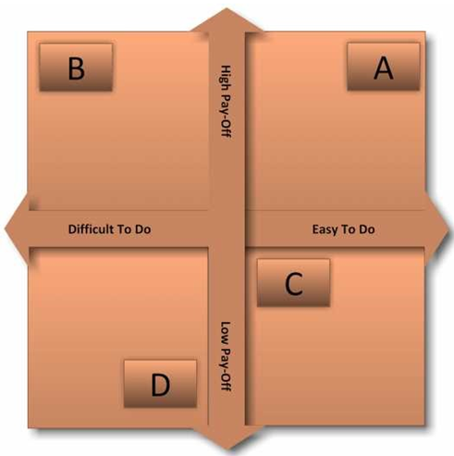
Figure 1.

2.1b: How do these Quadrant help in selecting projects?
As a Project Manager using the Priority Quadrant will enable you to capture potential tasks in one central location, from there the tasks can be prioritized and organized as a team or in individuals.
Using the Priority Quadrant will assist in both team and individual accountability as the system allows everyone to know what everyone is supposed to be working on. The Project Manager can track many tasks at all times giving the team complete visibility, and knowing that everything in the project is being done correctly and within the limitations of individual responsibility.
The management team or Project Manager can now use the Priority Quadrant to delegate tasks and responsibilities depending on where each task lies within the quadrant as follows:
High Pay Off, Low Effort (Quick Win Projects)
Quick wins are the most attractive projects, as they give the Project Manager a good return for relatively little effort. Focus on these as much as you can.
High Pay Off, High Effort (Major Projects)
Major projects give good returns, but they are time-consuming. This means that one major project can dominate over many quick wins.
Low Pay Off, Low Effort (Fill In Projects)
Do not spend too much time on these activities – if you have spare time, do them, but drop them or delegate them out to other members of the team if something better or more complex comes along.
Low Impact, High Effort (Thankless Task Projects)
Try to avoid these activities. Not only do they give little return, they also soak up time that you should be using on quick wins.
How to Use the Tool
To use the Priority Quadrant, download our worksheet and then follow these steps:
Step 1: List the major activities that you want to or need to complete.
Step 2: Score these on impact (from 0 for no impact to 10 for maximum impact), and on effort involved (from 0 for no real effort to 10 for a major effort).
Step 3: Plot the activities on the Priority Quadrant, based on your scores.
Step 4: Prioritize appropriately, delegate or eliminate low-impact activities.
Now that all projects and tasks have been identified and prioritized, the project Manager can allocate responsibilities within a project or delegate a project out to other teams or to an individual. The Project Manager is now free to select the projects they wish to work on.

2.2a: What is SPIRIT?
Goals and objectives are important for a project’s success. They are the heart of, and purpose for, creating a project. Each project you are working on has to make sense in terms of overall objectives of the organization, and benefit people in some way. You should be able to clearly describe the outcomes, deliverables, and benefits to stakeholders and end users. You must make certain your manager has described those goals to you in very clear terms. If that hasn’t happened, go back to them for clarification.
2.2b: How it is used for setting goals?
SPIRIT Goals
When managing projects or anything where people are involved, establishing clear goals is generally the primary objective which have been agreed upon and come with clear responsibilities. However, it is not uncommon to face problems meeting these goals for a variety of reason. There are a number of principles that if followed should make completing your goals more achievable. I would suggest that most people in management circle understand the SMART principle and if followed will assist your Project Team in completing their goals efficiently. However as a Project Manager I recommend the SPIRIT principle for setting individual or team project goals, as followed:

Specific: Project goals should clearly outline the criteria you will use to evaluate your success in a particular project. In order to fully understand what is wanted from the project, the Project Manager must ask the following 6 “W” questions to achieve your desired outcomes:
Who: Who is involved?
What: What do I want to accomplish?
Where: Identify a location.
When: Establish a time frame.
Which: Identify requirements and constraints.
Why: Specific reasons, purpose or benefits of accomplishing the goal.

Prizes: Completion of a project and the steps along the way can be intrinsically rewarding for project team members. Outwardly celebrating successes also can be a source of motivation for the team. When project milestones are reached, they should be communicated to project team members and stakeholders. Small rewards for team members who go above and beyond their duties also should be considered to communicate a job well done.

Individual: All members of a team must be involved in goal setting. Find ways for them to link into the project and get motivated. To keep everyone involved, it might be useful to keep a goal chart on the wall.

Review: Periodically reviewing your projects with your project team will allow you to monitor progress and discuss any issues and iron them out using the dynamics and diversity of the team. Lessons learned from Project Reviews are useful from many perspectives. The real benefit from Project Reviews is the opportunity to step back and take a deeper look into the system.
Time-Bound: Time or time-bound goals are important to define in the SPIRIT goal project planning process as time deadlines able you to achieve the deadline. What are some of the stopping blocks we may run into? Here, we define our timeline from start to finish based on our specific wants and needs, how we plan to measure and track our success, are able to agree unilaterally, and feel realistic about the project’s outcome and success.
By setting goal using the SPIRIT principle will help your team members make a greater positive impact on the project, on many occasions project goal setting may seem daunting but is simply a matter of taking a few forwards steps and following a simple SPIRIT recipe for success.
References:
Books:
Kerzner, H. PhD. 2013. Project Management, A Systems Approach to Planning, Scheduling and Controlling. New York: John Wiley & Sons
Web page:
Windsor, G. A Practical Guide to Prioritizing Project Tasks (Online). Available at: https://www.brightwork.com/blog/a-practical-guide-to-prioritizing-project-task. (Accessed 01 Mar 2018)
Flynn, A. Exploring Trends and Developments in Project Management (Online). Available at: http://www.projectsmart.com/project-management/celebrating-success.php (Accessed 04 Mar 2018)

Student Statement:

By submitting this assignment, I confirm that this is my own work.

Student Signature |  | Date

For Tutor / Assessor Use Only
Total Marks
Marks Obtained
Percentage / Grade

