
Assignment Cover Sheet

Student Name: | Lawrence Green
Student Number: | 22628
Course: | Diploma in Wedding Planning Level 4
Assignment NO: | #6 Planning for the big day

Marking Criteria:
We expect the learners to write minimum one well expressed point in three lines against each allocated mark. This means one needs to write 15 lines with 5 well expressed points to get high grades for a 5 marks question.
For high grades use examples and illustrations where appropriate.
Please insert your completed assignment ( in word format) here:

1. Give short answers for the following questions: (20)
i. Which questions should a venue manager ask when selecting a wedding venue?
When entering into initial discussing with a venue manager the possibility of holding a wedding at their venue, it is best to include the following questions;
- What is the minimum/maximum number of guests the venue is able to accommodate?
- What styles of reception are the venue able to cater for (Buffett, three course meals, afternoon tea, cocktails etc.)
- Is the option of exclusive hire available?
- If it is possible from what time does the hire commence and when does it end?
- If required, would vendors be able to gain access before the exclusive hire commences?
- Does the venue allow for third party vendors or vendors that are outside their approved contractor/vendor list?
- Does the venue provide drinks and food or will a third-party caterer be required?
- Does the venue provide waiting staff?
- Are all furnishings such as crockery and cutlery provided by the venue?
- What are the different wedding packages that the venue provides and what are the specifics of each package?
- Do any special offers come with venue’s wedding packages such as discounts on off peak, weekday, Sunday or winter weddings?
- Will the venue be prepared to make some reasonable changes to their packages so as to suit you client’s needs?
- If alcohol is provided, is the cost based on on consumed units or the number of guests?
- Does this also include spirits?
- Does the venue have a corkage policy, if so how much is the corkage cost per bottle?
- Does the Venue provide cake cutting services?
- If so, are these included in the package?
- Will the clients & consultant need to provide a cake stand, cake knife and/or cake boxes?
- Is the venue able to cater for special dietary requirements such as kosher, gluten free, sugar free and/or dairy free foods?
- Can the venue offer discounts on meal options for vendors such as the photographers, band members or reduced rates for younger guests?
- Are the any other additional expenses you should be made aware of?
- Are the addon options available for extending the time of the event, additional meal courses, wine upgrades?
- Is a Master of Ceremonies (Emcee) included in the packages?
- Is the venue able to provide decorations such as chair covers, a red carpet, table settings, candelabras etc.?
- If not, are they able to set up or aid in setting them up, should you provide them instead?
- Is a dance floor available?
- Are any entertainment options included in any of their packages?
- Are there any restrictions should third party/external entertainment be provided?
- Are there any noise restriction policies which may need to be considered when organising entertainment or the clients wishes for the inclusion of a fireworks display?
- How long does the reception run?
- Are there any overrun fees?
- What time does the venue close?
- If the event is at a hotel, is there a policy on resident only guests after a specific time?
- Is a bridal room or alternative room available for the bridal party for the duration of the reception?
- Does the venue have adequate heating and A/C systems?
- Have the venues fire detection, prevention and extinguisher systems been tested and maintained up to standards?
- Is the venue’s insurance valid?
- Are there cleaning requirements or costs associated with holding a reception at the venue?
- Are there cancelation fees?
- If so what are the applicable cancelation fee periods?
- Are there any current or forecasted building/refurbishment works planned on or around the clients proposed date?
- If the wedding is to be held outside, is there an area where a marquee could be set up as a contingency plan in the event of poor weather?
- Is the venue able to provide a simple or comprehensive building layout plan for use in the production schedule?
- Does the venue provide onsite parking?
- If so, how many spaces are available?

ii. If the ceremony is to be conducted outdoors, what important measures should a wedding planner take in advance?
If your clients wish for their ceremony to be conducted outdoors, there are several important factors to be consider and advance measures to be taken.
The most obvious consideration will be the weather. In the event of bad weather, it would be prudent for the planner to check to see if there is any shelter nearby. If this is not possible or as an alternative, it would sensible to suggest the clients consider the option of hiring a marquee as a contingency plan. If they agree the size and type (framed or pole) of marquee would need to be decided on as well as it’s décor.
Should the wedding be held at someone’s home or at a venue with what could be considered to be an inefficient number of restrooms or a poor sewage system, it would be advisable to hire additional portable bathrooms. If these are to be hired, then consideration must be made on their style (economic, rustic, luxurious etc) in accordance with the wedding vision, theme and the actually venue itself. They must also must be appropriately placed, away from any activities.
Depending on the time of your and/or the country/area that the wedding is being held, you may find that bugs and insects such as flies, wasps, mosquitos, ticks, blue bottles to name a few, could prove problematic. Heat sources such as lights, any open flames, guests and any uncovered food (particularly sugary or glazed foods) will likely attract swarms of insects and bugs. There are variety of options available to try and combat this issue. If it is likely that bugs are going to be an issue at the wedding, it might be sensible to advise their guests to bring and wear some bug repellent spray, though this should be applied at least 30mins before or after any sun screen (Department of Dermatology at Mt. Sinai Hospital in NYC 2017). Of course, it is also possible for this to be provided for the guests with supplies stored and handed out by staff during the event.
Fabric softener sheets could be taped to chairs or in other strategic areas as there is a variety of evidence to support that they ward away unwanted bugs/insects. Of course, it would be up to the planner to make sure that these are suitable placed so as to not go against the décor of the venue. For example, the sheets could be placed underneath seats.
Another tool available would be the flowers that incorporated into the wedding décor. Including plants/flowers which are known to repel bugs and mosquitos into the bouquet, such as lavender, lemon balm, marigolds and peppermint could prove helpful. Asking the venue to or consulting an exterminator directly in terms of an area being sprayed could be an option, however consideration must be made into as to if any sprays would present health and safety issues. Finally, a vast quantity of citronella candles could be used. It would be sensible to strategically place these at the external entrance points to the tent.
Any site layout plans for an external wedding should include ay marquee used (even if this is only as a backup in the event of bad weather). As the wedding is outdoors, further attention to detail will be required as the external element provides additional hazards, considerations and decisions.
Depending on the location, weddings held outside may much or any decoration. As such, this would reduce the floral and decorative areas of the wedding budget, allowing for funds to be reinvested elsewhere.
One subtle point of consideration is in relation to the quality of the photos. The best quality photos are often not taken in the sunniest of days. In fact, some of the best photos are taken on days where there is a fair mixture of sun and cloud cover. Should the wedding take place outside on a very sunny day, it would be sensible to take this into account and recommend that at least some of the photos are taken inside, undercover or in areas of slightly less light saturation.

iii. Briefly discuss the history of wearing a white wedding gown.
The now popular concept of the white wedding dress was first introduced in 15th century by Anne of Brittany. The white colour of the dress represented a bride’s purity and thus, her virginity. This replaced blue dress’s which up until this time were normally worn.
Though many believe she was the first to make the white wedding dress a popular culture powerhouse, Queen Victoria was in fact responsible for the trend’s revival, not its creation. This was done during the 19th Century and since this time, has been the measure of a brides standing in society. In the 19th Century, only those in high society would be able to afford a white dress, as the white fabric was extremely expensive and as there were no cleaning services available to suitable launder such a dress, it was considered a one wear item.
With the advance of technology and the popularity of various white fabrics, white wedding gowns grew in popularity and became more readily available to the masses, thus creating a huge variety of white wedding dress options at both value and luxurious price ranges. The symbol of purity conveyed by a white wedding gown is still prominent today.

iv. What are the three primary food service styles used for weddings?
The three primary food service styles used for weddings are;
- Plated – servers or waiters bring the plated meals out to the guests, ideally in an efficient manner. This is most suited to formal weddings but is not exclusive.

- Buffet – recognised as being the least formal service and thus ideal for more relaxed weddings. The self-service nature allows guests to eat exactly what and how much they want and will often reduce the number of servers/waiters required. It is important that any empty plates are quickly replenished as a buffet should also look full. It also allows for a greater aesthetic and logistical element as the buffet can be arranged in an elegant, eye pleasing fashion and in a sensible order for those queuing.

- French – French serving can be viewed as a step up from the plated style as it is orchestrated in such as way that every guest should receive special attention. The entirety of the meal (per table) is brought out and served on one large silver dish/platter. As in keeping with the premium nature of the service, each of the servers are well groomed and dressed, wearing white gloves and will serve with a almost graceful flow and coordination
v. What is the difference between buffet and French service styles?
Buffet and French service styles vary in several ways. Whilst buffet food is placed in vast quantities for people to help themselves, sometimes two or three times over and eat standing up or sitting down where they please, the French style service requires that the food is always brought out to the table on a single large platter. This also demonstrates another difference in that the buffet style is much more relaxed and informal, whilst the French style is quite the opposite; being very formal and elegant. Due to its formal nature and requirement to make each guest feel special, more servers are required serve the platter as well as arrange the cutlery, whilst the buffet style requires only enough servers to monitor the buffet and replenish any empty plates. Finally, the cutlery used will be quite different with the French style using fine dining equipment such as silver plates and cutlery whilst the buffet will normally cater for recyclable paper plates and plastic cutlery.
vi. Compare two wedding photography styles. Provide photos, as well.
The two main styles of wedding photography are traditional and photojournalistic;
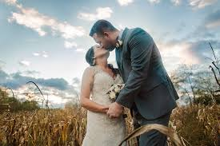
Traditional
- Posed
- Directed
- Staged
- Front and Centre
- Significant levels of communication required
- Very hands on
- Traditional mount album
- The directed and staged nature eats into the time of the event

Photojournalistic
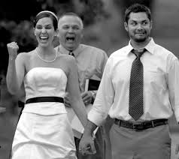
- Natural
- Candid
- All angles
- Spontaneous
- Little communication required
- Hands off
- Flush mount album
- Better variety of photograph types
- Little time taken away from the day as all photos are shot throughout
- More relaxed in nature and the result of the pictures

As seen in the comparative lists, it is clear to see that both styles are two different sides of the same coin – they vary greatly in their methods but both strive towards capturing great moments. The traditional style has a greater focus on creating those moments through micromanagement of the photographs composite by specifically positioning and directing those who are to be captured in the pictures This style seems appealing to couples who want great control over the types and makeup of photographs they would like to look back on of their wedding. Whilst it is still popular style of wedding photography, many find it stifling and uncomfortable due to the unrelaxed nature and the amount of time that is taken to take organise and take even a small selection of photographs

In comparison, the photojournalistic, candid or modern style of wedding photography is becoming increasingly popular, particularly with more relaxed couples that do not feel comfortable having large numbers of staged pictures and favour capturing as many of the days true moments as possible. The results will likely be more varied as the organic moments captured will be varied. The photographer(s) may have captured an exceedingly comical shot at one point, only take a “blink and you’ll miss it” moment of the couple exchanging a look of mutual adoration. The guests are also more relaxed as most of the time, they will not be aware that their picture is being taken. As there will be few if any staged pictures, less time will taken form the day.

vii. What is the tradition of bridal bouquet?
Bouquet (meaning “clump of trees” in French) is steeped in a rich history with its use in weddings. The ancient Greeks and Romans used scented herbs and spices to ward off evil spirits. The shape of the garlands or the symbolism of carrying a bunch of flowers represented new beginnings. Brides and grooms would wear garlands around their necks.
Originally, the bride would collect some flowers and shrubbery from every garland to form a small posy which would be carried throughout the ceremony. This tradition has evolved over the ages, with small poses being replaced with arm sheaves and longer, larger bouquets becoming prominent in the 20th century. Teardrops and princess bouquets were popular in during the 1980’s. It could be argued the wider of use of flowers as general wedding decorations can be traced back to the bouquets humble beginnings.
The tradition of the bride throwing or giving away her bouquet is thought to date back to the English middle ages. During this time, brides were considered lucky, so guests would try to grab something belonging to her (hair, dress, flowers, head wear) to bring them good fortune. So as to make her escape the brie would throw her bouquet into the crowd, where they would clamber over one another to obtain it.
viii. List the different music types that can be used at weddings
There are a variety of music types which can be used at weddings at various stages to different effect. Music can be used during the ceremony’s prelude, the procession, the ceremony, the recessional, the postlude, background music to the wedding breakfast and during cocktail hours.
The general types and examples of music that can be used;
Dramatic
- Choir
- Bagpipes
- String quartets
- Film soundtracks
- Operatic
Formal
- Harpist
- Classical or opera singer(s)
- Pianists
- Organist
- Cellist
- Violinist
- String quartets
- Trumpeter, bugle, or piccolo
- Classic guitar
- French horn
Fun
- Live bands
- DJ
- Guitarists
- Jukebox
- Jazz groups
- Pop singers
- Jazz pianist
- Bing Band groups
- Acapella groups
- Saxophone quartets
- Brass bands
- Swing bands
- Contemporary songs performed through classical methods e.g. Harp
- Modern Musical songs
Romantic
- Harpist
- Classical guitars
- Pianists
- Flutists
- String quartet
- Violinist
- Cellist
- Opera singer
- Classic musical numbers (e.g. from Phantom of the Opera)

ix. What are the different parts of wedding invitations? Give details using illustrations.
There are several elements that make up the wedding invitation. These include; an outer envelope, an inner envelope, the invitation card, an RSVP card, if the ceremony and reception are at different venues, a reception card will be included and with increasing popularity, an information card is also added.
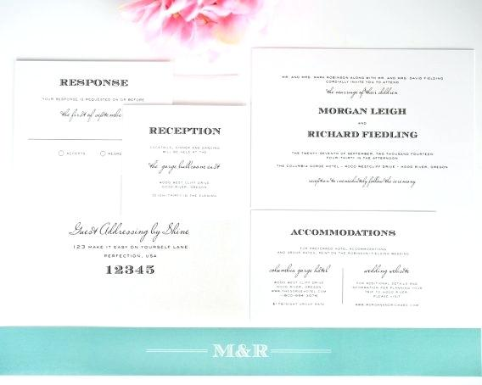
Invitation card
RSVPR card

Information cards

Reception card

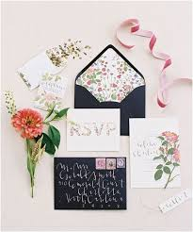
Outer envelope
Inner envelope

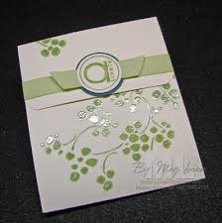

Although still very popular for their elegant look and high presentation value, the origins of the “dual envelope” dates back 100s of years ago when mail was delivered by the early form of a postal service or by courier via horse drawn carriage or lone riders. With there being few roads and vast areas open countryside, the purpose of the outer envelope was to protect its contents from any mud, dirt or the elements. This would then be discarded upon is deliverance. The outer envelope should obviously display the address for deliverance.

The inner envelope will normally just show the name of the guest(s) to be invited and maybe sealed, sometimes with wax – obviously this will be down the couple’s personal preference and should be in keeping with the weddings feel, vision and theme.

The invitation card should provide all relevant specific details of the wedding. Should the ceremony and reception be held at different locations, this should be indicated on the invitation card or a separate reception card be included. If both the ceremony and reception are to be held at the same venue then this should be made clear – a simple direction of “reception to follow” should be sufficient.

A response, reply or RSVP card including stamped address envelopes should also be added. Most contemporary RSVP cards also include other areas of input, beyond that of indicating that if a guest will be in attendance or not. This can sometimes include a guest’s menu preferences, dietary needs or a chance to have an input into what songs are played by the DJ. Traditionally, RSVP cards were not included in a wedding invitation as the invited guest would be expected to respond with a formal letter of acceptance or declination.

The wedding gift list is slowly becoming redundant as many couples feel uncomfortable in requesting specific gifts from a specific sore or vendor or even suggesting that their guests are expected to offer anything. Nowadays, many couples that forgo a guest list will often ask for optional monetary donations, either from a specific personal reason (honeymoon fund etc.) or for a charity. This is often suggested in the form of a poem or in a light-hearted fashion.

x. List some questions that should be asked from the vehicle company manager when booking the vehicle.

As with all other elements of planning the wedding day, it is imperative that you ask the right questions, particularly of third party vendors, to ensure that you able to deliver in the couples wedding vision.

With regards to the hiring of wedding vehicles, the following questions should be asked:

- Do you have any photos of videos of weddings that you have been involved in previously, specifically of your vehicles?
- Are we able to inspect the vehicles and staff that will be utilised on the day itself?
- How many passengers can each of your vehicles seat?
- How many staff/chauffeurs are provided with each vehicle?
- Do the chauffeurs bring umbrellas and would they be able to help the bride out of the vehicle?
- Are the vehicles used for other weddings on the same day, or are they exclusive for one wedding per day?
- If they are used several times a day, are they cleaned and inspected in-between each wedding?
- Are any food or beverages provided in the vehicles?
- Are you able to provide relevant insurance and/or licence documents?
- Do you provide any specific wedding packages and if so could you provide a comparison between them?
- Are there any special offers available, particularly in tandem with the venue’s packages (discounts for off peak, winter, Sunday weddings etc).
- How long is the hire period for each vehicle?
- Do all your vehicles have heating and A/C?
- What contingency options are available in the event that the primary hire vehicle breaks down?
- Are there any extra costs associated with the vehicle hire?
- What are the payment terms (initial deposit amount, final due date etc)?
- Are there any cancelation fees?
- If the couple wish to hire a wedding car to drive themselves (such as a classic car) are you able to provide discount on one off insurance policies?

2. Give some creative ideas about the modes of transport that could be used for wedding ceremony. Present your ideas in a report supported by evidence in the form of images or illustrations (10)

Introduction
Today, there are many transport options available to couples in regards to traveling to the wedding ceremony. These can vary from the romantic standards such as a horse drawn carriage to incredibly creative and alternative ideas, such as a fire engine or even parachuting.
No matter how crazy the idea, it is worth bearing in mind that the most seemingly bizarre choice, will normally be a very personal one – Those choosing to arrive via a road legal Armoured Personal Carrier or tank could be members of the armed forces. Another consideration is that the more inventive the method of transportation, the more it may well cost. This must be carefully considered when addressing the wedding budget.

Examples
Below I will exhibit several creative wedding ceremony transportation options:

Fire Truck/Engine
One of the numerous audacious options available, fire engines (classic & modern) have been purchased by private transportation companies adapted (sometimes by being painted pink) and offered out specifically as wedding transportation. This would naturally be a great alternative for a bride and/or groom that serve as a fireman/woman. The fire engine is most likely to be one of the biggest options of transportation so consideration must be made to the types of roads the vehicle will be travelling. If the ceremony is located in a secluded area which requires access over a small bridge, a large and heavy fire engine would most likely be unsuitable.
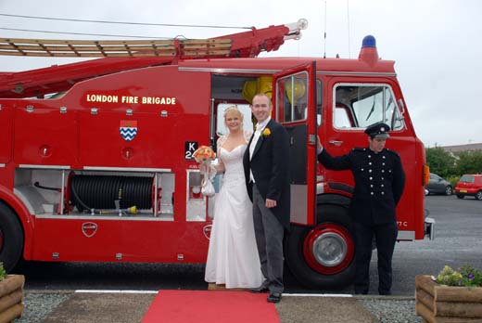

Tank or Armoured personnel carrier
A similar option to the fire truck for military vehicle enthusiasts or those who serve in the armed services could be a diss-armed, road legal tank or APC. Like the previous example, these are purchased by private companies and hired out as alternative transportation. The same logistical issues will also need to be considered. As the vehicle is large, the route must be carefully decided on. Like the fire truck, it is very unlikely that the couple would able to drive the vehicle themselves, nor is it likely to be very comfortable. If this is a concern to a couple, one option would be to transported to the venues entrance via traditional vehicles, then travel the rest of the way in or on top of the tank.

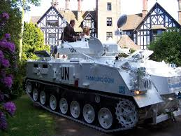

Tractor
A different option for farm/barn weddings or for those that have a certain affection for them could be a tractor or carriage variant towed by a tractor. A smaller option compared to the previous two examples, the tractor would be a great addition to a couple looking to have a rural and rustic wedding. The tractor should be fit for any road that a traditional wedding transport would travers and should cope perfectly on a rough path or off road.
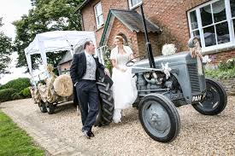

Princess/Cinderella carriage
A perfect selection for a bride or couple looking to have a fairy-tale wedding, a romantic princess carriage pulled by a selection of horses would be perfect. These are more associated with luxurious, large weddings but not exclusively so. There will naturally be a large cost for such an option. Consideration must be made as to how long it would take for the couple to reach the event in a carriage, given the slower pace they travel compared to a motorised vehicle. There is also likely to be a restriction on how far it can travel. It is also a possibility that the horses pulling the carriage will need to stop to defecate (it happens).
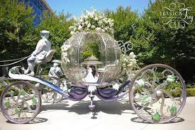

Gondola
Th gondola would be a great option for those who are getting married abroad at a destination that is close to body of water such as a river or places such as Venice that has a dispersed waterway throughout the city. As touched on, gondolas are limited to specific water routes, so prior planning must be made to ensure that the small boat will be able to reach a landing are at or near the wedding venue. If there is not one nearby, then an alternative vehicle should be hired to take the couple/ bride/groom the rest of the way
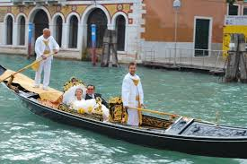

Student Statement:

By submitting this assignment, I confirm that this is my own work.

Student Signature |  | Date

For Tutor / Assessor Use Only
Total Marks
Marks Obtained
Percentage / Grade

