
Assignment Cover Sheet

Student Name: | Josephine Durosinmi-Etti
Student Number: | 31121
Course: | Advanced Diploma in Business Management Level 5
Assignment NO: | 05 Strategic planning

Marking Criteria:
We expect the learners to write minimum one well-expressed point in three lines against each allocated mark. This means one needs to write 15 lines with 5 well expressed points to get high grades for a 5 marks question.
For high grades use examples and illustrations where appropriate.
- Identifying stakeholders
A stakeholder is a party that has an interest in a company and can either affect or be affected by the business. The primary stakeholders in a typical corporation are its investors, employees, customers and suppliers. However, the modern theory of the idea goes beyond this original notion to include additional stakeholders such as a community, government or trade association.
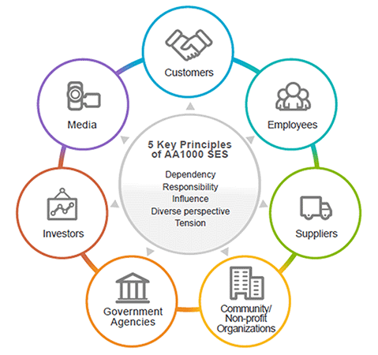
Classifying your stakeholders is essential as each will be more important than others and have more interest than others. This analysis will help you decide on how often you will communicate with certain groups of stakeholders and what you will communicate to them. You can break down your stakeholders into four categories:
High Power/High Interest (Fully engage)
These stakeholders are the ones that need to be engaged regularly and managed closely. These are the key players. This group will require the most effort to keep satisfied.

High Power/Low Interest (Keep satisfied)
Keep these stakeholders satisfied by striking a careful balance between keeping them informed, but not overloading them with too much information.

Low Power/High Interest (Keep informed)
You should keep these stakeholders adequately informed and consult with them regarding their area of interest, and make sure they do not have any major issues with the project. These stakeholders can often help with the detail of the project.

Low Power/Low Interest (Minimum effort)
Inform these stakeholders with general information. Do not overload them with excessive communication, but you should monitor them, because they may become more potent to the project and have a higher interest in it, for example, if they change job roles. Chen, J. (2018).

II. What is strategic planning
Strategic planning is an organisational management activity that is used to set priorities, focus energy and resources, strengthen operations, ensure that employees and other stakeholders are working toward common goals, establish agreement around intended outcomes/results, and assess and adjust the organisation's direction in response to a changing environment. It is a disciplined effort that produces fundamental decisions and actions that shape and guide what an organisation is, whom it serves, what it does, and why it does it, with a focus on the future. Effective strategic planning articulates not only where an organization is going and the actions needed to make progress, but also how it will know if it is successful. (Taylor 2015)

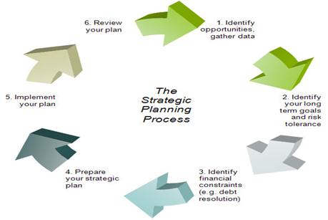
- The information content of the strategic plan
Vision Statement
A vision statement is an aspirational statement of where you want your unit to be in the future.

Mission Statement
While a vision describes where you want to be in the future, a mission statement describes what you do today.

Core Values
Core values describe your beliefs and behaviours. They are the things that you believe in that will enable you to achieve your vision and mission.

SWOT Analysis
SWOT stands for strengths, weaknesses, opportunities, and threats. A SWOT analysis sums up where you are now and provides ideas on what you need to focus on.

Long-Term Goals
Long-term goals are three to five statements that drill down a level below the vision and describe how you plan to achieve your vision.

Yearly Objectives
Each long-term goal should have a few (three to five) one year objectives that advance your goals. Each objective should be as “SMART” as possible: Specific, Measurable, Achievable, Realistic, and Time-based.

Action Plans
Each objective should have a plan that details how the objective will be achieved. The amount of detail depends on the complexity of the objective. forbes. (2018).
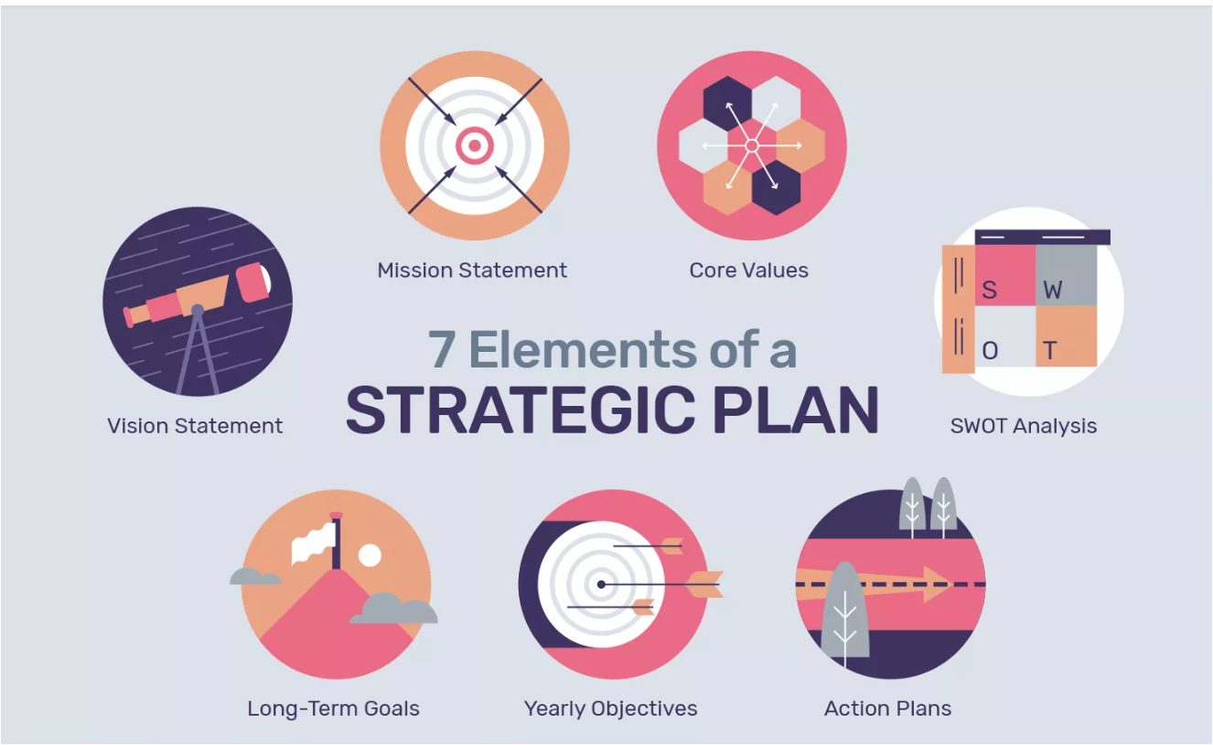

- SETTING GOALS WITH SPIRIT
When you comprehend what the destinations are, and how a long ways ahead you are looking, it is a great opportunity to make objective articulations (additionally called goals or targets). We prescribe that you utilize a precise way to deal with composing your objectives to make them simple to recollect and to ensure they are caught totally. We suggest defining objectives with SPIRIT, which implies that they have the accompanying components.

Specific
Be specific about what you need or would prefer not to accomplish. The outcome ought to be unmistakable and quantifiable. "Sell more items" is vague; however, "Increment piece of the pie by 7% every year" is specific.
Prizes
Motivation is critical. There should be a framework set up with the goal that we set aside some effort to perceive, strengthen, and remunerate individuals who are taking an interest in meeting benchmarks and by and large targets. Prizes do not have to break the financial plan. Here are some ways that you can compensate for individuals:
- Acknowledge an individual or a team in a meeting
- Offer praise through a company newsletter
- Issue bonuses (monetary, points systems, etc.)
- Record successes in notes for annual performance reviews

Individual
Employees will react to, and be roused to progress in the direction of, objectives that they can identify with. They need an approach to identify with their objectives on an individual premise. Setting up objectives and integrating them with execution destinations will put the 10,000 foot view into terms that they can identify with. This likewise gives an approach to impart the comprehensive view to them and let them recognize what course the organization is going in.
Review
Review progress periodically. Do the goals still make sense for the short and long term? Are people’s activities a good demonstration of the strategic plan, or have they wandered off track and taken to pursue their own goals? Are you measuring as you go and making adjustments, or is it more important to stay the course?
Inspiring
Frame the objective emphatically with the goal that individuals identify with it unequivocally, regardless of whether the objective has a negative result to it. On the off chance that the expenses of your worker advantage plan are expanding, you will see that cutting projects can dampen a working environment. Rather, include your representatives and ask what they are happy to yield. You may be flabbergasted at how inventive they are! Rather than having an objective like, "We should cut 15% of our representative advantage plan spending plan" have a go at something like this: "Through a procedure of worker conference, we will recognize and execute reserve funds of 15% to the representative advantage plan in the following a year."
Time-Bound
Give yourself a deadline for achieving the goal. If the goal is quite large, break it into smaller pieces and assign a deadline for each one.

- Succession planning
It is a strategy for identifying and developing future leaders at your company — at all levels. Succession plans are used to address the inevitable changes that occur when employees resign, retire, are fired, get sick, or die. They make sure the business is prepared for all contingencies by identifying and training high-potential workers for advancement into key roles.
This is a critical but often overlooked process for companies, and something they all need to continue to run smoothly. It is also a manageable event, not a major organisational crisis. A result is a well-oiled machine with a multitude of favourable outcomes, not least of which is staff retention.

2. Advantages of succession planning
What distinguishes high-performing organizations from underperforming ones is that successful entities understand the benefits of succession planning and thus engage in it continuously. In other words, their leadership perceives corporate succession planning as an investment and not an expense.

I, Availability of capable individuals for management positions is increased.
Effective corporate succession planning increases the availability of capable individuals who are prepared to assume such roles as they become readily available. Leadership roles can easily be filled as senior executives retire or if the senior management positions are vacated due to the resignation of key officers.
It then becomes imperative to realize that effective talent management is not simply about a position-driven replacement. The succession planning process is a well-planned-out, long-term procedure building some so-called "feeder groups" of qualified candidates, able to fill vacancies as they emerge.

- The risk of losing experienced corporate leaders are minimised
The most prominent potential benefit of workforce planning is associated with decreased risk of the loss of experienced corporate leaders. The existence of effective corporate succession planning diminishes the need for an external search of qualified candidates for a particular position.

- Less financial resources will be spent on the external search and development of candidates.
It also minimizes the use of time and financial resources looking for new people capable of running senior management positions in the company. In situations of abrupt personnel changes, the benefits of succession planning become very apparent. There will be less time and reduced financial expenditure on recruitment and leadership development as qualified internal candidates have been already identified and trained.
- HR departments can establish formal procedures to support the process of selecting top and middle management.
One of the advantages of succession planning concerns the ability of the HR department to engage and establish formal procedures to support the process of selecting top and middle management. Such actions minimize random or rushed selections and re-establish the much-needed degree of commitment to corporate succession planning from everyone in the firm.
Even though organizations are often dissatisfied with the manner of their implementation, they cannot operate successfully without a well-developed succession plan. The key to a successful leadership management approach is to engage and implement corporate succession planning and talent management continuously. (Half 2018)

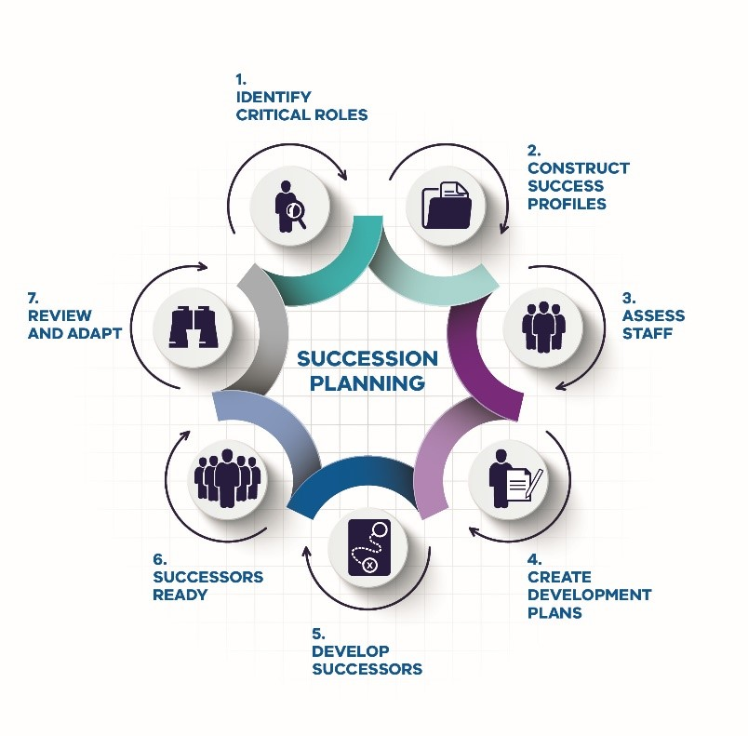
What is Ethics
Business ethics is the study of proper business policies and practices regarding potentially controversial issues such as corporate governance, insider trading, bribery, discrimination, corporate social responsibility and fiduciary responsibilities. Law often guides business ethics, while other times business ethics provide a basic framework that businesses may follow to gain public acceptance.
Business ethics ensure that a certain required level of trust exists between consumers and various forms of market participants with businesses. For example, a portfolio manager must give the same consideration to the portfolios of family members and small individual investors. Such practices ensure the public receives fair treatment.
The concept of business ethics arose in the 1960s as companies became more aware of a rising consumer-based society that showed concerns regarding the environment, social causes and corporate responsibility. Business ethics goes beyond just a moral code of right and wrong; it attempts to reconcile what companies must do legally versus maintaining a competitive advantage over other businesses. Firms display business ethics in several ways. (Kenton 2018)
Implementing an effective corporate ethics policy
When asked about their values, the vast majority of companies can provide a document they would describe as a code of ethics or conduct. However, research suggests a possible disconnect between companies’ stated intentions and the degree to which they genuinely value ethical behaviour.
Here are five steps that companies can take to ensure that their corporate ethics policy is effective and becomes embedded in the company culture. Also included are practical examples of the various ways organisations have accomplished this task.

1. CODE OF ETHICS
The essential elements of code include assurances of support for the policies from organisational leadership, practical guidance on what is expected regarding ethical issues, commitments concerning stakeholder relationships, example Q&As, scenarios or decision trees, details of how the code will be implemented and monitored, and the consequences of misconduct. Signposts to further support, advice and other relevant policies should also be included.

2. COMMUNICATION AND AWARENESS CAMPAIGNS
This is a continuous process. Communication of a company’s ethics policy never ends.

3. TRAINING AND REINFORCEMENT
Most organisations now offer online anti-bribery training. On its own, this is not enough; companies should not be comforted by a tick-the-box mentality. There is no substitute for face-to-face, qualitative training with wider discussion and debate of understanding and practical application.
4. SUPPORTING CONTEXT AND CULTURE
This involves having the “ethical architecture” in place to support a living, breathing code. That architecture includes outlining policies and regulations in employee contracts and supplier agreements, identifying individuals and boards who are accountable for outcomes, creating ongoing awareness-raising programmes, opening discussions with feedback and having oversight and monitoring procedures in place. Taking action against wrongdoing and communicating the action taken to staff is an essential element of this. (Webley 2006)
5. MONITORING AND ACCOUNTABILITY
Effective speak-up arrangements, such as anonymous helplines, through which employees, contractors and other third parties can raise concerns in confidence about unsafe, unethical or unlawful practices are an important element of good corporate governance. (Verschoor 2005)

References:

Chen, J. (2018). Stakeholder. Available: https://www.investopedia.com/terms/s/stakeholder.asp. Last accessed 08th Mar 2019.

forbes. (2018). Strategic planning. Available: https://www.forbes.com/sites/aileron/2011/10/25/five-steps-to-a-strategic-plan/#66aaa4705464. Last accessed 08th Mar 2019.
Half, R. (2018). What Is Succession Planning? Your Steps to Success.Available: https://www.roberthalf.com/blog/management-tips/7-steps-to-building-a-succession-plan-for-success. Last accessed 08th Mar 2019.
Kenton, W. (2018). Business ethics. Available: https://www.investopedia.com/terms/b/business-ethics.asp. Last accessed 08th Mar 2019.
Taylor. (2018). Strategic planning. Available: https://www.forbes.com/sites/aileron/2011/10/25/five-steps-to-a-strategic-plan/#66aaa4705464. Last accessed 08th Mar 2019.

Verschoor, Curtis C. "Benchmarking ethics and compliance programs." Strategic Finance. August 2005.
Webley, Simon. "Outline of the content of a code of business practice and ethics." Institute of Business Ethics. Available on http://www.ibe.org.uk/contentcode.html. Retrieved on 22 January 2006.

Student Statement:

By submitting this assignment, I confirm that this is my own work.

Student Signature | Josephine D Etti | Date | 10/03/2018

For Tutor / Assessor Use Only
Total Marks
Marks Obtained
Percentage / Grade

