
Assignment Cover Sheet

Student Name: | Anne Magdalene dela Fuente
Student Number: | 7385
Course: | Diploma in Construction Management
Assignment NO: | 4

Marking Criteria:
We expect the learners to write minimum one well expressed point in three lines against each allocated mark. This means one needs to write 15 lines with 5 well expressed points to get high grades for a 5 marks question.
For high grades use examples and illustrations where appropriate.
** Please see next sheets for the answers…

Student Statement:

By submitting this assignment, I confirm that this is my own work.

Student Signature | Anne dela Fuente | Date | 13 Aug 2017

For Tutor / Assessor Use Only
Total Marks
Marks Obtained
Percentage / Grade

Unit 4: Preliminary Investigations, Location and Site
1. Give short answers to the following questions.
i. what is an Environmental impact Study or EIS?
EIS is the assessment of the positive as well as the negative impact of a certain development to its surrounding ecosystem. This is important to assess this at an early stage to avoid for example non- compliance to the respective authorities, hazard to the surroundings, pollution, noise, air issues etc. which may cause the development not to operate or function accordingly.
ii. what is the basic criterion for judging the suitability of the site for construction?
Basic factors that affect the suitability of a site include: Availability of physical resources such as good water supply, power supply, and material supply; Climatic considerations such as temperature, humidity, solar radiation, rainfall and wind, etc. as climate affects people and their economic activities; Physical factors such as the contour of the site and nature/ condition of the soil.
iii. what are topographic data about?
Topographic data involves vast information about the land in general for example Elevation above sea-level, site orientation (Northing), Slopes and rolling terrains, Surface waters (rivers, drainage, ponds, etc.), Hills and valleys, Hood plains, swamps and quick sand, etc. These is sometimes drawn as a map or as seen in aerial views to study the basic land form of the site. This is useful for the technical people identify which foundation to be used, setbacks, types of soil, etc.
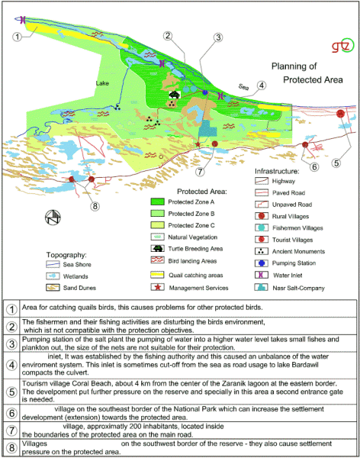
Sample of Topographic Data
With Swot Analysis
iv. what type of buildings should be constructed on rocky sites?
Quarries, Dams and tunnels are the main types of buildings that has to be built on rocky sites since it should not be pervious to water. The rising water level of water table and the deposition of sediments on the foundation must also be investigated thoroughly. Also avoid building at a fault line as leakage and non stability of the building may occur if fault lines are filled up with pervious material and/or opened joints are present in the structure.
2. Give the classification under which the following buildings fall:
a. Museum – Class D1
b. Hospital – Class C2
Commercial / Dept Store
c. Hotel – Class C1
Public Library
d. Library public – Class D1
Museum
e. Department store – Class A1
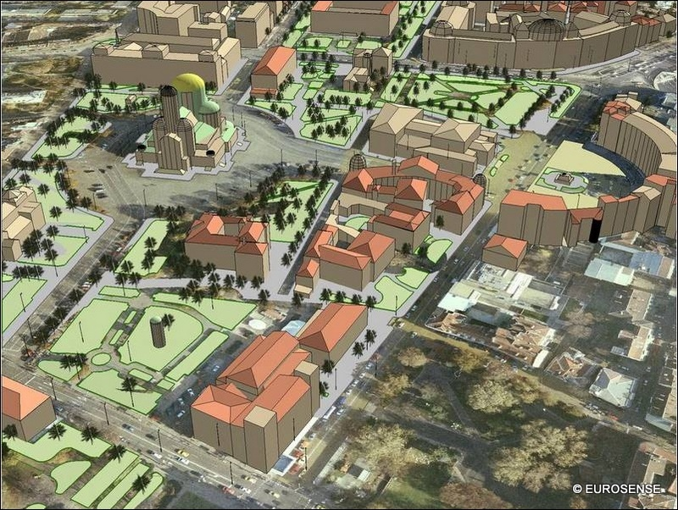
Hospital
Institution / Hotel
Residential
Religious
Institution
Residential
Industrial
*I have selected a possible example of a zoning layout based on classification
Parks

