
Assignment Cover Sheet

Student Name: | Hajar Haseeb
Student Number: | 14253
Course: | Diploma in fashion design level 4
Assignment NO: | 11

Marking Criteria:
We expect the learners to write minimum one well expressed point in three lines against each allocated mark. This means one needs to write 15 lines with 5 well expressed points to get high grades for a 5 marks question.
For high grades use examples and illustrations where appropriate.
1. Give short answers for the following questions:

- Define the following terms and concepts as discussed in the module:

- Sales promotions: schedule traditional activities throughout the retail calendar as well as promoting the six possible fashion seasons, these being spring, summer, holiday, resort, transitional and autumn (or fall). Bridal fashion shows are a part of the calendar activities, as are January and August white sales (towels, sheets, and linen), back-to-school sales and special features for Christmas and certain other holidays.

- Advertising: is the use of paid space or time in media to promote a particular product or event. This would include mediums such as radio, television, internet, newspapers, billboards and direct mail. In retail stores it is the advertising which is usually allocated the largest part of the sales budget. This would be approximately 1 to 3 % of sales. A large portion of the advertising budget will usually go to newspaper space. In order to attract a customer’s attention to a particular event or product there will be a huge amount of planning, designing, writing and scheduling of paid announcements.

- Publicity: is the promotion and exposure of information regarding people, special events and certain newsworthy topics through various forms of communications media. In the fashion industry publicity aids in promoting the sale of fashion products by making the public more aware of a particular manufacturer, retailer, style, trend or other fashion aspect. Media editors opt for material they feel will be of interest to the community. The how, when, and where of the message is determined by the media.

- Formal fashion show: This type of show requires a huge amount of planning including booking models, fittings, organising for a runway, any scenery that may be needed, music, lighting, seating etc. With formal or runway shows it is necessary to have rehearsals because they have a theatrical aspect to them which requires everyone to know exactly where to be and what to do at the right time. As these types of shows usually attract large audiences advance publicity and advertising has to be done in a very effective way. Depending on whether the fashion show is for sales or goodwill (charity) it will be done either in-store so people can buy immediately, or in an outside venue to promote the charity or other goodwill event. Fashion shows are planned and prepared by the fashion office or the special events office, and in some cases both offices together.

- What is the purpose of fashion promotion?
So that stores can reach for a bigger target market and also to update their fashion image.

- Explain the difference between advertising and publicity?
Advertising: is the use of paid space or time in media to promote a particular product or event. But Publicity: is the promotion and exposure of information regarding people, special events and certain newsworthy topics through various forms of communications media.

- When supplying apparels to the retailers sometimes financial problems are created. How?
In most cases, retailers buy from manufacturers on credit allowances. They buy product but do not need to pay for around 30 –to-60 days, depending on the agreement made. This can and often does create a problem for the manufacturer who must make an initial outlay for fabric, trims, labour costs and any overheads. In order to get this done many manufacturers will approach finance companies, banks or factoring firms for financing. In the case of bank loans they will either be unsecured for well-financed companies with good performance histories, or secured in which case they must have some collateral to bargain with such as property or equipment.

- ‘Textile sales people encourage manufacturers to make a commitment early in the season to buy a specific amount of yardage ‘Why?
Because It is the buyer’s responsibility to work out how much yardage is needed, both for duplicate cutting and for stock. The later stock yardage is based on past sales or careful prediction of future sales. Manufacturers are encouraged by textile salespeople to make a commitment to buying a specific amount of yardage early in the season.

- How the fabric should be inspected when it is received.
The fabrics must be carefully counted when they arrive at the factory to ensure the entire order has been received. In large factories there is a special piece of equipment that automatically counts the fabric yardage as it rolls from one bolt to another.

2. Describe various types of media and their role in fashion promotion.

Advertising is the use of paid space or time in media to promote a particular product or event. This would include mediums such as radio, television, internet, newspapers, billboards and direct mail. In retail stores it is the advertising which is usually allocated the largest part of the sales budget. This would be approximately 1 to 3 % of sales. A large portion of the advertising budget will usually go to newspaper space. In order to attract a customer’s attention to a particular event or product there will be a huge amount of planning, designing, writing and scheduling of paid announcements.

Projects
- 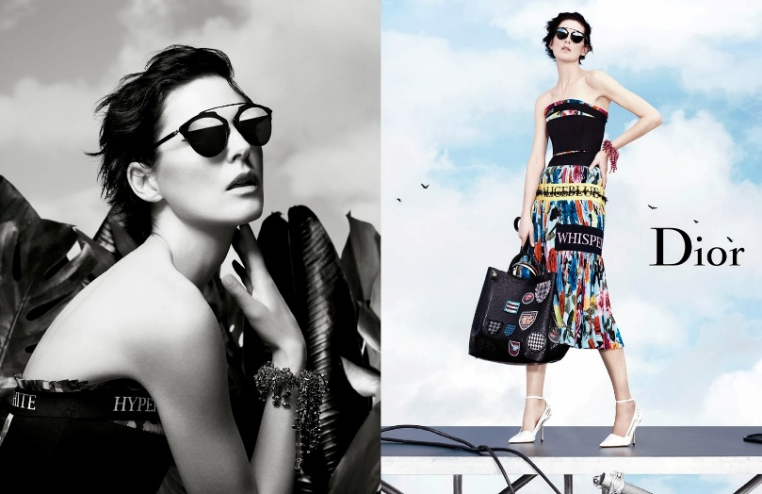Find at least two examples of co op advertising from a fashion magazine. 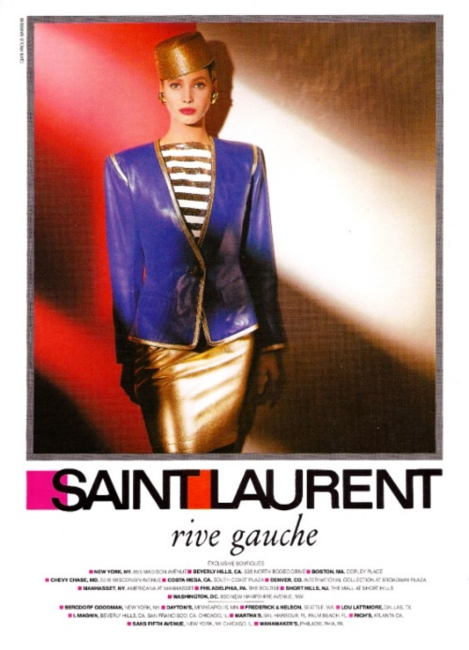

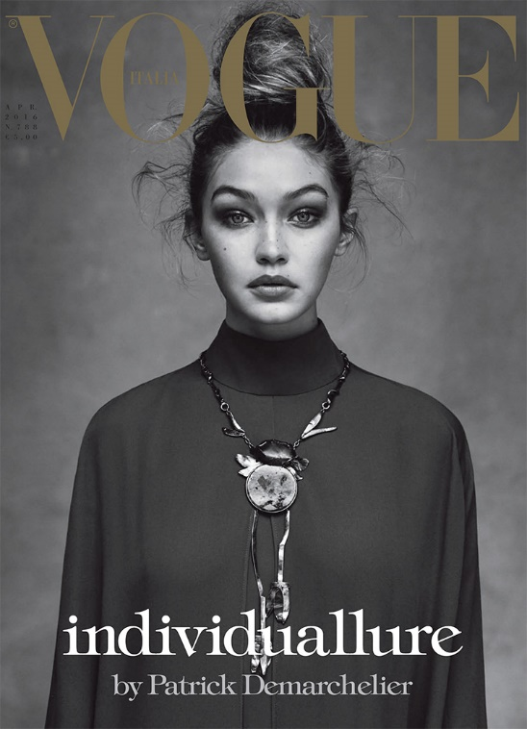

- Analyse the advertising campaign by a fashion designer in newspapers and fashion magazines. Do they have a high fashion image or popular appeal? Do you feel that the advertisements were effective? Do they use photography or the artists’ illustration? (write a report and produce the images of the campaign)
I think the fashion campaign went very well in those magazines. It hade shows the fashion pieces beautifully. And the models were pauses really well. So I believe it was very effective. And the photographers were very creative and illustration.

- Visit local designer, evaluate the display techniques, both in windows and interiors. Is lighting used effectively? Is the merchandise arranged attractively? (Produce a report on your observations)

I had visited zeena zaki fashion designer boutique (Julia domani)
I loved all the pieces were in the store and the way it was displayed
The lighting and everything.
Her dresses were really attractive and arranged in a very creative attractive way.

Student Statement:

By submitting this assignment, I confirm that this is my own work.

Student Signature | Hajar Haseeb | Date | Dec.4-2018

For Tutor / Assessor Use Only
Total Marks
Marks Obtained
Percentage / Grade

