
Assignment Cover Sheet

Student Name: | AYESHA KHAN
Student Number: | 2728
Course: | DIPLOMA BEAUTY THERAPY & SALON MANAGEMENT LEVEL 4
Assignment NO: | 11

Marking Criteria:
We expect the learners to write minimum one well expressed point in three lines against each allocated mark. This means one needs to write 15 lines with 5 well expressed points to get high grades for a 5 marks question.
For high grades use examples and illustrations where appropriate.
AYESHA KHAN / 2728
ASSIGNMENT NO.11 / PAGE NUMBER: 1

1. Discuss the procedures of hiring salon employees.

Answer – As you set out to hire salon employees, you should be sure that your salon’s online presence is updated and visually appealing. Along with your website, your social media profiles should be updated with visually interesting content so that people can fall in love with your salon before they even apply. The whole issue of hiring is further complicated by one sticky little problem: There’s a lot of competition out there for qualified salon personnel. It’s not uncommon for rival salon owners to try to lure away talented stylists from each other with promises of more money and better working conditions. Then there’s the issue of walk-outs: when salon staff—usually stylists—decide they can do better on their own and leave a salon en masse to start their own businesses. Not only does the original salon lose its qualified staff, but it also then must compete for new staff members with the turncoats who left.

Job Advertising for Salon Employees
Your job advertising for salon employees should be as colorful as the hairstyles you offer to customers, and should highlight the unique benefits of working for your salon.
Job advertising should include your rules for hair salon employees, but your main objective is to generate interest in your job openings, not bore people with a list of rules and “must haves.”

AYESHA KHAN / 2728
ASSIGNMENT NO.11 / PAGE NUMBER: 2

2. ‘Employee motivation is important for effective customer service delivery’. Discuss this.

Ans - Speedy employee turnovers are something every business wants to avoid. Apart from being very expensive in terms of time and money, they also cause issues with client relations and other employees. To minimize such issues, always treat your staff well.
Being generous and considerate towards any staff member will motivate them to do more for you and the salon. Treat them in the same way that you would wish to be treated, with dignity and fairness. However, if a worker becomes negative and does not seem to be receptive towards reconciliation, you should get that individual out of the salon immediately. One individual’s negative attitude can get transferred to the other employees—and even to the customers—thus causing a lot of damage to the salon’s image and the staff’s morale.
Having an open communication policy will resolve most issues well before they can develop into major problems. It is very important to talk to your staff, to provide feedback about their performance and to let them know how you feel. Tell them if they have been doing a good job. If the employees’ performances are not up to the mark, let them know that you are concerned and discuss ways in which you could assist them to get back on track.
In case some of your employees are students, school will generally take precedence over their work. You should make every effort for accommodating their special needs. Work towards making a schedule that works smoothly for them. If you don’t consider this acceptable, don’t employ students. Nevertheless, you should make them aware that your salon has special needs and that since you are running a business they need to make suitable contributions.
A fine line exists between maintaining your authority and being friendly with your staff. Socializing beyond work hours must be limited. Nonetheless, having lunch together whenever possible is perhaps an effective way of bridging any gaps in communication that may be present. Irrespective of what business you are in, the fact that motivated staff members are always more productive in comparison to their ambivalent counterparts has been proven beyond doubt. The personnel who want to work, and do their work well, are more likely to do a much better job in contrast to those interested in simply getting work done. Because motivated employees can make your salon money, motivation is extremely important.
Nevertheless, experts advise that a motivation program needs to be more than simply a reward system for customer service efforts and exceptional sales. Rewards should always play a role in the whole program. However, it is critical that the working environment should be motivating in itself.

3. You are a salon manager, how would you attract clients for your salon?

Ans - 7 Effective Ways to Attract Clients To Your Salon or Spa
- Introduce a solid loyalty program. A great loyalty program can win the hearts of your potential clients. ...

AYESHA KHAN / 2728
ASSIGNMENT NO.11 / PAGE NUMBER: 3

2. Start networking more. Don't be scared to go out there and network.

- Ask for referrals.

- Capture leads.

- Start blogging.

- Partner with other agencies.

- Use social media heavily.

As a salon owner, you need a steady flow of new clients to keep coming to you. Some people move away or move on while others pass away. These must be replaced with fresh customers. Additionally, it is wise to continually keep building a demand for your salon’s services. If you are comparatively new in the business, or have initiated some new type of services, you will need an abundant supply of clientele to enjoy financial success. To achieve all this, you need to have a fresh flow of clients that keep coming your way.

Activity 1
Meet with a salon manager, then, discuss in detail the following –

1). Their hiring and training procedures - Almost everything in your salon business depends upon the competency of your employees; therefore, the people you hire and the way in which you train them is critical to your success. The idea is to find employees who are going to earn their wages, not just collect them.
Hiring individuals with good personalities and good work ethics truly can increase your sales. Customers feel more comfortable, secure and happy when someone who is friendly and capable is aiding them. The employee becomes even more important if you add retail merchandise to your salon. The most common way to find employees is to place a newspaper advertisement. However, in order to attract the type of people you want to hire, you must stipulate your high standards in the ad. Mention that you are seeking an inside sales person with flexible hours in a pleasant, business atmosphere. Mentioning the word "business" right off the bat indicates to a potential applicant that he or she will need a professional attitude in order to land this job.It is also good to indicate that good phone skills are needed, as well as having excellent rapport with clients. Mention the importance of appearance as well. Being in the beauty/health field, it is important to have attractive, neat, fit employees. This alone can create a salon image.

AYESHA KHAN / 2728
ASSIGNMENT NO.11 / PAGE NUMBER: 4
The Training Process
After hiring, break the employee in slowly. Pushing too hard may cause a person with excellent work potential to become frustrated and discouraged. First, give employees a package of literature from the manufacturer or manufacturers of your tanning units. They also should be given copies of your ads, fliers, customer cards, daily record sheets and any other forms they will be expected to fill out. Have them read chapters of this book and copies of the trade journals and explain that it is imperative that they read all the information carefully. Review each form step by step and have them spend the day studying them, preferably in the salon so they can ask you questions at any time. Allow them to listen, on an extension, to inquiries you handle on the phone, and explain why you said what you did immediately afterward. Remember, there is no better teacher than hands-on experience. Don't expect them to get the hang of it the first few times--you probably didn't even do that. Allow them to go through the phone procedure with you for the first few days as practice makes perfect and builds confidence. Supply the new employee with a list of the questions most commonly asked by customers, and gives them the answers, along with a detailed explanation of why they are answered that way. You may want to give them a quiz at the end of their training period, just to be sure they are capable of being left on their own in the salon. Cleaning duties can be a touchy subject, so be sure to specify your expectations in the very beginning. Don't wait until after you've hired the person to explain that some cleaning duties are required. It's possible they wouldn't have been as interested in the job if they had known this and, if that's the case, concealing the fact won't make them any more receptive to it. Employees always should clean equipment thoroughly after each use. The cleaning may sound simple, but you must emphasize that it needs to be done carefully and properly. Explain why it is necessary and what the possible consequences are if it is done improperly. Go through the procedure a few times for the tanning units, then have them do it while you're watching. Don't be afraid to criticize; it is important that this procedure be done right. Let your employees know that you expect them to keep the reception desk as tidy as possible since this usually is the first impression clients get when they enter the salon. If it is messy or dirty, the client automatically will jump to the conclusion that the rest of the salon is the same way. Be sure to stress to your employees the importance of enforcing the salon's rules. Tell them they are never to extend tanning times or to allow clients to tan without protective eyewear. Make sure they understand why, and are able to explain the dangers of such practices to your clients. The dress code for the salon is up to the individual salon owner. If you are trying to portray an image of individuality in your salon, your employees should do the same. You may want to set certain guidelines, like khaki shorts and pastel-colored shirts, just to keep the general image the same, but it's not usually necessary. Clothing can be fun, but should never be risqué. Also, keep in mind that it should be loose and comfortable enough to allow ease of movement when cleaning equipment. If you find a good employee who you feel will stay with the salon for some time, consider taking the employee to one of the trade associations' training programs. The depth of knowledge that is presented, as well as the opportunity to network with other salon owners and employees, is invaluable.

AYESHA KHAN / 2728
ASSIGNMENT NO.11 / PAGE NUMBER: 5
If you can't justify the travel expenses for any of your employees, still give serious thought to going yourself. The knowledge you gain, as well as the training manual, will be an asset to your in-salon training program. Another, less expensive alternative is a correspondence training course offered by some of the associations.
2). Their customer services strategies - Following are smart strategies that will produce customer satisfaction through simple steps.
Creating the Perfect Experience
The services offered at a salon are very personal and require a lot more attention and dedication as compared to other service. Customers usually visit the salon to look good and get a relaxing experience after long days of work and stress. The environment in the salon must be peaceful, with aesthetic interior, soft music and extremely polite staff. Ensure that all items in the salon are clean and hygienic. You don’t want customers bad mouthing you for having dirty brushes and messy tables. Everything must be shining, organized and ready before the customer is served. If the customer is interested in getting a massage, make sure you have scented candles, clean sheets, and most importantly no noise. Chatter from the other rooms or staff conversations should not be disturbing the customer.

Time Management
If the salon is overbooked or is running late to accommodate an appointment, then inform your client in advance and offer them with free extra services or a discounted rate when they come in next time. Show your customers you value them and don’t just look to make business.
Inform your customers on how much time it will take for the haircut or facial and make sure to provide service effectively within that time. Don’t be in a hurry either, to quickly serve the customer and move on to a new one. Every customer is an asset to the business and should be served sincerely.

Consultation
Customers don’t like rushing into getting a spa treatment or a haircut without putting thought into it. It’s not just about the cost, but also the impact a treatment will have on them. Say will the red or shot hair suit them? Is an exfoliating body scrub the right choice for their skin type?
Give your clients the time and attention they are looking for and patiently try to understand what their requirements are. This will help your client gain trust on you and help you provide better customer service since you will know what the client is looking for and how to deliver it right! Make sure you ask your client all the questions and queries they have, and give them a rough idea about how it will all be carried out. Your customers must feel comfortable and at ease while getting the service from your beauty salon.

Trained Staff
Staff hired by the company must undergo proper training and attend workshops to master their art. They should be experienced and dedicated individuals who know
AYESHA KHAN / 2728
ASSIGNMENT NO.11 / PAGE NUMBER: 6

their work and will not disappoint the customer or deliver poor service.
For example a hair stylist should know her work well and be updated on what trends are in fashions. Also he or she should know how to take directions from the customer and produce work which the customer is satisfied with and not only what the stylist thinks looks good.
Staff shouldn’t talk unnecessarily with the customer, sharing their problems or work gossip. They don’t want to be let in on your issues or become friends, they are primarily there to forget their problems and have a nice experience.

Attention to Detail
Customers have a hundred choices to go to when it comes to salons, because the market is filled with them. It is a challenge to come out as the best and attract the most customers and gain customer loyalty.
One of the winning strategies is to pay attention to detail and win the customer buy offering what the market doesn’t. Invest in comfy furniture and beautiful lighting. Offer your customers tea and drinks.
Focus on the little things, remembering their name, how they like their coffee or tea, and service it in beautiful china or coffee cups. Offer them with mints and scrumptious cookies while they are waiting for their turn or even if they want it during the service.
Give them small giveaways like testers of new products or pocket size lotions, a come again card or even beautifully wrapped chocolates. These efforts don’t cost much but win your customers heart, resulting in a long lasting relationship.
3). Their marketing strategies –
Unlike product retail, it's difficult for salons to be highly profitable with walk-in business alone. Customers have to know where you are, and choose to come to you. Getting the word out about your business and starting a buzz about your stylists and product lines are key to building your salon's brand.

Sell the Experience
Whether the salon is stand-alone or attached to a spa, you will draw new customers through the lure of a particular experience. Your website should feature high-quality images of the location, which are inviting and promote your business' featured services. Appeal to your target market: feature creative styles for a younger demographic and time away from a busy life for mid-life professionals.

Focus on Customer Retention
A large portion of salon revenue comes from repeat business. Stylists should provide new clients with the salon's card and the stylists name so they can easily make
AYESHA KHAN / 2728
ASSIGNMENT NO.11 / PAGE NUMBER: 7
another appointment. Keeping in contact with customers through the use of an e-mail list, promotional cards or a monthly newsletter is a way to ensure customers remember your location. Incentives for repeat business, including discounts for subsequent visits or free product after 10 cuts, are good ways to keep people coming back.

Encourage Word-of-Mouth Promotion
It's not unusual for women to go to the salon together. If they come to your salon, that's two customers instead of one. That's the idea behind a "Bring a Friend" promotion where a client gets 50 percent off their cut if they bring a friend, or gets 10 percent off for every friend who comes to the salon and mentions the client's name. Tying these promotions with full-priced sales ensures your customers get a bonus, but your profit remains stable.

Partner With Other Businesses
Hotels near your salon might keep your marketing material on-hand in case a guest asks for a referral to a local stylist. Other businesses in the hospitality industry, including restaurants, fitness and community centers might also have a bulletin board with advertising from local businesses. Your city's tourism information center will stock brochures about the sites around your town, and might also agree to set a place aside for your advertising.

Encourage Product Sales
Product is a second revenue stream for salons and is a useful strategy to get customers in the door and to spend more once they are there. Advertise sales on products in combination with a service; for example, 50 percent off a shampoo and conditioner combo with any cut. Stylists can also contribute to this strategy during the cut by describing the product they are using to the client and encouraging its continued use.

At The Salon – 12 Tips
- Create a profitable front desk. Train your staff to re-book clients for their next session. Teach your front desk what services to cross-sell and up-sell.
- Set up a selfie station with your salon’s hashtag. Set up a mirror in front of your chair, so clients can take a selfie and post it to social media.
AYESHA KHAN / 2728
ASSIGNMENT NO.11 / PAGE NUMBER: 8
- Create a new, catchy hairstyle that clients will love
- Differentiate yourself from the traditional salon.
- Carry exclusive products. A great way to differentiate yourself from the competition is to carry products other salons don’t and are only distributed to salons. It will keep clients coming back.
- Develop a relationship. Developing a long term relationship with a client will undeniably help make a connection and win you a ‘lifetime’ guest who will also recommend your product.
- Be price savvy. Price your services and products too low, and you’ll lose money. Price them too high, and you’ll lose clients. Be concise about your pricing. Offer 20% discount for friends and family (great way to market within the salon itself).
- Be your own model. No one will want to get a haircut from someone with a bad one. Take time in the morning to make your hair look best.
- Throw a contest. Let all your clients and their friends know that you are running a contest, where you’ll award the customer who sends the most referrals your way. The choice of the gift is yours.
- Offer add-on services. Ask your guest if they would like to try a hot oil treatment, in addition to the service they already booked. This is called upselling.
- Hold a super sale. Hold a sale, maybe even just twice a year, where you let clients buy products and services for 30% off! Great way for a large turnout.
- Display testimonials. Have a few stellar testimonials from satisfied clients displayed in your salon. Print it, frame it, and display it visibly to clients.
- Offer a higher level of treatment. Offer scalp massage as an upgrade. A salon owner previously told us he made more tips from this little add-on service than stylists were making from their core service.
Marketing Online – 20 Tips
- Focus on social media. Post pictures of your work to your salon’s Facebook, Instagram, Pinterest, and Twitter pages. Engage with fans and provide exclusive deals to those who follow you on social media avenues.
- Boost online reviews. Ask your VIP clients to leave you a review online. At least 70% of potential clients search for online reviews before trying out a new salon.
- Google Adwords. This concept is pretty simple. People search for salons on Google, in your local market, and you pay for them to click on your ad. They head over to your website, and fill out a contact form or call you. That’s a lead.
- Facebook Ads. Similar to Adwords, you pay when people click on your ad. This method can be effective if you target very specific clientele. Facebook lets you set up specific demographics.
- Adroll Retargeting. Not all your advertising money from Google Adwords and Facebook Ads is going to convert. Adroll lets you remarket to those clients who didn’t convert to a sale the first time.They’ll see your ad again and come back to you.
AYESHA KHAN / 2728
ASSIGNMENT NO.11 / PAGE NUMBER: 9
- Magazine ads. Advertise in your local salon magazine. If they have a decent amount of followers, you may choose to advertise on their website as well, if possible. If you can’t have a display ad, ask to write a content piece for their blog and get coverage that way.
- Start a blog. If you don’t have one, set one up. If you do, continue writing quality content for your readers. It will pay off in the long run. Content marketing is one of the best ways to convert new client.
- Contribute to top salon blogs. Write guest posts on popular salon publications. Should they accept your content piece, you’ll enjoy free traffic to your website and coverage for your brand.
- Publish a case study. Conduct a survey or research that’s relevant to the salon industry. Show that you are a leader by evoking discussion.
- Run a contest. This type of promotion can work best on your Facebook page. Run a contest such as: “First 1,000 people to like and share our page will be entered to win a free salon service package valued at $200. One lucky winner will be announced on Friday.” Many businesses have done this effectively.
- Offer a download/whitepaper. On your website’s blog, offer a content piece that potential clients can download if they provide their name and e-mail address. This will help you build a list you can sell to later.
- Sign up for online listings. If your salon is not listed on NAP listing sites such as Yelp and Yellow Pages, you could be missing out on free marketing/clients!
- Get links to your website. One of the best ways to rise through the ranks on Google is to get other related businesses or blogs to link back to your site.
- Create something viral. It may not be easy, but if your image, video, or story is share-worthy, you could have the next coo thing skyrocket your salon’s exposure.
- Create a video. Educating through video marketing is one of the best ways to get views on websites like YouTube. You get free traffic and a chance to convert new business if the viewer loves your video content!
- Define your brand. Some salons only focus on Facebook or Instagram. In order to really develop a brand, you should be everywhere online. This includes Twitter, LinkedIn, and other social platforms.
- Invest in SEO. Search engine optimization is the process of having your website rank higher, organically, in search engines like Google. When people type in “Salon NYC” you’d like your salon to show up, right? That’s what SEO is all about.
- Solve a problem through content. People always Google things like: “My hair is thinning out. How can I fix it?” If you write about solutions to such topics that relate to the salon business, you could win over new clients.
- Sell products online. Selling retail doesn’t have to be limited to your salon. If you have a solid website, with an online store, new or current clients can buy from you without having to come in!
- Host a webinar. Similar to a workshop, a webinar is simply hosted online and will help educate your clients about what’s right for them. For example, you could host a webinar about the right type of product for every hair style.
AYESHA KHAN / 2728
ASSIGNMENT NO.11 / PAGE NUMBER: 10

NAME OF SALON – AAKURA
NAME OF OWNER / MANAGER – MRS. VANDANA RAI
Activity 2
Collect promotional materials from at least two different salons and compare both of them. Which of the two is best, according to your analysis? What suggestions would you give to the others for improving their promotional materials?
Running a salon is no easy task. You must constantly be learning the latest in fashion and style so that your looks correspond with them. It's also essential that you maintain certain guaranteed customers while enticing new ones at the same time. These wonderful salon promotional items do exactly what you need them to- get you noticed. Some people will spend days researching the latest styles and hottest salons. If you treat your clientele to these salon promotional products, you can bet that you'll be on that hottest salon's list. We know you have the talent and the drive, now you just need some great giveaways.

AYESHA KHAN / 2728
ASSIGNMENT NO.11 / PAGE NUMBER: 11

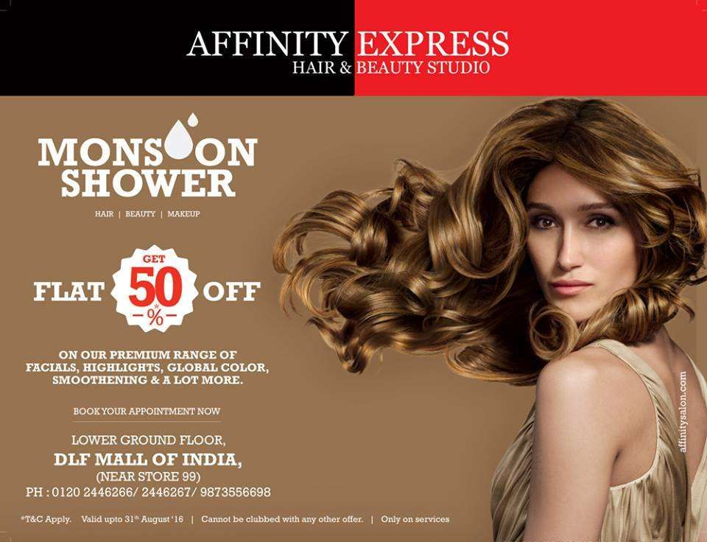

Boost business with any of these items. Custom shampoo and conditioner allow you to give your customers a little something extra to take home after their hair appointments. And custom imprinted matchbook emery boards are great giveaways at a nail salon. Incorporate these giveaways into your salon and we can guarantee some great business.

AYESHA KHAN / 2728
ASSIGNMENT NO.11 / PAGE NUMBER: 12

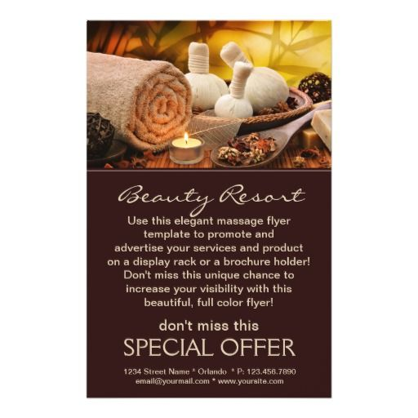

Student Statement:
By submitting this assignment, I confirm that this is my own work.

Student Signature | AYESHA KHAN | Date | 11 AUG 18

For Tutor / Assessor Use Only
Total Marks
Marks Obtained
Percentage / Grade

