
Assignment Cover Sheet

Student Name: | IDRIS OYEBAMIJI
Student Number: | 8394
Course: | Diploma in Travel And Tourism (Level 4)
Assignment NO: | 02

Marking Criteria:
We expect the learners to write minimum one well expressed point in three lines against each allocated mark. This means one needs to write 15 lines with 5 well expressed points to get high grades for a 5 marks question.
For high grades use examples and illustrations where appropriate.
1.

- Tourism enterprises usually offer both tangible and intangible products to their customers which are complementary each other and perceived as the integral parts of a whole travel experience. Although the tangible and intangible products are dissimilar in characteristics, they can be distinguished by their effects on customer satisfaction or combined for improving customer satisfaction.

Tangible: Touchable; able to be touched or felt; perceptible by the sense of touch; palpable.

Intangible: Incapable of being perceived by the senses.

For Example -Tangible aspects of service quality include the exterior and interior design of hotels, the equipment found at hotels and the ambient conditions in the environment of hotels.

Secondly A taxi service is a service that is tangible. A taxi driver provide both the good (a car), which provides the means of travel, as well as the act of driving to a place – which is measurable and essentially a service. Therefore a taxi cab driver provides both a good and a service, so he is providing a product.

On the other hand, the intangible aspects of service quality are those factors that are not touched; they include reliability, responsiveness, assurance and empathy.

For example – You pay for an online ticket but you have no idea how your travel will be. At best, you rely on the promise of the airline that your travel will be an experience to remember. But again, there is nothing tangible about that promise.

Secondly in the restaurant example above, you can have a good ambiance, good cutlery and thereby make the customer feel good so that his experience there is excellent. At the same time, you have to ensure that you deliver good food thus adding a lot of tangible elements to an otherwise intangible service.

- A tourism product is any product that is marketed by a country or an institution to visitors so as to attract them to visit a country as tourists and experience the said product. A tourism product is made up of intangible and tangible aspects. Things like natural and historical assets infrastructure and superstructure are all tangible. They may be appraised, measured and required to meet certain minimum standards. According to the Jamaica Tourist Board, for example, Jamaica has marketed its tourism products since 1890; as of 2014, tourism is one of the major industries in the country.

- Infrastructure and superstructure are the backbone of tourism industry.

Infrastructures are an essential component for the promotion of tourism in a systematic and scientific way which includes airports, electricity, road, water supply, sewerage system, and drainage.

Superstructure is an upward extension of an existing structure above a baseline which is composed of accommodation units, restaurants, hotels, and the total array of tourist mechanisms and services.

- Tourism, typically a service offering, cannot be stored for future consumption, this constitutes one of the unique features of services, referred to as ``perishability'' (Lovelock, 1980). In addition to the inability
to store tourism services, managers are also faced with the challenge of continuous fluctuation in demand. Seasonality may produce: fluctuation in demand at a ski resort between winter and summer; a fluctuation in
occupancy in a city Centre hotel during weekdays and weekends, the fluctuation in demand at a restaurant during breakfast, lunch and dinner hours to the rest of the day, the fluctuation of demand for travel facilities
during certain times of the day.

While the consumption of tangible goods may be delayed for future consumption and/or inspection of quality, services are generally produced and consumed almost simultaneously (Carmen and Langeard, 1980). These differences render the delivery system and quality control systems utilized in the product industry, inappropriate in tourism services. Tourism managers are thus required to consider alternative strategies to facilitate the efficient management of both demand and capacity (supply) of services as, unlike the goods manufacturing industry, service organizations are unable to increase the supply in accordance with the increase in demand.

When the demand for tourism service is higher than the firm's capacity, the firm effectively loses its chance to serve those customers. Similarly, when the demand is less than capacity, the firm loses revenue owing to unused resources, which directly leads to fluctuation in demand for tourism services.

- The tourism cluster Concept is a cluster which ambition is to reinforce, in terms of sustainable development, the destination identity – what makes it different from other destinations – and which stakeholders are all responsible for it.
Its core product is made up of the appropriate types of accommodations, eateries, and recreational amenities along with the tourist attractions. The marginal products adds to this by providing other tourist enticements in the way of different scenic, leisure, historic, amusement, shopping, entertainment, and recreational venues.

- Resort Complexes are well-thought incorporated resort centers which manage concentrate visitors in one location, minimize the infrastructural needs and facilitate numerous hotels and accommodation units to be erected swiftly in an organized and synchronized way e.g. the Langkawi development in Malaysia and Playa Dorada etc.

2. The factors on which the success of a destination depends are as follows :

Image: The image of a location is how it shows itself, and how it is perceived by viewers in the market which a positive image makes people want to visit, while a negative image will make them want to stay away. This is created through history and influences of culture, myth, and legend play a role, too which is one of the key factors of a successful destination in Tourism industry.

Price: The amounts visitors pay, or commit to paying before departure, are major determining factors.

Product Life Cycle: This work came from Levitt’s concept of a product’s lifecycle (Levitt, 1965). Products are introduced; it grows, becomes mature, levels and finally wanes off which at this point require new faces or forms. Tourist locations are forever in a process of transforming as they expand, develop and modify to market requirements in order to keep its competitiveness in the market.

Product Feasibility : There are always need to look at the demand for facilities, and then develop and operate the project on the basis of relationships between the three dimensions – market/product/and cost which trying to understand what visitors satisfactions are towards a particular location.

Transportation: The appropriate access to a country or location is clearly essential. Tourism requires a blend of transportation methods like
Fly/cruise, rail, good road, sea in order to enter or depart through varying points which is key to a successful tourism destination. For instance the hydrofoil variety of vessels now shuttles between Tanzania and Zanzibar, and Singapore and Batam Island.

Roads: Finally Development of good roads, especially construction of a new motorway, comes in direct conflict with environmental conservation goals in which tourism requires an acceptable network of roads, providing ample access to destinations and attractions in order to make such location marketable and attractive to tourist.

3. The image of a destination is a key element to attract tourists. This image is based on the perceptions of individuals about the destination, which determines their touristic behavior and, consequently, their choice of destination (Woodside and Lysonski 1989; Echtner and Ritchie, 1993). An image is created over a length of time; it is created through history and influences of
culture, myth, and legend play a role, too.
The image of a destination influence on the tourist demand, it influence destination on the behavior of tourists and their travel choices, it also shows most valued dimension of its construction in a touristic image, finally it shows why some communities of tourists prefer to advantage a touristic destination over another. For example The Case of Island of Djerba.

The link between price and image goes a long way in tourism industry because destinations are inclined to fall into price categories hence price becomes a part of the image. While prices are determined by the accommodation category selected, the total price range presented will vary from destination to destination. Amount of cost also suggests the exclusivity of the destination.

ACTIVITY

5 Days Sightseeing & Day Tours in Cape Town South Africa

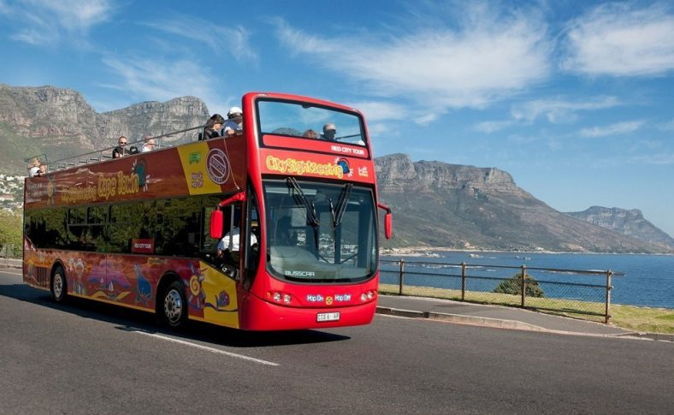

Day 1 : City Sightseeing’s Bus tour

- The City Sightseeing Hop-On Hop-Off busses take you to all key attractions of Cape Town.
- Different routes, to explore Cape Town, the Atlantic Sea Board, the Cape Peninsula and the Constantia Wine Estates.
- Audio channel with 15 languages.

Description

City Sightseeing’s open-top, double-decker buses take you to Cape Town’s must-see attractions. A single ticket gets you access to all the tour stops, with the power to hop-on and hop-off at your own pace. Choose to spend all day at a sight, or visit the whole tour’s offering, as each ticket gives you access to marked pick-up and drop-off points where buses come around regularly. Ride on the top deck to capture the picture-perfect scenery, or relax on the bottom deck when the weather is tricky. Along the way, enjoy the complimentary audio guide that’s available in 15 different languages and packed with useful info and insider tips.

Day 2: Enjoy a full-day guided tour of the Penguins at Boulders Beach, Cape Point and the Cape of Good Hope with the Cape Point Explorer.

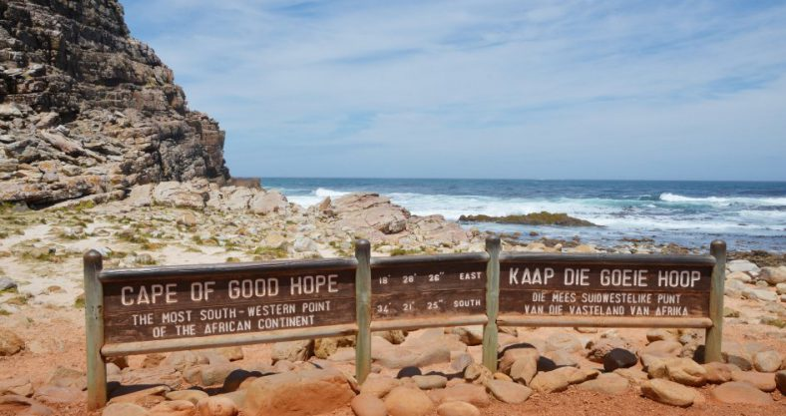

Highlights

- Full day tour around the Cape Peninsula
- Boulders Beach and its thousands of African penguins
- Hike to the Cape of Good Hope inside the Cape Point Nature Reserve
- Funicular to the Cape Point light house

Description

The Cape Point Explorer is a guided day tour to Cape Point in a luxury air-conditioned coach, operated by City Sightseeing South Africa. You will explore this spectacular nature reserve (part of the Cape Floral Kingdom World Heritage Site), with a stop at Boulders Beach, home to a colony of African penguins. This day tour to the Cape of Good Hope is a must-see for visitors and locals.

The Cape Point Explorer leaves Cape Town in the morning and starts with a scenic drive to Boulders Beach, through Muizenberg and Fish Hoek. The guide highlights the different points of interest along the way and is at hand to answer any questions you have about the route, Cape Point and Boulders Beach.

Boulders Beach is home to a colony of endangered African penguins, so this is your once-in-a-lifetime chance to come within metres of them in a natural environment. The pristine beach surrounded by impressive granite boulders is part of Table Mountain Nature Reserve.

After visiting the penguins, your next stop is Cape Point, where you can enjoy a bite to eat before exploring further. The Cape Point Nature Reserve offers some of the most breathtaking mountain and ocean scenery in the world. Using the Flying Dutchman funicular to the viewing point below the lighthouse, you can admire the views across False Bay. There is an optional hike from the Cape of Good Hope to the top of Cape Point. At Cape Point, you can also follow the footsteps of early Portuguese explorers Vasco Da Gama and Bartolomeu Dias, and enjoy a number of short walking trails leading to beautiful beaches and viewpoints.

After a day spent exploring, you can enjoy the coastal drive back to Cape Town via Scarborough and Kommetjie, with spectacular views from the Ou Kaapse Weg mountain pass.

Day 3 : Visit the Cape Wheel

Enjoy this 360-degree panoramic view of Table Mountain, Robben Island, the Cape Town city skyline and local mountains from the Cape Wheel in the V&A Waterfront. Each ride takes four revolutions, lasting about 15 minutes.

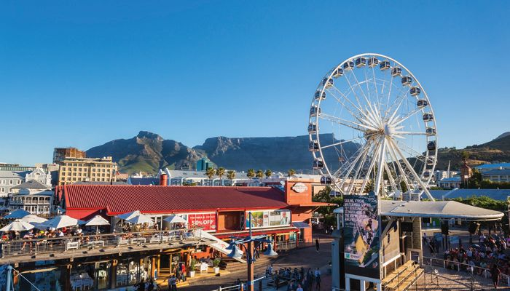
Highlights

- Panoramic views of the Atlantic Coast, Robben Island, Cape Town skyline Table Mountain and Hottentots range
- Detailed views of the working harbour, V&A Waterfront
- Wheelchair-friendly

Description

Enjoy a spectacular 360-degree panoramic view of the Mother City from the iconic and vibrant V&A Waterfront on the Cape Wheel. With 30 fully enclosed, air conditioned cabins which gently rise 40 metres above the ground in safety and comfort, it’s fun for the whole family, all year long. From a vantage point high in the sky, gorgeous views of Table Mountain, Robben Island, the Cape Town city skyline and local mountains are unveiled. The breath-taking display is enjoyed for four revolutions a ride, lasting about 15 minutes. Two wheelchair-friendly cabins are available, making this an inviting experience for everyone.

Day 4 : Helicopter Tours over Cape Town

Experience an unforgettable 20-minute flight that takes you from the V&A Waterfront along the Atlantic Coast to Camps Bay, across the Twelve Apostles, over False Bay and back!

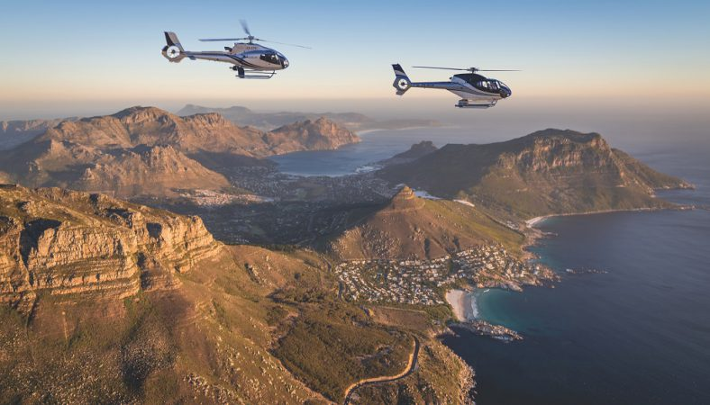

Highlights

- Fly along the Atlantic coastline of Cape Town, over the 12 Aspotles to False Bay and back to the V&A Waterfront
- Live commentary by the pilot

Description

Experience an unforgettable tour of the Mother City that is simply impossible to replicate from the ground. Fly from the dazzling V&A Waterfront helipad and along the mesmerising Atlantic Coast. Soak up incomparable views from above of the stunning beaches of Clifton and Camps Bay, and stare in awe at the Twelve Apostles mountain range, a prominent landmark which forms the spine of the Cape peninsula. Take in the rugged coastline of False Bay before circling at Karbonkelberg and making the return flight home. Receive constant, live commentary of the exquisite sights and noteworthy landmarks by the friendly and knowledgeable pilot. This well-organised, perfectly executed tour from the skies should not be missed!

Day 5 : final Day Sidecars Tours along the Atlantic Seaboard

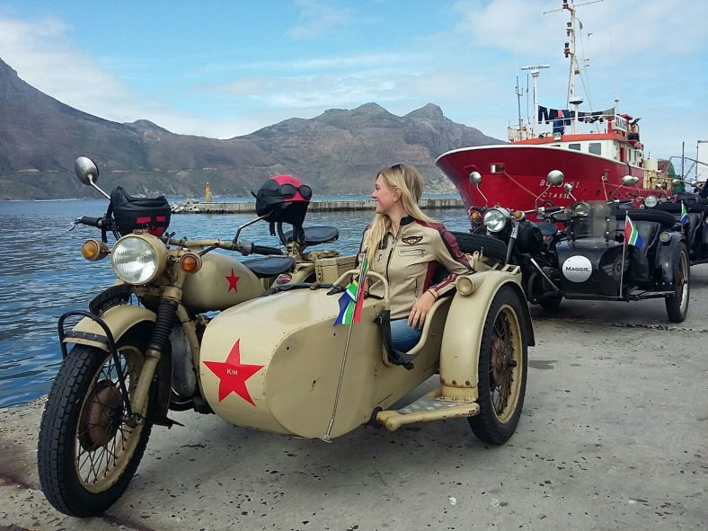

Highlights

- Experience vintage WWII motorbike sidecar tour
- Ride along the the Atlantic Coast and Chapman’s Peak Drive
- All gear supplied, disabled passengers friendly

Description

Tour the city of Cape Town from the unique vantage point of a vintage motorbike sidecar. Head into the city dressed for the occasion in retro riding gear including leather jackets, goggles, helmets and bandanas. Once fully-kitted, enjoy the unique experience of cruising around the Western Cape on a round trip from the Cape Peninsula to Cape Point. Notable stops along the way include a cruise through the Company’s Garden, and viewing the incredible artworks and exhibitions on display. Once you have passed Camps Bay and made it to the lookout on Chapmans Peak Drive, riders hop off the bikes, have a drink and a snack, and snap keepsake pictures of the tranquil and awe-inspiring seaside views.

Note: The proposed tour package to cape town in south Africa will be appealing to the group of tourist because, Whether you prefer museums, adventure, the great outdoors, cruising or touring, there really is something for everyone to satisfy there needs

Student Statement:

By submitting this assignment, I confirm that this is my own work.

Student Signature | IDRIS OYEBAMIJI | Date | 1/6/2017

For Tutor / Assessor Use Only
Total Marks
Marks Obtained
Percentage / Grade

