
Assignment Cover Sheet

Student Name: | Sally Tomlin
Student Number: | 18902
Course: | Diploma in Construction Management
Assignment NO: | Unit 13

Marking Criteria:
We expect the learners to write minimum one well expressed point in three lines against each allocated mark. This means one needs to write 15 lines with 5 well expressed points to get high grades for a 5 marks question.
For high grades use examples and illustrations where appropriate.
1i) The Oxford Dictionary of Construction, Surveying & Civil Engineering defines a contract as ‘the agreement between two or more parties comprising an offer, acceptance and consideration. The contract may be a standard form of agreement between the contractor and client such as a construction contract or may be a simple contract formed between the client and contractor’.
Some contracts may be just verbal and agreed on a handshake, however this, in most cases would not be legally binding, only a written, signed contract would be needed if a conflict occurs and results in a court case.
A contract should set out in detail what is expected from both parties and once an agreement is reached, signed by both and copies made, so that all parties involved have a copy.
There are so many different types of contract and since the law of contracts is at the heart of most business dealings, it is one of the three or four most significant areas of legal concern. Because the world of contracts is so vast there are many sayings worldwide including; Vox emissa volat, litera scripta manet – Words spoken vanish, the written letter remains. Dolo malo pacturne non servatum – An agreement induced by fraud is not valid. Scientia utrinque par pares contrahentesfacit – Equal knowledge on both sides makes the contracting parties equal. Legem enim contractus dat – The contract makes the law.

ii) A contract contains many elements, but there are four essential ones to ensure the contract is legally binding. Firstly the agreement, as discussed in the previous answer, both parties must read, fully understand, agree and only then should they sign. The contract may include an offer, an acceptance of the offer, a promise to perform, a valuable consideration (a promise or payment), a time when expected work will be completed, terms and conditions for performance and performance.
The second element is lawful subject matter, which refers to mutual assurance between the parties that the job and its performance would not be a violation of the law. For example dog fighting is illegal in the UK, so if a part of a site was used for conducting illegal dog fights the contract would become nul and void. This is an extreme example, but you get the idea. ‘Any undertaking may be the subject of a contract, provided that is not proscribed by law. When a contract is formed in restraint of trade, courts will not enforce it, because it imposes an illegal and unreasonable burden on commerce by hindering competition. Contracts that provide for the commission of a crime or any illegal objective are also void’ The Free Dictionary By Farlex.
A contract will also become void if someone tries to imply that they own something outright when they do not.
The third element is valid consideration which is the part of a contract which determines the mutual benefits between the parties who sign the contract. A court of law will not judge whether these mutual benefits are fair, because as long as both parties are happy with the written benefits and sign to this effect the courts will judge it was legally sufficient valid consideration.
In some situations courts may declare a contract enforceable because it lacks consideration eg. The promise is a gift not a contract or one of the parties was already legally obliged to perform i.e. a rugby player cannot claim a reward for scoring a try, because the player is already obligated to score if he can.
In everyday life people use valid consideration all the time, when they go shopping they agree to pay a set amount of money in exchange for what goods they have chosen.
Finally competent parties which is quite difficult to disprove, because the law in general presumes that has the capacity to sign contracts, however it is imperative to make sure that anyone signing a contract must be capable of understanding all of the contract including all technical details, etc, they must not be underage, drunk (this has a proviso if ‘they know what they are doing’) or mentally insane, also courts may rule on a competency issue (whether the company is up to the job).

iii) A lump sum contract is an overall price for the whole project rather than bidding on individual elements. It is possibly the most used agreement on sites that are not likely to throw up any problems with regard to different site conditions and have a well defined scope and most specifications, completed plans and all studies/assessments have been completed. This type of contract is developed by estimating labour costs, material costs and then adding a final amount to cover contractor’s overheads (vehicle costs, reward programmes, waste disposal, site accommodation, insurance etc) and the profit margin.
A lump sum contract would not be suitable for large, on-going projects where the ground conditions are not stable or cannot be guaranteed, if the drawings are not complete, are on-going or subject to change or on sites where extreme weather conditions may affect the work, as all of these issues will make a huge difference to the final costings.
The advantages of lump sum contracts start at the tender process, because the selection/bidding process is relatively easy, as there is a fixed overall cost, which cuts down on the admin and even design costs. There is low risk to the owner, because he has handed all risks to the contractor (although the contractor may ask for a higher mark up, due to unforeseen costs). Ordering will be easier, because of the minimal amount of change. Owner supervision will be reduced, again because the contractor has the risks. The contractors will be more likely to finish the project faster (the contractor will not be able to demand extra payments, so will want to complete asap to get onto his next project). The contractor will maximize the production and performance (to get a good name in the industry).
The disadvantages are the contract prices will be higher, as the contractor must cover all unforeseen circumstances in his costings, which is also a disadvantage to the contractor as his risk is much higher with this type of contract. Changes needed may cause problems to both parties. The project plans, drawings, specs and timings must be complete before it begins. Finally, because the contractor will select his own means and methods, the overall project could take longer than using other contract alternatives.
In brief lump sum contracts are ideal for small, simple jobs, but they may lead to disputes and claims on both sides mainly due to any changes needed or early completion issues.

iv) a cost plus percentage contract is a contract that is used in the construction industry, it is used on jobs that may change throughout the project, so it is virtually impossible to accurately estimate the job, by having a cost plus percentage contract it will cover the cost of the materials and labour plus a percentage to cover the operating overheads and time.
According to Study.com ‘the benefits and disadvantages can vary based on whether you are the buyer or the contractor. To a contractor, using a CPP contract benefits jobs that use a lot of materials. You wouldn’t use it if your material costs were minimal. The disadvantage to using a CPP contract is when you run into difficulty and you need to spend more time to work around it. Your material costs remain the same, so the extra time will not be covered, however this is of benefit to the buyer, as they won’t have to worry about the time needed to complete a project, even if the contractor takes longer to finish, the buyer still pays the same CPP.
A disadvantage for the buyer is that he or she can’t budget for this type of contract as the price can change as the project continues. If more materials are needed, then the cost will be higher.’
One good thing is with this contract is a project can begin before plans are completed or are subject to change.
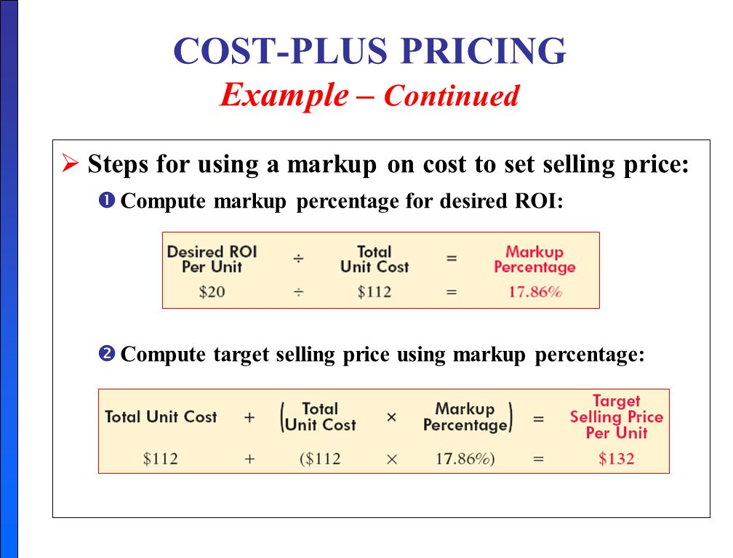
Example from university of Louisiana, Lafayette

v)When choosing the type of contract for a project it is usually down to the owner with assistance from the project engineer. There are two main catagories of contract (negotiated and competitive), but there are many variations, the top four being:
Lump sum or fixed price – this should be chosen if the risk is to be taken by the contractor and the owner wants to avoid change orders for unknown work. This contract would be used if the project is already finalized before the contract is awarded and there are not likely to be any major unforeseen problems.
Cost plus contracts – these should be chosen if the project details have not been completed or will be subject to change and the owner puts a limit on how mush a contractor can charge, this protects the owners interest, but also minimizes the risks to the contractor.
Time and materials contracts (unclear scope) – these would really only be used if the project is small or a sensible guess can be made on how long the project will take to complete.
Unit pricing contracts – this is used if a contractor wants to check that he is being charged fairly for goods or services. Unit prices can go up or down during the project changes, making it easier for the owner and contractor to reach agreements during any changes.
When selecting the type of contract depends on many things including, how far along are the plans, when funds will be available, how much the owner wants to be involved in assessments, inspections etc and of course which contract will be the most beneficial for all concerned and the overall project.
It is of great importance to choose the correct contract, because once signed it cannot be changed and it is vital to the smooth and trouble free running of a project.

vi) Insurance contracts are normally included in the main contract, it sets out who is responsible for damage/loss, employers liability, damage to properties, compensation and liabilities (general). It is a requirement in most cases to have some sort of specific coverage.
There are many kinds of insurance contracts now, that the construction industry are looking to provide coverage of every possible situation possible, in some cases project developers will require some of these before you will be eligible to tender.
Some of these are:
Contractor Liability – injuries, accidents, property damage
Builders Risk – damage coverage
Performance Bond – protects against performance failure/bankruptcy
Professional Liability – errors caused by contractor’s negligence
Flood Insurance – dependant on where the project is.

2) There are so many different types of contracts available this should be an easy question to answer, however the construction industry is so vast and varied it is not so easy, but as most companies have their expertise in working on specific types of jobs they will tend to work to the same type of contract for each job.
I would personally say that it is simpler to say that there are particular types of contract UNSUITABLE for a particular situation.
Contracts can be tweaked to suit either party, but they would still be using a particular contract standard template and as the number of different types of contract have increased it is fair to say that you should be able to find a particular contract to suit a particular situation.
Easy examples of which contracts to use:
An owner wants to construct a sports pavilion on a prepared piece of land, he has all the plans, designs and specifications finalized, he knows the weather is stable, doesn’t anticipate any major problems and knows when the project has to be completed by, so the best contract to use would be a competitive bid contract, ensuring the contractor has working capital, is free from litigation and be willing and able to provide guarantees and sureties. The owner would probably choose a Lump Sum Contract.
Example 2
An owner wants to build a shopping mall in Dubai, but wants UK contractors to complete the project, the plans are started, but in no way finalized. The location has been chosen, but the weather is extreme and there is a chance of sandstorms, the ground conditions have not yet been established, so the contract would be a negotiated contract and he would probably opt for an Incentive Type Contract for Work Outside the Country, although this type of contract is complicated it would most likely be the best option.
Contract selection is difficult and complicated, so extreme care should be taken before making the final decision.

Student Statement:

By submitting this assignment, I confirm that this is my own work.

Student Signature | S J Tomlin | Date | 21/8/18

For Tutor / Assessor Use Only
Total Marks
Marks Obtained
Percentage / Grade

