
Assignment Cover Sheet

Student Name: | Emma Taylor
Student Number: | 1465
Course: | Event management
Assignment NO: | 18

Marking Criteria:
We expect the learners to write minimum one well expressed point in three lines against each allocated mark. This means one needs to write 15 lines with 5 well expressed points to get high grades for a 5 marks question.
For high grades use examples and illustrations where appropriate.

Emma Taylor

Student ID 1465

Assignment 18



Address: 6 rue de l’ecole, mensdorf L6934
Webpage: www.weliketoparty.com
Email: we-like-to-party@hotmail.com
Telephone: 00352 661126333

1 Business summary
We like to party specialize in parties and weddings, we are a family run business that started up recently after a lot of demand from family and friends asking for help with special occasions, this in turn turned into a passion for party planning. We produce all of our own decoration designs, this helps us keep our costs low as we don’t out source, we also have a small but really nice selection of party hires these are used as centerpieces or just the right finishing touch to your event

1.1
Our business aim is to bring chic, original but foremost affordable party decorations to everyone! We also aim to produce high standard time and time again so every person can have that party planner look for their event even if they don’t have a party planner. We can be as hands on as needed

1.2
The business will be solely funded by the owner from private savings this will be a lump sum of 30,000 pounds this will cover buying of equipment for rental, materials for printing and die cutting and office equipment all startup costs and any legal fee’s that need to be paid. Due to our financial stability we can afford to invest in the business without having to take any drawings from it for at least the 1st 2 years this will give the business a chance to establish itself and be making a decent profit also it gives us money to help the business expand.

Business name
The business will be called ‘We like to party’ I feel this explains the business well and also hints to my passion for parties and experience.

1.4
Your party, your way! Affordable party planning and products

1.5 elevator pitch
We like to party will be the next big thing in the event planning market we aim to make every party special but also affordable with our mix and match party boxes all with a fixed price and in a range of sizes we believe this is possible. Party hires and event planning will also be available. We can be as involved as our client needs us to be.

About the me
My name is Emma I am a stay at home mum with 3 beautiful children my youngest is now at school full time so I’ve found myself with more time on my hands ive always had a passion for birthday parties, Christmas, Halloween any occasion that involves the potential to plan and throw a party. Previously I was a manager in a bar in a busy city center so I am able to work under pressure and have direct contact with customers/clients. I can handle difficult people and situations without losing my head.
My qualifications for starting and running the business include completed secondary education and also a level 4 diploma in Event management, I also think that the fact I have planned and thrown around 150 parties of all types over the past 20 years, most of those have been in the last 5 years for friends and family and of course my own children shows I have experience and also vision I feel everybody should be able to afford the party of their dreams.
In the future I plan to take courses in balloon crafting (archways characters and table centers) I will also be doing a course in creating my own party pack printables so that im not outsourcing and saving myself money, I short course in floristry for table centers plinths and bouquets and button holes is an idea at the moment.
My hobbies and interests include a lot of crafting items for the house and my children I enjoy walking and reading I also like to learn new things and the challenges that it brings.

products and services
we will be selling and hiring out products that we have purchased or produced ourselves the products we are hiring out will have a delivery distance limit, but the products we will produce for sale will be available worldwide. We will also provide an event planning service.

Items we will hire out
Popcorn machine- The machine will come fully equipped with everything you need to make fresh tasty popcorn and tubs this item can be part of a party package or as a stand alone item it can also be rented as part of a movie night package with a slushy machine.
Vase’s and table center decorations- these will range from rounded mirrors, tall and small vase’s and candelabra’s and vintage birdcages the range will be expanded as the business grows.
Chair covers and sashes-we will start with 2 colored chair covers ivory and white but stock around 20 different colored sashes again this amount will increase as the business grows
Table cloths-table cloths will come in different sizes and also 2 types of colors to start with ivory and white we will also provide table runners which will match the chair sashes in color
Disco equipment-a transportable sound system with USB pre-programmed with music and 2 disco lights on a stand can be rented as part of a party package or on its own.
Bell tents-The big rental that we will do, will be the bell tents these can be hired for any occasion and they will come with decoration and in the case of it being a ‘play tent’ it will come with toys and play equipment. It will also be packaged as a sleep over venue and will come with airbeds, bedding, decoration and snacks. The bell tent will also have a ‘romantic’ option which will come with a double bed and everything needed for a romantic night in this is great for a getaway when you don’t have time or big funds for a real getaway.
All rentals will be delivered and rented on a 24 hour basis unless pre-arranged with us and the customer. They will be set up and then collected the following day at a convenient time, all cleaning of equipment will be undertaken by We like to party. All package prices will be clearly stated and agreed with the customer with no hidden extra’s

Products we will sell
Invitations
Balloons
Plates and cutlery
Disposable table cloths
Banners and decorations
Giftbags
Sweet cones/fruit cones
Party Games
Prizes
Cupcake toppers
These items can be sold individually or in one of our party boxes which are themed boxes coming in a range of sizes depending on the size of the party this will be a one click buying option the customer chooses the theme and clicks either
Small-10 people
Medium-20 people
Large-30 people
Extra large-50 people
They will then receive the above products in 1 box with suggestions and photo’s on how to set up the party/display tables and how to run the games this gives everyone the party planner look without the price tag.

Services we will offer
We like to party will offer a full party planning service this can be for small events and those bigger affairs, clients will be able to meet with our qualified event planner who will then tailor to the client’s needs we can do as much or as little as you need. Our event planning service will strive to give a quality service every time to every client and to work either alongside the client to help them realize the dream and vision they have or in a full package capacity where we will do everything including coming up with the vision based on the clients wants and needs.
We will aim to make the party planning process as easy and painless for the client and keep them on budget with the end result being a fabulous party/wedding where their guests will be totally wowed!

the market
The majority of our customers will be individuals to start with as we grow as a business we will also offer party packages to businesses for office parties (summer, Christmas etc) the Event market is expanding constantly with new idea’s , bringing new and exciting things to your clients is a must researching your area and seeing what’s missing who isn’t being catered for and why? And what we as a business can do to tap into that market.
After some initial research I have concluded there is a massive gap in the market for Birthday parties for children aged from around 6 years to teen’s
There are a few `soft’ play area’s that hold birthday parties but I think after a certain age these places don’t really work for the older child. Ive also found a home party company who bring soft play and bouncy castle to your home again I feel this has an age limit and also a wow factor limit there are only so many times you would want to have this sort of party.
We like to party want to offer new and exciting parties we will work with Venue’s and several party entertainers to build up a mix and match party package that’s affordable for everyone.
The adults in my local area are well paid individuals but tend to not have a lot of time I will target these people with attractive party packages with a minimum of fuss involved for them but maximum enjoyment for their guests.

my marketing plan
My marketing plan for the business is to get as much exposure as possible leading up to and during the launch I will use the following mediums
Radio-I have a friend who has her own 2 hour slot on the radio she also on a Monday has guests in who are local business’s in to talk about there services and how they got into the business they are in this would be a great way to let people know about my new business and a way for people to understand the person behind the business this gives the business a face so to speak.
Flyering- This is one of the cheapest forms of advertising once the flyer’s are printed it’s a case of posting them in the postboxes and asking local business’s if they can leave them on the counter. Targeting places where adults go with children is a must children’s clothes shops would be perfect.
Word of mouth- This of course is great because it is FREE telling friends about your new business and making sure they tell their friends in return helps you gain a reputation as someone to go to for a party.
Social media-taking to facebook,twitter instergram etc is a brilliant way to advertise your business for free, I will also run a competition with the prize being a party this can be run on facebook a like and share element thus making the person entering have to share your page.

Launch party- having a launch party is expensive but as a party themed business it is a great way of showcasing your talents! Being original and different is what will set my business aside for competitors I will also run a competition with the prize being a party this can be run on social media with maybe a like and share element.

Profit and loss
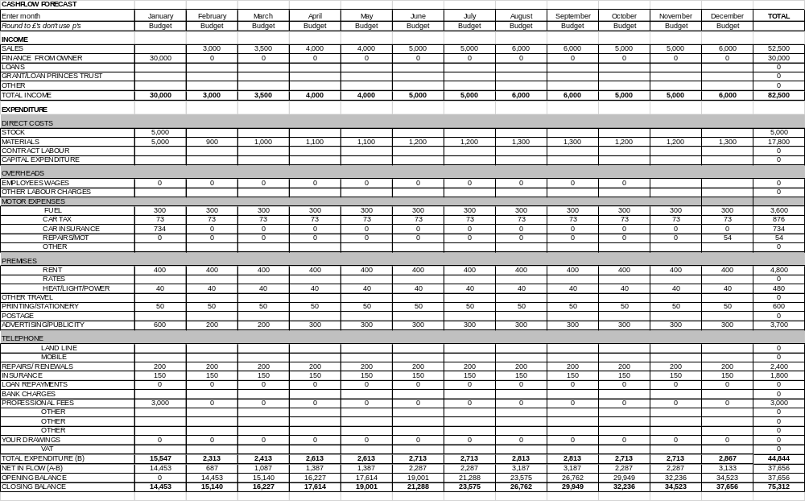

This Table is a brief look at what I hope to make during the first year and my outgoings, a big loss in the first month is set up costs and also the initial buying in of stock, after that the customer covers most of the costs so as long as I have customers I will be making money.
I will invest an initial £30,000 in the business this will be to cover start up costs, legal advice and contract draw up.
Then the money will be used to rent a lock up to store stock this shouldn’t be much as it wont actually be an office my office will be in a spare room at my home where all bills are already covered in our day to day living expenses.
We will buy a van so that deliveries of rentals are easier and several can be done in one round to help save money on fuel.
Materials will need to be replenished month by month depending on how busy we are and what we have used this will include card, paper, ink for the printer bags and boxes.
Printing and stationary will cover business cards and leaflets or flyers that we have made.
Advertising and publicity will be expensive in the first month but this is due to a need to get the name of my new business out there and making sure people know what we do.
I will take no drawings or payment from the company in the first 2 years as I am supported by my husband so have no need to. This I hope will give the business a more stable ground and also help with expansion as I can keep putting money back in and have the cash to keep up with market trends.

The Success of this business lies with me being good at what I do, keeping things affordable not only for me to produce, but also how much I then charge my customer. We will start relatively small but I hope eventually we can become the go to company when you are buying party supplies or planning an event.

Q2

Event management plan

This event is being conducted with the sole purpose of raising as much money for cancer research as possible. The event has the backing on Cancer research UK and all proceeds will be passed onto the charity after the event.

Name of event: Kicking Cancer’s Butt
Venue: Queens park Luxembourg
Date: 1st September
Time:12pm to 8pm
Contact person: Emma Taylor
Position: Event coordinator
Phone: 00352 661126333
Email: ema.jane@hotmail.co.uk
Mailing Address: 6 rue de l’ecole, Mensdorf, Luxembourg L6934
This event is a charity football tournament with multiple teams being sponsored to play with an overall winning team at the end.
The Event will be open to teams from all over the country and all levels excluding professional teams. The aim will be to make as much money for the charity cancer research UK. We are expecting a lot of families coming to support the teams so it will be very family orientated with entertainment and food.
Due to the recent success of the world cup the event will be marketed as a mini world cup. This we hope will bring the excitement that comes with the world cup and that football fever!
The main activities at the site will be of course the tournament itself but also an area that is for families this area will have face painting, inflatable giant table football a workshop for football skills held by professionals and also a celebrity football area where professional players will sign autographs, music will be provided by a DJ.
The long term objective of this event if it is successful is to make it an annual thing in the long term to make as much money for the charity into the future.
Our short term objective is to attract as many people to the event. Making it a fun day so visitors enjoy themselves and thus meaning spending more money with the idea to raise as much as possible.

The event is being sponsored by Power aid drinks they will have main advertising space and will appear on all flyers, tickets and posters and the drinks will be sold onsite.
The event will be run by a committee that is headed by myself (Emma Taylor) I will have several people who will report directly to me on a daily basis.
Site Manager-David Hill will be responsible for the construction of the site and safety of the temporary structures.
Media and sponsorship-Ava Jay will be responsible for all contact with Media for advertising and also be responsible for sponsorship deals to help keep our costs down. She will also be tasked with recruiting our vendors and entertainment.
Security and steward training-Kaiden Giles will be our head of security he will be responsible for the onsite security leading up to, during and after the event he will also be charged with making sure that all volunteer stewards are all properly trained and aware of what is expected of them.
Waste management- Craig Clifton will be the head of waste management he will oversee the training of refuse collectors and safe disposal in main bin area’s onsite but also the refuse companies for big collections during the event, he will also be responsible for all toilet area’s and the assignment of cleaning staff to keep these areas as clean as possible. he will also be tasked with coordinating the clean up after the event.
Transport and parking-Lily Townsend will be responsible for the ticketing parking next to the venue and also the park and ride. She will be responsible for contacting public transport agencies to see what they can offer in terms of extra public transport.

If during your time working on the lead up to this event if you have any query of who you should report directly to please contact the head of the committee.

Local businesses are being encouraged to become involved by entering a team in the event or by sponsoring one of the teams involved with branded football kit.
Taxi companies have been contacted to see if they can offer a flat rate ride for people travelling to the train or airport.

The local council are very much in favor of our event and have asked to be updated with any new news about our event they have also said they will help with any licenses we require and the quick process of them.
The event will be run very much with the help of volunteers we will source skilled volunteers from companies and sporting associations needed for this event but we can also source volunteers from the general public who after training making excellent stewards.
Our Target market for this event is Families we will bill this day as a family fun day in support of a great cause.
To increase our attraction to the target market we could run competitions in schools to win tickets or local supermarkets, the attraction of professional footballers will be a big draw. We can also do a range of family tickets that cover not just 2 adults and 2 children but 1 adult 3 children 2 adults 1 child all at a discount of the per person price.
Funding will come from our sponsors and also from donations of time, money and materials we have a basic budget but after that we have to rely on the kindness of local people and large companies.
Our main sponsor so far is Power aid and they have pledge a good amount to get us up and running but we can still attract sponsors from other types of companies.
Sportswear company
Local Radio station
Car company
Food outlet

Ava will be in charge of a small team who will contact all the companies in the area that fit into the above categories she will then hopefully sign up some more sponsors for our event. she will also contact a printing or Vinyl company who can hopefully provide us with flags and hats of the participating teams for their supporters to buy. Cancer Uk will provide their own merchandize to be sold along side.
We will contact local food trucks to see if they are interested in renting a pitch from us on the site for around £1000 for the day we will guarantee no food of the same type being sold as competition and the amount of trucks limited to 6 for the whole site.

Site plan
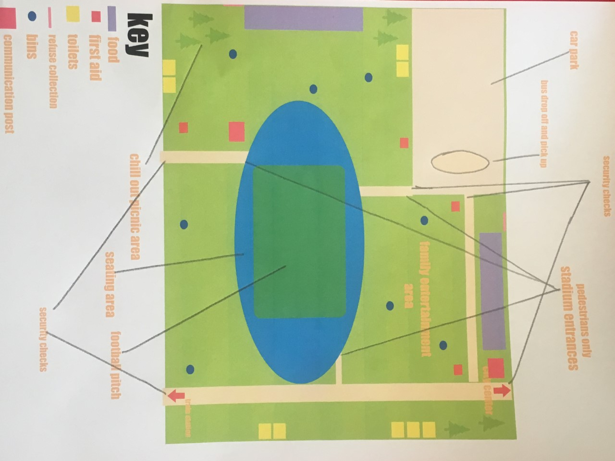

Onsite we will have facilities to suit everyone we will have walkways on the grass to allow free movement of wheelchairs and pushchairs between main site area’s including food, toilets, first aid area’s and entertainment the priority is the outside arena area is accessible to everyone and that the arena is equipped with a disabled viewing area and a pushchair parking lot outside and that these areas have easy access to emergency exits and also not blocking those area’s.
As head of the committee I will be in charge of liaising with the council, insurance company, Emergency services to make sure we have all permits and risk assessments in place proper training for staff with the help of Kaiden and that our event is a as safe as it can possibly be.
Craig will be in charge of waste management but our main plan is to make sure bins on the site are emptied on a regular basis into the large bins located behind the food area’s this area should be separated from attendees so no risk of fire. Craig will also liaise with an outside refuge company who will come several times during the day to remove the waste in the big bins.

Parking at the venue will be sold as ticketed spaces attendees will pay by the day and guaranteed a spot it will be sold first come first served.
Aswell as the parking at the venue there will be several park and ride carparks based about 15 minutes away from the venue with a bus running from the venue carpark at regular intervals.
The main idea for transport is public transport we will liaise with the transport department to come to a traffic light conclusion.

Evaluation of the event can be measured firstly by tickets sales have we sold all the tickets
Has the advertising done what it was supposed to?
Are people talking about the event?
Are we on target to make a profit and therefore money for the charity?
Ways to collect this data can be social media are we trending on twitter, facebook, etc market research is more than just surveys now social media is probably the easiest way to gauge peoples reactions to an event that you are doing.

Evaluation of the event can only really be done hindsight after the event has been and gone clean up is done and the event is deemed a success by the attendee’s.

Student Statement:

By submitting this assignment, I confirm that this is my own work.

Student Signature | Emma Taylor | Date | 26.07.2018

For Tutor / Assessor Use Only
Total Marks
Marks Obtained
Percentage / Grade

